# Tides Module

The tide module makes water go up and down. It has a buoy with a script to make boats and objects float with the changing water level. It must be used on a single sim surrounded by water.

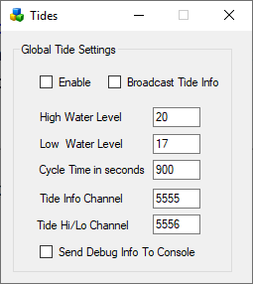

**Enable**: If set, Tides are enabled globally. Individual region Tide setting must be enabled to make the water go up and down in each region.

**Broadcast Tide Info**: This must be checked to send tide level info to the provided buoy. It uses channel 5555.

**High Water Level**: default 20 meters

**Low Water Level**: default 17 meters

**Cycle time in seconds**. default 900 seconds = 15 minutes

**Tide Info Channel**: As the tides rise and fall, a tide level command is broadcast on this channel. This must be set to 5555 for the provided script to work.

**Tide High Low Channel**: An announcement will be made on this channel when the tide is at a high or low level.

**Send Debug Info to console:** will send chat to the regions console for debugging.

## Buoy:

A floating buoy is provided in the Load Local IAR menu.

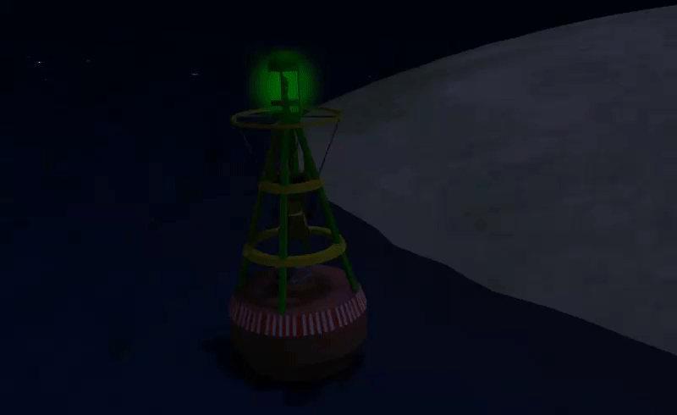

## Tide script:

To make items float on water just place this script into their root prim.

integer listen_handle;  
vector myPos;  
float tideLevel = 20.0;

default {  
 on_rez(integer start_param)  
 {  
 llResetScript();  
 }

state_entry()  
 {  
 listen_handle = llListen(5556, "TIDE", NULL_KEY, "");  
 }

listen( integer channel, string name, key id, string message )  
 {  
 tideLevel=(float)message;  
 myPos = llGetPos();  
 llSetPos(<myPos.x, myPos.y, tideLevel + 0.05>);  
 }   
}

To make items float on water just place this script into their root prim.

More complex stuff can be done using the full info channel, which has data about where in the tide cycle we are. Rez a cube prim and place this script inside:

integer listen_handle;  
default  
{  
 state_entry()  
 {  
 listen_handle = llListen(5555, "TIDE", NULL_KEY, "");  
 }

listen( integer channel, string name, key id, string message )  
 {  
 llWhisper(0,channel + " " + name + " " + id + "\n" + message);  
 }  
}

The cube will whisper info about the current tide position every time the tide is updated.

## Links:

Tides is by Jak Daniels from <https://github.com/JakDaniels/OpenSimTide>