# Vivox Voice Settings

Please Note that Vivox is no longer giving out codes.

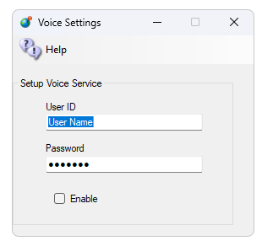

Add your User ID and Password to this form and enable it. Restart the system and voice should work.

## Links:

<https://support.vivox>

<http://www.hypergridbusiness.com/2011/12/free-vivox-for-all>