Publicity – Publish your Grid
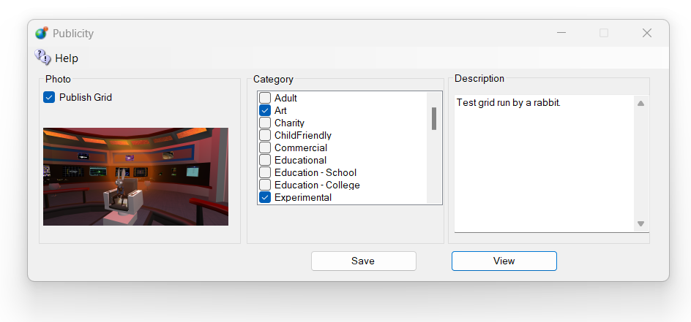
Publish Grid Checkbox = Checked sends shows your grid in the list at https://outworldz.com/search and in all viewers in all DreamGrids.
Categories are used to put your grid into the Destination Guide https://outworldz.com/DestinationGuide and in all viewers in all DreamGrids.

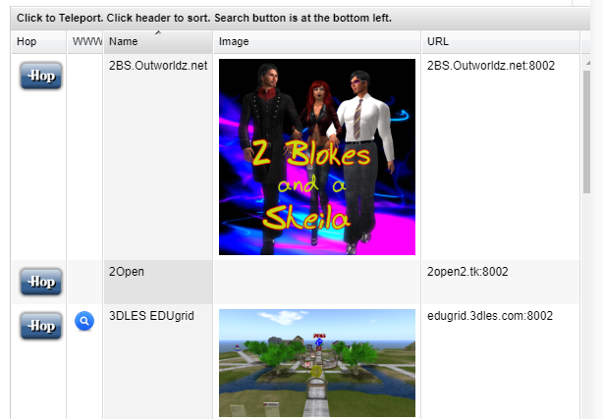
Photos: Click the box to load a PNG image and it will appear in your listing.

