Robust and Server Type
This menu item “Server Type” lets you choose from either a Grid Server with Robust, or from different Region Server choices to connect to another grid.
You MUST first run as a regular grid, then switch to a region server. DreamGrid needs certain tables in robust, even though regions do not use them.
After it boots, stop the grid, drop the Welcome region it created, and make a new region at a free spot coordinate on the OsGrid map. Then you can change to a region server.
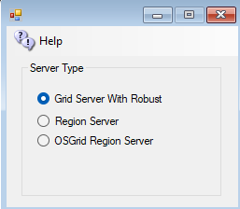

Grid Server with Robust
A grid server is modeled after the World Wide Web, with independent domains. Content is spread across small, independent and on large domains, independently, yet interlinks. Robust is the service that lets Hypergrid users enter each world. A Grid Server can also support regions locally. A grid server can host as many Region servers as its memory and CPU capacity allows.

OsGrid Region Server
The OsGrid region server is a preconfigured region server already set up to connect to OsGrid.
The port values are hard coded in a separate set of INI files used for OsGrid.

Region Server
A Region server uses a separate DreamGrid Robust Grid Server for all assets and login services. Only regions and their content are stored locally. The grid server may be on the same LAN, or on another WAN.
A Region Server always uses the same Domain Name and port 8002 as the Hosting server.

Region Ports
External Hostname: If on the same LAN as the Host Robust machine, this can be left alone, as port forwards do the work. If on a Different WAN, the IP address of DNS name of the Region Server MUST be entered here.
Internal IP For Regions: The LAN IP of the remote region server. Typically a 192.168.*.* IP.
