Text to speech

DreamGrid has a text to speech converter that can make wave and mp3 files from text. These files can be played by your viewer in-world by uploading the wav file, or by playing either wav or mp3 using media on a prim.
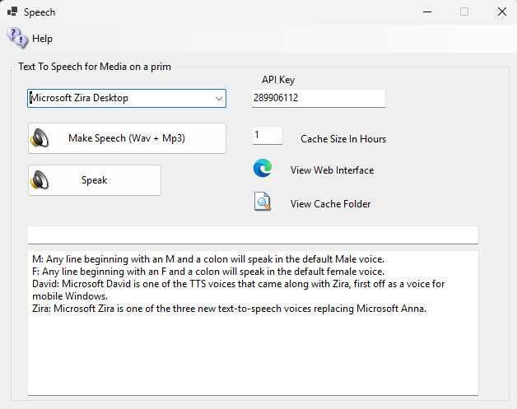

An API allows LSL scripts to request Mp3 files by name for media-on-a-prim use so that products can talk in-world, without uploading as wav files.
This setting uses a Microsoft or a 3rd party Speech Synthesizer to announce when visitors arrive or leave. You can choose Zira or David voices, or add a 3rd party voice by purchasing and installing a SAPI compatible voice. Windows 10 and 11 users get to use both Cortana voices., Eve and Mark.

Requirements
You must have a sound card to use this feature. VPS Servers typically do not have sound cards. Physical servers as well. There are several solutions:
If you have physical access to the server, plug in a USB sound card. If you do not have access, you can install a virtual sound card.

This speech feature will not work on Contabo/Windows Servers without there actually being a sound card. A virtual sound card may fix that.

GUI
This GUI makes the files. You can disable speech or select a voice in the upper left
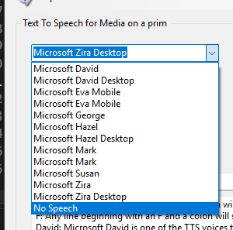
The API key is for your security. You may change this at any time, and it will go into effect at once. It is used when scripting to make a text unto a MP3 and a wav file.

Voices
Windows 10 and 11 have two that are enabled by DreamGrid. Windows 7 comes with just one voice, typically Microsoft Anna. Windows Server may not have a sound card so this may work.

You can install new voices in Windows. There are many free ones available for Windows 11:
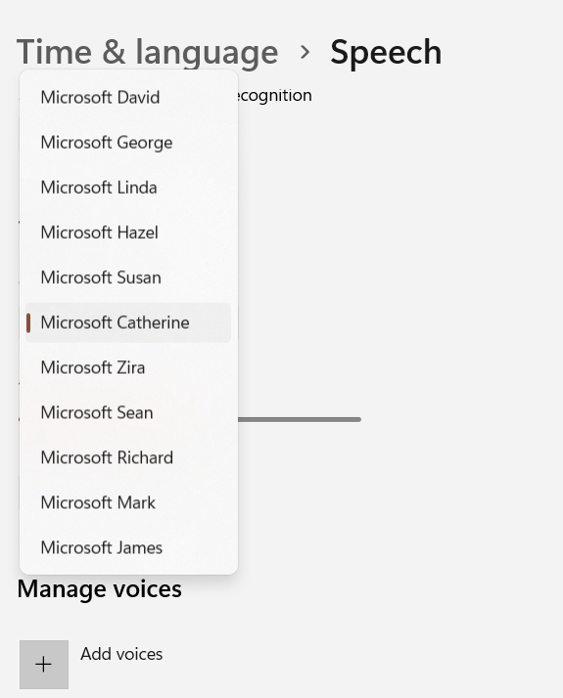
You can find SAPI5 voices that are on your machine in the Control Panel. You are looking for the Text to Speech window, which is hidden away in the Speech Recognition settings in Control Panel. Some SAPI5 voices may be hidden (e.g., Acapela voices) but the ones you can see there can work in any program that uses SAPI5.
You may add more SAPI5 voices by purchasing. Sources of compatible speech systems:

Vendor | URL
Acapela | https://www.acapela-group.com/
Cereproc | https://www.cereproc.com/en/buy-voices
Ivona | https://nextup.com/ivona/
AT&T | https://nextup.com/attnv.html

Control the voices
You can control the speech in several ways.
Any line beginning with M: will speak in a male voice. F: will speak in a female voice. Any line without a letter is spoken in the pre-selected voice.
Select the desired engine and click the button:

Then click View Folder

The folder should show a list of wave and MP3 files.

API
You can make the system speak over the Web, or by using Media On A Prim (MOAP)

Parameters:
Text to speak:
- TTS= Some text to speak
- If a line begins with M: it will speak in a Male voice.
- If a line begins with F: it will speak in a female voice.

APIKEY
- APIKey=123 must match the Voice password set in the settings->Speech

Sex
- Sex=M it will speak in a Male voice
- Sex=F it will speak in a female voice

Voice
- Voice=Zira|Mark|”Some SAPI5” says TTS in the specific voice name

Save
Save=Any value will save the speech as MP3 and WAV files. The response should be the path to a Mp3 file.
A .wav file is also available. The .wav will be in Opensim/Second Life compatible format of 44.1Khz, Mono, 16 bits.

Examples
Minimum URL to say "Hello" in the default voice:
http://127.0.0.1:8001?APIKey=123&TTS=Hello

If your Diagnostics port is not set to port 8001, you must change it:
http://127.0.0.1:7001? APIKey=123&TTS=Hello

Use Ziras voice to say 1 2 3 4 5
http://127.0.0.1:8001?TTS=test 1 2 3 4 5&Voice=Zira&APIKey=123

Force a Male voice to say A B C D
http://127.0.0.1:8001?TTS=A B C D&APIKey=123&Sex=M

Force a Female voice to say A B C D
http://127.0.0.1:8001?TTS=F:A B C D&APIKey=123

Force a Specific voice to say A B C D
http://127.0.0.1:8001?TTS=A B C D&APIKey=123&Voice=Zira
http://127.0.0.1:8001??TTS=A B C D&APIKey=123&Voice=Mark
http://127.0.0.1:8001??TTS=A B C D&APIKey=123&Voice=Eva
http://127.0.0.1:8001??TTS=A B C D&APIKey=123&Voice=David

