Apache Webserver
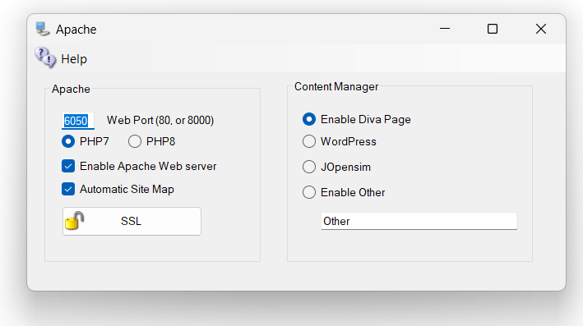
You may optionally set up an Apache Web server with PHP7 or PHP8, WordPress, Joomla/jOpensim, or other Content Management (CMS) systems. The default purpose of Apache/PHP is to serve maps, object search and other useful functions. It is optional. You may disable it and still run Opensimulator. If you do not need the extra maps or a CMS, then you can leave Apache & PHP disabled.

Web Port
Defaults to 80. If your ISP blocks port 80, try 8000. DreamGrid will automatically open this port in your PC’s firewall. You must Port forward whatever port you select in your router, or use UPnP.
If you are going to run a SSL connection, this must be on Port 80. See the section on SSL below.

Enable Apache Web Server
The checkbox for [Enable Apache Web Server] must be set so the web server will work.
Apache will then start when your PC is booted. No DOS boxes will appear. There is less clutter and 24-hour operation of the web server.
Caution: If you move the grid to another folder after installing Apache, the server will still attempt to run from the original folder. You need to click the Menu at the top of The Main interface and Delete the Apache Service, and then Start Apache Service. It will re-install itself and point to the correct folder.
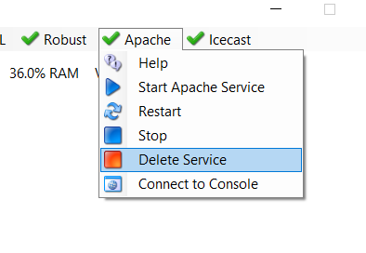

Content ManageR
A content management system (CMS) is computer software used to manage the creation and modification of digital content. CMS’s are typically used for enterprise content management (ECM) and web content management (WCM)
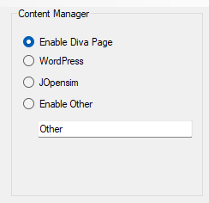
Enable Diva Web Page is setup in Setup-> Setting->Webserver Control Panel section.

Enable WordPress will redirect all traffic to the home page to the WordPress folder in Outworldzfiles\Apache\htdocs\WordPress. You must install WordPress there. Instructions are in that folder.
Enable jOpensim will redirect all traffic to the home page to the JOpensim folder in Outworldzfiles\Apache\htdocs\JOpensim. Instructions are in that folder.
Enable Other will redirect all traffic to the ‘Other’ folder in Outworldzfiles\Apache\htdocs\other. You can make a different folder and 3use that name, provided it is in the Apache\htdocs folder structure.

SSL
The SSL setup screen lets you create a free SSL certificate for Apache. DreamGrid obtains the certificate from Let's Encrypt using win-acme (wacs.exe), and win-acme registers its own Windows Scheduled Task to renew it automatically - DreamGrid itself does not set or track any renewal interval, so there is no fixed number of days to quote here. Let's Encrypt certificates are valid for 90 days and win-acme renews them well before that, so leave the scheduled task in place and your PC on often enough for it to run.
The process is simple and automatic. You must be running Apache on Port 80. You cannot do this without that set up.
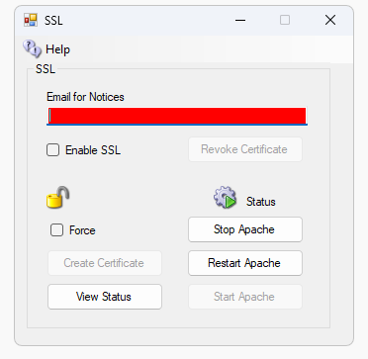
Step 1. Enter your real email.
Step 2. Click “Create Certificate”. The System will take about one minute to create and authorize the certificate. This will create the SSL Certificates. Wait a minute and the icon will show green or it will show it unlocked.
Step 3. Enable SSL
Step 4. Stop and Start Apache. Or click Restart if it is available.
Detail: It makes a batch file in the \SSL folder. You need to type CMD and run CMD as Administrator. Then type cd … to get to the SSL folder, and type this.
InstallSSL.bat {enter}
That is what the Create Certificate button does. DreamGrid makes that batch file and runs it. It captures the output to a log.
If the batch file reports success, DreamGrid will enable the Apache server to use Certificates. It goes into effect when Apache restarts.

Troubleshooting:
There are some rules:
- You must run the Apache webserver.
- Apache must be using port 80. After this step completes you can use port 443 for SSL.
- You must be using a domain name in Setup->Settings->HG DNS Name.
- The domain must be accessible from the Internet so the system name can be validated. A simple test is to see if canyouseeme.org works on port 80. Then try your domain name + :80

There is a log specifically for SSL issues. It is located in Outworldzfiles\Logs.
2022-01-29 00:53:30:OK: A simple Windows ACMEv2 client (WACS)
Software version 2.1.20.1185 (release, pluggable, standalone, 64-bit)
Connecting to https://acme-v02.api.letsencrypt.org/...
Scheduled task looks healthy
Please report issues at https://github.com/win-acme/win-acme
Running in mode: Unattended
Source generated using plugin Manual: smartboot.outworldz.net
Overwriting previously created renewal
Using cache for [Manual] smartboot.outworldz.net. To get a new certificate within 1 days, run with --force.
Store with PemFiles...
Exporting .pem files to C:\Users\XXX\Desktop\Dreamgrid\Dreamworld\OutworldzFiles\Apache\Certs
Installing with None...
Scheduled task looks healthy
Next renewal scheduled at 2022/3/25 5:40:43
Certificate [Manual] smartboot.outworldz.net created
2022-01-29 00:53:31:Info:Certificate installed

