Opensim COnsole

The Opensim Console works when your system is running Service Mode.
Windows: http://opensimulator.org/downloads/ConsoleClient.zip
Mac: http://opensimulator.org/downloads/ConsoleClient.dmg
Service mode must be enabled and the system must be running. In service mode you can connect to your regions or robust from any computer that can reach the IP address and the Ports.
DreamGrid ships the Console Client and keeps its saved connection list up to date for you: it writes one entry for Robust and one for every region, so normally you do not have to add connections by hand. Use Settings -> Console -> Console Client -> Open Console to launch it, and Set Password there to set the console password first. The steps below describe adding a connection manually if you need to. Start ConsoleClient.exe in the folder ConsoleClient:
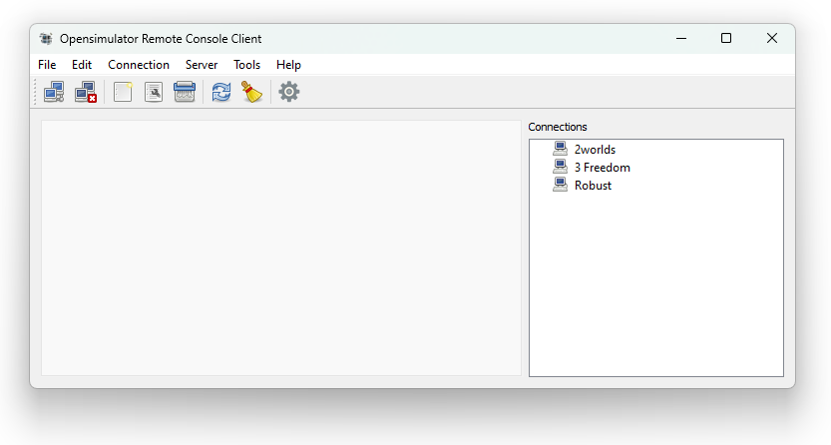
Select New under Connection at the top:
Note: Robust is usually port 8002.
Connection > Enter a name that matches the server connection.
Host > Enter the URL to the server here DNS name.
Port > Enter the region HTTP port here. You can get this from the Region List report
User > Enter the name for the Wifi Admin.
Password > Enter the console password. This is the separate console password set with Settings -> Console -> Console Client -> Set Password, not the Wifi Admin web page password.
Clicking on OK saves this and displays it on the right-hand side.
You can enter your entire server in the same scheme.
Now click on one of the servers listed on the right-hand side, choose Connection at the top and Connect and you are on the server in the console.

This is what Robust looks like:
