Database Settings
Did MySQL crash? See section Crashes.
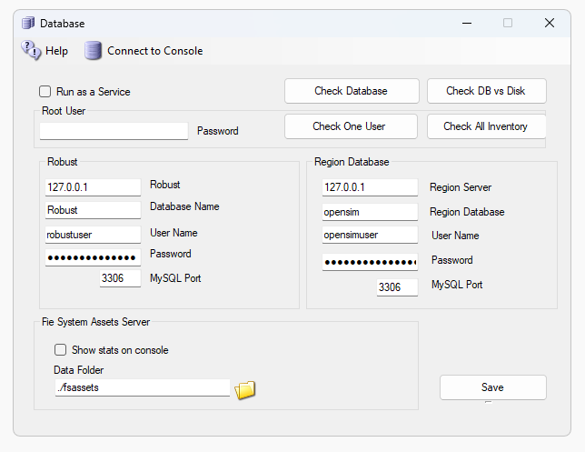
Do not change any of these settings without knowing what you are doing!
Any change here must match complicated hand-made changes in MySQL! See the bottom of this help section for more details.
There are two databases in DreamGrid: Robust is the login and inventory database. Each region also uses a separate Opensim database for storing what is in the region.
The database root password is blank. This is safe as it only listens on localhost, which is your server. You can type in a new password when Mysql is running, and it will be saved.

Robust Database:
- Robust Server: should always be 127.0.0.1. This is the Server that runs Robust (itself). It can be the IP address of a different server running MySQL.
Default: 127.0.0.1
- Robust name: The name of the Robust database.
Default: robust
- Username: The login name 'robustuser'@localhost'.
Default: robustuser
- Password: The password for Robust.
- Default: robustpassword
- MySQL Port: The TCP/IP port that both databases use.
Default = 3306. You can set this to 3307, 3308 or 3309 to not interfere with the Other MySQL’s that may be running.
- FSAssets: You can select the FSAssets button to set up a File System as Assets Database. This is recommended only for large grids, with hundreds of Gigabyte sized databases.

Local Region Database:
- DB name: The name of the region database.
default: opensim
- Username: The login name 'opensimuser'@localhost'.
default: opensimuser
- Password: The password for the opensim region database.
default = opensimpassword
- MySQL Port: The TCP/IP port that both databases use.
This is the same single port field shown above - both databases share it. Default = 3306.

Flotsam asset cache
Note: You must run the Flotsam asset cache as you are running the FsAssets file system database. If you disable this manually it will get very slow.
The Flotsam asset cache stores assets on disk and in memory.
At the moment, the amount of memory or filesystem storage used by the cache can only be limited via manual actions (wiping all or part of cached assets from the filesystem), by console commands (e.g. "fcache clear") or by timeout settings (e.g. FileCacheTimeout = 1 to automatically remove cache files not accessed for 1 hours).
General principles
When OpenSimulator needs an asset (e.g., in response to a viewer request for a notecard), then it first asks the cache for this data. If the data is not found in the cache, then it asks the grid asset service (or a foreign asset service in the case of Hypergrid). If the asset is found, then it is both stored in the cache and returned to the user.
If an asset is uploaded to OpenSimulator (e.g., by the viewer uploading an animation), then the asset is immediately kept in cache (if there is room and the asset is not temporary) and sent to the asset service (if the asset is not temporary).
Therefore, at any point you can wipe any temporary data stored by the asset cache (e.g., on the filesystem), since the next request for that asset will simply query the asset service as the asset will not be found in cache.

Restore a Database
Restoring the database is a drastic step. You should rarely, if ever need to do this!
The first thing to do is make a copy of the folder Outworldzfiles\Mysql\Data. If the restore fails, you can delete the Data folder and rename or copy the backup folder back to \Mysql\Data.
To restore the entire database, you must have a .SQL backup. Look in your AutoBackup folder. It will have a zip file named Backup_(date).zip. Unzip it.
It has the regions from Outworldzfiles\Opensim\bin\Regions, the Settings.INI files from Outworldzfiles, a statistics database from Outworldzfiles\Opensim\bin, and any Wifi Pages from Outworldzfiles\Opensim and OutworldzFiles\Opensim\bin.
The database is in two or more files:
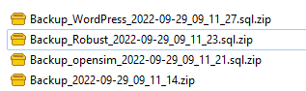
Unzip these files. In this is a file with the .sql extension. Go to GUI, and in the Mysql menu, select Restore Database.
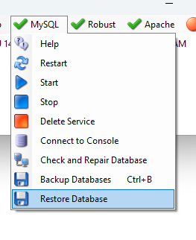
Browse the .sql files, one at a time, and select them. You can restore more than one file at the same time. This may take a LONG TIME to run. Do not interrupt it!
This will drop each table, recreate it, and load it with the content from the backup.

Running MySQL as a Service
DreamGrid will detect any running MySQL using the same port.
You can enable mysql to always be running even if DreamGrid is stopped.
You can install MySQL as a Windows service. There is a batch file “InstallAsAService.bat” in MySQL\bin to set this up. MySQL will then start and stop safely with Windows. This batch file must be run once, as an Administrator. You type "CMD" in the search box, and then right click the Command Prompt and select "Run as Administrator".

Use that DOS box to run Outworldzfiles\Mysql\bin\InstallAsAService.bat. Then type in 'Services.msc", and use it to start MySQL, or type in ‘net start MySQL’<enter>.
You can verify MySQL is running by typing mysql - u root<enter>. If you get a MySQL prompt, it is running as a service. Then type quit; with the semicolon and enter.
You should also set the service to restart so MySQL restarts on any crash. Windows knows about services and will send signals to MySQL to shut itself off gracefully. The only danger is that power fails and you corrupt the database. If you are serious about running a grid, then a UPS is necessary.

MySQL Crashes:
Your MySQL database may have crashed and will not start. Here is a way to recover and start MYSQL manually.
Navigate to the Outworldzfiles\mysql\bin folder.
Then double-click "StartManually.bat”
Any error message it prints may be helpful. If the DOS window closes, a MySQL LOG file will be saved in OutworldzFiles\mysql\data as a *.err file. That may give you a clue as to what to do.

My database still did not start!
Try running Outworldzfiles\mysql\bin\Repair_ISAM.bat.
Then double-click StartManually.bat. The DOS window that appears should ‘stick’ open.
Run Task manager by typing Ctrl-Shift-ESC.
Look for mysqld.exe. Wait for the CPU usage to go to zero on mysqld.exe. This may take a long time as MySQL is rebuilding the database. It could take an hour or more, depending upon the size and your disk and CPU speed.
Double click CheckandRepair.bat to run diagnostics.
If errors appear, answer any questions with a ‘Y.’ This will take a long time as MySQL is repairing the database.
Once the Check and Repair is finished, double-click Mysql\bin\StopMySQL.bat
The DOS box that first appeared should now close. Your database has been recovered and it is safe to start DreamGrid.

I still cannot get it to start
If you still have issues, delete the file MySQL\Data\ib_logfile0 and ib_logfile1. Do not delete ibdata1! Then repeat the above sequence.
If I had deep issues with a database and it was unrecoverable, I would try the last copied one, then the SQL restore method, then an OAR, and the very last thing I would try is an OAR/IAR restore. So far, I have recovered at least a dozen databases for people. One developed a bad bit which took about a week to ftp, to develop a fix for and a simple query to repair.
Also have fixed a crashed "primitems" table that has reoccurred on one grid. You log in to MySQL with the command ‘mysql -u root’ and type in:
use opensim;
repair table primitems;
quit;
Please do not give up if your database will not start! Contact me at fred@outworldz.com and I will see what I can do. I have not yet lost a database except one that was deleted, and then the recycled bin was emptied.

Starting Over with a Blank Database
You can wipe ALL data out. If you do this, you must re-enter all accounts and recreate your system from OAR and IAR files. This WILL LOSE ALL DATA.
I recommend you make a backup copy of the MySQL\Data folder first.
I have not yet ‘lost’ a database, and I have seen dozens of them crash in oddball ways. Please contact me at fred@outworldz.com if you have questions or need more help in recovering a database. The largest was 70 Gigabytes which took four days just to get a copy sent to me. It was fixed in a few hours. The problem was to a single bad character in a UUID. So please do not drop it unless you really, really want to start over!
If you MUST wipe out the database and start over, drop the folder MySQL\data. Then extract the contents of the file Blank-Mysql-Data-folder.zip to make a new MySQL\Data folder.
Then run Upgrade.bat in Mysql\bin
This will make it start over at the very beginning. The database should start up now. You must go to Robust; type create user<enter>’ and re-enter your Avatar name and password. You can then re-enter your estate information in each DOS box for each region and load OARS and IARs.
Or restore from the .sql backups, which contains everything you need.

