Grid Type
Grid Type lets you choose from either a Grid Server with Robust, or from 2 Region Server choices to connect to another grid.
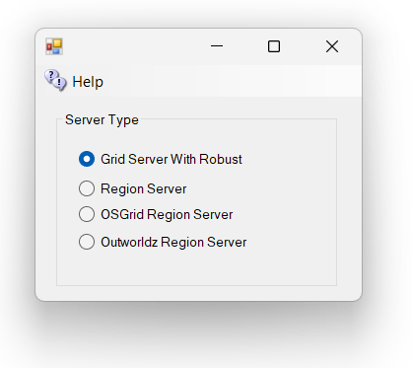

Grid Server with Robust
Grid Server with Robust is a complete DreamGrid, with your own inventory, logins, and name. This is the default. When you start your grid, a Robust Box will open to control all your users’ inventory.
One server must have a running copy of Robust. More PC's can connect to the Robust server to add more regions. These are called Region Servers

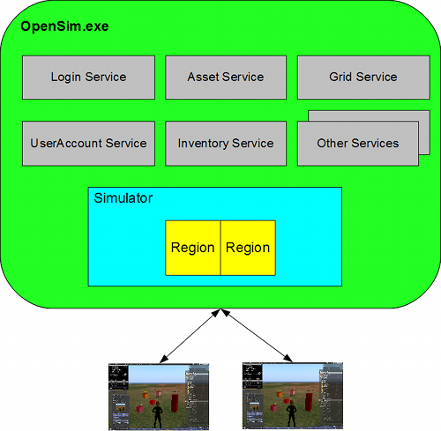
http://opensimulator.org/wiki/Configuration

Region Server
Region Server is an add-on to an existing DreamGrid, or OsGrid. You can connect additional regions on one or more PC's to an existing Grid Server. You must have access to port 8003 on the Robust server to do this.
Region Servers can connect to another DreamGrid, provided it can reach the DreamGrid’s Port 8003. You connect to the DreamGrid server by changing the DNS name on the Region Server to the same name as the grid. For example, my grid is normally named ‘outworldz.com:9000’. So I change the DNS name in my Region server, no matter where it is located, to outworldz.com, and change the HTTP port to 9000 and the robust port to what the grid runs on (which happens to be 9003).
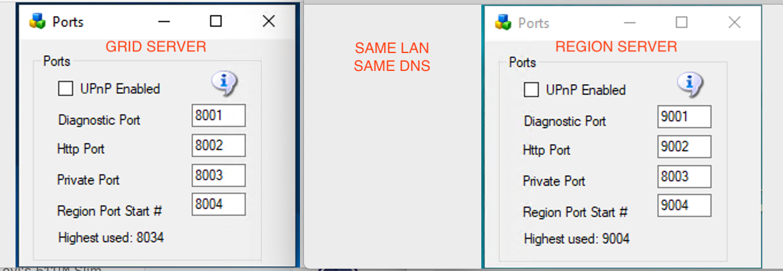
pic courtesy of Michael Bradley
The firewall must also be opened between the two machines. This is not normally an issue on a LAN. But if the region Server(s) are on the Internet, you should not allow access to the port 8003 from everyone unless you want others to connect to your grid with their own regions. Set up a firewall rule to allow only the Region Servers to access your servers port 8003.
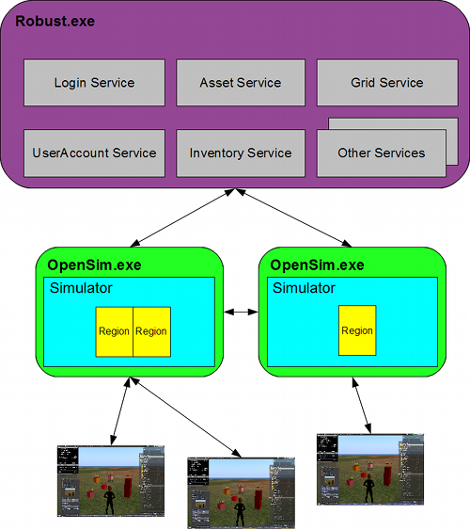
http://opensimulator.org/wiki/Configuration

OSGrid Server
OsGrid Server This choice is running a Region server connect to OsGrid. OsGrid is already configured to accept your connections. There are some simple rules you must follow to connect to OsGrid.
You will need to choose an empty spot on OsGrid's map for each region.
Your viewer login must be set to hg.osgrid.org.

Outworldz.Com Server (REMOVED)
This choice has been removed and is no longer offered. The Server Type screen now has only three choices: Grid Server with Robust, Region Server, and OSGrid Region Server. The text below is kept for reference only. Outworldz.com Region Server This choice is also much like running a Region server. These servers connect to outworldz.com. Outworldz Settings are already configured to accept your connections.

