JANUS-WEBRTC Voice Settings
THIS IS UNTESTED ALPHA CODE.
WebRTC voice for OpenSimulator is enabled here using the server-side addon module os-webrtc-janus paired with a Janus WebRTC gateway to provide plugin-free, browser- and viewer-compatible real-time audio. You need access to an online Janus server to use this system.
Janus Gateway: A separate WebRTC server (like Janus) manages audio routing.
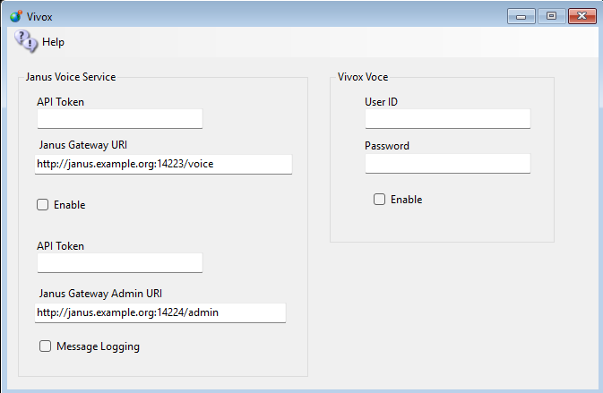
Add your API Token and gateway URL to this form and enable it. Restart the Robust system and voice should work.
The Janus Voice Service box has four fields plus one checkbox:
Janus Gateway URI - the address of your Janus gateway's voice endpoint, e.g. http://janus.example.org:14223/voice
API Token - the token for that gateway (entered masked).
Janus Gateway Admin URI - the address of the gateway's admin endpoint, e.g. http://janus.example.org:14224/admin
Admin API Token - the token for the admin endpoint (entered masked).
Message Logging - logs the messages exchanged with the Janus gateway, for troubleshooting.
Janus-WebRTC and Vivox are mutually exclusive: only one voice system can be active at a time. Both are set up on the same Voice Settings screen, and ticking Enable under Janus Voice Service automatically un-ticks Enable under Vivox Voice.

Links:
http://opensimulator.org/wiki/WebRTC
https://blog.misterblue.com/2024/2024-10-28-webrtc-voice-for-opensim

