Map Editor

DreamGrid has a drag and drop map editor.
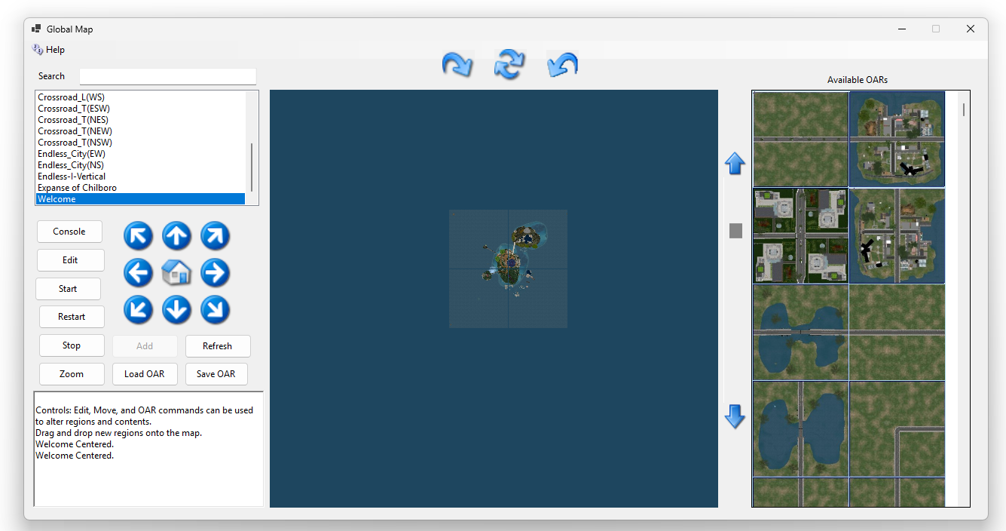

Region List
When you first open the map from some laces it will be centered on your “Welcome” region.
Clicking any region in this section will re-center the map.

Available Oars
DreamGrid has many free OARs contributed by users, many more I have mode, and DLC I have purchased with exclusive redistribution rights. I have invested tens of thousands of dollars in OARS and countless hours of time my personal time, not counting the endless hours others have spent making them.
You can drag and drop any OAR from the right onto the map in any blank spot. Or click Load and browse to one on your file system. This will create everything it needs to boot the region. After it boots, the OAR will be loaded. I then issue a command to back up the region to the database. If you have maps enabled, you need to restart the region to see them.
To see anything other than the default tile, you must select a map type in Setup->Settings->Map in the main GUI and then restart the region.
You can also drag the region onto the any region to load the OAR into the region. DreamGrid will check the size of the region and make sure it will fit inside the region.

Local Oars
You can select the Load OAR or Save OAR button to make a backup of any selected region, or load an OAR from local file system

Controls
Console: Will open the DOS control panel for the region. If in service mode this will be a more linited console that communicates to the region which is running as a service.
Edit: Select a region by clicking its name or clicking the cell and then edit it.
Start: Will boot the selected region.
Restart: will safely shut down the region and restart it.
Stop: Stops the selected region.
Zoom: will open the full-sized map.
Add: will enable when you click a empty cell on the map. It will create a region with a Pimple island. You can rename the region, or just accept enter, as there are thousands of names in DreamGrid.
Names are saved in a file in Outworldzfiles\RegionNames.txt. You may replace this with your own desired names.

Map
You can drag and drop and region to move it and its map tiles.
If a Region is Locked in the region editor, it will not move.

