Maps
Opensim has many different maps settings. DreamGrid has multiple easy-to-use combinations. Opensimulator has several Map tile makers which vary in quality, and speed. It can take an exceedingly long time to boot when using the Better and Best maps. These maps which use the Warp3D engine must load all prims, mesh, and textures, so it takes a long time to generate new maps. Also, any bad textures may cause harmless errors from corrupted assets to appear on your console.
I recommend you run all maps at Best setting once, then set Maps to None. You can remake maps when enough changes have been made.
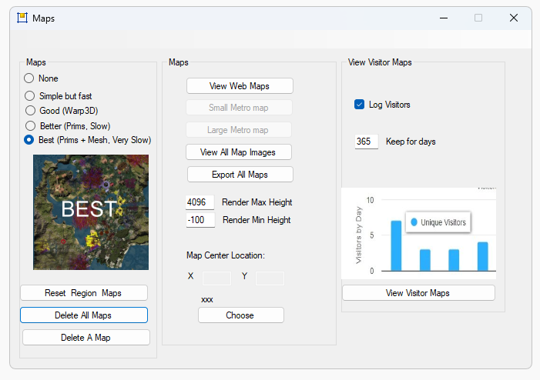
- None: No maps will be made. This is a good setting as the regions will boot very quickly. Any existing maps are not deleted and will appear in world.
- Simple but Fast: MapImageModule is used with just Land showing
- Good: Uses Warp3D module with just Land showing.
- Better: Uses Warp3D module with Land, Prims, and land Textures showing.
- Best: Uses Warp3D module with Land, Prims, Mesh, Sculpts, and all Textures including prims showing.
- Only Missing Maps: When ticked, a region that already has a map tile is left alone and only regions with no tile yet are drawn. A per-region override still wins over this.
Map Center Location (X and Y, with a Choose button): sets the coordinate the web map is centred on. Choose picks a region and fills in its coordinates.
Reset Region Maps: This resets all regions to use the default map type.
- Delete a Map: Brings up a region chooser so you can delete all the maps for that one region.
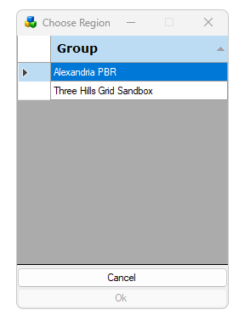
- Delete All Maps: Click this to clear out all maps. You will need to regenerate all maps again by choosing a setting and restarting all regions.
- Edit/Move Maps opens the Map Editor so you can move region tiles around, and Export All Maps writes every map tile out to a file. The web map itself is served at http://localhost:8002/wifi/map.htm.
- Web Maps: Available only if your Apache/PHP is enabled in Settings Web Pages. These maps are generated by PHP and the Apache web server, and the button opens them in a browser.
- View All Maps displays all maps. You can save or print them. Clicking a map causes it to exit.
Visitor section: View Visitor Maps shows the visitor heat maps, Log Visitors turns visitor logging on, Public Maps makes the maps publicly reachable, and Keep for Days sets how long visitor data is retained.
- Render Max Height can be changed to not show skyboxes.
- Render Min Height can be changed to not show water or ground structure.

Manual regeneration
Normally you would generate map tiles at startup. You can also manually force map tile regeneration with the console command 'generate map<enter>'.
A) Go to Setup Settings->Maps and erase them all with "Delete All Maps"
B) Now choose "Best (prims + Mesh Very Slow)"
C) Close this window which saves the new Global setting.
D) Press Start.
E) Once all the regions have booted to the DOS boxes, set map back to "None". They can still be making maps. They just need to all be starting up and then you can change the Global Settings.
The next time you boot, the regions will load very quickly as the maps will not be remade. Maps only need to be cleared when you delete a region or move them around.
F) Each region has an override setting. If set, the override will choose a different setting for maps.
Example: I leave the global maps off all the time. But I may be working heavily on a region and changing it around, and want that to appear after every reboot. I go to the Regions List and click the Region and set the override to the desired setting, and reboot the region

