Physics
The Physics selection box lets you set basic physic engines and also disable physics on demand
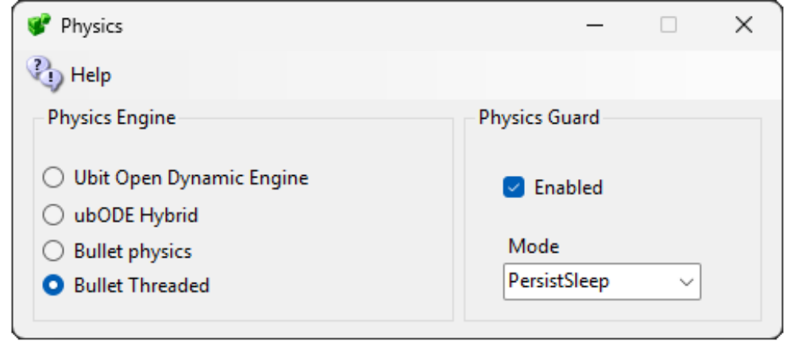
The ubODE engine by Ubit Umarov is an advanced version of ODE that is closer to Second Life compatibility with vehicles.
Bullet is an award-winning physics engine.
- UBODE is closer to Second Life in vehicle performance.
- BulletSim provides the best performance and most functionality. UBOde is much slower on collisions and has poor bounce performance according to the various free OARS for physics testing. It can only collide with basic shapes.
- Bullet in a separate thread prevents physics from crashing the region. It is the default physics engine.
ubODE Hybrid is a fourth choice on this screen, combining Ubit ODE and Bullet.

HOLO PHYSICS GUARD

Enabled: Will disable physics in all regions when no on is in the region
Mode:
Supported values:
Report Only logs what would be slept but does not change objects.
Persist Sleep records objects in the guard table, clears their physical flag, and wakes them later.

What It Does
When a region becomes empty, HoloPhysicsGuard can:
- detect physical root prims/linksets
- optionally filter by object name
- record the object in a separate database table
- clear the object’s physical flag using OpenSim’s normal UpdatePrimFlags() path
- zero velocity and angular velocity
- reduce idle physics load
When an avatar enters the region, it can:
- look up previously slept objects
- restore their physical flag
- remove the sleep record
- clean up stale records for deleted objects

Why This Exists
Some physical objects can heavily impact region performance, especially when they are stuck colliding, poorly shaped for physics, or scripted to remain active.
This module is not meant to replace good object scripting. It is a safety guard for idle regions.

Features
- OpenSimulator non-shared region module
- Sleeps physical objects when a region is empty
- Wakes slept objects when an avatar enters
- Optional wake-on-start behavior
- Separate database table for reversible sleep state
- Dry-run/report-only mode
- Name-based allow/block filters
- Persistent sleep tracking across restarts
- Uses OpenSim’s UpdatePrimFlags() path instead of directly rebuilding physics actors

Recommended Use Cases
Good candidates:
- bowling_pin
- bowling_ball
- vehicles
- physics toys
- temporary game props
- physical NPC props
- Objects to be careful with:
- elevators
- boats
- scripted rides
- region infrastructure
- anything expected to remain physical all the time

Configuration Options

Enabled
Turns the module on or off.

Mode
Supported values:
- Report Only
- Persist Sleep
Report Only logs what would be slept but does not change objects.
Persist Sleep records objects in the guard table, clears their physical flag, and wakes them later.

DryRun
When true, forces report-only behavior.

SleepWhenEmpty
Controls whether the module sleeps objects when the region has no root agents.

WakeOnStart
If true, slept objects are woken when the region starts.
If false, slept objects remain asleep until an avatar enters.

WakeOnAvatarEnter
If true, slept objects are restored when the first avatar enters the region.

CheckIntervalSeconds
How often the module checks region occupancy.
Recommended values:
Dev/testing: 5
Known problem objects: 30
General production guard: 60

EmptyDelaySeconds
How long a region must remain empty before objects are slept.
Recommended values:
Dev/testing: 10
Known problem objects: 60
General production guard: 300

AlwaysSleepNameContains
Comma-separated list of object name fragments that are eligible for sleep.
If empty, all physical root objects are eligible unless blocked by NeverSleepNameContains.
AlwaysSleepNameContains = bowling_pin,bowling_ball

NeverSleepNameContains
Comma-separated list of object name fragments that should never be slept.
NeverSleepNameContains = elevator,boat,vehicle

ZeroVelocities
Sets velocity and angular velocity to zero when sleeping an object.
ZeroVelocities = true

Verbose
Logs more details about scans, sleeps, wakes, and skipped objects.
Verbose = false

Links
ODE: http://www.ode.org/
Bullet https://en.wikipedia.org/wiki/Bullet_(software)
Physics Guard https://github.com/holoneon/HoloPhysicsGuard

