Auto Restart and Startup Settings
Opensim uses up increased RAM as people arrive and leave. Periodic restarting of regions is necessary to clear memory. You can set up a restart timer here.
DreamGrid will not restart a region if avatars are present. It will restart the region only after all avatars leave.
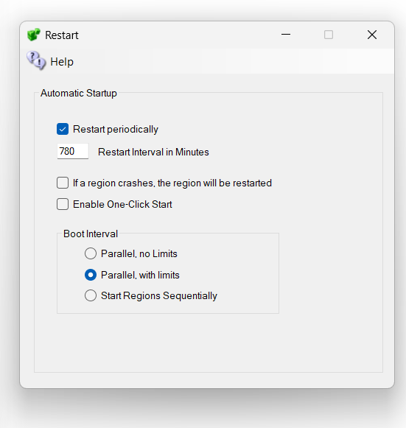
Restart periodically: If enabled, all regions are rebooted on the days you tick and at the Start Time you set. If disabled, the regions will try to run forever.
Days and Start Time: Tick the day letters (S M T W T F S) for the days you want the restart to happen, and set the Start Time for the time of day it runs.
No days ticked = Off.
If a region crashes, the region will be restarted: when ticked, DreamGrid reboots any region that crashes, independently of this schedule.
If Autobackup is enabled, the restart is delayed so Autobackup can complete first.
Boot Interval: choose how regions are booted. Start Regions Sequentially waits for each region to load completely before starting the next. Parallel, no Limits starts regions in parallel with no CPU or RAM limits enforced. Parallel, with limits starts regions in parallel but pauses loading when CPU or RAM goes over 90%; this is the default.
Enable One Click Start: If set, running Start.exe will automatically start Opensim without needing to click the second [Start] button.

