SSL Certficates
The SSL setup screen lets you create a free SSL certificate for Apache. DreamGrid obtains the certificate from Let's Encrypt using win-acme (wacs.exe), and win-acme registers its own Windows Scheduled Task to renew it automatically - DreamGrid itself does not set or track any renewal interval, so there is no fixed number of days to quote here. Let's Encrypt certificates are valid for 90 days and win-acme renews them well before that, so leave the scheduled task in place and your PC on often enough for it to run.
The process is simple and automatic. You must be running Apache on Port 80. You cannot do this without that set up.
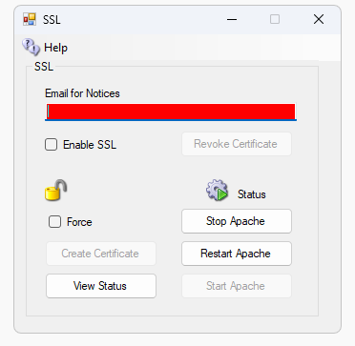
Step 1. Enter your real email.
Step 2. Click “Create Certificate”. The System will take about one minute to create and authorize the certificate. This will create the SSL Certificates. Wait a minute and the icon will show green or it will show it unlocked.
Step 3. Enable SSL
Step 4. Stop and Start Apache. Or click Restart if it is available.
Detail: It makes a batch file in the \SSL folder. You need to type CMD and run CMD as Administrator. Then type cd … to get to the SSL folder, and type this.
InstallSSL.bat {enter}
That is what the Create Certificate button does. DreamGrid makes that batch file and runs it. It captures the output to a log.
If the batch file reports success, DreamGrid will enable the Apache server to use Certificates. It goes into effect when Apache restarts.

Other controls on this screen
Force - re-runs win-acme with the --force option. Normally win-acme reuses a cached certificate if one was issued recently; tick Force to make it request a brand new certificate anyway.
Revoke Certificate - asks for confirmation, then marks the certificate as no longer installed in DreamGrid so SSL is switched back off.
View Status - opens crt.sh in your browser, showing the certificates that have been issued publicly for your address.
Use this certificate for OpenSim HTTPS too - reuses the same Apache certificate for Robust/OpenSim's own HTTPS listener. DreamGrid converts the Apache .pem files into a password-protected .p12 file in OutworldzFiles\Apache\Certs and points Robust.HG.ini at it. This can only be ticked once the certificate is installed and SSL is enabled.
Certificate Export Password - the password used for that PKCS12 (.p12) export and written into Robust.HG.ini as cert_pass. Changing it re-exports the .p12 immediately so the file and the .ini always agree.
Start / Stop / Restart - control the Apache server without leaving this screen, so you can restart Apache to put a new certificate into effect (Step 4 above).

.

Troubleshooting:
There are some rules:
- You must run the Apache webserver.
- Apache must be using port 80. After this step completes you can use port 443 for SSL.
- You must be using a domain name in Setup->Settings->HG DNS Name.
- The domain must be accessible from the Internet so the system name can be validated. A simple test is to see if canyouseeme.org works on port 80. Then try your domain name + :80

There is a log specifically for SSL issues. It is located in Outworldzfiles\Logs.
2022-01-29 00:53:30:OK: A simple Windows ACMEv2 client (WACS)
Software version 2.1.20.1185 (release, pluggable, standalone, 64-bit)
Connecting to https://acme-v02.api.letsencrypt.org/...
Scheduled task looks healthy
Please report issues at https://github.com/win-acme/win-acme
Running in mode: Unattended
Source generated using plugin Manual: smartboot.outworldz.net
Overwriting previously created renewal
Using cache for [Manual] smartboot.outworldz.net. To get a new certificate within 1 days, run with --force.
Store with PemFiles...
Exporting .pem files to C:\Users\XXX\Desktop\Dreamgrid\Dreamworld\OutworldzFiles\Apache\Certs
Installing with None...
Scheduled task looks healthy
Next renewal scheduled at 2022/3/25 5:40:43
Certificate [Manual] smartboot.outworldz.net created
2022-01-29 00:53:31:Info:Certificate installed

