Save IAR
OpenSimulator Inventory Archives (IARs) are a means by which inventory folders and items ca n be saved offline to a single file (an IAR). This file can then be loaded into a different OpenSimulator installation.
Like Opensim Archives, IARs save all the necessary asset data to fully restore the items including textures, sounds, scripts, and objects contained in the inventory of other objects.
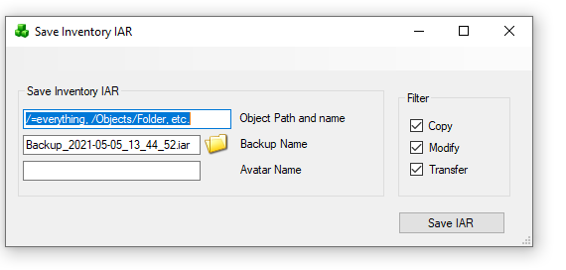
The command to save an IAR on the region console is
save iar [-h|--home=<url>] [-v|--verbose] [--noassets] [--perm=<permissions>] <user-name> <path> [<filename>]
where <user-name> is the name of the user to save inventory.
<path> is the path to an inventory item or folder. If the path is for a folder, that folder and all its contents (both descendant folders and items) are saved. If the path is for an item, then only that item is saved.
Components of the path are separated by a forward slash ("/"). If you need to specify a path with spaces, you can surround the whole thing with double quotation marks (e.g. "Folder A/Folder B")
You can specify that the contents of a folder should be saved rather than the folder itself using the * wildcard. For instance, "a/b/*" will save the contents of folder b but not folder b itself.
If a name or folder contains a forward slash ("/") then it can be escaped with the backslash (i.e. "\/") to stop it being seen as a path separator. Back slashes themselves need to be escaped with another backslash (i.e. "\\").
One further issue here is that it is not possible to distinguish between identically named folders or items on the path - the workaround is to rename your items/folders if you need to specify them in the path :)
filename> is an optional filename for the IAR. If none is supplied, then the filename user-inventory.iar is used in the current directory. I recommend that IARs have the .iar extension.

Switches
There is no password parameter; current OpenSimulator versions do not take one. DreamGrid also passes --skipbadassets on its bulk IAR backups so a single corrupt asset does not abort the whole archive. If the --noassets option is specified, then the archive will be saved without assets. This can be handy if you are backing up the asset database separately and do not want the expense of including all the assets in each archive.
--home=<url> is the URL of this world's profile service. It is not required that the profile service is operational; the information will be saved, and it will be displayed wherever the archive will be loaded. NOTE: the older --profile option (the previous name of this switch) produced IARs that are not compatible with OpenSimulator 0.7.0.2 and earlier; do not use this option if you want to produce a compatible IAR.
--verbose prints out verbose saving messages
When the C/MX switches are set, the --perm option is specified, and items with insufficient permissions will not be saved to the IAR. This can be useful for grids that allow their customers to export their inventory to IARs, because it ensures that exporting to IAR cannot be used to bypass content permissions.
<permissions> specifies which permissions are required. It is a string that contains one or more of these characters:
"C" = Copy
"T" = Transfer
"M" = Modify
Examples
Here is an example. Suppose you have an inventory structure like this
My Inventory
|
+-- FolderA
|
+-- FolderB
| |
| +-- ItemX
|
+-- ItemY
If you type:
save iar John Doe FolderA my-items.iar
then FolderA and everything in FolderA (FolderB, ItemX and ItemY) will be saved into an IAR called my-items.iar. On the other hand, if you type
save iar John Doe FolderA/FolderB/ItemX my-items.iar
then only ItemX will be saved.
If there is a space in the path to the item, for example if John Doe's folder was named "Folder A" instead of "FolderA", then quotes around the path are necessary on the command line:
save iar John Doe "Folder A/FolderB/ItemX" my-items.iar

Saving an entire user's inventory
With save iar you can save your entire inventory as well as the contents of particular folders or individual items.
For instance, typing
save iar John Doe /

