VieweR settings
Your viewer has default distance. You can override those in this dialog
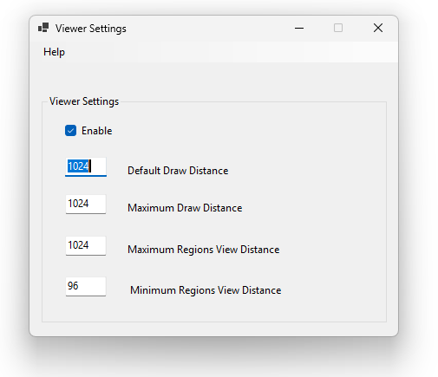
Some of these are expermental. Or not implemented in all cciewers.
Default Draw Distance in OpenSimulator's OpenSimDefaults.ini file is a server-side setting that defaults to 255.0 to help limit the maximum view range and manage region visibility boundaries,
Maximum Draw Distance limits the maximum view range on the simulator side, though modern viewers often override or handle client-side draw distances directly.
Maximum Regions View Distance is a setting in OpenSimulator's OpenSimDefaults.ini (and configurable in OpenSim.ini) under the [Startup] section that limits the maximum view range in meters for seeing neighboring regions
Default Value: Usually defaults to 255 meters if not specified.
Function: It caps the distance limit for viewing adjacent or distant regions relative to the avatar's position, working alongside MinRegionsViewDistance (which defaults to 96 meters).
Relationship: It is constrained by MaxDrawDistance; MaxRegionsViewDistance cannot exceed MaxDrawDistance.
Minimu Regions View Distance defines the minimum view distance bounds used by the simulator for rendering or tracking neighboring regions.
Default Value: Typically set to 96 meters in OpenSim
Function: Works alongside parameters like MaxRegionsViewDistance, DefaultDrawDistance, and MaxDrawDistance to manage visibility and distance calculations for adjacent regions relative to an avatar's position

Links:
https://github.com/nebadon2025/opensimulator/blob/master/bin/OpenSimDefaults.ini

