Vivox Voice Settings
Please Note that Vivox is no longer giving out codes.
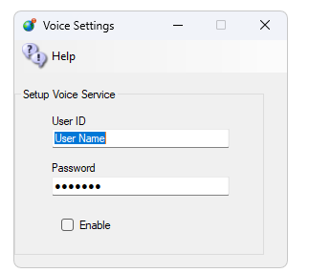
Add your User ID and Password to this form and enable it. Restart the system and voice should work.
Vivox and Janus-WebRTC are mutually exclusive: only one voice system can be active at a time. Both are set up on the same Voice Settings screen, and ticking Enable under Vivox Voice automatically un-ticks Enable under Janus Voice Service.

Links:
https://support.vivox
http://www.hypergridbusiness.com/2011/12/free-vivox-for-all

