Who Got What Module
This Opensimulator Region module lets you send data from scripts to a comma delimited list in your Opensim\bin folder. With just a bit of LSL you can determine who touched, e.g. “Who Got What” prim, or what door they opened, or what they collided with, or who went where in a sim.
A Demo Form included in DreamGrid will help explain. Navigate in a web browser to http://127.0.0.1:8004/diva/WhoGotWhat on your server.
The data the module accepts can be an Avatar Name, the region the item is on, the object (prim) name, the Location, such as <127,128,22> and a Text string. This can be the description or some other text.
The system also requires a password that only you know. The module reads it from the MachineID setting in WhoGotWhat.ini in your Opensim\bin folder, and it ships with a placeholder value you must replace. Note that this is not your Dynamic DNS password itself - elsewhere DreamGrid uses the MachineHash, which is the MD5 hash of the Dynamic DNS password you set in Setup->Settings->Hypergrid (the "Dynamic DNS password" box), and never the raw password. Your raw Dynamic DNS password should not be put into WhoGotWhat.ini either; use the MachineHash value or another password of your own choosing.
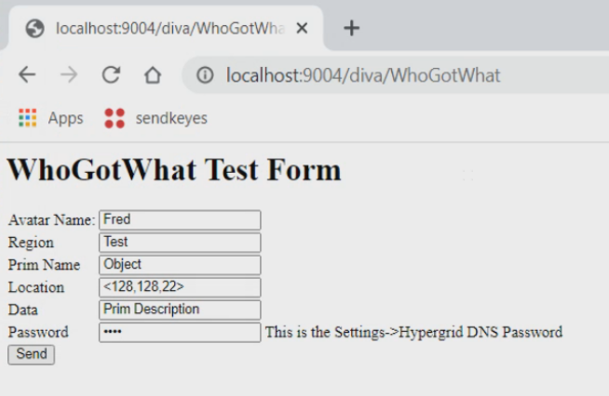
Pressing send will say “OK your object has been recorded.” And add this data to a Comma Separated (.CSV) file named WhoGotWhat.csv in Opensim\bin. You can open this file with a spreadsheet.
11/16/2020 10:43:04 PM,Fred,Test,Object,<128,128,22>,Prim Description

