Map Editor

DreamGrid has a drag and drop map editor.
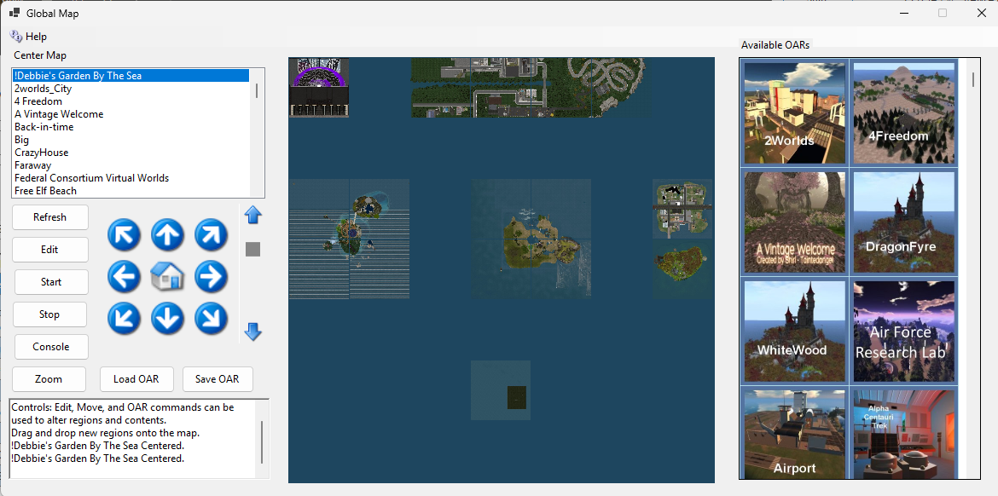

Center Map
When you first open the map from some laces it will be centered on your “Welcome” region.
Clicking any region in this section will re-center the map.

Available Oars
DreamGrid has many free OARs contributed by users and ones I have purchased with redistribution rights.
You can drag and drop any OAR onto the map in any blank spot. This will start DreamGrid, which will make everything it needs to boot the region. After it boots, the OAR will be loaded. The final step is issued to backup the region to the database.
To see anything other than the white default tile, you must select a map type in Setup->Settings->Map in the main GUI and then restart the region.
You can also drag the region onto the lower left cell of any region to load the OAR into the region. DreamGrid will check the size of the region and make sure it will fit inside the region.

Local Oars
You can select the Load OAR or Save OAR button to make a backup of any selected region, or load an OAR from local file system

Controls

Edit: Select a region by clicking its name or clicking the cell and then edit it.
Start: Wil boot the select region.
Stop: Stops the selected region.
Console: Will open the DOS control panel for the region. If in service mode this will be a more linited console that communicates to the region which is running as a service.
Zoom will open the full sized map.

Map

You can drag and drop and region to move it
If a Region is Locked in the region editor, it will not move.

