V7.2119+ features, one crash fix, and a few minor changes.
Want to chat? Reach me at fred@outworldz.com
NEW SYSTEMS may need two free Microsoft runtimes.
1. Dot Net 9 Desktop Runtime, for DreamGrid: https://aka.ms/dotnet/9.0/windowsdesktop-runtime-win-x64.exe
2. Dot Net 8 Runtime, for Opensim: https://aka.ms/dotnet/8.0/dotnet-runtime-win-x64.exe

FSASSETS WAS BUSTICATED
I’m tired of lost inventory so finally redid the Robust FsAssets writer this weekend. I’ve spent a lot of time reworking old PHP inventory code and found some missing files. I had 4 empty files, with the database pointing to nothing. Ugh.
OpenSim now writes the asset file to disk before it writes the database row, so a row can no longer point at a missing file.
Why it happened:
1. Store wrote the fsassets row right away, while the asset data only sat in the spool folder (fsassets\tmp).
2. A background thread gzipped it into data\ later. It wrote straight onto the final name and never forced it to disk. A crash or power cut could leave an empty or broken .gz, and OpenSim then treated it as present forever. It didn’t bother to flush to disk which is bad.
3. That thread's error check only works under Mono. On .NET, any locked file (antivirus, a robocopy backup) crashed Robust.
4. Two saves of the same content could race. Proof: 4 orphaned temp files in bin\fsassets\tmp\spool, from 2025-04-23.
And it’s fixed. 40 different unit tests pass. And If you load an OAR and halfway through you crash it, nothing is corrupted.
1. Each save now writes hash.gz.tmp, forces it to disk, renames it to hash.gz, and only then writes the database row.
2. A lock per hash stops the same-content race.
3. An empty or non-gzip .gz no longer counts as present, so the next save rewrites it.
4. The background thread now only clears files left in the spool folder by older versions. It logs errors now, and never crashes Robust.
My Opensim is on https://github.com/Outworldz if anyone wants the fix.

Mesh Uploader
While a picked zip was still loading its preview, picking a different file or closing the form cleared the unpacked zip. The code then tried to use it and crashed. A slow unpack could also replace a newer pick with an older one.
Also added physics and LOD to the physics engine. Default gives ubODE doors!
No need to fiddle with LOD and Physics but you can.
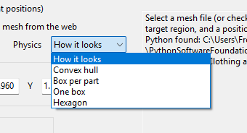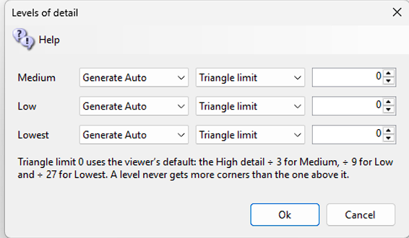

Map Editor
Marianna and I have been adding fresh content to the Map Editor. The Endless Land and Sea Setting in Smart Start now support Cities, Parks and corners and half regions with auto populated content from the Outworldz. You can create a city in a few minutes, or as you travel a city appears around you. One click can remote it all or you can make it permanent and rearrange it or change with drop and drag.
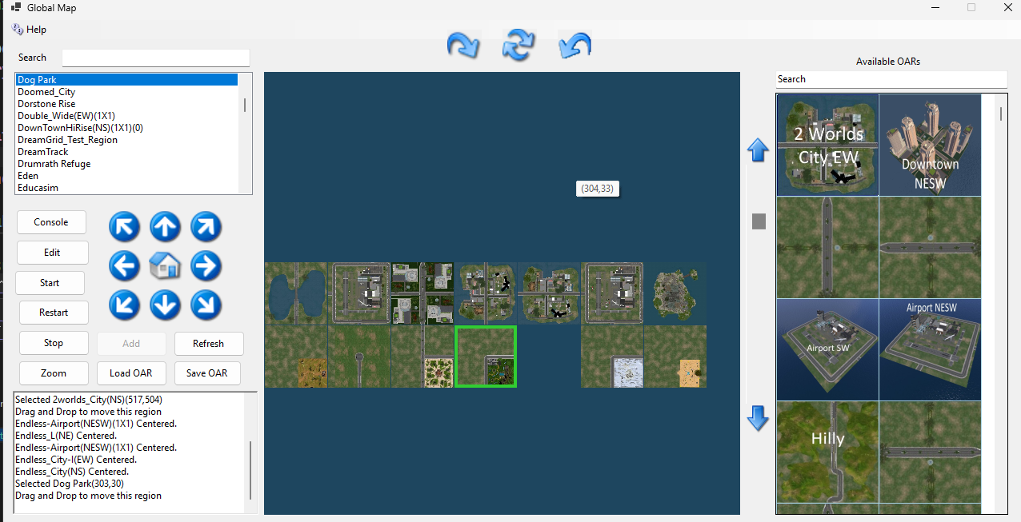
How to open it:
Open the Region List and click Users.
Drag and drop items from the right into the map and connect the roads.
Search for regions.
16 zoom levels!
Endless land, and seas:
Two ways to use it, automatic land that disappears when you are not near, wherever you go, or make a city and keep it.
Go to Smart Start and in Tab 2 “Endless Land Seas and Cities”, pick a blank spot at random in X and Y and choose 2, 3, or more rings.
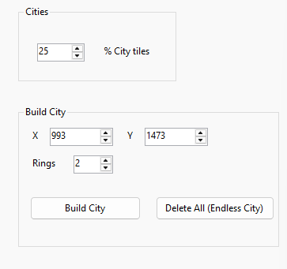
Click Delete All and the city will Poof.

Filters:
What you get (Regions/Details, Avatars and Visitors grids):
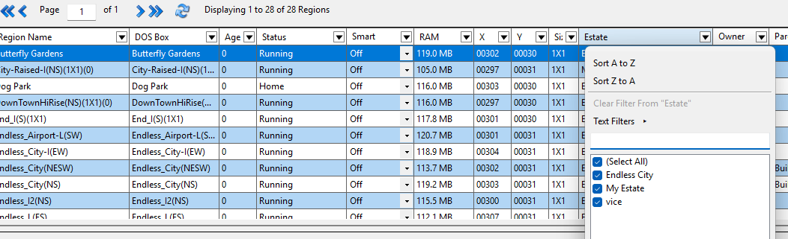
1. Every column heading now has a small ▼ at its right edge. Clicking the column name still sorts; clicking the ▼ (or right-clicking the heading) opens the filter menu:
- Sort A to Z / Z to A
- Clear Filter From "column"
- Text, Number or Date Filters, picked automatically from what the column holds (contains, begins with, greater than, between, Top 10, above average, before/after, today, last 7 days…)
- A searchable tick list of the column's values, including (Blanks), with OK/Cancel
2. A filtered column shows a blue funnel instead of the ▼.
3. Right-clicking a cell gives "Filter by Selected Cell's Value", "Clear Filter From…" and "Clear All Filters".
4. The Search box now matches every column on those three grids: estate, owner, DOS box and so on.
5. On the Details view, a "Clear All Filters" link appears next to the region count while any filter is on.

Better caching:
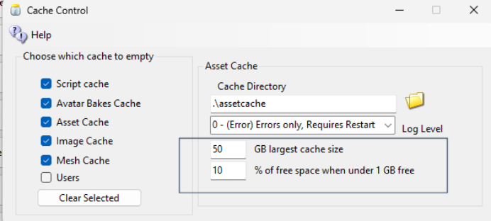
Allows you to use larger caches that will never fill up the disk. Both % free and Absolute size limits instead of time.
Eliminated hundreds to thousands of noisy useless log clutter - no changes to Opensim.

OAR loading
Loading an OAR can take up to 5 minutes or longer after loading to RAM to save to disk. It’s important that it's not shut it off too soon.
DreamGrid waits for the 'backup' command to finish before reporting "Done". It has done this for a long time, but on a DOS box with 8 regions and 88,000 prims, Opensim closed the connection after 3 minutes. An endless retry now makes Opensim operate as expected.

Form tabbing
Tabbing is fixed everywhere. A few were out of order. Much more natural feel to press tab to advance through the settings.

Inventory viewer
This is a new screen that shows one avatar's inventory the way File Explorer shows a hard drive: the folders on the left, and what is inside the chosen folder on the right. It only looks. Nothing can be changed, moved or deleted here.
How to open it: Open the Region List and click Users. Click any user to open the Edit User screen, then click Inventory.
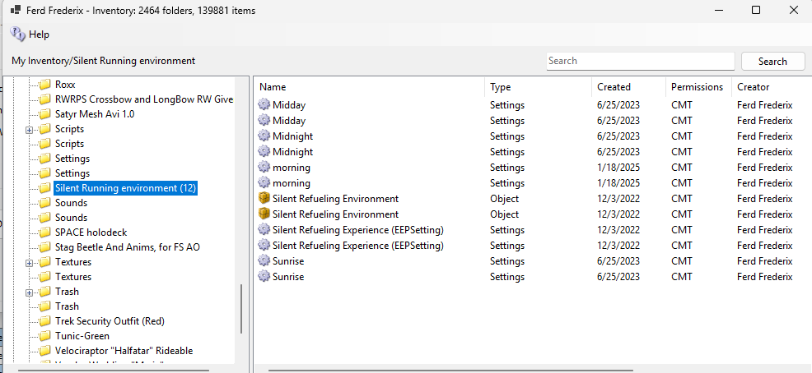
The left side is the tree of folders. My Inventory is at the top. Under it are the system folders every avatar has (Textures, Clothing, Objects, Notecards, Trash and so on) and the folders the avatar made. Click a folder to see what is in it. The number in brackets after a folder name is how many items it holds; it appears once the folder has been opened.
My Suitcase is the folder a Hypergrid visitor carries along when visiting other grids.
The title bar shows how many folders and items the avatar has in all.
The right side lists the sub-folders first, then the items, each with its icon and these columns:
- Name. For a link, the name is followed by an arrow and the name of what it points to.
- Type: Texture, Sound, Calling Card, Landmark, Object, Notecard, Script, Snapshot, Wearable, Animation, Gesture, Mesh, Settings or Material. A wearable also says what it is, such as Wearable: Shirt or Wearable: Skin.
- Created: the date the item was made.
- Permissions: three letters, C M T, for Copy, Modify and Transfer. A dash means the owner does not have that permission. Hover over an item to see the permissions the next owner would get.
- Creator: who made it. A creator from another grid is shown with an @ and the name of their grid.
- Description: the item's description, if it has one.

