EMAIL
There are three places you can send email:
- You can send email to yourself when someone creates an account (See Help on Diva) or to the user when they reset their password.
- LSL can send email from a prim, and you can send email to a prim using Opensim.
- You can send email to your users.

You will need access to an SMTP server to send the emails. These can be commercial places such as pobox.com, your own email server using Microsoft Server, or a free SMTP server.
You must first set up email in the Email panel:

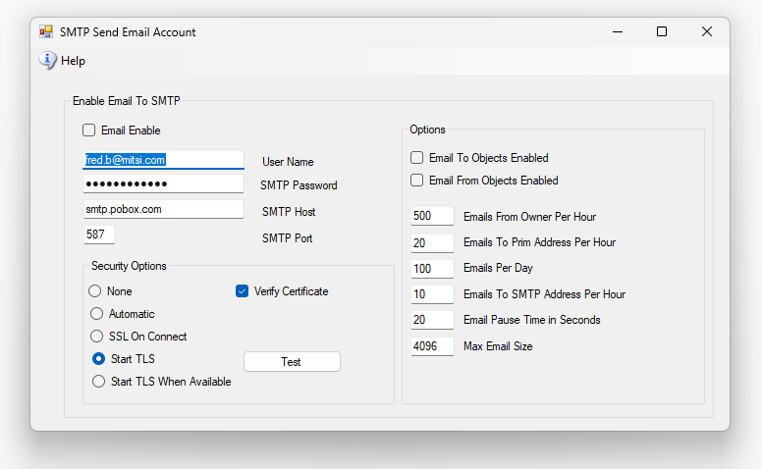
Emails must be enabled with “Email Enable.”
“User Name” and SMTP Password is the email name and password you normally use to log into your email server to send email. Gmail is different: it needs a special “app password.” See GMAIL below.
The port should be what your server documentation says. This is typically twenty-five for unsecure email, 465 for SSL/TLS Email (choose SslOnConnect), or 587 for TLS (choose StartTls).
In my case, I had to use the Automatic setting as none of the others worked.
There are many options for Opensim prims.

GMAIL
1. Open https://myaccount.google.com/security and turn on 2-Step Verification.
2. Open https://myaccount.google.com/apppasswords, type the name "DreamGrid", press Create.
3. Copy the sixteen letters. Google shows them only once.
4. In DreamGrid's Email panel:
- User Name: your full Gmail address
- SMTP Password: the sixteen letters, with the spaces, as Google shows them
- SMTP Host: smtp.gmail.com
- SMTP Port: 587
- Security: StartTLS
5. Press Test. Restart the regions so that scripts (llEmail) use the new settings.
Good to know:
- If you change your Google password, Google deletes the app password.
- "App passwords" are missing from work or school accounts.
- Gmail allows for about five hundred emails a day.

More details:
Mail protocols (SMTP, IMAP, and POP3) all have two separate ways of doing SSL.
There is STARTTLS way of doing SSL and a true SSL mode. This can do both, or you can use auto detected.
The options are as follows:
- None: Does not use any form of SSL (or TLS).
- Auto: Automatically decides which type of SSL mode to use based on the specified port. Note: This only works reliably when the port is a standard defined port (e.g., 25, 587 or 465 for SMTP).
- SslOnConnect: This specifies that it should connect via an SSL-wrapped connection.
- StartTls: Use the STARTTLS method for SSL/TLS encryption. If the server does not support the STARTTLS command, abort the connection.
- StartTlsWhenAvailable: Use the STARTTLS method for SSL/TLS encryption if the server supports it, otherwise continue using an unencrypted channel.
Since you must be using SMTP, you might find this useful:
Port twenty-five was the original port used for SMTP, and it originally only supported unencrypted communications.
Later, administrators and users demanded SSL encryption so admins and mail clients started supporting SSL-wrapped connections on port 465 because this was very easy to do for admins (no server software needed to be upgraded and clients that didn't support SSL-wrapped connections could continue connecting on port 25).
After a few years of this, mail protocol authors introduced the STARTTLS command extension for IMAP, SMTP and POP3 (well, for POP3, the command is STLS but it is otherwise the same thing) that clients could optionally use if they supported it. This extension only made sense on the original (non-SSL-wrapped) ports.
These days STARTTLS is the preferred method for encrypting communications between a client and a mail server, but SSL-wrapped ports are still in wide use as well.
This program treats port 587 the same as it treats twenty-five. In other words, it treats port 25 and 587 as a plain-text connection port but will switch to SSL/TLS if requested to do so via STARTTLS.

