Setting Up WordPress with DreamGrid
Download WordPress from https://wordpress.org/download/
Extract the zip file into wherever you installed your Grid in the Outworldzfiles\Apache\htdocs\WordPress folder. Do not put a second ‘Wordpress’ folder in there. If you do, just drag and drop the contents of the lower Wordpress folder to the htdocs\ WordPress folder. It should look like this:
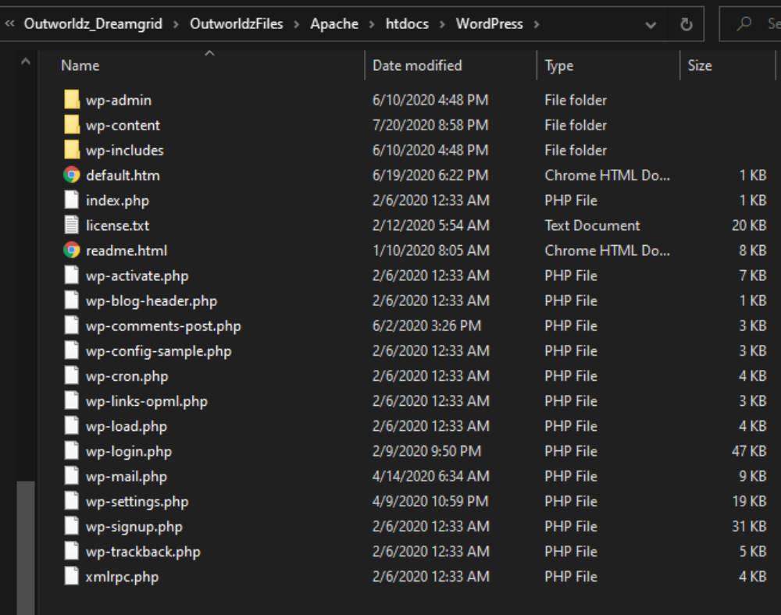
- Go to DreamGrid settings -> Apache. Set the WordPress switch on.
- Enable the Apache Webserver on port 80 to run as a service.
- If you have not yet done so, install the necessary Visual C++ runtimes by clicking the button. **WARNING* This may suddenly reboot your machine, so save your work.
- If it does reboot, make your way back the Settings Apache page and , install the necessary Visual C++ runtimes by clicking the button.
- Stop the grid, exit the app, and start it again.
- Using a web browser, navigate to http://localhost. You should see a language choice screen:
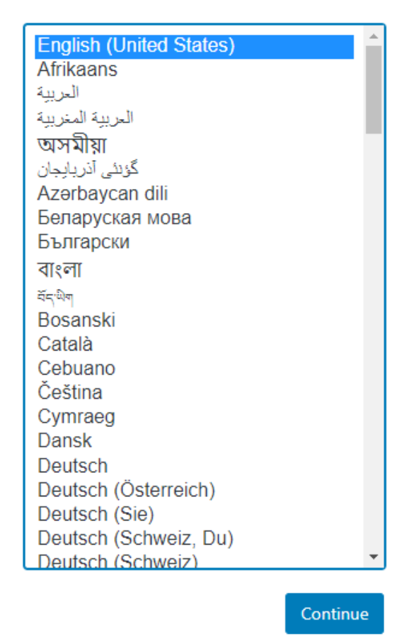
After choosing your language, use these settings to set up WordPress and then Click Submit:
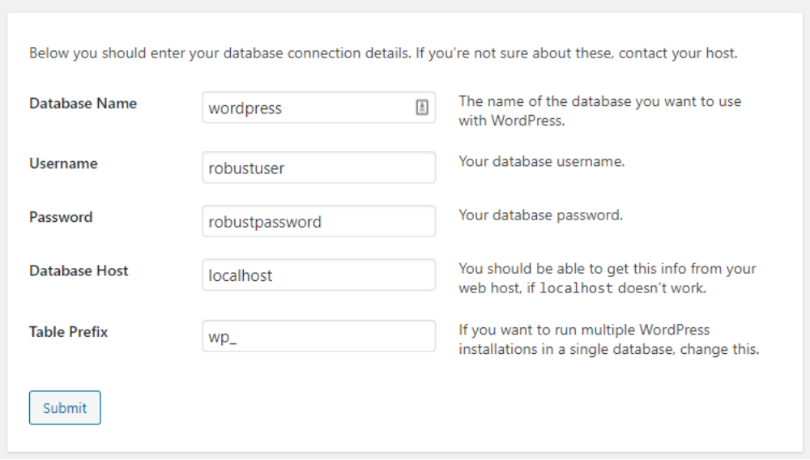

You should get this screen:
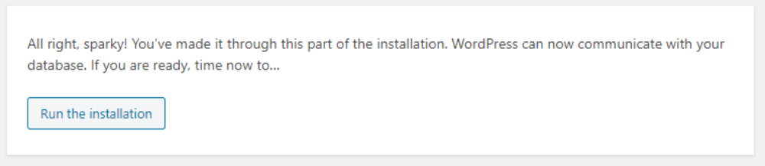
After this WordPress will ask for your name, password and email. Please a very strong password you have never used before! It is extremely importatnt that this be a long, strong password.
You can now navigate to http://localhost to view your new web site.

