Bird Module
The bird module makes flocks of birds possible.
You will need a bird. There is a button at the top of the Setup Page that will ask you for your Avatar Name and password. It will load a pair of Seagulls into your inventory.
You should log in and rez "SeaGull1" on the ground in one or more of your regions.
You will need to enable the bird module in each region's control panel.
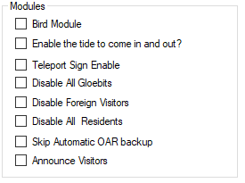
Check this Box to Enable Birds in this region

Global Settings
There are many settings for the Bird Module. You can use the defaults. You must also click Enable and reboot the grid. Birds must also be enabled in each Region. See each Region’s edit screen for the checkbox.
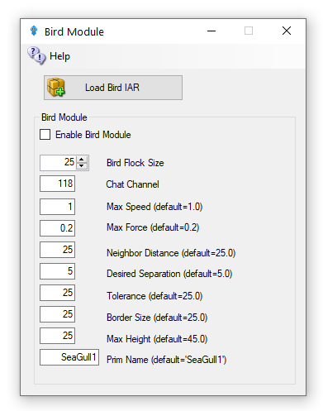
Enable Bird Module: Determines whether the module does anything.
BirdsFlockSize = 50: The number of birds to flock
BirdsMaxFlockSize = 100: The maximum flock size that can be created (keeps things sane)
BirdsMaxSpeed = 3: How far each bird can travel per update. An update is 11 FPS
BirdsMaxForce = 0.25: The maximum acceleration allowed to the current velocity of the bird
BirdsNeighbourDistance = 25: Max distance for other birds to be considered in the same flock as others
BirdsTolerance = 5: How close to the edges of things can we get without being worried
BirdsBorderSize = 5: How close to the edge of a region can we get?
BirdsMaxHeight = 25: How high are we allowed to flock
BirdsUpdateEveryNFrames = 1: Update bird positions every N simulator frames
BirdsPrim = SeaGull1: By default, the module will create a flock of plain wooden spheres, however this can be overridden to the name of an existing prim that needs to already exist in the scene - i.e., be rezzed in the region.
Console Commands
The following commands can be issued on the Console or via in-world chat or scripted chat on the Chat Channel to control the birds at runtime:
- Birds-stats or /118 stats
Shows the current status of the birds
- birds-stop or /118 stop
stop all birds flocking
- birds-start or /118 start
start all birds flocking
- birds-enable or /118 enable
enable the flocking simulation if disabled and rez new birds
- birds-disable or /118 disable
stop all birds and remove them from the scene
- birds-prim <name> or /118 prim <name> changes the name of the bird prim that it loads
- framerate <num>
only update the flock positions every frame, only useful for photography and debugging bird behavior.
- These commands are great for playing with the flock dynamics in real time:
- birds-size or /118 size
change the size of the flock
- birds-speed or /118 speed
change the maximum velocity each bird may achieve
- birds-force or /118 force
change the maximum force each bird may accelerate
- birds-distance or /118 distance
change the maximum distance that other birds are to be considered in the same flock as us
- birds-separation or /118 separation
sets how far away from other birds we would like to stay
- birds-tolerance or /118 tolerance
sets how close to the edges of things can we get without being worried. If distance is less than separation, then the birds will never flock. The other way around and they will always eventually form one or more flocks.

Security
By default, anyone can send commands to the module from within a script or via the in-world chat on the 'BirdsChatChannel' channel. You should use a high negative value for this channel if you want to allow script access, but not in-world chat.

Bird Prims
Any currently rezzed in-scene-object can be used as the bird prim. However, fps is very much affected by the complexity of the entity to use. It is easier to throw a single prim (or sculpty) around the scene than it is to throw the constituent parts of a 200 linked prim dragon.
Tests show that <= 500 single prims can be flocked effectively - depending on system and network. However maybe <= 300 simple linksets can perform as well.

Network Traffic
I tested the amount of network traffic generated by bird updates. 20 birds (each with 4 linked prims) take up about 300kbps in network position updates. 50 of the same birds generates about 750kbps traffic. Each bird uses roughly 15kbps of network traffic. This is all measured using an update framerate of 1, i.e., birds' position is updated every simulator frame.

Statistics
The stats command in-world or via script returns data to BirdsChatChannel. The console command returns stats to the console. All the modules parameters are returned including a list of the active bird prims currently rezzed in the region, and the UUIDs of those prims' root prim. Also included is a list of any avatar UUIDs that may be sitting on those prims.
Here is an example output:
birds-stats (or /118 stats
birds-started = False
birds-enabled = True
birds-prim = SeaGull1
birds-framerate = 1
birds-maxsize = 100
birds-size = 20
birds-speed = 1.5
birds-force = 0.2
birds-distance = 25
birds-separation = 10
birds-tolerance = 5
birds-border = 5
birds-prim0 = OpenSimBirds0: 01abef79-7fb2-4c8d-831e-62ce1ce878f1 :
birds-prim1 = OpenSimBirds1: af85996d-af4d-4dda-bc89-721c51e09d0c :

