Users
This screen lets you edit any user Title, Email, Name, and Login Levels
Change any data and close the windows and it will save the changes.
You may rename the avatar, add a title, and change the email and password.
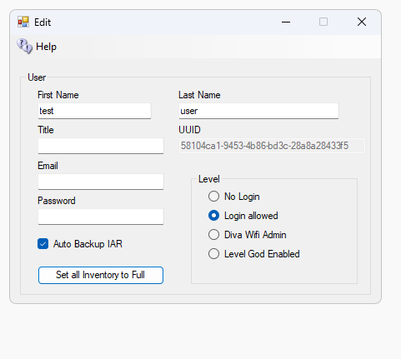
Level sets the login level for this avatar: No Login, Login allowed, Diva Wifi Admin, Level God Enabled, or Level WebAdmin. Auto Backup IAR adds this avatar to the list of users whose inventory is saved by the automatic IAR backup.
Web IAR/OAR save lets this user make their own backups from the web. They can save their own inventory as an IAR. If they own an estate, they can save a region on that estate as an OAR. When the file is ready, DreamGrid emails them a link to download it. This box is not ticked until you tick it.
CAUTION: This box does nothing on its own. You must also tick “Let users save their own IAR and OAR from the web” on the System Backup screen. Both must be ticked. See the Backup Manually help page.
Web mesh upload lets this user upload mesh from the DreamGrid web page. The mesh appears in front of their avatar and belongs to them. They can only upload into a region whose estate they own or manage. This box is not ticked until you tick it.
CAUTION: This box does nothing on its own. You must also tick “Let users upload mesh from the web” on the Mesh Uploader window. Both must be ticked. See the Mesh Uploader help page.

