Region List
Open the Region Panel with Ctrl-R or go to Setting-Region.
There may be many Region.INI files in your system. These show up in this panel. The default is an island called "Welcome".

Refresh button
Click Refresh to rescan the system status and update this panel.

Details button
This screen shows the regions plus all the details on each region.
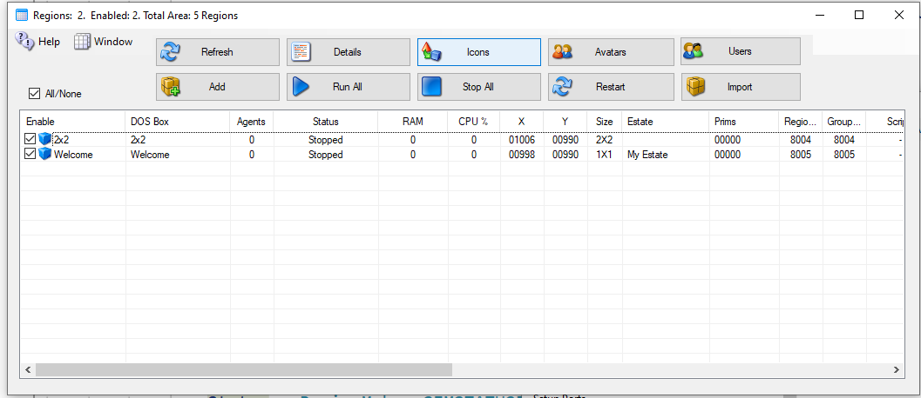
The Detail view can be sorted by Name, Group, Agents or Status, or any column by clicking the column name.

Search box
Type in the Search box to show only the rows that hold your text.
On the Details, Avatars and Visitors screens it looks in every column. You can type an estate name, an owner, or a DOS box name. On the Icons screen it looks at region names only. On the Users screen it looks at avatar names.

Filtering a column
On the Details, Avatars and Visitors screens, every column heading has a small arrow at its right edge. It works like the filter arrow in Excel.
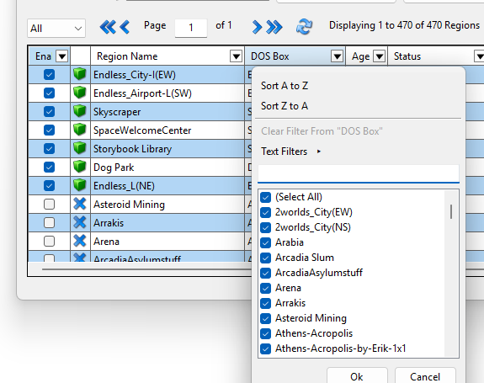
Click the column name to sort by that column. Click the arrow, or right-click the heading, to open its filter menu:
- Sort A to Z, or Sort Z to A.
- Clear Filter From the column.
- Text Filters, Number Filters or Date Filters, depending on what the column holds. For example: contains, begins with, greater than, between, top 10, above average, before, after, today, or last 7 days.
- A list of every value in the column, each with a tick box. Untick the values you want to hide. In a long list, type in the small search box to find a value.
Click OK to apply the filter.
A filtered column shows a blue funnel in place of the arrow. You can filter several columns at once. A row shows only when it passes every filter.
Right-click any cell to filter by that cell’s value, to clear the filter on that column, or to clear all filters.
On the Details screen, a Clear All Filters link appears next to the region count while any filter is on.
Filters are not saved. They are cleared when you close the Region List.
CAUTION: The Select All/None box and the Export button only act on the regions you can see. Clear the filters first if you mean every region.

Icons button
This screen shows the Icon on each region. Clicking a Region opens the Region Control panel.

Avatars button
This screen shows the Hypergrid and Local Visitors to your regions. If you have a viewer on the server, you can click the person and it will generate a Teleport link to that person.

Users button
This screen has a list of all registered users on your system.
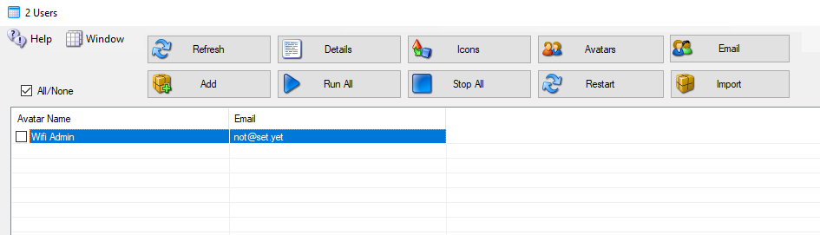
You can Checkmark each user to send an email to them. The Email button appears to top right

Add
Click the Add button to make a new region. You only need to give it a name and save it.

Run All Button
Runs all Checked regions.

Stop All Button
Stops all regions.

Restart Button
Restarts all checked regions.

Import Button
This button lets you find region.ini files from other system, such as the standalone Dream World or backups, and import the file into DreamGrid in a new or existing DOS box.

File Folder Arrangement
DreamGrid uses a slightly different folder setting than stock Opensim. You cannot just copy them over in a file explorer unless you make a special pattern of folders, with an extra set of folders inside it.
The format is:
Opensim\bin\Regions\DOS Box Name\Region\RegionName.ini
DreamGrid has several simple rules for *.INI files that differ slightly from stock Opensim.
- The INI file name must match the [Region Name] inside it. This example region [Region Name] must be saved as “Region Name.ini”.
- Only one [Region Name] is allowed in an INI file.
- All contents of a Region file are made by Dreamgrid and will be overwritten. See the Region Control Panel to change the settings.

Clicking a Region
A new panel appears if you click a region:
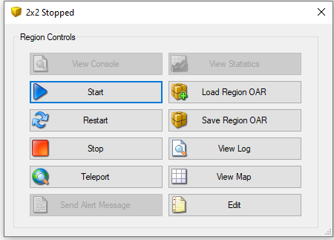

View Console Button
Shows the DOS Box console window.

Start Button
Starts this one region.

Restart Button
Restarts this one region.

Stop Button
Stop this one region.

Teleport Button
Generates a Teleport to the region in the viewer.

Send Alert Message Button
Send a region wide message to all users in the region

Load Region OAR Button
Loads an OAR into the region

Save Region OAR button
Saves an Oar from the region

View Log Button
Views the Opensim.log file

View Map Button
Shows the region Map.

Edit Button
Edits the region.

Region Stats
The region stats are a web-based data collector. First, choose a region:
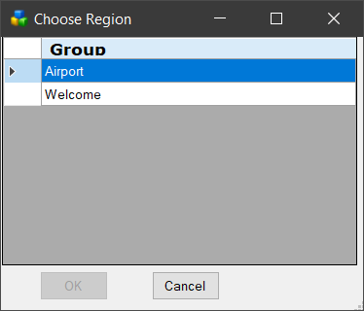
The first screen shows general statistics:
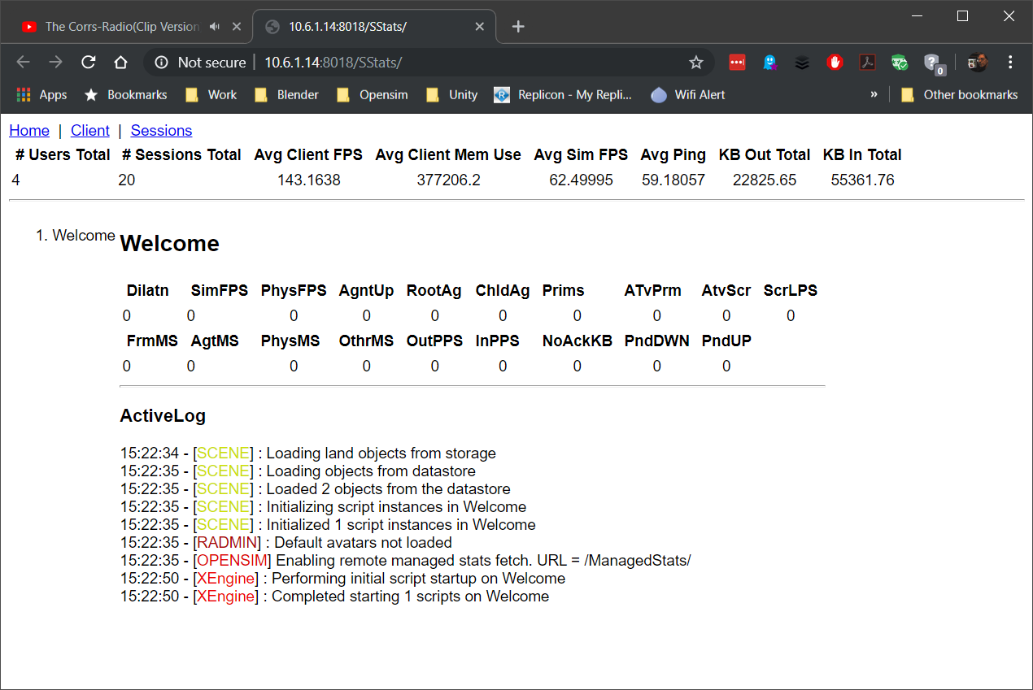

The client screen shows the types of viewers that have visited
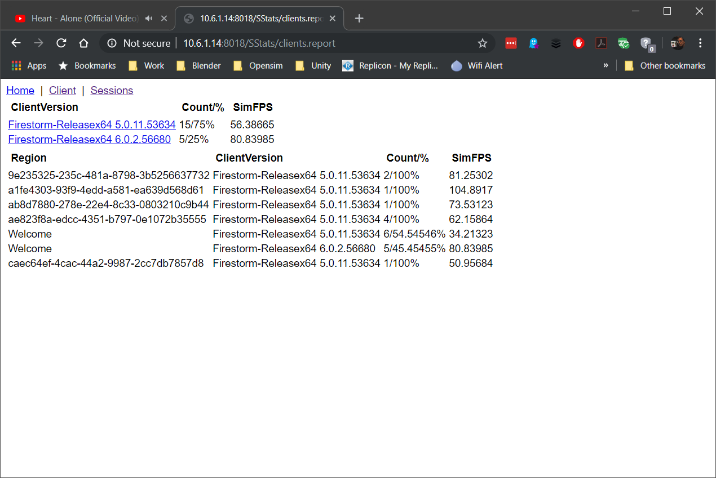
The Sessions screen shows the visitor list
