Installing and Running Joomla and jOpensim V4

Make sure Apache is enabled. See the Help file for Apache on how to enable it. You must install the C++ Runtimes.
Leave the Apache Content Manager set at “Diva” to prevent redirects. When you finish with Joomla, you can enable JOpensim. This redirects all traffic to your web server to Joomla/jOpensim.
Note: This is Joomla + JOpensim V4, a new major version. It is a fresh install, not an in-place upgrade from the older, deprecated Joomla/JOpensim V3. The Install button below installs V4 from scratch; it will refuse to run if the JOpensim folder is not empty (for example, if an old V3 install is still there - back it up and remove it first).
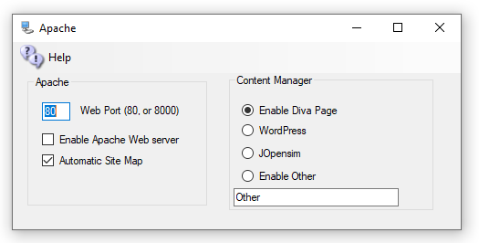

Both the MySQL and Apache icons should be Green.
Click Setup->Settings->Install CMS, then click Joomla. On the JOpensim screen, click the Install button.
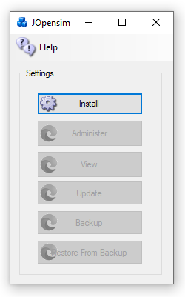
It will install the files
You should see the Joomla Setup Page. Fill in the Site Name, a short Description, and pick a Super User Account name and password. Joomla is exposed to the public Internet, so be sure that you use a long and secure password that you have never used before. Write it down as you will need it often!
Press Next
- Fill in the Host name as 127.0.0.1
- Database name as Joomla
- Username should be robustuser
- Password should be robustpassword.

Press Next
Verify that there are no errors
Press Install
Click

Restore data

In your web browser go to http://127.0.0.1/JOpensim/kickstart.php, or in Setup->Settings->Install CMS->Joomla, click the [Restore] button.
Press <esc> key to close the warning screen.
Select the latest backup jOpensimBackupV{X}.jpa.
If it is blank or cannot be found, look in \OutworldzFiles\jOpensim_Files for the .jpa file and copy/paste it into the field.
CAUTION: There is NO PASSWORD. If your browser adds one, please blank it out or the setup will fail.
Click Start. It will show it is extracting.
Click Run the Installer
Press Next at Upper Right

Fill in the values:
- Database Host is 127.0.0.1
- User name is robustuser
- Password is robustpassword
- Database name is Joomla
Leave the table prefix alone, as the name is assigned randomly for security.
Click Next at the top right
Fill in the upper part and leave the ‘Live Site URL’ blank.
Fill in the bottom part with your Desired Super User Password. You need to remember this! The login id will be Admin with this password, not the prior one you used!
Press Next at Upper right

Close this window to return to Kickstart. Click the Clean Up button to start using your restored site.

Edits
Joomla will require some edits to match your preferences.
Click the Administer button to log in as “Admin” with your Super User password.
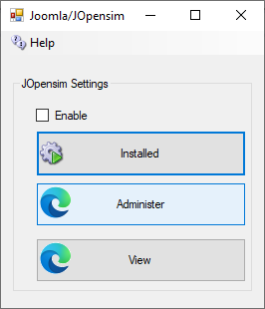

Important Group Setting

Navigate to System->Global->JOpensim and in the Groups tab set both Group keys the password located in you Setup->Setting->HG Dns Name

Backups:

You can back up Joomla and JOpensim with Akeeba backup, which I built into your distribution.
Click Components->Akeeba Backup and select “Full Backup”.
To restore a backup, Click [Restore] in the Dreamgrid jOpensim menu to extract kickstart-core-7.0.2.zip and load the URL as shown in section “Restore the Data”, above.

Update

Press the Update button to update to the latest jOpenSim. This will take you to this screen:

Click “Or Browse for file” and navigate to the Outworldzfiles\jOpensim_Files\ folder and select the JOpen*.zip file found there (e.g. JOpensim.0.4.0.4_RC7.zip). This will update you to the latest jOpensim V4.

jOpensim Money

This is NOT available

References:
Jopensim Wiki http://wiki.jopensim.com/
JOpensim Bugs https://mantis.jopensim.com/

