DreamGrid MCP Server

How to connect to a Claude session
DreamGrid exposes a Model Context Protocol (MCP) server on its existing diagnostics port, at the path /mcp. This lets an MCP-capable AI client (such as Claude) query and control your grid. You can chat with Claude and ask it to restart DreamGrid, reboot your server, tell you the status and analyze reports and log files. You can even have it speak to you (if your server has a sound card), or make wav and mp3 files you can play in world.
You can directly: check region status, start/stop/restart regions and services, run backups, and even speak out loud through the host's text-to-speech engine - including making the AI's voice play inside the virtual world itself.
No new port is opened. It rides on the same HTTP listener DreamGrid already uses for teleport signs, SmartStart, and the web API (Settings -> Diagnostics port; default 8001, but this can be changed per-grid - check your own Settings panel for the actual port in use).
The endpoint URL is:
http://<your-host>:<DiagnosticPort>/mcp
Example (using my grid's configured diagnostics port):
http://developer.ittybittymachine.net:5001/mcp

ADDING THIS MCP SERVER TO A CLAUDE SESSION
Claude Code (the CLI) and Claude Desktop both support adding a remote MCP server by URL. The exact steps depend on which Claude product you're using:

CLAUDE CODE (CLI)
From a terminal, run:
Claude mcp add --transport http <MyDreamGridName> http://<your-host>:<port>/mcp
In my case I used this command from Claude:
Claude mcp add --transport http DreamGrid http://developer.ittybittymachine.net:8001/mcp
I can type “restart Dreamgrid” and it understand what steps to do.
Replace <your-host>:<port> with your grid's actual host and diagnostics port. This registers the server under the name "DreamGrid" for that project/session. Claude Code will call "initialize" and "tools/list" automatically the next time you start a session, and the tools below will be available for Claude to use.
To check it's connected:
In Claude, type mcp list
and I get back this
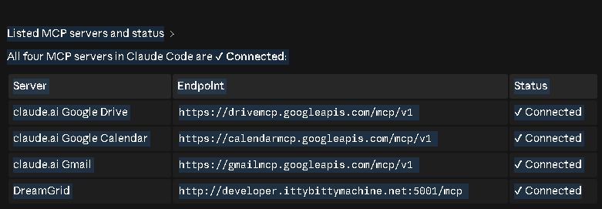

Commands:
Here are all the DreamGrid MCP tools available:
Region control
- region_list — paged region list (name, status, RAM, SmartStart, etc.)
- region_status — status for a specific region
- set_region_status — set a region's status
- start_region / stop_region / restart_region
- enable_region — enable a region
- freeze_region — freeze a region
- thaw_region — thaw (unfreeze) a region

Backups
- save_oar — save an OAR (region archive)
- save_iar — save an IAR (inventory archive)
- backup_all — back up everything

Grid-wide services
- start_grid / stop_grid / restart_all / restart_all_full
- start_robust / stop_robust
- start_apache / stop_apache
- start_mysql / stop_mysql
- start_icecast / stop_icecast

Windows service management
- install_dreamgrid_service / delete_dreamgr
- start_dreamgrid_service / stop_dreamgrid_service

Host/misc
- reboot_host — reboot the machine
- speak — text-to-speech
- speak_to_file — text-to-speech saved to file, reports back the URL.

CLAUDE DESKTOP
Open Settings -> Connectors (or Developer -> Edit Config, depending
on your Claude Desktop version) and add a custom connector:
Name: DreamGrid
URL: http://<your-host>:<port>/mcp
Save and restart Claude Desktop. The DreamGrid tools will then show up in the tool picker for any conversation.
Here is the Claude “list regions” command
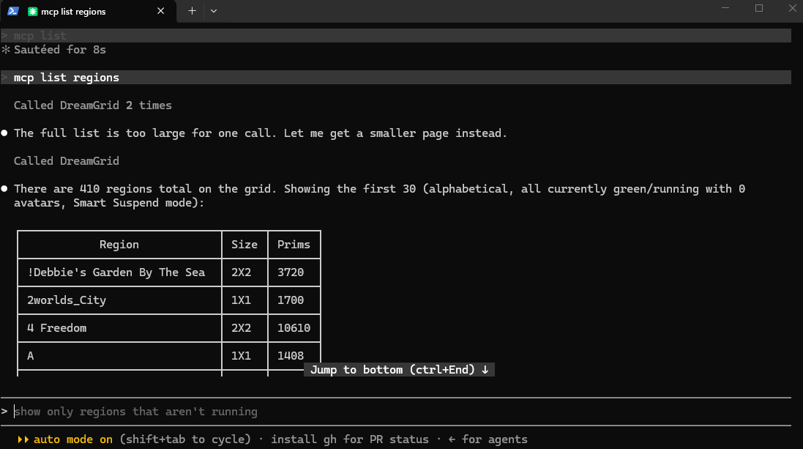
Here is a command that shows how AI can think about a project. There are many commands. None of them return a count of regions that are running. But the AI has combined them to find all running regions. The correct count is 410 which it calculated.
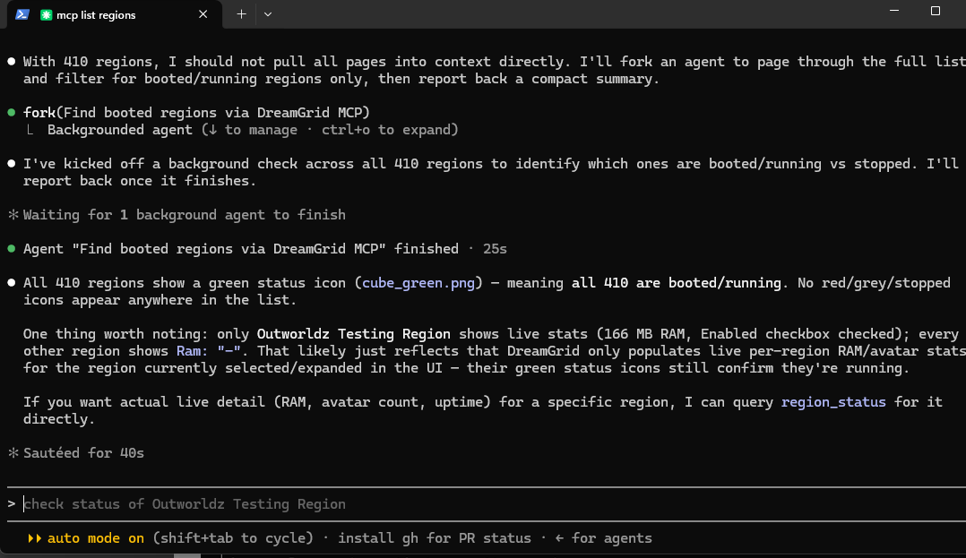

NOTES
- The DreamGrid MCP server only speaks plain HTTP (no TLS), so if your Claude client requires https:// for remote connectors, you will need to put it behind a reverse proxy/TLS terminator, or use a client that allows plain http:// for local/LAN servers.
- No password is required to list tools or call the read-only ones (region_status, region_list).
State-changing tools (starting or stopping regions/services) are gated the same way the classic DreamGrid web API is: pass "avatar" and "password" arguments, where "password" can be the grid's MachineHash (found in OutworldzFiles\Settings.ini) for full admin access, or a normal avatar name/password for a lower permission level. Omitting both simply means the call gets rejected ("NAK You do not have permission...") rather than silently succeeding.

AVAILABLE TOOLS

SPEECH

speak
Speaks text aloud on the DreamGrid host's sound card right now. Fire-and-forget - the same mechanism DreamGrid already uses to announce visitors arriving/leaving. Does not return audio; it just plays through the host's speakers. Requires the host to have a working sound card (real or virtual).
Arguments:
text (required) - text to speak. Claude will prefix a line with "M:" or "F:" to force that line's gender.
voice (optional) - a specific SAPI5 voice name, e.g. Zira, Mark, Eva, David, or any other voice installed on the host.
sex (optional) - "M" or "F" to force a male or female voice for the whole request., Or the name of the voice .

speak_to_file
Synthesizes text to an MP3/WAV file on the host and returns a playable URL (served by Apache under /TTS/Audio/...). Use this instead of "speak" when the audio needs to be heard IN-WORLD, for example by an LSL object playing it via Media-On-A-Prim(MOAP), rather than just heard on the host's own speakers.
Arguments: same as "speak" (text required; voice and sex optional).

REGION INFORMATION (read-only, no password needed)

region_status
Returns the current status of one region (Booted, Suspended, Stopped, RecyclingDown, Booting, Error, etc.).
Arguments: region_name OR region_uuid (one required).

region_list
Returns the paged region list (name, status, RAM usage, SmartStart mode, prim count, estate, etc.) exactly as the DreamGrid web UI's region grid sees it.
Arguments (all optional):
page - 1-based page number, default 1.
rp - rows per page, default 100.
query - filter text (matches region name).
sortorder - "asc" or "desc".

REGION CONTROL (state-changing - needs avatar/password)

start_region
Starts (boots) a stopped region.
Arguments: region_name or region_uuid (required), avatar, password.

stop_region
Stops a running region.
Arguments: region_name or region_uuid (required), avatar, password.

restart_region
Restarts (recycles) a region.
Arguments: region_name or region_uuid (required), avatar, password.

freeze_region
Suspends (freezes) a region in place to reclaim memory without a full shutdown - the same mechanism used by the hourly SmartStart
freeze/thaw cycle.
Arguments: region_name or region_uuid (required), avatar, password.

thaw_region
Resumes a suspended (frozen) region.
Arguments: region_name or region_uuid (required), avatar, password.

enable_region
Enables or disables login/visibility for a region.
Arguments: region_name or region_uuid (required), value (required - the enabled/disabled value), avatar, password.

set_region_status
Forces a region into a specific state directly (e.g. "Restart").
Arguments: region_name or region_uuid (required), param (required - the state to force), avatar, password.

save_oar
Saves an OAR (OpenSim region archive) backup of a region.
Arguments: region_name or region_uuid (required), avatar, password.

save_iar
Saves an IAR (inventory archive) backup for one avatar.
Arguments: avatarname (required), avatar, password.

GRID-WIDE CONTROL

backup_all
Runs a full backup of all regions.
Arguments: avatar, password.

restart_all
Restarts the entire DreamGrid application.
Arguments: avatar, password.

start_grid
Starts all regions on the grid.
Arguments: avatar, password.

stop_grid
Stops all regions on the grid.
Arguments: avatar, password.

SERVICE CONTROL (MySQL, Robust, Apache, Icecast)

start_mysql / stop_mysql
Starts or stops the MySQL service.
Arguments: avatar, password.

start_robust / stop_robust
Starts or stops the Robust grid server.
Arguments: avatar, password.

start_apache / stop_apache
Starts or stops the Apache web server.
Arguments: avatar, password.

start_icecast / stop_icecast
Starts or stops the Icecast streaming service.
Arguments: avatar, password.

EXAMPLE: RAW JSON-RPC CALLS (for testing without a Claude client)

List all tools:

curl -X POST http://<host>:<port>/mcp ^
-H "Content-Type: application/json" ^
-d "{\"jsonrpc\":\"2.0\",\"id\":1,\"method\":\"tools/list\"}"

Check a region's status:

curl -X POST http://<host>:<port>/mcp ^
-H "Content-Type: application/json" ^
-d "{\"jsonrpc\":\"2.0\",\"id\":2,\"method\":\"tools/call\",\"params\":{\"name\":\"region_status\",\"arguments\":{\"region_name\":\"A\"}}}"

Speak something out loud:

curl -X POST http://<host>:<port>/mcp ^
-H "Content-Type: application/json" ^
-d "{\"jsonrpc\":\"2.0\",\"id\":3,\"method\":\"tools/call\",\"params\":{\"name\":\"speak\",\"arguments\":{\"text\":\"Hello from DreamGrid\",\"sex\":\"M\"}}}"

Thaw a suspended region (requires the grid's MachineHash from Settings.ini as the password) or an abatar name and passeord with High level permissions in the User settings.

curl -X POST http://<host>:<port>/mcp ^
-H "Content-Type: application/json" ^
-d "{\"jsonrpc\":\"2.0\",\"id\":4,\"method\":\"tools/call\",\"params\":{\"name\":\"thaw_region\",\"arguments\":{\"region_name\":\"A\",\"password\":\"<your MachineHash>\"}}}"

