Smart Start
Smart Start regions shut down when no one is in them. A Smart Start region appears as a different icon in the Regions panel. This means they boot once, then power off or freeze and wait for a teleport before they start again.
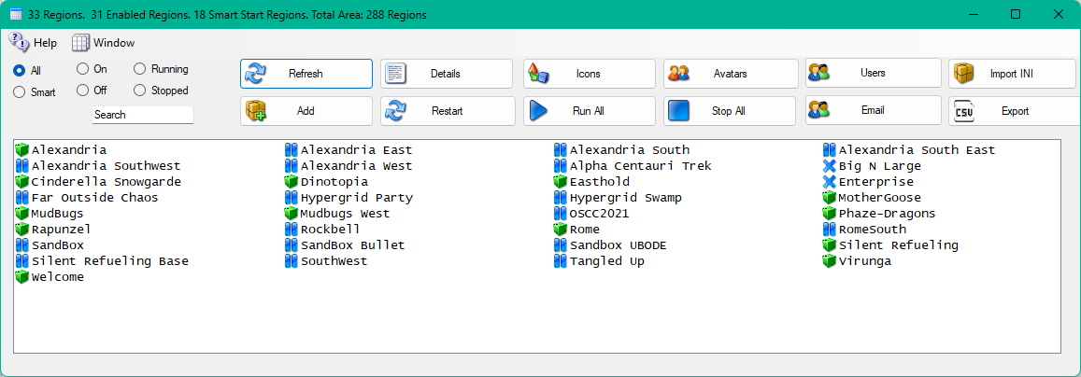
It can also appear as a ‘frozen’ ice cube. This type is frozen in RAM. All the treads it was executing are put to sleep, but it stays in RAM. Windows will see this as inactive RAM and will swap the region to disk when RAM is needed for another process. When a teleport occurs, the region is thawed out, and runs again.

Teleports
Smart start detects teleports. When someone teleports into the system, or logs in, the system decides if their destination is already booted. If so, teleport happens normally. But if the region is not ready, the system sends the avatar to a waiting area while the region is booted. When the original destination region is ready for logins, the avatar is teleported to the original destination.

Enable Smart Start
Smart Start is disabled by default. You must first enable it in Setup->Settings->Smart Start:
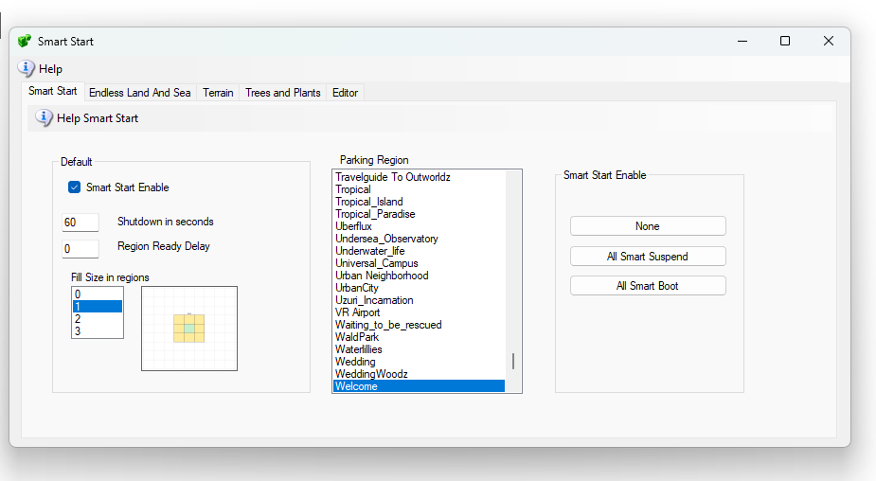
There are two modes: Suspend or Shut Down.

Shutdown Mode
The system can be set to power down the region when no one is in it. This length of time is from 15 seconds upward. If no one is in the region, it will power down after the timer expires. When set to Shutdown Mode, the system will boot all regions and then power it off with a ‘quit’ after the “Shutdown In seconds” delay happens. This registers the region as “Persistent” in Robust, so you can teleport to it.
If the region is shutdown, or offline, DreamGrid will move you to a temporary parking area if you are hypergriding in. DreamGrid will announce how long it takes to wait for the region while it is booted. When the region is ready, you will be sent there.
There is a Region Ready Delay that is adjustable. DreamGrid cannot know when a region will accept teleports due to the way regions are coded. A delay of from 5 to 30 seconds may be needed. Regions with more data and/or scripts will take more time. If you get teleport fails yet the region is boots and is running, increase this time.

Suspend Mode
When set to suspend, the system will boot all regions and then power it off after the “shutdown In Seconds” passes. It works the same way as Shutdown in the way teleports work. However, after the region has run long enough for the timer to expire. It is not powered off. It is frozen. It stays in RAM. The icon is an ice cube.
You will not be able to type or interact with a frozen region. You can thaw the region by clicking on the region name in the region panel. Then click “Console.” The region will be unfrozen for five minutes.
The power-on Region Ready delay is unused for Suspend Mode. The Shutdown in Seconds should usually be at least 20 seconds, or it can shut off before anyone arrives. Minimum is 15 seconds.

Surrounding Sims
Smart Boot can boot surrounding sims when a visitor arrives. The default is to not do this (Fill Size = 0). In any Smart Start Mode, you need it to be a one or larger to be able to walk across boundaries. If zero, you can only teleport into a sim.
If you set the fill size to one, and an avatar lands in a sim, then any Smart Start regions that touch the region will be booted. If the avatar moves to one of those, then added regions surrounding that region will boot.
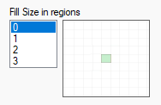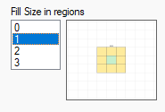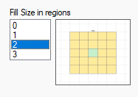

Details
These regions will always boot once to register themselves. The Smart Settings only go into effect when the entire grid restarts, or Robust restarts and the Region restarts. If you change a region to Smart Start while robust is running, Robust will restart.
Any teleport request is intercepted in Opensim and sent to DreamGrid. The desired Region UUID is sent, such as “000-A…" and DreamGrid returns "UUID -000A…" if the region is ready, or UUID = 000-B…, or a Parking other region UUID, if not ready.
You get a message from the viewer saying your region will be available in so many seconds. This is the recorded time it took to previously boot the sim. There is a different time saved in a Map Time variable if maps are enabled. Ideally, maps are off for the fastest boot time.
The region must be a) enabled to boot b) Smart Start is enabled globally, c) the region must be Smart Boot-enabled in its Modules section of the region setting for this region. It then shows the Pause icon of || in the region listings. If this is set, the region will power up. All three conditions must be met.
Once DreamGrid decides the timer is finished, you will be found wherever you are (if still on the grid) and teleported to the destination. If you leave, the system will shut off the region. The last teleport always overrides the earlier one. If you try three different landmarks in a few seconds, then you will end up in the third.

Choose a Parking Region
If a region is offline and a teleport is started, the region will be booted.
If an avatar is arriving from the Hypergrid, the avatar is teleported to a waiting region, aka, a “Parking Region.” You may choose any Always-On region, such as your Welcome region, which is the Default.
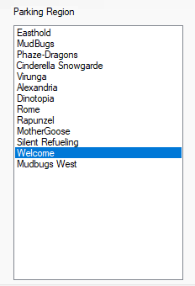

Region Setup
You must enable Smart Start in the region panel.
This can be enabled or disabled for any region. Edit any region and set the Smart Start Checkbox to True. This goes into effect at once.
If the region is running and no avatar in it, it will shut down within the time you set.
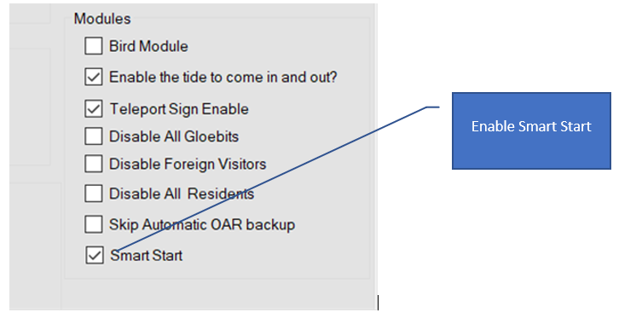

Endless Land and Sea
This optional feature will trigger an automatic fill of surrounding regions with the Landscaping and Trees/Plants modules if an avatar arrives. In those screens you can choose water regions, as just one example. If set to water, your avatar can walk, fly, or boat across the entire expanse of your grid. It is an “Endless Sea”.
You should select an avatar that will own the Estate named “SimSurround,” which is the owner of these Regions.
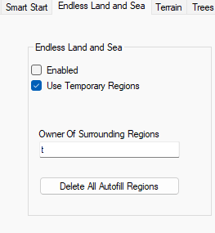

How it works
Think of a tic-tac-toe board. The region a visitor arrives in is the middle square.
- DreamGrid looks at the squares around it.
- Every empty square gets a new region with a random name, and DreamGrid starts it.
- When the visitor walks, flies or sails into a new region, that region becomes the middle square, and it all happens again.
So wherever a visitor goes, there is always more world ahead. They never reach the edge of the map.

How far out it builds
The Fill Size sets how many rings of new regions are built around the visitor:
- 1 ring: up to 8 new regions.
- 2 rings: up to 24 new regions.
- 3 rings: up to 48 new regions.
Visitors can see about 4 regions away, so more rings fill the horizon. More rings look better, but need a stronger computer.

What the new regions look like
- Water: open sea to sail or fly over.
- Land: ground to walk on, flat or with hills and mountains. Trees and plants can be added.
The Landscaping and Trees/Plants screens set how the land and plants look.

Temporary regions
- Temporary on: when the visitor moves away, the regions built for them are deleted again. This saves memory and disk space.
- Temporary off: the new regions stay, and your world keeps growing.
Temporary only removes regions built by Endless Land and Sea. Regions you made yourself are never touched. If a visitor comes back to a place that was deleted, it is built fresh, so it may look different.

Delete All Autofill Regions
This button removes every region Endless Land and Sea has built, at any time. Your own regions are never touched. Stop your regions first. The button asks you to confirm.

Roads and Cities (coming soon)
A future version adds roads and cities to the new regions.
Each road region has roads leaving by some of its four sides: north, east, south or west.
The one rule is that all roads must fit:
- A road leaving the east side meets a road coming in on the west side of the next region.
- A road leaving the north side meets a road coming in from the south.
- A side with no road faces a side with no road.
So roads never stop dead against a wall, and they never run into your own regions. Your Welcome region has no roads, so no new road ever points into it. DreamGrid picks each road region at random from the pieces that fit, so every trip can look a little different.
Roads cut each region into four corners. On a plain road region, DreamGrid can put a building, such as a gas station or a bakery, on none, some or all of the four corners. A City region already has all its buildings, so nothing is added to it.

Building by hand
You can still place regions yourself. In the Region Map Editor, drag and drop water, road and city regions exactly where you want them.

