Regions
Region Settings hold various defaults for all regions.
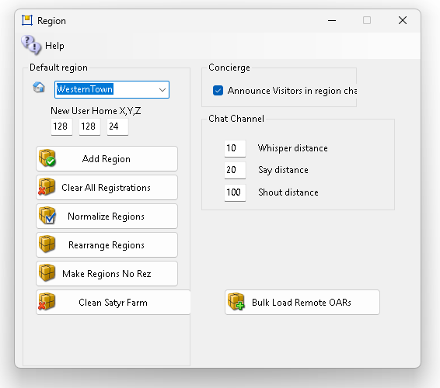
Default region for visitors: This is your “Welcome” region. Hypergrid visitors and people who log in for the first time get sent to this region. The region must be online.
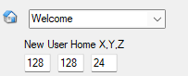
New User Home X, Y, Z: Users that create accounts on the web page will land at this spot on your Welcome region. Their home is set here. Default: 128,128,24. It’s a nit over the land height so they drop in and don’t get their legs bent under.
Add a Region: will bring up a dialog form for adding a new region.
Clear All Registrations: You may get an error when you add a region where another region once existed or overlapped. This operation will remove all registrations of all regions from the database. All regions, including Smart Boot regions re-register when the grid is booted.
Why is this useful? crashed region will leave behind this registration, and you cannot place another region in the same spot. Pressing this will deregister all regions so all regions can be moved. This button deletes all regions from the “present and accounted for’, region table in Robust.
This requires that the grid not be running. See below for more details in Troubleshooting.
Normalize Regions: The Javascript web map requires that the lower left corner starts at 1000,1000. This will move all regions so that the chosen region is at 1000,1000. All regions maintain their relative positions.
Rearrange Regions takes you to a form where you may make your regions all move into a block.
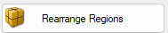
Make Regions No Rez is a security feature. It sets all parcels to no Script, No Rez for visitors. This happens automatically when you load an OAR.
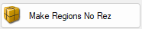
Announce Visitors: This is a global enable. Visitors that arrive in a region are chatted using Opensimulator’s Concierge module. The region must also have an override for “Announce Visitors” in the Modules section of the Region settings.
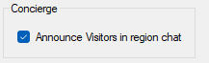
Chat Channel: The chat channel controls the distance each chat type stops working.
Clear Satyr Farm will delete all loose Satyr Farm items such as Tomato buckets or Water cans from any chosen region.
Bulk load is a form where you can load large numbers of oars at one time.
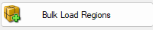

Troubleshooting:
Region Error: if you add a region where another already exists, you may get this error.
2021-03-27 09:53:51,132 ERROR [GRID CONNECTOR]: Registration failed: Region overlaps another region when contacting http://192.168.2.139:8003/grid
2021-03-27 09:53:51,137 ERROR [STARTUP]: Registration of region with grid failed, aborting startup due to Region overlaps another region at OpenSim.Region.Framework.Scenes.Scene.RegisterRegionWithGrid() in C:\Opensim\Outworldz_Dreamgrid\OutworldzFiles\Opensim\OpenSim\Region\Framework\Scenes\Scene.cs:line 2384
at OpenSim.OpenSimBase.CreateRegion(RegionInfo regionInfo, Boolean portadd_flag, Boolean do_post_init, IScene& mscene) in C:\Opensim\Outworldz_Dreamgrid\OutworldzFiles\Opensim\OpenSim\Region\Application\OpenSimBase.cs:line 499
Robust says:
09:59:23 - [GRID SERVICE]: Register region conflict in scope 00000000-0000-0000-0000-000000000000. Region overlaps another region
You can click the Deregister regions button to clear these.
Another solution is to deregister it by hand. Go to robust and type this:
show regions < enter>
You get a list of all regions.
R.O.B.U.S.T.# show regions
Name ID Position Size Flags
Region 1016, 1007 0e871ad3-41ec-4eb5-8aad-96d9b5561803 1016,1007 256x256 RegionOnline
Region 1017, 1010 0f75a6ba-bbc0-4489-846d-a3aaa286c3ae 1017,1010 256x256 RegionOnline
Region 1017, 1008 1b47af46-9364-4cde-909c-a3173d98291f 1017,1008 256x256 RegionOnline
Region 1015, 1007 2302b841-11d3-4c2c-9ebb-0fce4c26beea 1015,1007 256x256 RegionOnline
Region 1013, 1009 4e69b298-c084-466f-b450-f34fbffa2238 1013,1009 256x256 RegionOnline
Region 1015, 1009 74f9d745-fa42-450b-96e5-0770eae37928 1015,1009 256x256 RegionOnline
Region 1016, 1009 a357ccd6-43d6-45ff-8563-35f09345908e 1016,1009 256x256 RegionOnline
Region 1017, 1007 c8775e97-ae1d-4164-8db8-ec205e46a148 1017,1007 256x256 RegionOnline
Welcome c91ceea4-77f5-40f6-afad-36f822097a4d 1016,1008 256x256 DefaultRegion, RegionOnline, DefaultHGRegion
Region 1015, 1008 dce9b253-789f-497a-b040-7df958262c69 1015,1008 256x256 RegionOnline
Region 1017, 1009 e819b0f7-86d7-4391-9064-67f6cb8708cd 1017,1009 256x256 RegionOnline
Region 1016, 1017 eab4f2bb-c92f-42fe-be92-30b29ba5a61b 1016,1017 256x256 RegionOnline
Find the region at the same coordinates as the one you are trying to boot. The one that is conflicting on my test server is this one at 10156,1009
Region 1016, 1009 a357ccd6-43d6-45ff-8563-35f09345908e 1016,1009 256x256 RegionOnline
This UUID is different than the one there previously. So it will not let the new region steal it.
Copy the UUID from, above: a357ccd6-43d6-45ff-8563-35f09345908e
Type in this:
deregister region id <PASTE UUID HERE>
R.O.B.U.S.T.# deregister region id a357ccd6-43d6-45ff-8563-35f09345908e
Deregistered Region 1016, 1009 a357ccd6-43d6-45ff-8563-35f09345908e
R.O.B.U.S.T.#

