You need to install Google Drive Client (this is very convenient to automatic download your result). Your need install “gdal”, ”pandas”, “GEE” package in your Python.

**get_NLDAS_to_Driver.py**

1. **You can change the date for download.**



1. **You need to put your shape file in the folder “shape”**

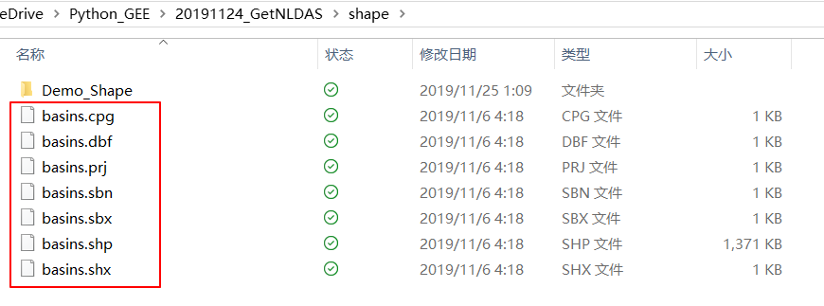

1. **Change your shape name in the code.**



1. **Change the folder name of your Google Drive in the code.**

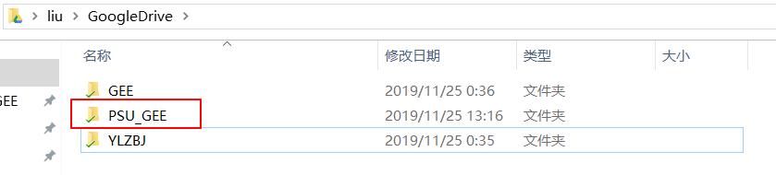

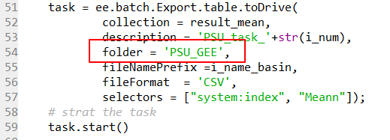

**Click “run”, you can get the results in Google Drive (1 year data is about 2 hours, which depends on how many people are using GEE. Sometime it is just half hour)**

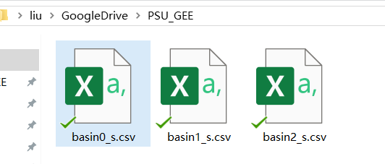

**read_CSV.py**

**1. You need to put all csv files in the folder ”_csv”**

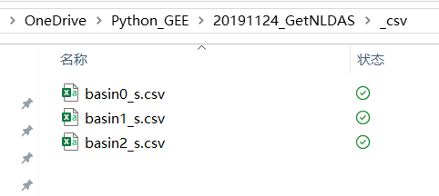

**or change the code**





**2.You can add, delete or adjust the order of features, which depends on your final txt.**



**3.You can change decimal points.**



