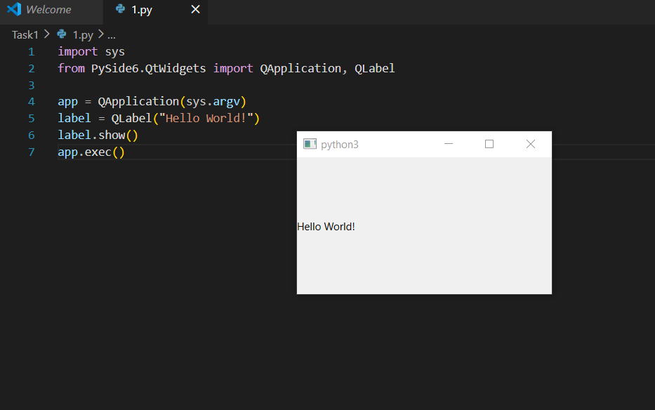

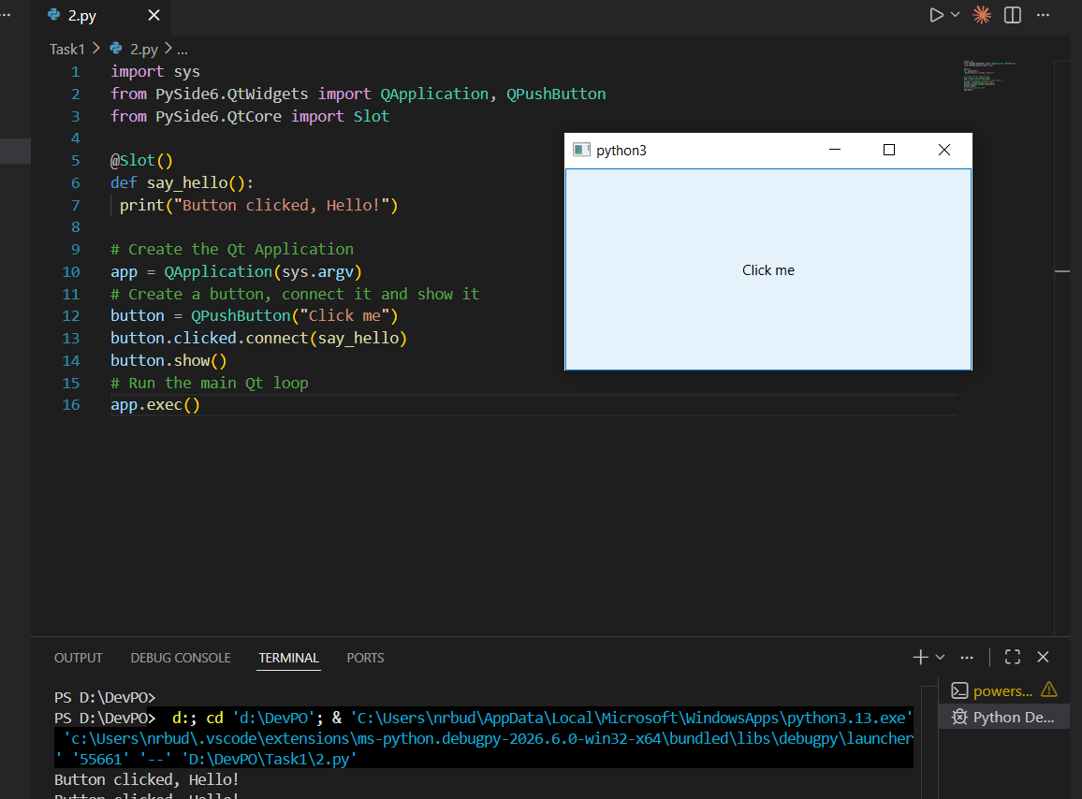

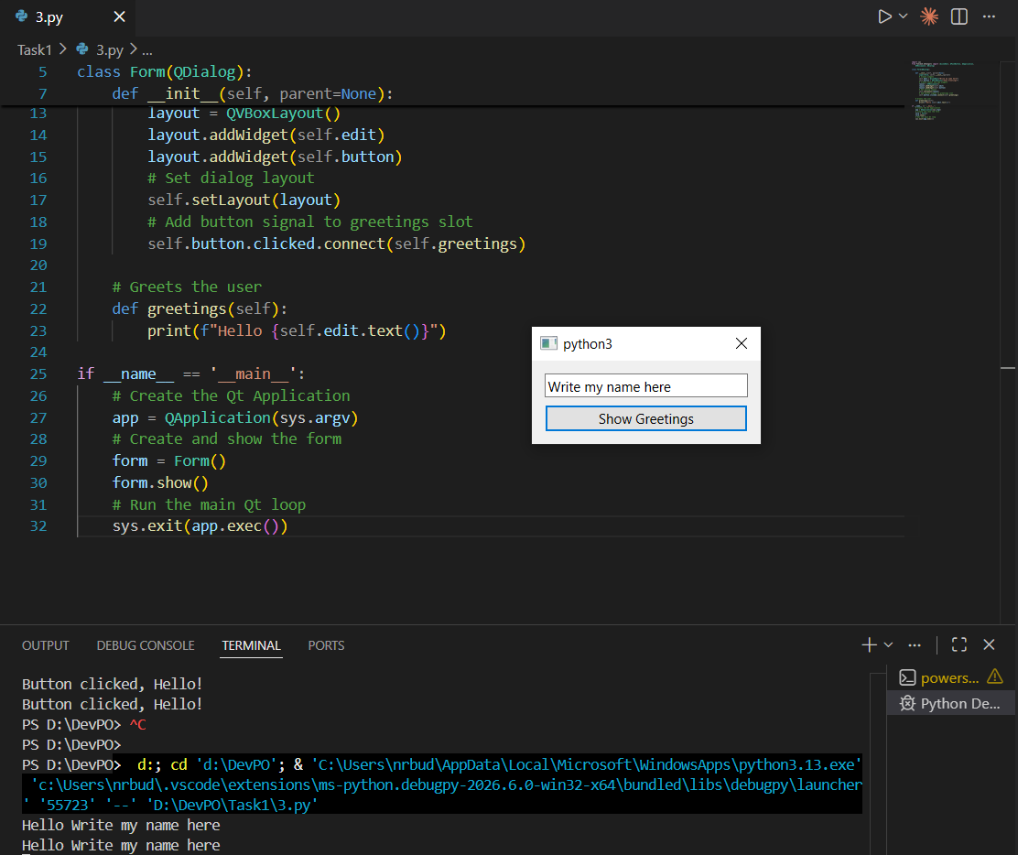

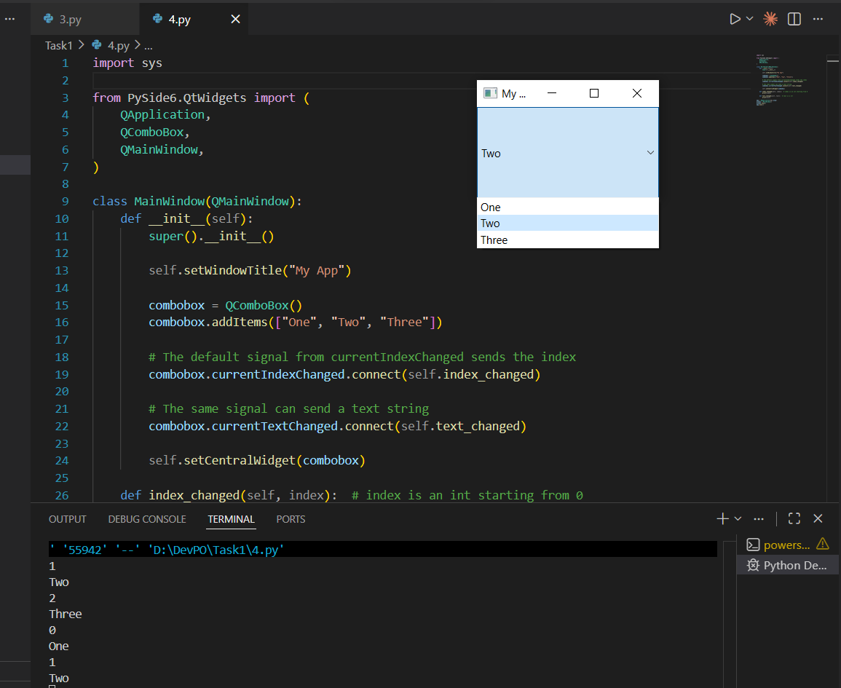

2.
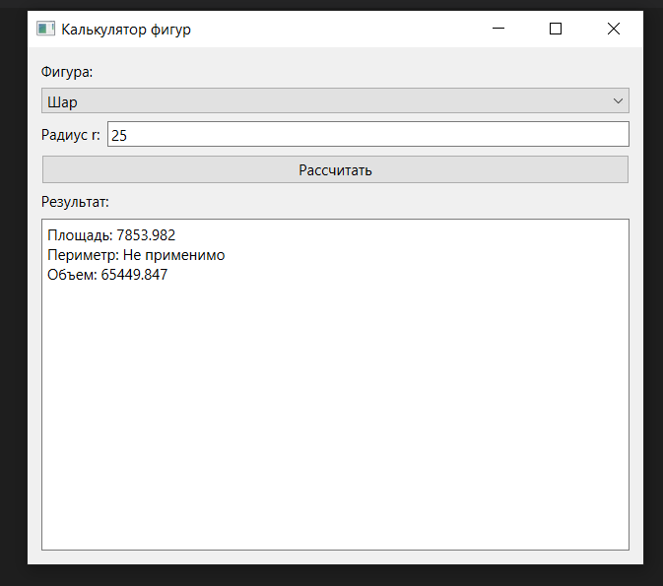

Код
import sys
from math import pi

from PySide6.QtWidgets import (
QApplication,
QComboBox,
QFormLayout,
QLabel,
QLineEdit,
QMessageBox,
QPushButton,
QVBoxLayout,
QWidget,
QTextEdit,
)

class ShapeCalculator(QWidget):
def __init__(self):
super().__init__()
self.setWindowTitle("Калькулятор фигур")
self.resize(500, 420)

self.shape_combo = QComboBox()
self.shape_combo.addItems(["Круг", "Квадрат", "Треугольник", "Куб", "Шар"])

self.input_layout = QFormLayout()
self.fields = {}

self.calculate_button = QPushButton("Рассчитать")
self.calculate_button.clicked.connect(self.calculate)

self.result_box = QTextEdit()
self.result_box.setReadOnly(True)
self.result_box.setPlainText("Выберите фигуру и введите данные.")

main_layout = QVBoxLayout(self)
main_layout.addWidget(QLabel("Фигура:"))
main_layout.addWidget(self.shape_combo)
main_layout.addLayout(self.input_layout)
main_layout.addWidget(self.calculate_button)
main_layout.addWidget(QLabel("Результат:"))
main_layout.addWidget(self.result_box)

self.shape_combo.currentIndexChanged.connect(self.update_fields)
self.update_fields()

def update_fields(self):
shape = self.shape_combo.currentText()

for i in range(self.input_layout.count()):
item = self.input_layout.takeAt(0)
widget = item.widget()
if widget is not None:
widget.deleteLater()

self.fields.clear()

if shape == "Круг":
params = [("Радиус r:", "r")]
elif shape == "Квадрат":
params = [("Сторона a:", "a")]
elif shape == "Треугольник":
params = [
("Основание a:", "a"),
("Высота h:", "h"),
("Сторона b:", "b"),
("Сторона c:", "c"),
]
elif shape == "Куб":
params = [("Ребро a:", "a")]
elif shape == "Шар":
params = [("Радиус r:", "r")]
else:
params = []

for label_text, key in params:
line_edit = QLineEdit()
line_edit.setPlaceholderText("Введите число")
self.input_layout.addRow(label_text, line_edit)
self.fields[key] = line_edit

def parse_number(self, key, required=True):
value = self.fields[key].text().strip().replace(",", ".")
if value == "":
if required:
raise ValueError(f"Поле '{key}' не заполнено.")
return None
try:
return float(value)
except ValueError as exc:
raise ValueError(f"Поле '{key}' должно быть числом.") from exc

def calculate(self):
shape = self.shape_combo.currentText()

try:
if shape == "Круг":
r = self.parse_number("r")
area = pi * r ** 2
perimeter = 2 * pi * r
volume = "Не применимо"
result = (
f"Площадь: {area:.3f}\n"
f"Периметр: {perimeter:.3f}\n"
f"Объем: {volume}"
)

elif shape == "Квадрат":
a = self.parse_number("a")
area = a ** 2
perimeter = 4 * a
volume = "Не применимо"
result = (
f"Площадь: {area:.3f}\n"
f"Периметр: {perimeter:.3f}\n"
f"Объем: {volume}"
)

elif shape == "Треугольник":
a = self.parse_number("a")
h = self.parse_number("h")
b = self.parse_number("b")
c = self.parse_number("c")
area = (a * h) / 2
perimeter = a + b + c
volume = "Не применимо"
result = (
f"Площадь: {area:.3f}\n"
f"Периметр: {perimeter:.3f}\n"
f"Объем: {volume}"
)

elif shape == "Куб":
a = self.parse_number("a")
area = 6 * a ** 2
perimeter = 12 * a
volume = a ** 3
result = (
f"Площадь: {area:.3f}\n"
f"Периметр: {perimeter:.3f}\n"
f"Объем: {volume:.3f}"
)

elif shape == "Шар":
r = self.parse_number("r")
area = 4 * pi * r ** 2
perimeter = "Не применимо"
volume = 4 / 3 * pi * r ** 3
result = (
f"Площадь: {area:.3f}\n"
f"Периметр: {perimeter}\n"
f"Объем: {volume:.3f}"
)
else:
result = "Выберите фигуру."

self.result_box.setPlainText(result)

except ValueError as exc:
QMessageBox.critical(self, "Ошибка", str(exc))

def main():
app = QApplication(sys.argv)
window = ShapeCalculator()
window.show()
sys.exit(app.exec())

if __name__ == "__main__":
main()

