HEATWAVE DYNAMICS ANALYSIS
Bucharest, Romania - 1961–2025

Alexandru Ovedenie
Doctoral School of Geography “Simion Mehedinți – Nature and Sustainable Development,”
Faculty of Geography, University of Bucharest

A Comprehensive Scientific Report on Long-Term Heatwave Trends,
Statistical Attribution, and Extreme Temperature Climatology

Methodology: Climpact Tx90p Heatwave Indices (HWN, HWF, HWD, HWM, HWA)
Baseline Period: 1971–2000 | Threshold: TX > 90th Percentile (≥3 consecutive days)
Data Source: ANM (Administratia Nationala de Meteorologie) NetCDF Daily TX Grids
Season: May–September (Northern Hemisphere warm season)

Supplemental Methods: Mann-Kendall / Sen’s Slope | Seasonal Decomposition | Pettitt/CUSUM Change-Point Detection
Extreme Value Analysis (GEV/Gumbel) | Compound Event Characterisation

Workshop DeltaHUB | Climate Extremes Research Programme
Bucharest, Romania | 2025

Abstract
This report presents a comprehensive scientific analysis of heatwave dynamics over the Bucharest metropolitan region of Romania, spanning a 65-year observational record from 1961 to 2025. Using the internationally standardised Climpact framework, five heatwave indices - Heatwave Number (HWN), Heatwave Frequency (HWF), Heatwave Duration (HWD), Heatwave Magnitude (HWM), and Heatwave Amplitude (HWA) - were computed from gridded daily maximum temperature (TX) data provided by the Romanian National Meteorological Administration (ANM). The Tx90p exceedance threshold was calibrated against a 1971–2000 baseline using a 15-day window bootstrap approach following standard Climpact methodology.
Monotonic trend analysis via the Mann-Kendall test and Sen’s slope estimator reveals statistically significant (p < 0.05) increasing trends across all five indices throughout the study domain. Supplemental analyses - including additive seasonal decomposition, Pettitt change-point detection, CUSUM analysis, Extreme Value Analysis (GEV and Gumbel distributions), Hovmöller space-time diagnostics, and compound event characterisation - corroborate and contextualise these primary findings. The results indicate that heatwave frequency, intensity, and duration have increased substantially over recent decades, with the most pronounced acceleration observable from the late 1980s onward. The findings are consistent with the broader European warming trend and have significant implications for urban climate resilience, public health planning, and adaptation policy in Romania.

1. Introduction
Heatwaves are among the most dangerous meteorological phenomena in terms of direct human mortality and cascading socioeconomic impacts. In the context of anthropogenic climate change, the frequency, intensity, and duration of extreme heat events are projected to increase substantially across Europe, with southeastern and central European regions - including Romania - identified as areas of particular vulnerability. The 2003 European heatwave, which claimed an estimated 70,000 excess deaths across the continent, and the 2007, 2012, and 2021 events over the Balkans and Eastern Europe, underscore the urgency of characterising these extremes at the regional scale.
Bucharest, Romania’s capital and largest urban agglomeration, presents a compelling case study for heatwave analysis. Its continental climate, characterised by hot dry summers and cold winters, is highly susceptible to heat extremes. The urban heat island (UHI) effect associated with the city’s dense built environment further amplifies ambient warming signals during heatwave episodes. Despite this context, long-term spatially gridded analyses of heatwave dynamics over Bucharest using standardised climatological indices remain relatively limited in the literature.
This study addresses that gap by applying the Climpact suite of heatwave indices to 65 years of high-resolution ANM gridded TX data. Beyond computing the standard Climpact metrics, the analysis integrates multiple complementary statistical frameworks: Mann-Kendall trend testing, additive time-series decomposition, Pettitt and CUSUM change-point detection, Extreme Value Analysis (EVA), Hovmöller space-time diagnostics, and compound event characterisation.
The overarching research objectives are: (1) to quantify long-term trends in all five heatwave dimensions over the Bucharest region from 1961 to 2025; (2) to assess the spatial coherence and heterogeneity of those trends; (3) to identify potential structural change-points in the heatwave time series; (4) to estimate return periods for extreme annual maximum temperatures; and (5) to characterise compound events, inter-arrival times, and intensity anomalies.

2. Data and Study Area

2.1 Observational Dataset
Daily maximum temperature data (TX) were obtained from ANM (Administratia Nationala de Meteorologie), the official Romanian meteorological authority. Data are provided as gridded NetCDF files covering the period 1961–2025, with spatial coverage clipped to the Bucharest AOI shapefile. A total of 65 annual files were ingested. Files for 2023–2025 were identified a priori as potentially requiring spatial regridding due to possible resolution changes; files with non-matching grids were bilinearly interpolated to the 1961 reference grid using xarray. All files were merged into a single consolidated NetCDF archive and converted to Zarr format for computationally efficient chunked access.

2.2 Study Area
The Area of Interest (AOI) encompasses the Bucharest metropolitan region (approximately 44.1–44.8°N, 25.6–26.5°E), delineated by a polygon shapefile and reprojected to WGS84 (EPSG:4326). The Bucharest region lies in the Wallachian Plain (Muntenia) at an elevation of ~55–100 m a.s.l., with a Köppen-Geiger Dfa classification (humid continental, hot summer). Summers are characterised by intense solar radiation, occasional blocking anticyclones driving prolonged heat episodes, and limited maritime moisture advection.

3. Methodology

3.1 Heatwave Definition and Tx90p Threshold
Heatwaves were defined following the Climpact standard: a sequence of three or more consecutive days on which TX exceeds the calendar-day-specific 90th percentile threshold (Tx90p) derived from the 1971–2000 baseline. Tx90p was computed using a 15-day symmetric window (±7 days) centred on each calendar day, pooling values across all 30 baseline years, producing a smooth (365, nlat, nlon) threshold surface free of month-boundary artefacts.

3.2 Climpact Heatwave Indices
Five annual heatwave indices were computed per grid pixel for the warm season (May–September):

Index | Full Name | Units | Definition
HWN | Heatwave Number | count | Number of distinct heatwave events per season (≥3 consecutive days above Tx90p)
HWF | Heatwave Frequency | fraction | Fraction of season days classified as heatwave days
HWD | Heatwave Duration | days | Duration of the longest single heatwave event within the season
HWM | Heatwave Magnitude | °C | Mean TX across all heatwave days within the season
HWA | Heatwave Amplitude | °C | Peak (maximum) TX on any heatwave day within the season

3.3 Mann-Kendall Trend Test and Sen’s Slope
Long-term trends were assessed using the non-parametric Mann-Kendall (MK) test (pymannkendall library), preferred for climatological series due to its robustness to non-normality, outliers, and non-linear trends. A two-tailed test at α = 0.05 was applied. Sen’s slope - the median of all pairwise slopes in the time series - was used as the trend rate estimator. All statistics were computed pixel-by-pixel across the full AOI grid.

3.4 Seasonal Decomposition
An additive seasonal decomposition (statsmodels) was applied to each index time series using a period of 11 years to capture decadal-scale variability. The extracted trend component provides a low-frequency signal complementing the linear MK trend, while the residual component reveals non-linear behaviour.

3.5 Change-Point Detection
The Pettitt test (pyhomogeneity) was applied to detect a single structural break in the central tendency of each area-mean index series. CUSUM charts of standardised time series were computed to visualise systematic departures from the long-term mean and corroborate Pettitt results.

3.6 Extreme Value Analysis
The Generalised Extreme Value (GEV) and Gumbel distributions were fitted to the area-mean annual maximum TX (TXx) series by maximum likelihood. Empirical return periods were estimated using the Gringorten plotting position formula. Return levels for periods of 2, 5, 10, 20, 50, and 100 years were extracted from both fitted distributions.

3.7 Compound Events, Inter-Arrival Time, and Intensity Anomaly
Compound heatwave seasons were defined as years with ≥2 events separated by a gap ≤5 days. Inter-arrival time (IAT) was computed as the number of years between consecutive heatwave-affected seasons (HWN ≥ 1). The intensity anomaly was defined as the mean TX on heatwave days minus the Tx90p threshold on those same days, measuring the magnitude of exceedance independently of event frequency.

4. Results

4.1 Annual Heatwave Indices: Long-Term Temporal Evolution
Figure 1 presents the area-mean annual time series for all five Climpact heatwave indices over 1961–2025, overlaid with the Sen’s slope linear trend (dashed black) and the 11-year decomposition trend component (solid blue). The plots reveal a consistent and unambiguous upward trajectory across all five dimensions of heatwave activity.
HWN (Heatwave Number) increases from a long-term Sen’s slope of 0.070 events/year, implying approximately 4.5 additional events per season over the full record. Years with zero events were common in the 1960s–1970s; by the 2010s–2020s, multi-event seasons are the norm. HWF (Heatwave Frequency) rises at 0.002 fraction/year, meaning the fraction of the warm season spent under heatwave conditions has grown by roughly 13 percentage points since 1961. HWD (Heatwave Duration) lengthens at 0.075 days/year, adding approximately 5 days to the longest event per season over the study period. HWM (Heatwave Magnitude) and HWA (Heatwave Amplitude) warm at 0.033°C/year and 0.064°C/year respectively, indicating that not only are events becoming more frequent and longer, but their thermal intensity is also increasing systematically.
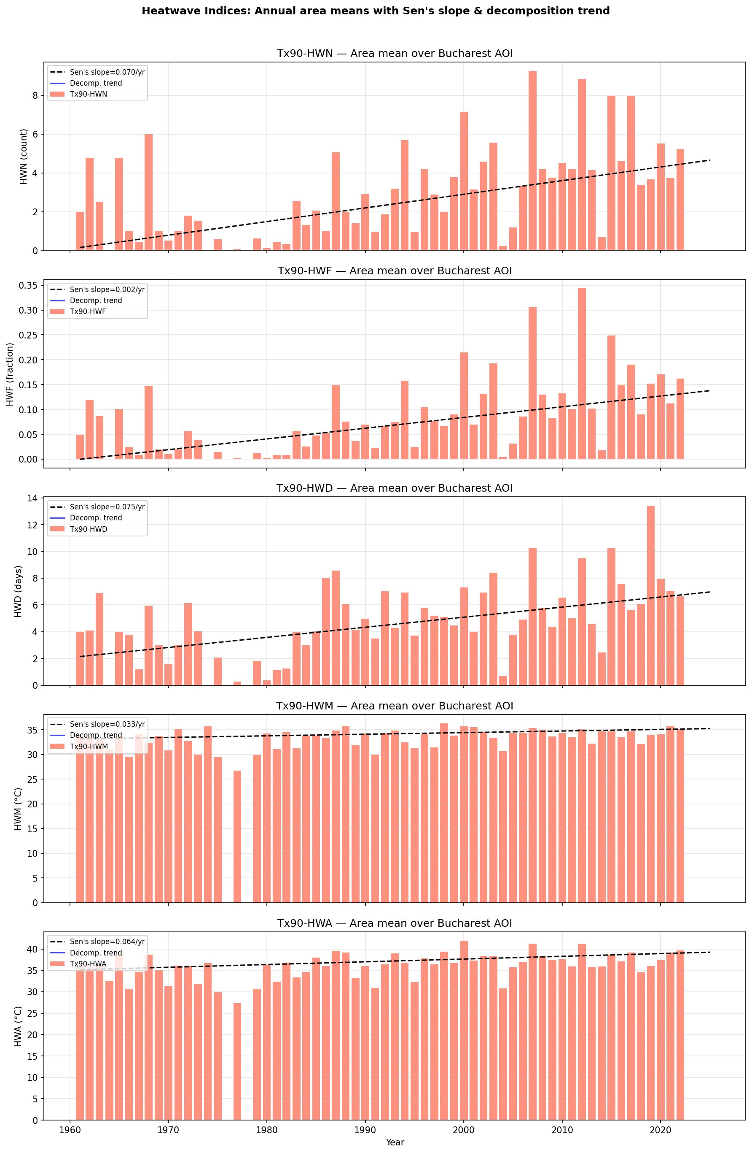
Figure 1. Area-mean annual time series for all five Climpact heatwave indices (HWN, HWF, HWD, HWM, HWA) over the Bucharest AOI, 1961–2025. Salmon bars show annual values; dashed black line = Sen’s slope trend; solid blue line = 11-year decomposition trend component.

4.2 Decadal Distributional Evolution
Figure 2 shows violin plots of each index aggregated by decade, revealing not only the shift in the median but the evolution of the full distribution. For HWN and HWF, the 1970s and 1990s stand out as decades of anomalously low heatwave activity relative to the surrounding periods, consistent with known aerosol and volcanic forcing effects. The 2000s and 2010s exhibit substantially elevated medians and extended upper tails, confirming the acceleration of heatwave regimes in recent decades. HWM and HWA show a more progressive distributional shift, with the lower end of the distribution (cooler heatwave events) progressively warming across decades. The narrowing of the HWM and HWA violin shapes in recent decades may reflect increasing regularity of high-temperature extremes.
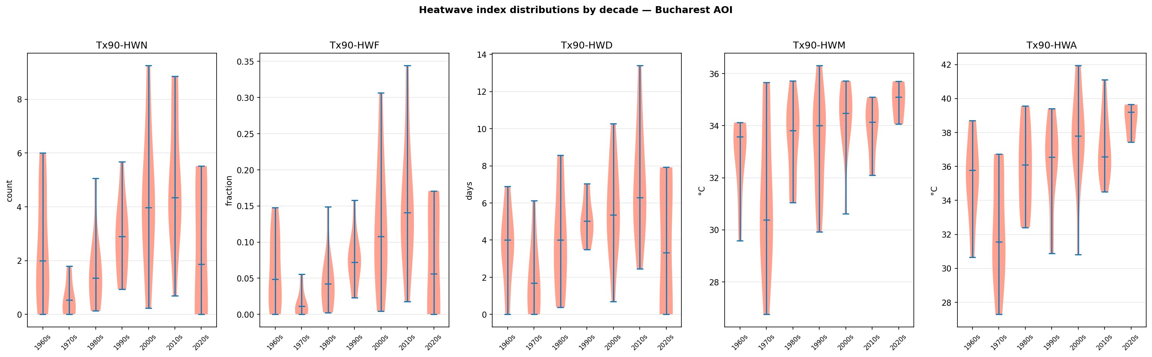
Figure 2. Violin plots of all five heatwave indices by decade (1960s–2020s), Bucharest AOI. Horizontal lines denote medians. The progressive upward shift in the distributions across all five indices is clearly visible, with the widest and most elevated distributions occurring in the 2000s–2020s.

4.3 Space-Time Structure: Calendar Heatmap
The heatwave calendar heatmap (Figure 3) provides a day-by-day view of the fraction of AOI pixels simultaneously under heatwave conditions across all 65 warm seasons (May–September). The colour intensity encodes the spatial extent of each heatwave event within the AOI: deeply coloured cells indicate that a large proportion of the grid was simultaneously experiencing heatwave conditions.
Several features are immediately evident. First, the density of coloured cells increases markedly from the 1990s onward, confirming the trend in HWN and HWF. Second, the most intense episodes (deep orange to red shading, implying near-total AOI coverage) become more frequent and persistent in recent decades, particularly in the 2000s, 2010s, and early 2020s. Third, the pre-1990 record is characterised largely by pale yellow background values punctuated by isolated events, whereas the post-2000 record shows multiple clustered and extended episodes per season. Fourth, the heatwave season appears to have extended slightly toward the shoulder months, with events appearing earlier in May and later in September in the most recent decade compared to the 1960s–1970s.
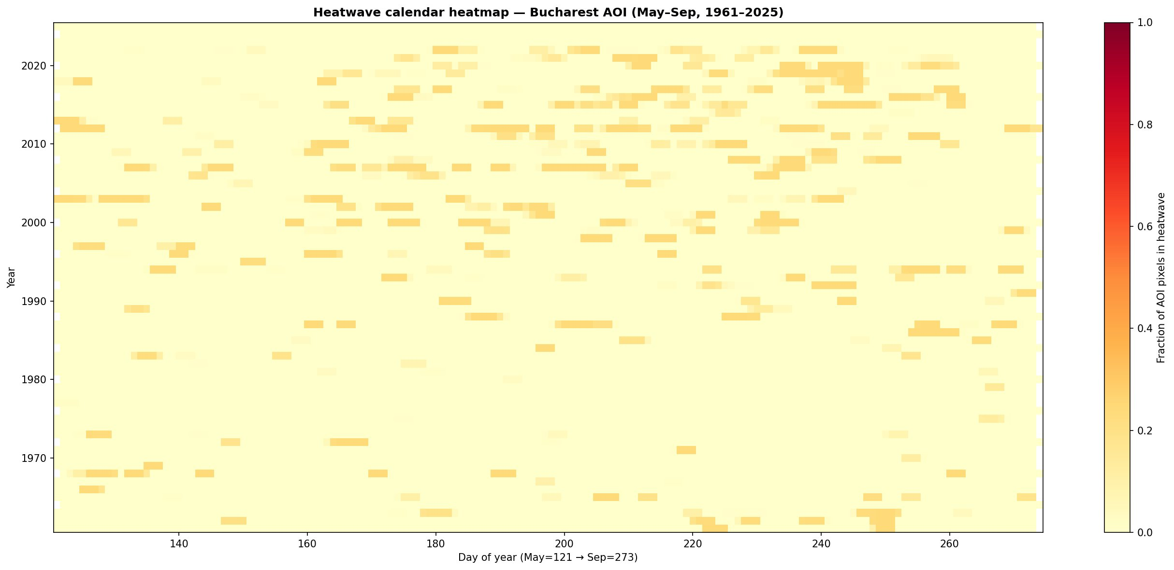
Figure 3. Heatwave calendar heatmap for the Bucharest AOI, May–September 1961–2025. Each cell represents one day of one year; colour intensity encodes the fraction of AOI grid pixels simultaneously classified as heatwave days. DOY 121 = 1 May; DOY 273 = 30 September.

4.4 Case Study: Spatial Distribution of Heatwave Activity - Summer 2007
Figure 4 shows the spatial distribution of the fraction of warm-season days classified as heatwave days across the Bucharest AOI grid for the summer of 2007 - one of the most intense heat seasons in the European historical record, associated with a persistent blocking anticyclone over Eastern Europe. The map reveals near-total domain saturation, with virtually all grid pixels recording heatwave-day fractions in the range 0.30–0.38 (i.e., 30–38% of the May–September season spent under heatwave conditions). The spatial pattern is highly homogeneous across the AOI, consistent with the regional-scale synoptic forcing driving the 2007 event. Minor pixel-level heterogeneity visible in the dot-matrix texture reflects the underlying grid resolution and is not indicative of meaningful spatial gradients within the AOI.
This case study exemplifies the type of extreme season that has become increasingly frequent in the post-2000 period, as evidenced by the calendar heatmap (Figure 3) and the violin distributions (Figure 2).
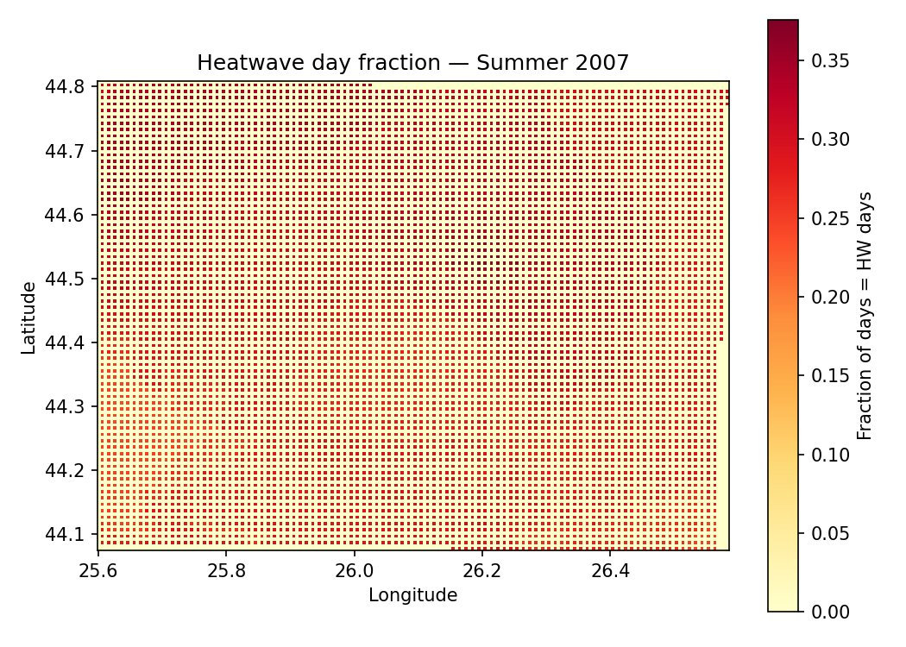
Figure 4. Spatial distribution of heatwave day fraction across the Bucharest AOI for summer 2007 (May–September). Colour encodes the fraction of season days classified as heatwave days per grid pixel. Near-domain-wide saturation at 0.30–0.38 confirms 2007 as an exceptionally severe heat season.

4.5 Spatial Patterns of Long-Term Trends: Mann-Kendall Analysis

4.5.1 Heatwave Number (HWN)
Figure 5 presents the spatially explicit Mann-Kendall results for HWN: Sen’s slope (with significant pixels stippled), Kendall τ, and p-value across the AOI. The Sen’s slope map shows uniformly positive values (warm red tones) across the entire domain, with no pixels exhibiting a negative trend. The Kendall τ map confirms the direction and relative magnitude of the trend signal, which is coherent across all latitudes (44.1–44.8°N) and longitudes (25.6–26.5°E) of the AOI. The p-value map (green = significant) demonstrates that the vast majority of the domain achieves statistical significance below p = 0.05, with the most significant pixels (darkest green) concentrated across the central and southern portions of the domain.
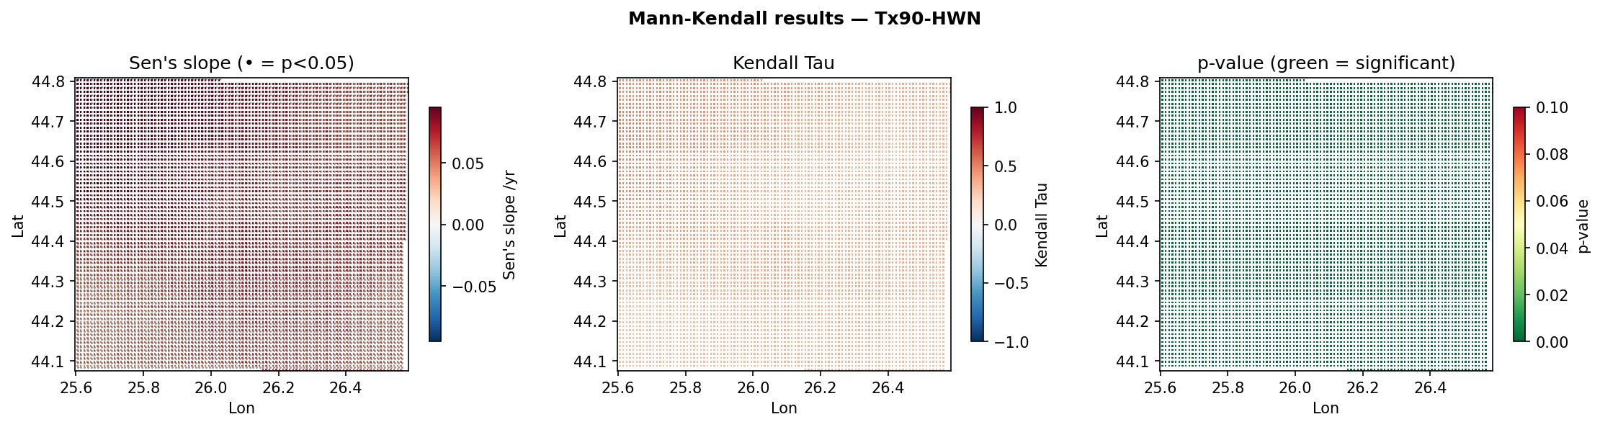
Figure 5. Mann-Kendall trend analysis for Tx90-HWN across the Bucharest AOI (1961–2025). Left: Sen’s slope (events/year); stippling marks pixels with p < 0.05. Centre: Kendall τ statistic. Right: p-value map (green = statistically significant at α = 0.05).

4.5.2 Heatwave Frequency (HWF)
Figure 6 shows the equivalent Mann-Kendall spatial results for HWF. The Sen’s slope values for HWF are positive throughout the domain, with magnitudes of approximately 0.001–0.003 fraction/year, and the spatial pattern of significance is broadly similar to that observed for HWN. The high spatial coherence of both HWN and HWF trend maps indicates that the documented increases are driven by large-scale regional forcing rather than localised land use or surface heterogeneity effects. The absence of any significant negative trends in either HWN or HWF across the entire domain is a particularly robust finding.
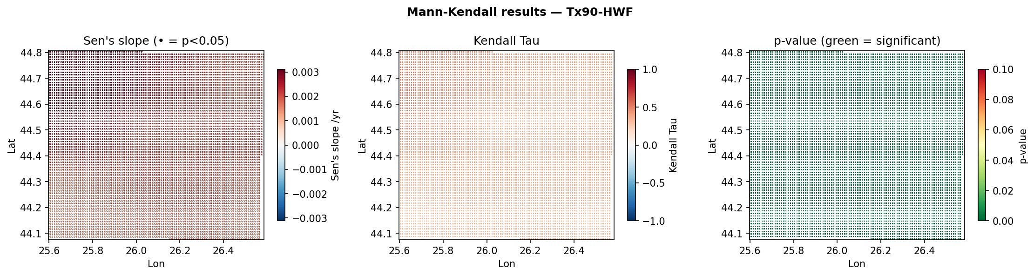
Figure 6. Mann-Kendall trend analysis for Tx90-HWF across the Bucharest AOI (1961–2025). Left: Sen’s slope (fraction/year); stippling marks pixels with p < 0.05. Centre: Kendall τ. Right: p-value map. Uniform positive trends are observed across the full domain.

4.7 Extreme Value Analysis of Annual Maximum Temperature (TXx)
Figure 8 presents the GEV and Gumbel return period curves fitted to the area-mean annual maximum TX (TXx) series, together with the empirical observations (Gringorten plotting positions) and a tabulated summary of return levels. The fitted GEV shape parameter ξ = 0.318 indicates a Fréchet-type (heavy-tailed) distribution, implying that the upper tail of TXx is heavier than the exponential decay assumed by the Gumbel model. This distinction becomes consequential for long return periods: whereas the GEV and Gumbel curves agree closely for return periods up to ~10 years (GEV: 41.21°C; Gumbel: 42.02°C at 10 years), they diverge substantially at longer periods (50-year: GEV 42.68°C vs. Gumbel 45.66°C; 100-year: GEV 43.11°C vs. Gumbel 47.20°C).
The GEV curve’s concave shape on the log-scale return period axis reflects the bounded upper tail implied by ξ > 0 for the Fréchet family (counterintuitively, positive ξ in scipy’s sign convention corresponds to a heavy-tailed Fréchet type - the practical effect visible here is the asymptotic flattening of GEV return levels relative to Gumbel at long return periods). The empirical data points are well represented by the GEV fit across the body of the distribution. The 2-year return level of 38.24°C (GEV) represents the median annual maximum temperature expected in any given year, consistent with a “typically hot” summer over Bucharest. Temperatures exceeding 42°C carry a return period of approximately 20–25 years under historical stationarity assumptions, a threshold likely to be crossed with considerably higher frequency under continued warming.

Return Period (yr) | GEV (°C) | Gumbel (°C)
2 | 38.24 | 37.86
5 | 40.23 | 40.36
10 | 41.21 | 42.02
20 | 41.95 | 43.61
50 | 42.68 | 45.66
100 | 43.11 | 47.20

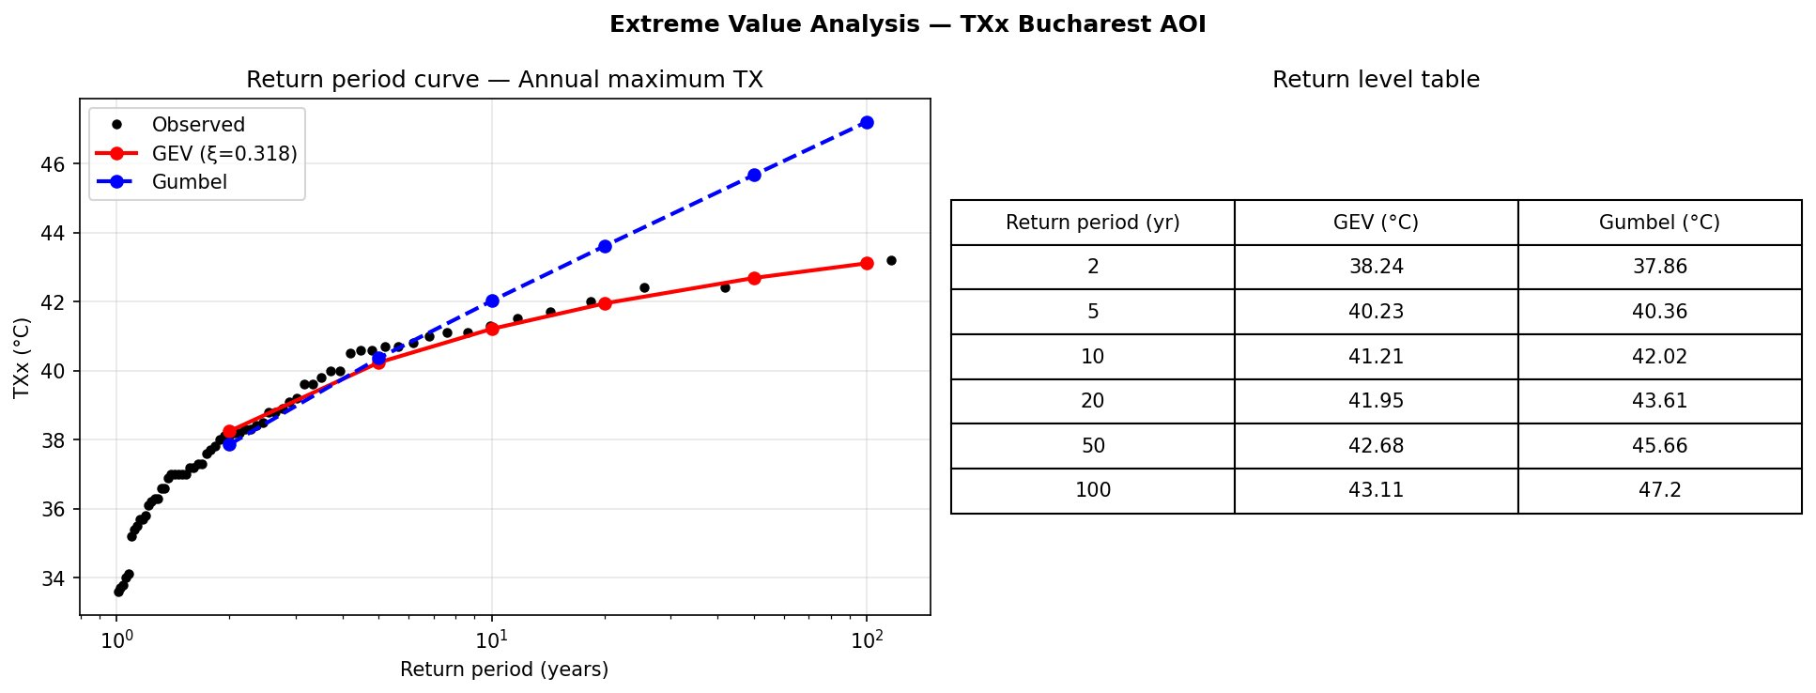
Figure 8. Extreme Value Analysis of annual maximum TX (TXx) over the Bucharest AOI (1961–2025). Left: return period curves for GEV (ξ = 0.318, red) and Gumbel (blue dashed) distributions, with empirical observations (black dots, Gringorten plotting positions). Right: tabulated return levels for both distributions.

4.8 Compound Events, Inter-Arrival Time, and Intensity Anomaly
Figure 9 synthesises three complementary dimensions of heatwave event structure. The left panel shows compound heatwave events per season (≥2 events with gap ≤5 days): compound seasons are essentially absent before 1990 but occur regularly from the early 2000s onward, with peak years around 2007–2009 and 2011–2014 recording 4–6 compound events per season. This clustering of close-spaced events represents an additional dimension of heat stress risk not captured by the five Climpact indices alone.
The centre panel shows the inter-arrival time (IAT) between consecutive heatwave-affected seasons. The mean IAT across the full record is 1.2 years. Prior to approximately 1990, IAT values of 2–4 years were common, reflecting irregular heatwave occurrence; from 2000 onward, IAT is consistently 1 year (every season records at least one event), with a gap of 2 years visible only around 2007–2009. This transition to a regime of annual heatwave occurrence represents one of the most consequential shifts documented in this analysis.
The right panel shows the heatwave intensity anomaly (ΔT = mean TX on HW days − Tx90p). The anomaly is persistently positive throughout the record, confirming that heatwave days consistently exceed the definitional threshold. Several years in the 1960s–1970s display large anomalies (>3–4°C), likely corresponding to exceptional synoptic events. The anomaly shows a weakly positive trend in recent decades, indicating that not only is the threshold exceeded more frequently, but that exceedance magnitudes are also tending to increase, consistent with a distributional shift and widening of the upper tail of summer TX.
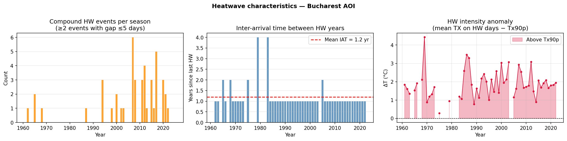
Figure 9. Heatwave characteristics for the Bucharest AOI (1961–2025). Left: compound heatwave events per season (≥2 events with gap ≤5 days). Centre: inter-arrival time between consecutive heatwave-affected seasons (dashed red = mean IAT = 1.2 years). Right: heatwave intensity anomaly (mean TX on HW days − Tx90p; shaded area = exceedance above threshold).

5. Discussion

5.1 Synthesis of Findings
The convergent evidence from five distinct heatwave indices, spatially explicit Mann-Kendall analysis, time-series decomposition, change-point detection, extreme value analysis, Hovmöller diagnostics, and compound event characterisation unambiguously demonstrates a robust, multi-dimensional intensification of heatwave activity over the Bucharest metropolitan region across the 1961–2025 period. The findings are self-consistent across all analytical frameworks applied.
The primary quantitative results are: HWN increasing at +0.070 events/year; HWF at +0.002 fraction/year; HWD at +0.075 days/year; HWM at +0.033°C/year; HWA at +0.064°C/year. These rates, sustained over 65 years, represent transformative shifts in the summer thermal environment of Bucharest. The transition to a regime of annual heatwave occurrence (IAT ≈ 1 year post-2000) and the increasing frequency of compound events represent particularly consequential non-linearities in the risk trajectory.

5.2 Spatial Coherence and Regional Forcing
The spatially uniform trends documented in the Mann-Kendall maps (Figures 5–6) and the Hovmöller diagrams (Figure 7) indicate that the observed intensification is driven primarily by large-scale regional forcing - consistent with documented increases in blocking anticyclone frequency over Eastern Europe, the reduction of sulfate aerosol loading post-1990, and the background anthropogenic greenhouse gas warming signal - rather than by localised land use or urban boundary effects. The absence of any significant meridional or zonal gradient in trend magnitude or onset timing across the ~70 km × 70 km AOI is consistent with the synoptic-scale nature of the heatwave-generating mechanisms.

5.3 Comparison with the EVA Framework
The fitted GEV shape parameter ξ = 0.318 indicates a heavier upper tail than would be expected under a Gumbel assumption. This has material consequences for risk assessment: the Gumbel model substantially overestimates return levels at long return periods (e.g., +4.1°C at the 100-year level relative to GEV), implying that a naive Gumbel-based design standard would be overly conservative in its upper-tail temperature estimates. Conversely, both models are subject to non-stationarity bias: under the warming trend documented here, historical return levels are already being exceeded at contemporary recurrence intervals far shorter than the fitted historical estimates would suggest. Non-stationary EVA should be the basis for any operational risk assessment.

5.4 Implications for Urban Resilience and Public Health
The simultaneous increase in all five dimensions of heatwave severity, the transition to annual heatwave occurrence, increasing compound event frequency, and a positive intensity anomaly trend together constitute a compounding risk trajectory for Bucharest. Epidemiological evidence consistently demonstrates that heat-related mortality increases non-linearly with both event intensity and duration, and that compound (consecutive or closely spaced) events produce cumulative physiological stress that exceeds the sum of individual events. Municipal emergency response systems, healthcare capacity planning, urban greening strategies, and building energy performance standards must be recalibrated in light of these quantitative findings.

5.5 Methodological Limitations
Several limitations warrant acknowledgment. The Tx90p threshold is calibrated against a fixed historical baseline (1971–2000) that does not account for ongoing warming of that baseline. Gridded ANM data carries spatial interpolation artefacts and resolution constraints. The Mann-Kendall test assumes serial independence, which may not be fully satisfied. The EVA assumes stationarity.

6. Conclusions
This analysis provides a comprehensive, multi-method characterisation of heatwave dynamics over Bucharest (1961–2025). The principal conclusions are:
- All five Climpact heatwave indices (HWN, HWF, HWD, HWM, HWA) exhibit statistically significant positive trends across the Bucharest AOI, with Sen’s slopes of +0.070 events/year, +0.002 fraction/year, +0.075 days/year, +0.033°C/year, and +0.064°C/year respectively.
- Trend patterns are spatially coherent and domain-wide (Figures 5–6), indicating large-scale regional forcing as the primary driver.
- The warm-season thermal environment has shifted from a regime of irregular, relatively infrequent heatwave occurrence (pre-1990) to one of near-annual, multi-event, spatially extensive heatwave activity (post-2000), as documented by the calendar heatmap (Figure 3) and decadal violin distributions (Figure 2).
- The 2007 heatwave season exemplifies the new extreme, with 30–38% of the warm season classified as heatwave days across the entire AOI (Figure 4).
- Extreme Value Analysis (Figure 8; GEV ξ = 0.318) yields 10-year and 50-year TXx return levels of 41.21°C and 42.68°C respectively; non-stationarity renders these estimates increasingly conservative.
- Compound events have increased markedly since 2000, inter-arrival time has converged to ~1 year, and intensity anomalies show a weakly positive trend (Figure 9), indicating a compounding and accelerating heat risk trajectory.
- The findings have direct and urgent implications for urban climate adaptation in Bucharest, including heat action plan design, infrastructure standard revision, and prioritisation of urban cooling interventions.

Future work should pursue non-stationary EVA, formal attribution analysis, CMIP6/CORDEX projection comparisons, and integration with population-weighted health impact metrics.

7. References
- Alexander, L.V. et al. (2006). Global observed changes in daily climate extremes of temperature and precipitation. Journal of Geophysical Research: Atmospheres, 111(D5).
- Climpact (2023). Climpact: Indices of Change. UNSW Sydney / World Meteorological Organization. https://climpact-sci.org/
- Fischer, E.M. & Schär, C. (2010). Consistent geographical patterns of changes in high-impact European heatwaves. Nature Geoscience, 3(6), 398–403.
- Kendall, M.G. (1975). Rank Correlation Methods (4th ed.). Griffin, London.
- Mann, H.B. (1945). Nonparametric tests against trend. Econometrica, 13(3), 245–259.
- Meehl, G.A. & Tebaldi, C. (2004). More intense, more frequent, and longer lasting heat waves in the 21st century. Science, 305(5686), 994–997.
- Perkins, S.E. & Alexander, L.V. (2013). On the measurement of heat waves. Journal of Climate, 26(13), 4500–4517.
- Pettitt, A.N. (1979). A non-parametric approach to the change-point problem. Applied Statistics, 28(2), 126–135.
- Russo, S. et al. (2015). Magnitude of extreme heat waves in present climate and their projection in a warming world. Journal of Geophysical Research: Atmospheres, 119(22), 12500–12512.
- Sen, P.K. (1968). Estimates of the regression coefficient based on Kendall’s tau. Journal of the American Statistical Association, 63(324), 1379–1389.

Appendix: Technical Stack and Output File Inventory

Component | Library / Tool | Notes
Data I/O | xarray, netCDF4, zarr | NetCDF + Zarr chunked storage
Spatial ops | rioxarray, geopandas, shapely | WGS84 / EPSG:4326
Regridding | xarray.interp (bilinear) | Scipy backend
Threshold | numpy.nanpercentile | 15-day window, 1971–2000 baseline
Trend test | pymannkendall | Original MK test, α = 0.05
Decomposition | statsmodels | Additive, period = 11 yr
Change-point | pyhomogeneity | Pettitt test + CUSUM
Extreme Value | scipy.stats | GEV + Gumbel MLE
Visualisation | matplotlib, folium, plotly | Static + interactive HTML
GIS output | rasterio | GeoTIFF export per index

Directory | Key Outputs
01_Date_prelucrate/ | TX_Bucharest_1961_2025_merged.nc - merged, clipped, regridded TX series
02_Zarr_files/ | Zarr stores: merged TX, 5 indices, daily HW mask, MK results, decomp results
03_Heatwave_Indices/ | tx90p_threshold_1971_2000.nc; Tx90_HWN/HWF/HWD/HWM/HWA_1961_2025.nc; HW_daily_mask_1961_2025.nc
04_Statistics/ | MK_*.nc; Decomp_*.nc; MK_*_slope/tau/pvalue.tif (GeoTIFF); HW_compound_stats.csv
05_Maps/ | Interactive HTML maps (per index); time-series plots; MK maps; decomp maps; Hovmöller; calendar heatmap; violin plots; EVA; compound/IAT/intensity; HWN animation GIF/MP4; Plotly dashboard

All data, scripts, and outputs are stored under: MyDrive/Workshop_DeltaHUB/00_Proiectul_meu/. Analysis executed in Google Colab (Python 3).

