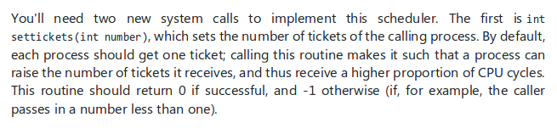
Completed

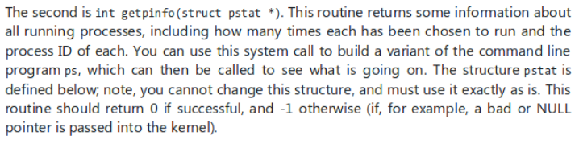
Built as a variant of ps, all values printed in syscall. Completed

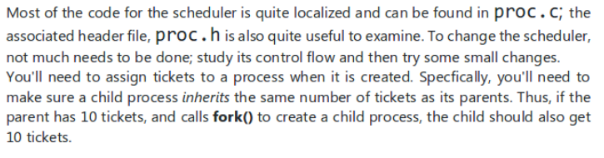
In progress.

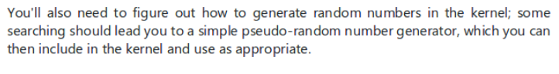
Completed

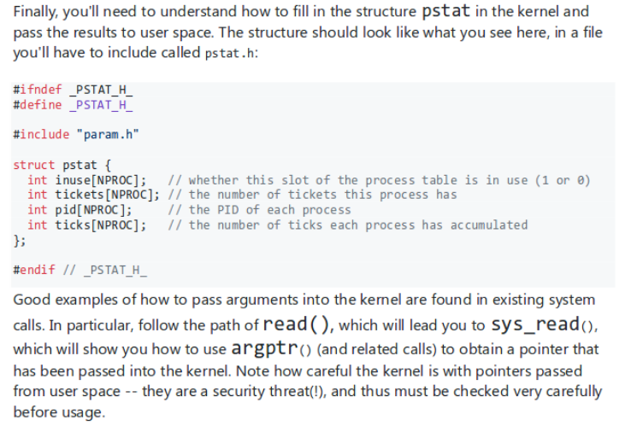

???

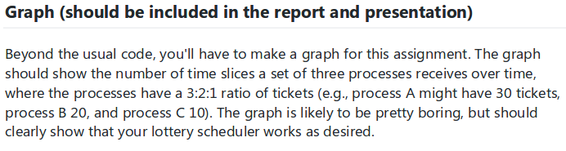

Solved through the ps call

