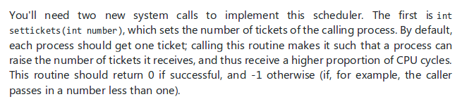Completed

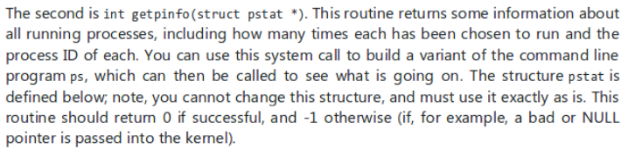Built as a variant of ps, all values printed in syscall. Completed

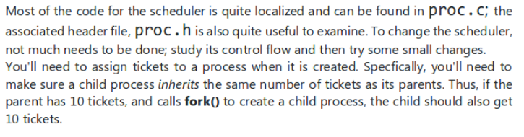In progress.

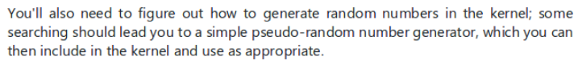Completed

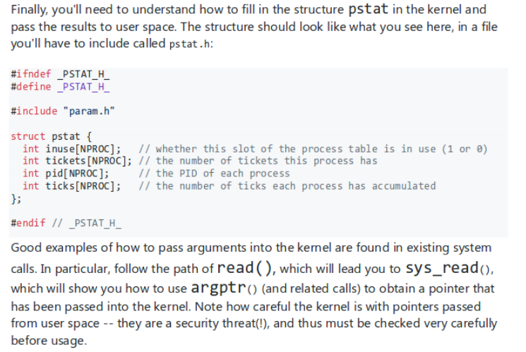

???

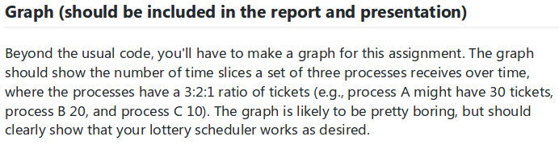

Solved through the ps call