Practical 1: MiniBank Console Menu Shell
Problem Definition:
Initialize the MiniBank console application menu shell. Create a BankInfo record holding bank name and branch, a MenuOption enum (OPEN_ACCOUNT, DEPOSIT, WITHDRAW, TRANSFER, WORKING_HOURS, EXIT), and a switch-expression driven menu loop handling user choices.
Code:
import java.util.Scanner;
class PartB {
public record BankInfo(String name, String branch) {}
public enum MenuOption { OPEN_ACCOUNT, DEPOSIT, WITHDRAW, TRANSFER, WORKING_HOURS, EXIT }
public static void main(String[] args) {
System.out.println("RUDRA MODI || 25DCS058");
System.out.println();
System.out.println("Practical 1 - Part B: MiniBank Console Menu Shell");
System.out.println();
Scanner scanner = new Scanner(System.in);
BankInfo bank = new BankInfo("MiniBank Central", "Main Branch (DEPSTAR)");
System.out.println("BANK: " + bank.name() + " | BRANCH: " + bank.branch());
boolean running = true;
while (running) {
System.out.println("\n1. Open Account\n2. Deposit\n3. Withdraw\n4. Transfer\n5. Working Hours\n6. Exit");
System.out.print("Enter choice (1-6): ");
int choice = 0;
if (scanner.hasNextInt()) {
choice = scanner.nextInt();
} else {
System.out.println("Please enter a valid number!");
scanner.next();
continue;
}
MenuOption option = switch (choice) {
case 1 -> MenuOption.OPEN_ACCOUNT;
case 2 -> MenuOption.DEPOSIT;
case 3 -> MenuOption.WITHDRAW;
case 4 -> MenuOption.TRANSFER;
case 5 -> MenuOption.WORKING_HOURS;
case 6 -> MenuOption.EXIT;
default -> null;
};
if (option == null) {
System.out.println("Invalid menu option!");
continue;
}
switch (option) {
case OPEN_ACCOUNT -> System.out.println("Open Account - to be implemented in a later lab.");
case DEPOSIT -> System.out.println("Deposit - to be implemented in a later lab.");
case WITHDRAW -> System.out.println("Withdraw - to be implemented in a later lab.");
case TRANSFER -> System.out.println("Transfer - to be implemented in a later lab.");
case WORKING_HOURS -> System.out.println("Working hours: 09:00 AM to 04:00 PM, Mon-Fri.");
case EXIT -> {
System.out.println("Thank you for using MiniBank. Goodbye!");
running = false;
}
}
}
scanner.close();
}
}
Output:
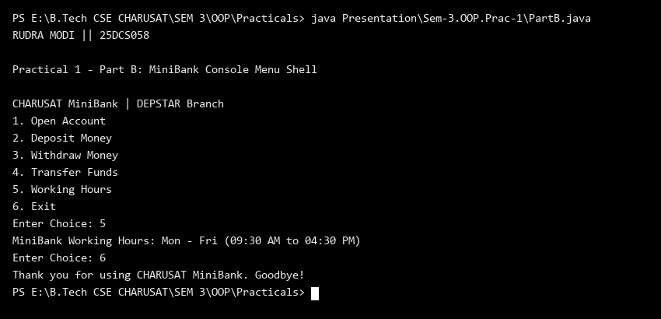
Key Questions & MiniBank Architecture Analysis:
Q1: Why is an enum used for MenuOption and a record for BankInfo?
Answer: MenuOption is modeled as an enum to restrict menu choices strictly to valid operations (OPEN_ACCOUNT, DEPOSIT, WITHDRAW, TRANSFER, WORKING_HOURS, EXIT) with compile-time type safety. BankInfo is modeled as a record because it represents immutable bank metadata (name and branch), automatically providing getters, toString(), and value-based equality without boilerplate.
Q2: How does the switch expression improve menu navigation logic?
Answer: Modern switch expressions with arrow syntax (case 1 -> MenuOption.OPEN_ACCOUNT) cleanly map integer inputs to enum constants without verbose break statements or risk of fall-through bugs, providing concise and readable dispatching.

