Practical 7: MiniBank Runtime Metadata & Annotation Validator
Problem Definition:
Equip MiniBank with custom metadata annotations @Id, @Positive, @MaxLength, standard annotations @Override, @FunctionalInterface, and create AnnotationValidator using reflection (getDeclaredFields(), setAccessible(true), isAnnotationPresent()) to validate domain objects.
Code:
import java.lang.annotation.ElementType;
import java.lang.annotation.Retention;
import java.lang.annotation.RetentionPolicy;
import java.lang.annotation.Target;
import java.lang.reflect.Field;
import java.util.ArrayList;
import java.util.List;
class PartB {
@Target(ElementType.FIELD)
@Retention(RetentionPolicy.RUNTIME)
public @interface Id {}
@Target(ElementType.FIELD)
@Retention(RetentionPolicy.RUNTIME)
public @interface Positive {
String message() default "must be > 0";
}
@Target(ElementType.FIELD)
@Retention(RetentionPolicy.RUNTIME)
public @interface MaxLength {
int value();
String message() default "exceeds maximum allowed length";
}
@FunctionalInterface
public interface WithdrawRule {
boolean allow(Account account, long amount);
}
public static class Account {
@Id
private final String accountNumber;
@MaxLength(value = 30, message = "Holder name exceeds 30 characters")
private final String holderName;
@Positive(message = "must be > 0")
private long balance;
public Account(String accountNumber, String holderName, long balance) {
this.accountNumber = accountNumber;
this.holderName = holderName;
this.balance = balance;
}
public String getAccountNumber() { return accountNumber; }
public String getHolderName() { return holderName; }
public long getBalance() { return balance; }
@Override
public String toString() {
return "Account [" + accountNumber + " | " + holderName + " | Balance: Rs. " + balance + "]";
}
@Override
public boolean equals(Object obj) {
if (this == obj) return true;
if (obj == null || getClass() != obj.getClass()) return false;
Account acc = (Account) obj;
return accountNumber.equals(acc.accountNumber);
}
@Override
public int hashCode() {
return accountNumber.hashCode();
}
}
public static class AnnotationValidator {
public static String[] validate(Object obj) {
List<String> errors = new ArrayList<>();
Class<?> clazz = obj.getClass();
for (Field field : clazz.getDeclaredFields()) {
field.setAccessible(true);
try {
Object value = field.get(obj);
if (field.isAnnotationPresent(Positive.class)) {
Positive pos = field.getAnnotation(Positive.class);
if (value instanceof Number num) {
if (num.longValue() <= 0) {
errors.add("Field '" + field.getName() + "': " + pos.message() + " (Actual: " + num + ")");
}
}
}
if (field.isAnnotationPresent(MaxLength.class)) {
MaxLength max = field.getAnnotation(MaxLength.class);
if (value != null && value.toString().length() > max.value()) {
errors.add("Field '" + field.getName() + "': " + max.message() + " (Max: " + max.value() + ", Actual: " + value.toString().length() + ")");
}
}
} catch (IllegalAccessException e) {
errors.add("Cannot access field " + field.getName());
}
}
return errors.toArray(new String[0]);
}
}
public static void main(String[] args) {
System.out.println("RUDRA MODI || 25DCS058");
System.out.println();
System.out.println("Practical 7 - Part B: MiniBank Runtime Metadata & Annotation Validator");
System.out.println();
Account invalidAccount = new Account("AC1001", "Rudra Modi With An Excessively Long Account Holder Name Example", -500);
System.out.println("Validating Problematic Account Instance:");
System.out.println("Account Info: " + invalidAccount);
String[] invalidErrors = AnnotationValidator.validate(invalidAccount);
for (String err : invalidErrors) {
System.out.println(" [VALIDATION ERROR] " + err);
}
System.out.println("\nValidating Compliant Account Instance:");
Account validAccount = new Account("AC1002", "Rudra Modi", 15000);
System.out.println("Account Info: " + validAccount);
String[] validErrors = AnnotationValidator.validate(validAccount);
if (validErrors.length == 0) {
System.out.println(" [VALIDATION SUCCESS] All annotation constraints satisfied (0 errors).");
} else {
for (String err : validErrors) {
System.out.println(" [VALIDATION ERROR] " + err);
}
}
}
}
Output:
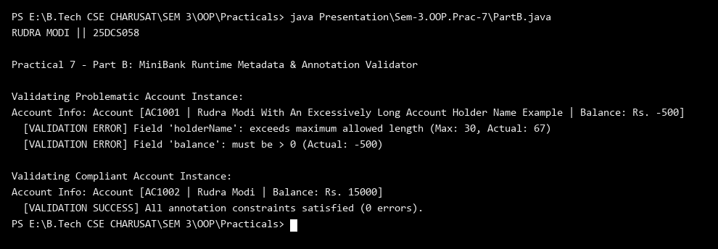
Key Questions & MiniBank Architecture Analysis:
Q1: How does AnnotationValidator inspect private annotated fields?
Answer: AnnotationValidator uses Java Reflection methods (getDeclaredFields(), setAccessible(true), and getAnnotation()) to inspect private domain fields and dynamically enforce constraints (@NotBlank, @MaxLength, @Positive) at runtime.
Q2: Why must custom validation annotations specify @Retention(RetentionPolicy.RUNTIME)?
Answer: RetentionPolicy.RUNTIME ensures that annotation metadata is retained in the compiled .class bytecode and remains accessible to the reflection framework during application execution.

