Practical 8: MiniBank Robust Exception Handling Architecture
Problem Definition:
Create a checked exception hierarchy with BankException base class, InsufficientFundsException (carrying shortfall), AccountNotFoundException, and InvalidAmountException; enforce throws declarations in deposit(), withdraw(), and transfer(); and manage sessions with try-with-resources.
Code:
class PartB {
public static class BankException extends Exception {
public BankException(String message) {
super(message);
}
}
public static class InsufficientFundsException extends BankException {
private final long shortfall;
public InsufficientFundsException(String accNo, long balance, long requested) {
super("Account [" + accNo + "] has insufficient funds. Balance: Rs. " + balance + ", Requested: Rs. " + requested);
this.shortfall = requested - balance;
}
public long getShortfall() {
return shortfall;
}
}
public static class AccountNotFoundException extends BankException {
public AccountNotFoundException(String accNo) {
super("Account [" + accNo + "] was not found in the bank directory.");
}
}
public static class InvalidAmountException extends BankException {
public InvalidAmountException(String message) {
super(message);
}
}
public static class BankSession implements AutoCloseable {
private final String sessionId;
public BankSession(String sessionId) {
this.sessionId = sessionId;
System.out.println(" [SESSION] Banking Transaction Session '" + sessionId + "' opened.");
}
@Override
public void close() {
System.out.println(" [SESSION] Banking Transaction Session '" + sessionId + "' safely closed & committed.");
}
}
public static class Account {
private final String accountNumber;
private final String holderName;
private long balance;
public Account(String accountNumber, String holderName, long balance) {
this.accountNumber = accountNumber;
this.holderName = holderName;
this.balance = balance;
}
public String getAccountNumber() { return accountNumber; }
public String getHolderName() { return holderName; }
public long getBalance() { return balance; }
public void deposit(long amount) throws InvalidAmountException {
if (amount <= 0) {
throw new InvalidAmountException("Deposit amount must be strictly greater than 0. Received: Rs. " + amount);
}
balance += amount;
System.out.println(" [DEPOSIT SUCCESS] Deposited Rs. " + amount + " to " + accountNumber + ". New Balance: Rs. " + balance);
}
public void withdraw(long amount) throws InsufficientFundsException, InvalidAmountException {
if (amount <= 0) {
throw new InvalidAmountException("Withdrawal amount must be strictly greater than 0. Received: Rs. " + amount);
}
if (amount > balance) {
throw new InsufficientFundsException(accountNumber, balance, amount);
}
balance -= amount;
System.out.println(" [WITHDRAW SUCCESS] Withdrawn Rs. " + amount + " from " + accountNumber + ". Remaining Balance: Rs. " + balance);
}
public void transfer(Account recipient, long amount) throws BankException {
if (recipient == null) {
throw new AccountNotFoundException("TARGET-ACCOUNT-NULL");
}
System.out.println(" [TRANSFER ATTEMPT] Initiating transfer of Rs. " + amount + " from " + accountNumber + " to " + recipient.accountNumber);
this.withdraw(amount);
recipient.deposit(amount);
System.out.println(" [TRANSFER COMPLETED] Successfully transferred Rs. " + amount + " to " + recipient.accountNumber);
}
@Override
public String toString() {
return "[" + accountNumber + " | " + holderName + " | Rs. " + balance + "]";
}
}
public static void main(String[] args) {
System.out.println("RUDRA MODI || 25DCS058");
System.out.println();
System.out.println("Practical 8 - Part B: MiniBank Robust Exception Handling Architecture");
System.out.println();
Account acc1 = new Account("AC1001", "Rudra Modi", 5000);
Account acc2 = new Account("AC1002", "Dhyey Patel", 2000);
System.out.println("Initial State: " + acc1 + " and " + acc2);
System.out.println("\nTest 1: Invalid Amount Exception on Negative Deposit:");
try {
acc1.deposit(-1000);
} catch (InvalidAmountException e) {
System.out.println(" [CAUGHT EXCEPTION] " + e.getMessage());
}
System.out.println("\nTest 2: Insufficient Funds Exception on Large Withdrawal:");
try {
acc1.withdraw(8000);
} catch (InsufficientFundsException e) {
System.out.println(" [CAUGHT EXCEPTION] " + e.getMessage());
System.out.println(" -> Deficit / Shortfall Amount: Rs. " + e.getShortfall());
} catch (InvalidAmountException e) {
System.out.println(" [CAUGHT EXCEPTION] " + e.getMessage());
}
System.out.println("\nTest 3: Transaction Session with Try-With-Resources & Successful Transfer:");
try (BankSession session = new BankSession("TXN-SES-991")) {
acc1.transfer(acc2, 3000);
} catch (BankException e) {
System.out.println(" [TRANSFER FAILED] " + e.getMessage());
} finally {
System.out.println(" [AUDIT] Final Balances -> " + acc1 + " | " + acc2);
}
}
}
Output:
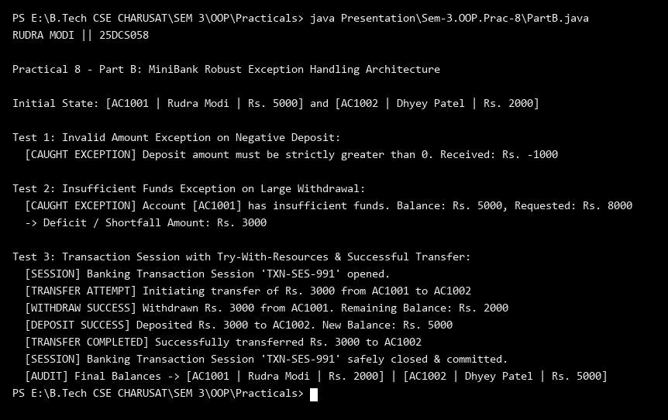
Key Questions & MiniBank Architecture Analysis:
Q1: Why are business errors like InsufficientFundsException designed as checked exceptions?
Answer: Checked exceptions require callers to explicitly anticipate and handle predictable banking failures (such as overdraft or invalid account lookups) using try-catch blocks, ensuring robust transaction safety.
Q2: How does try-with-resources ensure BankSession closure?
Answer: BankSession implements the AutoCloseable interface, allowing it to be managed within a try-with-resources statement where close() is invoked deterministically upon exit, guaranteeing transaction auditing and cleanup.

