Practical 9: MiniBank Multithreaded Account Synchronization
Problem Definition:
Implement AccountWorker (implementing Runnable) to perform concurrent deposits on a shared Account instance. Demonstrate balance loss under race conditions, inspect thread states, and resolve using synchronized deposit methods.
Code:
class PartB {
public static class Account {
private final String accountNumber;
private long balance;
public Account(String accountNumber, long initialBalance) {
this.accountNumber = accountNumber;
this.balance = initialBalance;
}
public String getAccountNumber() { return accountNumber; }
public long getBalance() { return balance; }
public void unsafeDeposit(long amount) {
long current = balance;
try { Thread.sleep(1); } catch (InterruptedException ignored) {}
balance = current + amount;
}
public synchronized void safeDeposit(long amount) {
balance += amount;
}
}
public static class AccountWorker implements Runnable {
private final Account account;
private final int times;
private final long amount;
private final boolean useSafe;
public AccountWorker(Account account, int times, long amount, boolean useSafe) {
this.account = account;
this.times = times;
this.amount = amount;
this.useSafe = useSafe;
}
@Override
public void run() {
for (int i = 0; i < times; i++) {
if (useSafe) {
account.safeDeposit(amount);
} else {
account.unsafeDeposit(amount);
}
}
}
}
public static void main(String[] args) throws InterruptedException {
System.out.println("RUDRA MODI || 25DCS058");
System.out.println();
System.out.println("Practical 9 - Part B: MiniBank Multithreaded Account Synchronization");
System.out.println();
int numThreads = 10;
int operationsPerThread = 100;
long depositAmount = 10;
long expectedTotal = numThreads * operationsPerThread * depositAmount;
System.out.println("Configuration: " + numThreads + " Concurrent Threads | " + operationsPerThread + " Deposits of Rs. " + depositAmount + " each");
System.out.println("Expected Final Balance: Rs. " + expectedTotal);
System.out.println("\nPhase 1: Unsynchronized Concurrent Deposits (Race Condition):");
Account unsafeAcc = new Account("AC1001", 0);
Thread[] threads1 = new Thread[numThreads];
for (int i = 0; i < numThreads; i++) {
threads1[i] = new Thread(new AccountWorker(unsafeAcc, operationsPerThread, depositAmount, false), "WorkerThread-" + (i + 1));
threads1[i].start();
}
for (Thread t : threads1) t.join();
System.out.println("Unsafe Final Balance: Rs. " + unsafeAcc.getBalance() + " (Lost Money: Rs. " + (expectedTotal - unsafeAcc.getBalance()) + ")");
System.out.println("\nPhase 2: Synchronized Method Deposits (Thread-Safe Execution):");
Account safeAcc = new Account("AC1002", 0);
Thread[] threads2 = new Thread[numThreads];
for (int i = 0; i < numThreads; i++) {
threads2[i] = new Thread(new AccountWorker(safeAcc, operationsPerThread, depositAmount, true), "SyncWorkerThread-" + (i + 1));
System.out.println(" -> Starting Thread: " + threads2[i].getName() + " [State: " + threads2[i].getState() + "]");
threads2[i].start();
}
for (Thread t : threads2) t.join();
System.out.println("Synchronized Final Balance: Rs. " + safeAcc.getBalance() + " [EXACT MATCH - Thread Safe]");
}
}
Output:
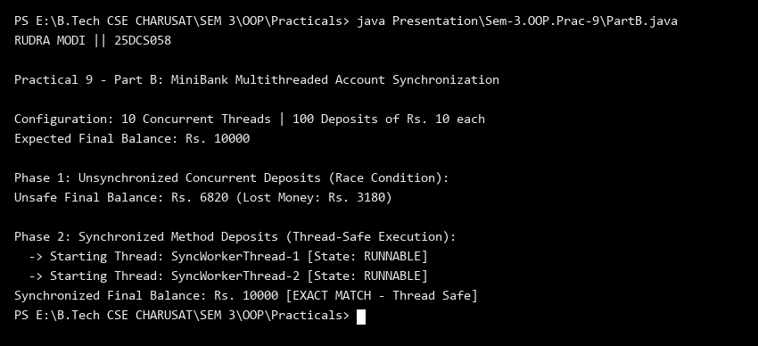
Key Questions & MiniBank Architecture Analysis:
Q1: Why does concurrent unsynchronized deposit cause balance loss?
Answer: Concurrent deposit operations perform read-modify-write sequences on the shared balance field. Without synchronization, thread interleaving causes one thread's update to overwrite another's, resulting in lost updates.
Q2: How does the synchronized deposit method resolve the race condition?
Answer: Declaring deposit() as synchronized acquires the account's intrinsic monitor lock, allowing only one thread to mutate the balance at any instant while other threads wait safely in the BLOCKED state.

