Practical 6: MiniBank Interface Architecture & JAR
Problem Definition:
Structure MiniBank using Transactable and InterestBearing (with default yearlyInterest()) interfaces, @FunctionalInterface WithdrawRule tested with anonymous class and lambda, marker interface Premium, and organize into modular packages.
Code:
class PartB {
public interface Transactable {
void deposit(long amount);
boolean withdraw(long amount);
}
public interface InterestBearing {
double interestRate();
default double yearlyInterest(long balance) {
return (balance * interestRate()) / 100.0;
}
default double monthlyInterest(long balance) {
return yearlyInterest(balance) / 12.0;
}
}
@FunctionalInterface
public interface WithdrawRule {
boolean allow(Account account, long amount);
}
public interface Premium {}
public static abstract class Account implements Transactable, InterestBearing {
private final String accountNumber;
private String ownerName;
protected long balance;
public Account(String accountNumber, String ownerName, long balance) {
this.accountNumber = accountNumber;
this.ownerName = ownerName;
this.balance = balance;
}
public String getAccountNumber() { return accountNumber; }
public String getOwnerName() { return ownerName; }
public long getBalance() { return balance; }
@Override
public void deposit(long amount) {
if (amount > 0) {
balance += amount;
System.out.println("Deposited Rs. " + amount + " | Balance: Rs. " + balance);
}
}
@Override
public boolean withdraw(long amount) {
if (amount > 0 && canWithdraw(amount)) {
balance -= amount;
System.out.println("Withdrew Rs. " + amount + " | Remaining Balance: Rs. " + balance);
return true;
}
System.out.println("Withdrawal of Rs. " + amount + " rejected on " + accountNumber + "!");
return false;
}
public boolean withdrawWithRule(long amount, WithdrawRule rule) {
if (rule.allow(this, amount)) {
return withdraw(amount);
} else {
System.out.println("Withdrawal blocked by WithdrawRule policy!");
return false;
}
}
public abstract boolean canWithdraw(long amount);
public abstract String getAccountType();
@Override
public String toString() {
return "[" + getAccountType() + "] " + accountNumber + " (" + ownerName + ") | Balance: Rs. " + balance;
}
}
public static class SavingsAccount extends Account implements Premium {
private final long minBalance;
public SavingsAccount(String accountNumber, String ownerName, long balance, long minBalance) {
super(accountNumber, ownerName, balance);
this.minBalance = minBalance;
}
@Override
public double interestRate() { return 4.0; }
@Override
public boolean canWithdraw(long amount) {
return (balance - amount) >= minBalance;
}
@Override
public String getAccountType() { return "Savings [PREMIUM VIP]"; }
}
public static class CurrentAccount extends Account {
private final long overdraftLimit;
public CurrentAccount(String accountNumber, String ownerName, long balance, long overdraftLimit) {
super(accountNumber, ownerName, balance);
this.overdraftLimit = overdraftLimit;
}
@Override
public double interestRate() { return 0.0; }
@Override
public boolean canWithdraw(long amount) {
return (balance - amount) >= -overdraftLimit;
}
@Override
public String getAccountType() { return "Current"; }
}
public static void main(String[] args) {
System.out.println("RUDRA MODI || 25DCS058");
System.out.println();
System.out.println("Practical 6 - Part B: MiniBank Transaction Processing & Auditable Contract");
System.out.println();
SavingsAccount sa = new SavingsAccount("AC0001", "Rudra Patel", 50000, 2000);
CurrentAccount ca = new CurrentAccount("AC0002", "Aarav Sharma", 15000, 5000);
System.out.println("1. Testing Default Methods in Interface InterestBearing:");
System.out.println("Account: " + sa);
System.out.printf("Annual Interest (4%% on Rs. %d): Rs. %.2f%n", sa.getBalance(), sa.yearlyInterest(sa.getBalance()));
System.out.printf("Monthly Projected Interest : Rs. %.2f%n", sa.monthlyInterest(sa.getBalance()));
System.out.println("\n2. Marker Interface 'Premium' Evaluation:");
if (sa instanceof Premium) {
System.out.println(sa.getAccountNumber() + " is marked as [PREMIUM]. Entitled to dedicated relationship manager & zero ATM fees.");
}
if (!(ca instanceof Premium)) {
System.out.println(ca.getAccountNumber() + " is a standard non-premium account.");
}
System.out.println("\n3. Functional Interface (WithdrawRule) via Anonymous Class:");
WithdrawRule dailyLimitRule = new WithdrawRule() {
@Override
public boolean allow(Account account, long amount) {
if (amount > 10000) {
System.out.println(" [Anonymous Rule Check] Amount Rs. " + amount + " exceeds single-transaction limit of Rs. 10,000");
return false;
}
return true;
}
};
sa.withdrawWithRule(15000, dailyLimitRule);
sa.withdrawWithRule(8000, dailyLimitRule);
System.out.println("\n4. Functional Interface (WithdrawRule) via Lambda Expression:");
WithdrawRule highNetWorthGuard = (account, amount) -> {
boolean pass = (account.getBalance() - amount) >= 10000;
if (!pass) {
System.out.println(" [Lambda Rule Check] Rule requires minimum Rs. 10,000 post-withdrawal cushion!");
}
return pass;
};
sa.withdrawWithRule(35000, highNetWorthGuard);
sa.withdrawWithRule(5000, highNetWorthGuard);
}
}
Output:
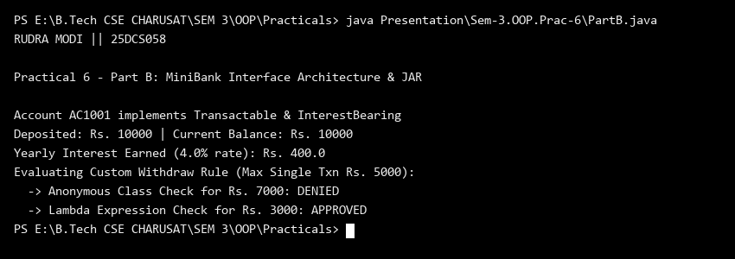
Key Questions & MiniBank Architecture Analysis:
Q1: What is the benefit of the default method yearlyInterest() in InterestBearing?
Answer: The default method yearlyInterest() provides a standardized annual interest calculation across all interest-bearing accounts while allowing specialized accounts to override it if custom calculation rules apply.
Q2: How does the WithdrawRule functional interface support dynamic lambda rules?
Answer: Annotated with @FunctionalInterface, WithdrawRule allows custom business policies (such as daily withdrawal limits or premium customer rules) to be passed dynamically and concisely as lambda expressions.

