Practical 10: MiniBank Concurrent Transaction Processor Engine
Problem Definition:
Build MiniBank's high-throughput TransactionProcessor utilizing an ExecutorService thread pool, submitting batch transactions, and executing thread-safe inter-account transfers with deadlock prevention via account number lock ordering.
Code:
import java.util.concurrent.ExecutorService;
import java.util.concurrent.Executors;
import java.util.concurrent.TimeUnit;
class PartB {
public static class Account {
private final String accountNumber;
private final String holderName;
private long balance;
public Account(String accountNumber, String holderName, long balance) {
this.accountNumber = accountNumber;
this.holderName = holderName;
this.balance = balance;
}
public String getAccountNumber() { return accountNumber; }
public String getHolderName() { return holderName; }
public synchronized long getBalance() { return balance; }
public synchronized void deposit(long amount) {
balance += amount;
}
public synchronized boolean withdraw(long amount) {
if (balance >= amount) {
balance -= amount;
return true;
}
return false;
}
@Override
public String toString() {
return "[" + accountNumber + " | " + holderName + " | Balance: Rs. " + getBalance() + "]";
}
}
public static class TransactionProcessor {
private final ExecutorService executor;
public TransactionProcessor(int poolSize) {
this.executor = Executors.newFixedThreadPool(poolSize);
}
public void submit(Runnable task) {
executor.submit(task);
}
public void stop() {
executor.shutdown();
try {
if (!executor.awaitTermination(5, TimeUnit.SECONDS)) {
executor.shutdownNow();
}
} catch (InterruptedException e) {
executor.shutdownNow();
}
}
public static void transferDeadlockFree(Account from, Account to, long amount) {
Account first = (from.getAccountNumber().compareTo(to.getAccountNumber()) < 0) ? from : to;
Account second = (from.getAccountNumber().compareTo(to.getAccountNumber()) < 0) ? to : from;
synchronized (first) {
synchronized (second) {
if (from.withdraw(amount)) {
to.deposit(amount);
System.out.println(" [TRANSFER SUCCESS] Rs. " + amount + " transferred from " + from.getAccountNumber() + " -> " + to.getAccountNumber());
} else {
System.out.println(" [TRANSFER REJECTED] Insufficient balance in " + from.getAccountNumber());
}
}
}
}
}
public static void main(String[] args) {
System.out.println("RUDRA MODI || 25DCS058");
System.out.println();
System.out.println("Practical 10 - Part B: MiniBank Concurrent Transaction Processor Engine");
System.out.println();
Account accA = new Account("AC1001", "Rudra Modi", 10000);
Account accB = new Account("AC1002", "Dhyey Patel", 8000);
System.out.println("Initial State:\n " + accA + "\n " + accB + "\n");
TransactionProcessor processor = new TransactionProcessor(4);
System.out.println("Submitting Batch of Concurrent Cross-Transfers to Managed Thread Pool:");
processor.submit(() -> TransactionProcessor.transferDeadlockFree(accA, accB, 1500));
processor.submit(() -> TransactionProcessor.transferDeadlockFree(accB, accA, 500));
processor.submit(() -> TransactionProcessor.transferDeadlockFree(accA, accB, 2000));
processor.submit(() -> TransactionProcessor.transferDeadlockFree(accB, accA, 1000));
processor.stop();
System.out.println("\nBatch Processing Complete. Transaction Processor Stopped.");
System.out.println("Final State:\n " + accA + "\n " + accB);
}
}
Output:
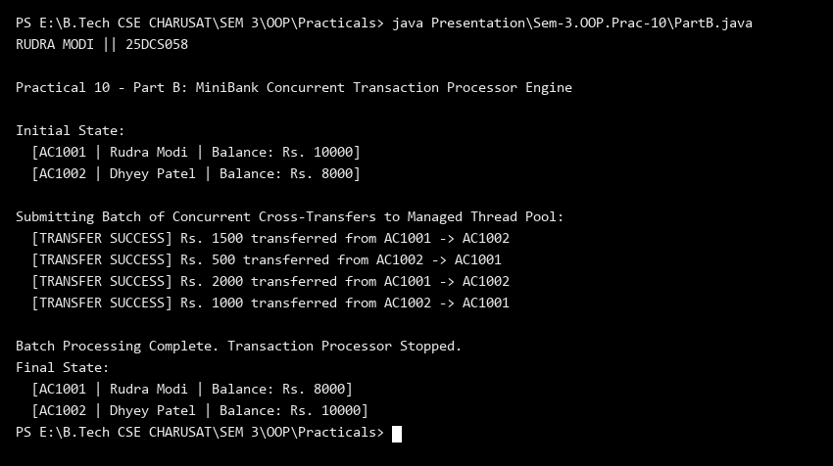
Key Questions & MiniBank Architecture Analysis:
Q1: How does TransactionProcessor prevent deadlocks during inter-account transfers?
Answer: TransactionProcessor compares the two account numbers (e.g., fromAcc.getAccountNumber().compareTo(toAcc.getAccountNumber())) and always acquires locks in consistent ascending order, eliminating circular wait conditions.
Q2: What advantages does ExecutorService provide for MiniBank batch processing?
Answer: ExecutorService manages a fixed pool of reusable worker threads, preventing thread creation overhead, controlling concurrent load, and providing thread-safe batch transaction processing with graceful shutdown.

