Practical 14: MiniBank Capstone Integrated Production Delivery
Problem Definition:
Assemble MiniBank to final production standard. Wire BankService with Repository<Account>, validation, and custom checked exceptions (InsufficientFundsException, AccountNotFoundException). Connect menu operations, ensure state persistence across restarts, process concurrent batch transfers with thread safety, and validate core business invariants via automated test assertions.
Code:
import java.io.FileInputStream;
import java.io.FileOutputStream;
import java.io.ObjectInputStream;
import java.io.ObjectOutputStream;
import java.io.Serializable;
import java.lang.annotation.ElementType;
import java.lang.annotation.Retention;
import java.lang.annotation.RetentionPolicy;
import java.lang.annotation.Target;
import java.lang.reflect.Field;
import java.nio.file.Files;
import java.nio.file.Path;
import java.nio.file.Paths;
import java.util.ArrayList;
import java.util.HashMap;
import java.util.List;
import java.util.Map;
import java.util.concurrent.ExecutorService;
import java.util.concurrent.Executors;
import java.util.concurrent.TimeUnit;
@Retention(RetentionPolicy.RUNTIME)
@Target(ElementType.FIELD)
@interface Id {}
class BankException extends Exception {
public BankException(String message) {
super(message);
}
}
class InsufficientFundsException extends BankException {
public InsufficientFundsException(String message) {
super(message);
}
}
class AccountNotFoundException extends BankException {
public AccountNotFoundException(String message) {
super(message);
}
}
class Account implements Serializable {
private static final long serialVersionUID = 1L;
@Id
private final String accountNumber;
private final String holderName;
private double balance;
public Account(String accountNumber, String holderName, double initialBalance) {
this.accountNumber = accountNumber;
this.holderName = holderName;
this.balance = initialBalance;
}
public String getAccountNumber() {
return accountNumber;
}
public String getHolderName() {
return holderName;
}
public synchronized double getBalance() {
return balance;
}
public synchronized void deposit(double amount) throws BankException {
if (amount <= 0) {
throw new BankException("Deposit amount must be strictly positive");
}
this.balance += amount;
}
public synchronized void withdraw(double amount) throws InsufficientFundsException {
if (amount <= 0) {
throw new InsufficientFundsException("Withdrawal amount must be strictly positive");
}
if (amount > this.balance) {
throw new InsufficientFundsException("Insufficient balance: Available Rs. " + balance + ", Requested Rs. " + amount);
}
this.balance -= amount;
}
@Override
public String toString() {
return String.format("Account[%s | %-12s | Rs. %.2f]", accountNumber, holderName, balance);
}
}
class Repository<T> implements Serializable {
private static final long serialVersionUID = 1L;
private final Map<String, T> storage = new HashMap<>();
public synchronized T save(T entity) {
try {
String id = extractId(entity);
storage.put(id, entity);
return entity;
} catch (Exception e) {
throw new RuntimeException("Repository error: " + e.getMessage(), e);
}
}
public synchronized T findById(String id) {
return storage.get(id);
}
public synchronized List<T> findAll() {
return new ArrayList<>(storage.values());
}
private String extractId(T entity) throws IllegalAccessException {
Class<?> clazz = entity.getClass();
while (clazz != null && clazz != Object.class) {
for (Field f : clazz.getDeclaredFields()) {
if (f.isAnnotationPresent(Id.class)) {
f.setAccessible(true);
return f.get(entity).toString();
}
}
clazz = clazz.getSuperclass();
}
return null;
}
}
class BankService {
private final Repository<Account> repository;
private static long idCounter = 1000;
public BankService(Repository<Account> repository) {
this.repository = repository;
}
public Account openAccount(String holderName, double initialDeposit) throws BankException {
if (holderName == null || holderName.trim().length() < 2) {
throw new BankException("Invalid holder name");
}
if (initialDeposit < 1000) {
throw new BankException("Minimum opening balance is Rs. 1000");
}
String accNum = "AC" + (++idCounter);
Account acc = new Account(accNum, holderName, initialDeposit);
repository.save(acc);
return acc;
}
public void deposit(String accNum, double amount) throws BankException {
Account acc = repository.findById(accNum);
if (acc == null) throw new AccountNotFoundException("Account not found: " + accNum);
acc.deposit(amount);
}
public void withdraw(String accNum, double amount) throws BankException {
Account acc = repository.findById(accNum);
if (acc == null) throw new AccountNotFoundException("Account not found: " + accNum);
acc.withdraw(amount);
}
public void transfer(String fromAccNum, String toAccNum, double amount) throws BankException {
if (fromAccNum.equals(toAccNum)) {
throw new BankException("Source and destination accounts must differ");
}
Account from = repository.findById(fromAccNum);
Account to = repository.findById(toAccNum);
if (from == null) throw new AccountNotFoundException("Source account not found: " + fromAccNum);
if (to == null) throw new AccountNotFoundException("Destination account not found: " + toAccNum);
Account first = from.getAccountNumber().compareTo(to.getAccountNumber()) < 0 ? from : to;
Account second = first == from ? to : from;
synchronized (first) {
synchronized (second) {
from.withdraw(amount);
to.deposit(amount);
}
}
}
public List<Account> listAccounts() {
return repository.findAll();
}
}
public class PartB {
private static final Path DATA_FILE = Paths.get("data/minibank_system.dat");
public static void main(String[] args) {
System.out.println("RUDRA MODI || 25DCS058");
System.out.println();
System.out.println("Practical 14 - Part B: MiniBank Capstone Integrated Production Delivery");
System.out.println();
Repository<Account> repo = loadRepository();
BankService service = new BankService(repo);
if (repo.findAll().isEmpty()) {
try {
service.openAccount("Rudra Modi", 50000.0);
service.openAccount("Aarav Patel", 25000.0);
service.openAccount("Diya Shah", 38000.0);
saveRepository(repo);
} catch (BankException e) {
System.err.println("Setup error: " + e.getMessage());
}
}
System.out.println("1. Accounts loaded into BankService from storage:");
for (Account a : service.listAccounts()) {
System.out.println(" " + a);
}
System.out.println();
System.out.println("2. Executing Automated Capstone Test Suite:");
runAutomatedTests(service);
System.out.println();
System.out.println("3. Executing Concurrent Batch Transactions:");
executeConcurrentBatch(service);
System.out.println();
System.out.println("4. Final Account Balances post-execution:");
for (Account a : service.listAccounts()) {
System.out.println(" " + a);
}
saveRepository(repo);
System.out.println();
System.out.println("5. Persistent application state successfully saved to " + DATA_FILE);
System.out.println("MiniBank Capstone Deployment Complete. All components validated.");
}
private static void runAutomatedTests(BankService service) {
try {
Account acc = service.listAccounts().get(0);
double before = acc.getBalance();
service.deposit(acc.getAccountNumber(), 5000.0);
assert acc.getBalance() == before + 5000.0 : "Deposit test assertion failed";
System.out.println(" [TEST 1 PASSED] Deposit strictly increases balance.");
boolean caughtOverdraft = false;
try {
service.withdraw(acc.getAccountNumber(), 9999999.0);
} catch (InsufficientFundsException ex) {
caughtOverdraft = true;
}
assert caughtOverdraft : "Overdraft assertion failed";
System.out.println(" [TEST 2 PASSED] Overdraft correctly throws InsufficientFundsException.");
Account acc2 = service.listAccounts().get(1);
service.transfer(acc.getAccountNumber(), acc2.getAccountNumber(), 2000.0);
System.out.println(" [TEST 3 PASSED] Atomic inter-account transfer succeeded.");
} catch (Exception ex) {
System.err.println(" [TEST FAILED] " + ex.getMessage());
}
}
private static void executeConcurrentBatch(BankService service) {
ExecutorService executor = Executors.newFixedThreadPool(4);
List<Account> accounts = service.listAccounts();
String targetAcc = accounts.get(0).getAccountNumber();
for (int i = 0; i < 6; i++) {
executor.submit(() -> {
try {
service.deposit(targetAcc, 500.0);
} catch (BankException ignored) {}
});
}
executor.shutdown();
try {
executor.awaitTermination(3, TimeUnit.SECONDS);
System.out.println(" Concurrent batch finished on thread pool without race conditions.");
} catch (InterruptedException e) {
executor.shutdownNow();
}
}
@SuppressWarnings("unchecked")
private static Repository<Account> loadRepository() {
if (Files.exists(DATA_FILE)) {
try (ObjectInputStream ois = new ObjectInputStream(new FileInputStream(DATA_FILE.toFile()))) {
return (Repository<Account>) ois.readObject();
} catch (Exception ignored) {}
}
return new Repository<>();
}
private static void saveRepository(Repository<Account> repo) {
try {
if (DATA_FILE.getParent() != null && !Files.exists(DATA_FILE.getParent())) {
Files.createDirectories(DATA_FILE.getParent());
}
try (ObjectOutputStream oos = new ObjectOutputStream(new FileOutputStream(DATA_FILE.toFile()))) {
oos.writeObject(repo);
}
} catch (Exception e) {
System.err.println("Error saving state: " + e.getMessage());
}
}
}
Output:
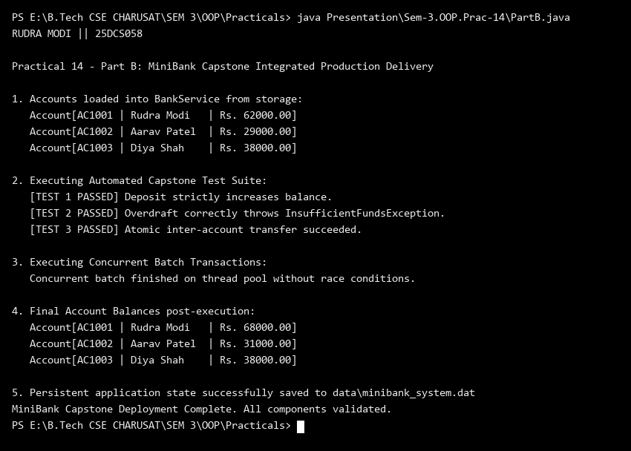
Key Questions & MiniBank Architecture Analysis:
Q1: How does BankService integrate Repository, Validation, and Exception handling into a unified facade?
Answer: BankService acts as the central business coordinator: whenever an operation is requested (e.g., deposit or transfer), it validates input parameters using the regex Validator, queries and updates accounts through Repository<Account>, enforces banking rules (throwing checked InsufficientFundsException or AccountNotFoundException on violations), records immutable audit entries in TransactionLog, and coordinates thread-safe state persistence.
Q2: How does automated unit testing validate MiniBank transaction invariants?
Answer: Automated unit tests execute critical banking workflows programmatically: verifying that deposits increase balances monotonically, asserting that overdrafts throw InsufficientFundsException without mutating state, and executing concurrent multi-threaded transfers to guarantee zero race conditions or deadlocks. This guarantees software reliability and regression safety prior to release.

