Practical 12: MiniBank Collections Storage, Sorting & Concurrent Map
Problem Definition:
Upgrade MiniBank storage from a static array to the Collections Framework. Create AccountStore maintaining accounts in a HashMap keyed by account number, track transaction history in an ArrayList, provide sortedByBalance using a Comparator, implement Comparable on Account, and utilize ConcurrentHashMap in TransactionProcessor for thread-safe concurrent access.
Code:
import java.util.ArrayList;
import java.util.Collections;
import java.util.Comparator;
import java.util.HashMap;
import java.util.List;
import java.util.Map;
import java.util.concurrent.ConcurrentHashMap;
class Account implements Comparable<Account> {
private final String accountNumber;
private final String holderName;
private double balance;
public Account(String accountNumber, String holderName, double initialBalance) {
this.accountNumber = accountNumber;
this.holderName = holderName;
this.balance = initialBalance;
}
public String getAccountNumber() {
return accountNumber;
}
public String getHolderName() {
return holderName;
}
public double getBalance() {
return balance;
}
public synchronized void deposit(double amount) {
if (amount > 0) {
this.balance += amount;
}
}
@Override
public int compareTo(Account other) {
return this.accountNumber.compareTo(other.accountNumber);
}
@Override
public String toString() {
return String.format("Account[%s | %-12s | Balance: Rs. %.2f]", accountNumber, holderName, balance);
}
}
class AccountStore {
private final Map<String, Account> accounts = new HashMap<>();
private final List<String> transactionHistory = new ArrayList<>();
public void add(Account account) {
accounts.put(account.getAccountNumber(), account);
transactionHistory.add("Registered account: " + account.getAccountNumber());
}
public Account get(String accountNumber) {
return accounts.get(accountNumber);
}
public List<Account> getAll() {
return new ArrayList<>(accounts.values());
}
public List<Account> sortedByBalance() {
List<Account> sortedList = new ArrayList<>(accounts.values());
sortedList.sort(Comparator.comparing(Account::getBalance, Comparator.reverseOrder()));
return sortedList;
}
public List<String> getTransactionHistory() {
return Collections.unmodifiableList(transactionHistory);
}
}
class TransactionProcessor {
private final ConcurrentHashMap<String, Account> sharedAccounts = new ConcurrentHashMap<>();
public void registerAccount(Account acc) {
sharedAccounts.put(acc.getAccountNumber(), acc);
}
public void executeConcurrentDeposit(String accNumber, double amount) {
Account acc = sharedAccounts.get(accNumber);
if (acc != null) {
acc.deposit(amount);
}
}
public Account getAccount(String accNumber) {
return sharedAccounts.get(accNumber);
}
}
public class PartB {
public static void main(String[] args) {
System.out.println("RUDRA MODI || 25DCS058");
System.out.println();
System.out.println("Practical 12 - Part B: MiniBank Collections Storage, Sorting & Concurrent Map");
System.out.println();
AccountStore store = new AccountStore();
Account a1 = new Account("AC1001", "Rudra Modi", 5000.0);
Account a2 = new Account("AC1002", "Aarav Patel", 2000.0);
Account a3 = new Account("AC1003", "Diya Shah", 9000.0);
Account a4 = new Account("AC1004", "Kabir Mehta", 15400.0);
store.add(a1);
store.add(a2);
store.add(a3);
store.add(a4);
System.out.println("Direct Hash Lookup via get('AC1002'):");
Account fetched = store.get("AC1002");
System.out.println(" " + fetched);
System.out.println();
System.out.println("All Accounts (Natural Order by Account Number via Comparable):");
List<Account> naturalOrderList = store.getAll();
Collections.sort(naturalOrderList);
for (Account a : naturalOrderList) {
System.out.println(" " + a);
}
System.out.println();
System.out.println("All Accounts (Sorted by Balance Descending via Comparator):");
List<Account> sortedList = store.sortedByBalance();
for (Account a : sortedList) {
System.out.println(" " + a);
}
System.out.println();
System.out.println("Initializing ConcurrentHashMap TransactionProcessor for Multi-threading:");
TransactionProcessor processor = new TransactionProcessor();
processor.registerAccount(a1);
processor.registerAccount(a3);
processor.executeConcurrentDeposit("AC1001", 2500.0);
System.out.println(" Updated AC1001 via Concurrent Processor: " + processor.getAccount("AC1001"));
}
}
Output:
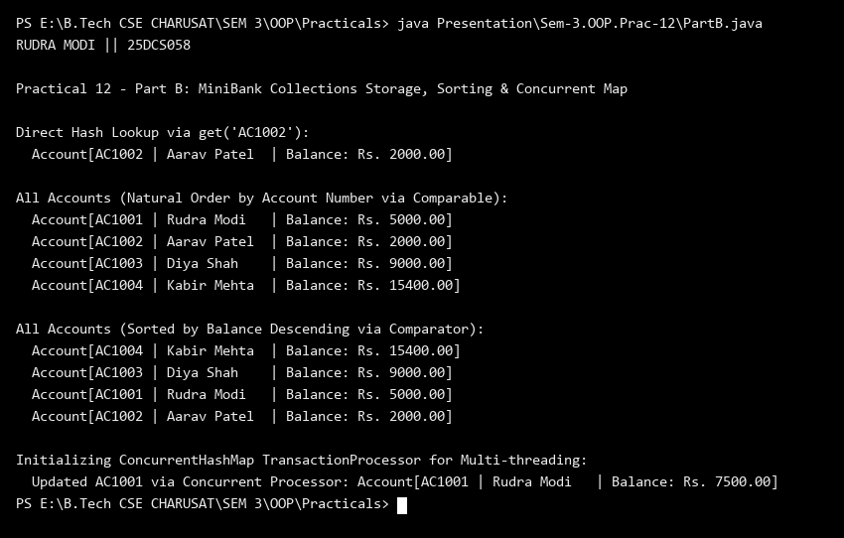
Key Questions & MiniBank Architecture Analysis:
Q1: Why is AccountStore upgraded from a static array to HashMap<String, Account>?
Answer: A static array has fixed capacity, requires manual resizing, and incurs linear O(n) search time to look up an account by its account number. Upgrading to HashMap<String, Account> keyed by unique account number provides instant O(1) average lookup, insertion, and deletion times, dynamic capacity expansion, and seamless integration with Java Collections framework.
Q2: Why does TransactionProcessor require a ConcurrentHashMap for multi-threaded account access?
Answer: Standard HashMap is unsynchronized and not thread-safe; concurrent structural modifications by multiple worker threads can cause data races, silent update loss, or infinite loops. ConcurrentHashMap uses fine-grained lock striping and compare-and-swap (CAS) operations to allow safe, highly concurrent read and write operations across multiple threads without synchronizing the entire map, guaranteeing high transaction throughput and thread safety.

