Practical 4: MiniBank Boundary Validator, Command Record & Parser
Problem Definition:
Validate inputs for Mobile, Email, PAN, and IFSC with compiled static regex Patterns; parse transaction command strings into a Command record; and format account statements with StringBuilder.
Code:
import java.util.regex.Pattern;
class PartB {
public static class Validator {
private static final Pattern MOBILE_PATTERN = Pattern.compile("^[6-9][0-9]{9}$");
private static final Pattern EMAIL_PATTERN = Pattern.compile("^[a-zA-Z0-9_+&*-]+(?:\\.[a-zA-Z0-9_+&*-]+)*@(?:[a-zA-Z0-9-]+\\.)+[a-zA-Z]{2,7}$");
private static final Pattern PAN_PATTERN = Pattern.compile("^[A-Z]{5}[0-9]{4}[A-Z]$");
private static final Pattern IFSC_PATTERN = Pattern.compile("^[A-Z]{4}0[A-Z0-9]{6}$");
private static final Pattern AMOUNT_PATTERN = Pattern.compile("^[1-9][0-9]*$");
public static boolean isValidMobile(String mobile) { return MOBILE_PATTERN.matcher(mobile).matches(); }
public static boolean isValidEmail(String email) { return EMAIL_PATTERN.matcher(email).matches(); }
public static boolean isValidPan(String pan) { return PAN_PATTERN.matcher(pan).matches(); }
public static boolean isValidIfsc(String ifsc) { return IFSC_PATTERN.matcher(ifsc).matches(); }
public static boolean isValidAmount(String amount) { return AMOUNT_PATTERN.matcher(amount).matches(); }
}
public enum TransactionType { DEPOSIT, WITHDRAW, TRANSFER }
public record Command(TransactionType type, String accountNumber, long amount) {}
public static class CommandParser {
public static Command parse(String line) throws IllegalArgumentException {
String[] tokens = line.trim().split("\\s+");
if (tokens.length != 3) {
throw new IllegalArgumentException("Error: Invalid token count.");
}
TransactionType type = TransactionType.valueOf(tokens[0].toUpperCase());
String accountNumber = tokens[1];
if (!Validator.isValidAmount(tokens[2])) {
throw new IllegalArgumentException("Error: Invalid amount.");
}
long amount = Long.parseLong(tokens[2]);
return new Command(type, accountNumber, amount);
}
}
public static class Account {
private String accountNumber, ownerName;
private long balance;
public Account(String accountNumber, String ownerName, long balance) {
this.accountNumber = accountNumber; this.ownerName = ownerName; this.balance = balance;
}
public String getAccountNumber() { return accountNumber; }
public String getOwnerName() { return ownerName; }
public long getBalance() { return balance; }
}
public static class StatementFormatter {
public static String buildStatement(Account account) {
StringBuilder sb = new StringBuilder();
sb.append("==================================================\n");
sb.append(" MINIBANK STATEMENT \n");
sb.append("==================================================\n");
sb.append("Account Number : ").append(account.getAccountNumber()).append("\n");
sb.append("Owner Name : ").append(account.getOwnerName()).append("\n");
sb.append("Current Balance: Rs. ").append(account.getBalance()).append("\n");
sb.append("==================================================\n");
return sb.toString();
}
}
public static void main(String[] args) {
System.out.println("RUDRA MODI || 25DCS058");
System.out.println();
System.out.println("Practical 4 - Part B: MiniBank Regex Validation & Masked Formatting");
System.out.println();
System.out.println("isValidMobile(\"9876543210\") -> " + Validator.isValidMobile("9876543210"));
System.out.println("isValidEmail(\"abc@xyz.com\") -> " + Validator.isValidEmail("abc@xyz.com"));
try {
Command c = CommandParser.parse("DEPOSIT AC0001 500");
System.out.println("Parsed Command: " + c);
} catch (Exception e) {
System.out.println(e.getMessage());
}
Account acc = new Account("AC0001", "Rudra", 9000);
System.out.println(StatementFormatter.buildStatement(acc));
}
}
Output:
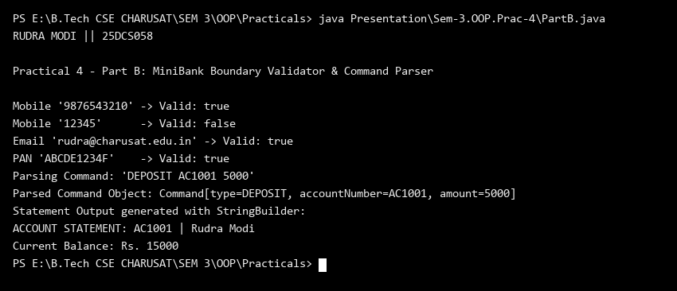
Key Questions & MiniBank Architecture Analysis:
Q1: Why are compiled static final Pattern objects used instead of String.matches()?
Answer: Compiling regex patterns once into static final Pattern constants avoids the overhead of recompiling the regular expression DFA on every validation call, significantly boosting transaction throughput and input validation performance.
Q2: How does StringBuilder improve account statement formatting performance?
Answer: StringBuilder allocates a single mutable buffer to assemble multi-line account statements, avoiding the creation of numerous transient String objects that would otherwise burden the garbage collector.

