ST20210475_ENG7003_WRIT1
Contents
Introduction 2
What is the problem we are solving? 2
Motive 2
Why is solving this problem important? 2
Definitions 2
Objectives 3
Methodology 3
Outline of the report. 3
Related Works 3
Design and Implementation 3
Design 3
Prerequisites 3
Installing Dependencies 3
Real Time Feed Detection. 3
Implementation 3
Analysis and Evaluation 3
Conclusion 3
References 4

Introduction

What is the problem we are solving?
The problem that is being solved is that traditional methods of physiotherapy rely on manual observation, are time consuming for both the patient and physiotherapist and can even result in physical error, such as a misdiagnosis.
However, through the use of pose detection and body landmarking, the Artificial Intelligence (AI) can produce precise readings on the patient and help identify the patient’s issues using overlayed visuals (Nawal Y & Al-Kazzaz, 2023).

Motive
The motive behind this project is implement AI in physiotherapy and give both doctors and patients an alternative option by using AI to help diagnose a problem or to help a patient with physiotherapy exercises. The aim is by using AI, to further improve both physical physiotherapy by providing better visuals on a patient’s problems, through the use of a pose-detection and body landmarking AI, as well as addressing how AI can be a major benefit for tele-physiotherapy, If physical appointments are not available.

Why is solving this problem important?
The reason solving this problem is important is by using body landmarking and pose detection on a patient that needs physiotherapy, the patient can be recorded with the pose detection and landmarking overlayed on their body and see how well their joints can move as well as visualise any problems that the patient may have.

Definitions
Computer Vision – A type of AI that uses machine learning to derive information from visual inputs such as videos or images (IBM, 2021).
Machine Learning – A type of AI that teaches machines to learn from experience, using computation methods to learn information from data. These algorithms improve the performance of a computer more effectively through an increasing number of samples (Carta, 2022).
Deep learning – A type of AI that “focuses on creating large neural network models that are capable of making accurate data-driven decisions” (D. Keller, 2019).
Novel ensemble models – An AI model that consists of multiple individually trained models, to which the combined outputs are used to make a prediction (Zeyu, et al., 2018).
Gaussian Mixture Model (GMM) – a specific machine learning method that determines the probability of each data point that belongs to a cluster (Whitfield, 2024).
Holistic model – An AI model that combines decision making, data, analysis, ethics and risk management to produce a comprehensive solution (Hyscaler, 2024).

Objectives
For this project, there are 3 main objectives:
- Create the AI model and test is using a variety of different gestures.
- Evaluate the model’s effectiveness
- Identify how the model can be further upgraded in the future.
The first objective is based on how we have created this AI and to test if the AI works, via using a different range of poses and seeing how effectively the camera can pick the landmarks up on a person.
The second objective is based on testing the model’s effectiveness by repeating a select number of poses and evaluating how well the AI picks these poses up on the camera.
The third objective is identifying how the current AI model can be implemented with other AI features to become more effective in the future.

Methodology
The report utilizes quantitative data to provide insight to the AI’s performance. The data collected focuses on evaluating the effectiveness of the pose estimation and body landmarking as well as evaluating the accuracy and precision of the landmarking.

Outline of the report.
This report will cover similar works that are relevant to the topic discusses and provide a good background and foundation on the existing topic. The report will also detail the design process and outline its implementations as well as an analysis regarding the AI’s effectiveness. The analysis will assess the AI’s performance as well as highlight the AI’s current strengths, limitations and areas for future improvements.

Related Works
LogRF: An Approach to Human Pose Estimation Using Skeleton Landmarks for Physiotherapy Fitness Exercise Correction (Raza, et al., 2023`)
This journal both studies and proposes an AI method to enhance the accuracy of a patients pose estimation. Through the use of computer vision and machine learning, the AI is able to precisely estimate human pose, which allows physiotherapists to analyse the movement of their patients and determine if they have the correct posture for effective physiotherapy as well as offering alternative / corrected poses if needed.
Smart Physiotherapy: Advancing Arm-Based Exercise Classification with PoseNet and Ensemble Models (Hussain, et al., 2024)
Since the Covid-19 pandemic, tele-physiotherapy has become an increasing solution for the delivery of remote healthcare. The paper explains how a study conducted has found that tele-physiotherapy can be enhance through the use of PoseNet (a deep learning pose estimation model) and novel ensemble models to classify exercises in real time, with the test data using 49 people doing 7 different exercises to achieve a 99.6% accuracy rating.
The success rate from the study has allowed for real-time feedback and the improving of patient care through the effectiveness of remote physiotherapeutic care.
PE-USGC: Posture Estimation-Based Unsupervised Spatial Gaussian Clustering for Supervised Classification of Near-Duplicate Human Motion (Iyer & Jeong, 2024)
This study introduces a posture estimation based on Gaussian mixture model (GMM) data to outperform standard neural networks. This model achieved a 96% accuracy, in comparison to the neural network model which was 7.2% lower and worked through focusing on spatial and temporal patterns of body landmarks.
AI Technologies for Machine Supervision and Help in a Rehabilitation Scenario (Baranyi, et al., 2022)
Using a composite AI framework which is supported by high-quality video examples, methods of home rehabilitation can be developed. This can be done by using key components such as 3D environment mapping, navigation dialogues and semantic maps to optimise both camera and pose accuracy. This paper proposes communication methods such as video guides and conversational dialogues to address challenges with at-home rehabilitation and to also effectively improve performance.

Design and Implementation

Design

Prerequisites
Before the implementation and design of the programme is explained, a background of what applications and tools used should be explained as well as what they are. For this project, 4 main tools are being used:
- A webcam (in this case, a laptop webcam was used),
- Mediapipe
- OpenCV
- Jupyter Notebook.
- Python version 3.9.1rc1
The reason for using mediapipe and OpenCV is because Mediapipe is a low-level tool used for the creation of machine learning models (Boesch, 2023) whilst OpenCV is a large computer vision (CV) library that is designed specifically for the creation of computer vision models (geeksforgeeks, 2024). Together, these 2 tools can be used simultaneously to develop CV AI models in Python using Machine Learning. The reason for using Jupyter Notebook is to see the outputs in real-time as well as the use of the applications ability to create specific code blocks where only the code inside specific blocks can be run. This is ideal once OpenCV and Mediapipe have been installed as it means you do not have to run the pip install commands multiple times and can just run the code blocks underneath.
Before the AI model can start being built, first Jupyter Notebook needs installing. To do this, run the command terminal and add the following line of code:
python -m pip install jupyter
This will start the Jupyter Notebook install. From there, create a folder on desktop and run jupyter notebook within the folder, which is where the AI model will be built. Once jupyter notebook is open, create a new file and start installing the dependencies that will be the foundations for the AI creation.
However, other programmes can be used instead of Jupyter Notebook such as Google Colab and Pycharm, however Jupyter Notebook was the chosen IDE as It can be used offline as well as works efficiently with both Mediapipe and OpenCV. Not only this but it also allows for ability to insert accurate documentation alongside the code as well as for the ability to create graphs and other data visuals in Markdown (Jacques, 2024).

Installing Dependencies
Once the IDE is installed, the next step is to install and import the dependencies.
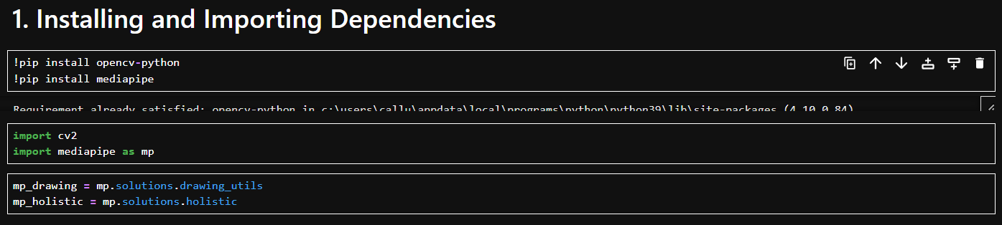
Figure 1: Installing the dependencies.
As seen in figure 1 above, the first code block consists of installing opencv and mediapipe onto the machine. Once the ‘pip install’ has been executed for both the opencv and mediapipe tools, the machine will add these tools to the source python file on the machine which can then be imported into Jupyter Notebook, as seen in the second code block in figure 1.
The 3rd block of our dependencies is declaring the “mp_drawing” and “mp_holistic” functions. By adding the drawing and holistic functions, the AI can now start to begin with creating the landmarking through the “mp_holistic” function and can also start drawing the skeletal mesh seen in figure 4 which connects the landmarks together to create the pose estimation section of the AI, using the “mp_drawing” function. These 2 functions are importing the mediapipe features that are required to create body landmarking and pose estimation so they can be used further down the line in different aspects which can be seen in both figure 2 and figure 3, which both use a different utilization of the “mp_drawing” function such as “mp_drawings.draw_landmarks” in figure 2 and “mp_drawing.DrawingSpec” in figure 3.

Real Time Feed Detection.
The main code block seen in figure 2, is what defines which camera to use, as well as defines the holistic model for different parts of the body such as the torso, both arms, which is connected together with the “mp_holistic.POSE_CONNECTIONS” seen in figure 3 below.
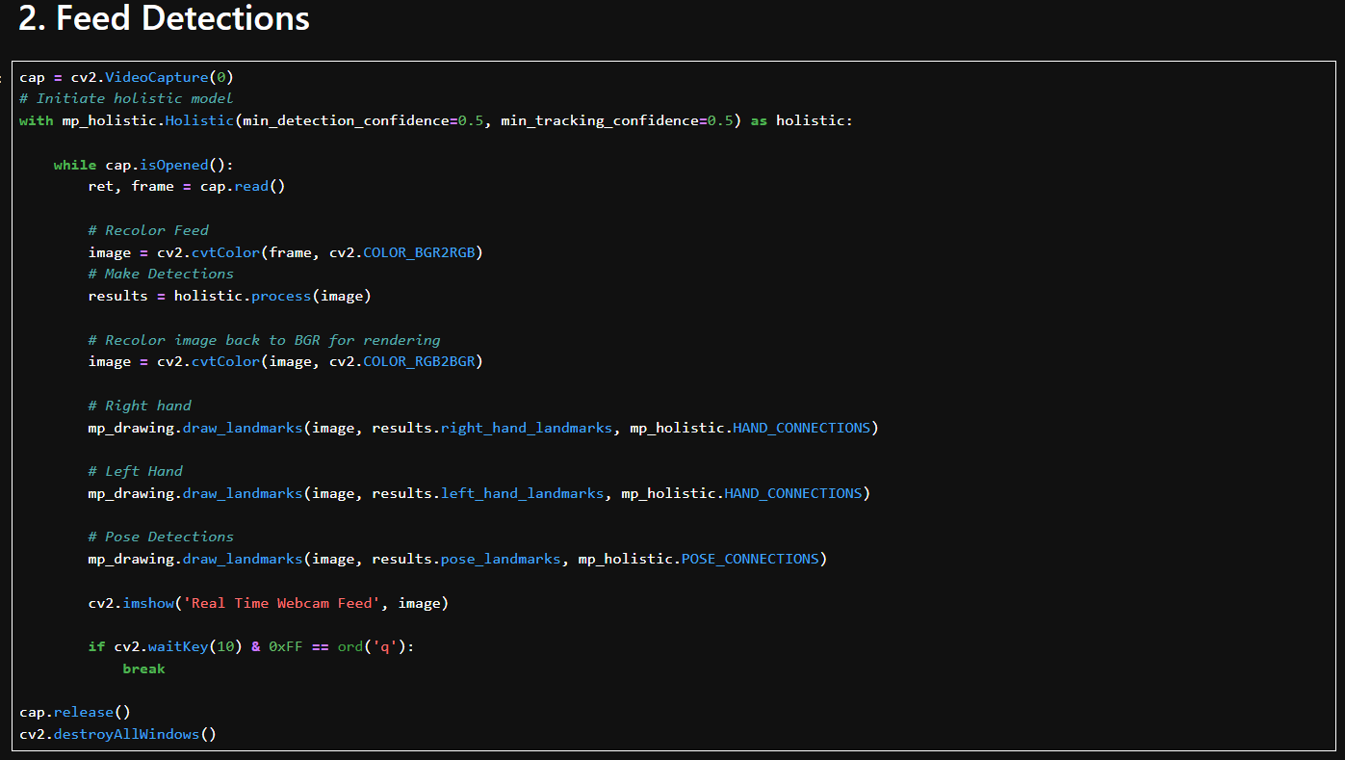
Figure 2: Real Time Feed Detection.
The first 3 lines of figure 2 declare that the laptop’s camera is going to be used rather than an external USB camera. To change the code to use a USB camera instead of the laptop’s built-in camera, can be done by changing first line from, “cap = cv2.VideoCapture(0)” to “cap = cv2.VideoCapture(1)”. This is essentially changing the visual output from automatically using the built-in hardware to using external hardware.
The code indent underneath “while cap.isOpened();” is stating that whilst the camera is opened to draw the landmarks in their respected place which is annotated with in-code comments, as well as to set those landmarks to a specific colour, in this case, the landmarks have been set to red, as seen in figure 4 below.
Also, within the code indent, a command has been given to shut down the camera using the “Q” key on the laptop’s keyboard which can be seen using the break command at the end of the code indent.
After the main code block, the next 3 code blocks will dictate the landmarks connection to each other as well as the details of the lines between the landmarks, that make up the pose estimations skeletal-mesh, which is seen in figure 3 below:
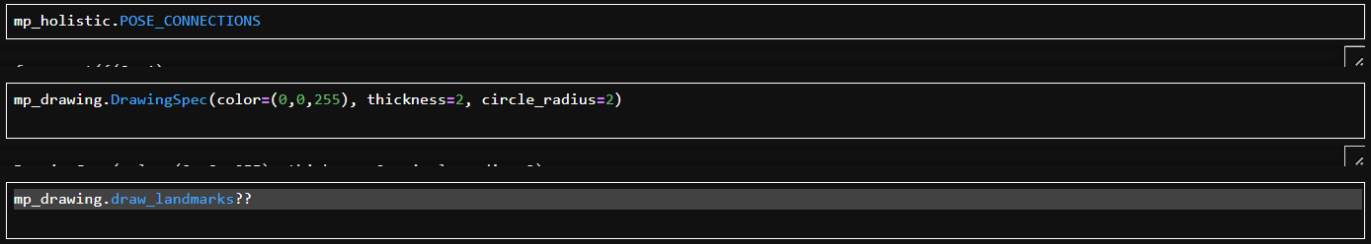
Figure 3 :Connecting the Landmarks
The code shown in figure 3 can be broken down as follows:
“mp_holistic.POSE_CONNECTIONS”. This will connect the body landmarks to each other to produce a skeletal-like overlay when the camera opens.
“mp_drawing.DrawingSpec(color=(0,0,255), thickness=2, circle_radius=2)”. This defines the thickness and colour of the lines that connect the landmarks which are connected together using previous line of code.
Finally, using “mp_drawing.draw_landmarks??” will display the source code for the function. This is done through using “??” after a declared function which will display the source code (Ipython Development Team, 2024)
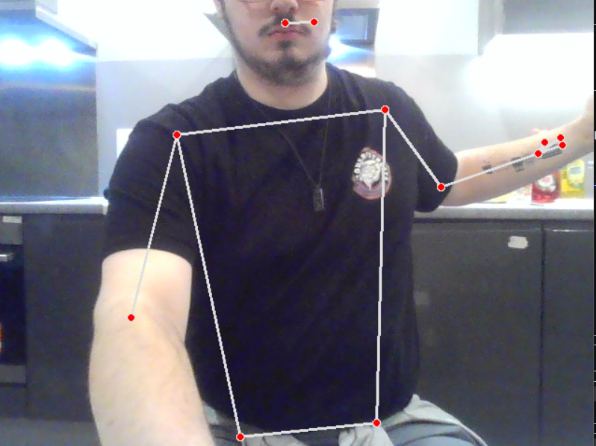
Figure 4:
As seen in figure 4 the body landmarking and pose estimation AI is adding an overlay on the laptop’s camera and creating specific landmarks around the body. Going back to the code in figure 3, the first block is what is connecting the red dots (the landmarks) between each other, again creating a skeletal mesh, with the second block is the design of the lines themselves.

Implementation
The implementation of this within physiotherapy is fairly straightforward as the code can work on both built-in hardware cameras as well as external USB cameras, allowing universal access to the pose estimation and body landmarking AI. The code itself could need to be adapted to run on an application rather than through Jupyter which is inconvenient for patients, especially those who aren’t technically intelligent. However, even in the code’s current state, the simplicity to the code makes it easier to run on any form of hardware allowing universal access for both the physiotherapist and the patient.
The implementation would essentially need this AI to be more user friendly than it currently is by adding a simple application with a GUI which when started, would initialise the programme and run it adding the overlay on the patient’s body. This would allow for a physiotherapist to visualise a patient’s problems better over tele-physiotherapy appointments as the landmarking can identify how well a patient can move or if the patient has movement issues, without the need for a physical appointment.

Analysis and Evaluation
As a solution to using AI to help diagnose physiotherapy, this shows promising results, as the body landmarking is very precise even at a range, making it ideal for tele-physiotherapy due to its accuracy. With the accuracy of the AI, it can help determine a diagnosis based on how the patient can or cannot move as if the patient cannot move in specific areas for example:
If a patient’s shoulder is injured it will reflect on the movement of the patients arm which can be easily detected by the AI and the landmarking, which can then be identified by the physiotherapist.
As seen in figures 5 and 6 below, when part of the body is obscured, the AI using its pose estimation to capture where the obscured parts may be. In this case it was a simple test to see how well the AI still picks up an obscured hand when it is both behind the subject’s head, as well as when the subject’s fist is balled up. The AI is still tracking the fingertips with moderate accuracy.
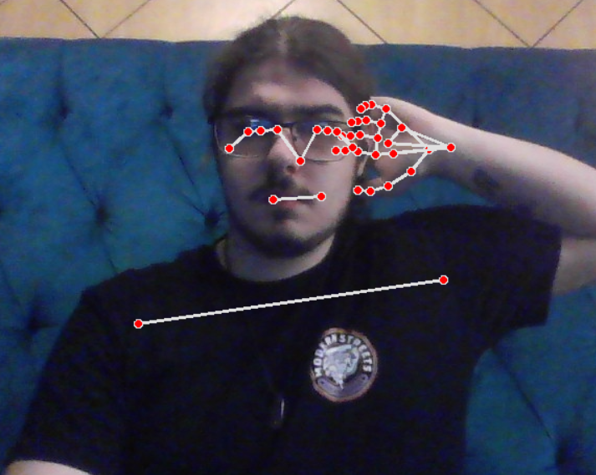
Figure 5
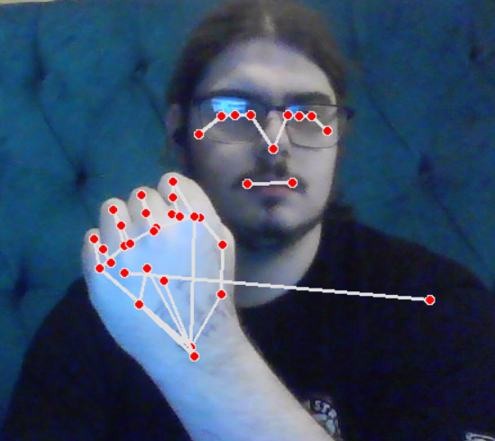
Figure 6
However, as seen in figure 7, there are limitations to the pose estimation and body landmarking. When the subject’s hand is obscured, the landmarking fails to detect the hand entirely. Due to the pose estimation AI relying on the visibility of the body landmarks, a common challenge has been highlighted which can affect the accuracy of the programme, in that the programme requires visible landmarks to identify the user.
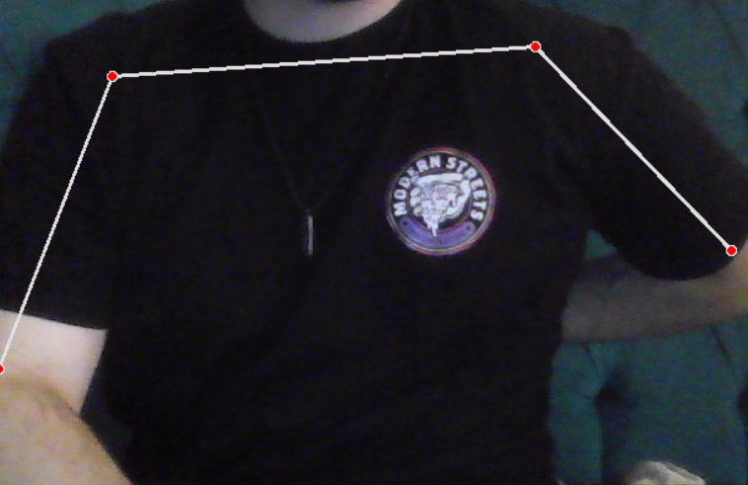
Figure 7
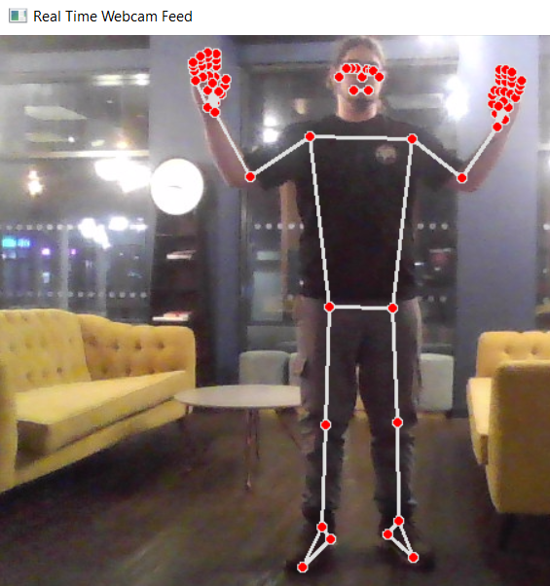
Figure 8: Full Body Landmarking
Overall, the pose estimation and body landmarking works with very accurate levels when the body is on full display, as seen in figure 8. Figure 8 was taken from roughly 10ft away from the camera with the hands and facial landmarks still showing very accurate results even from a good distance from the camera. However, the pose estimation software it cannot detect what it cannot see to a large extent as if the object Is semi-obscured as seen in figure 5 & 6, then the pose estimation AI kicks in and figures out where the rest of the fingertip landmarks should be. However, if the object is completely obscured then the landmarking will not be active and only landmark what it can see.

Conclusion
Overall, the objectives for this report were adequately met as not only was the AI created and tested, completing objective 1, but also testing the effectiveness in the Analysis and Evaluation which completed objective 2. In regard to objective 3 (future works) however, that still requires a discussion.
The next step for this AI is to create an application so the programme doesn’t need to be run on jupyter and can be used independently, making it ideal for mainstream consumer use. Implementing this into an easy-to-use application allows for any patient whether they are technologically illiterate or know their way around technology, to use this AI universally.
Not only this but to also put the AI through more rigorous machine learning to increase the accuracy of the pose estimation which can benefit the AI further, giving it more capabilities and to be adapted for use outside of the physiotherapeutic use mentioned throughout this report.

References
Baranyi, g. et al., 2022. AI Technologies for Machine Supervision and Help in a Rehabilitation Scenario. Interactive Artificial Intelligence and Man-Machine Communication.
Boesch, G., 2023. MediaPipe: Google’s Open Source Framework (2024 Guide). [Online]
Available at: https://viso.ai/computer-vision/mediapipe/
[Accessed 18 December 2024].
Carta, S., 2022. Machine Learning and the City: Applications in Architecture and Urban Design. s.l.:John Wiley & Sons Ltd.
D. Keller, J., 2019. Deep Learning. Illustrated ed. s.l.:MIT Press 2019.
geeksforgeeks, 2024. What is OpenCV Library?. [Online]
Available at: https://www.geeksforgeeks.org/opencv-overview/
[Accessed 18 December 2024].
Hussain, S. et al., 2024. Smart Physiotherapy: Advancing Arm-Based Exercise Classification with PoseNet and Ensemble Models. Sensors, 24(19).
Hyscaler, 2024. Holistic Approach to AI: Debunking Myths, Accentuating Importance, and Exploring Functions in 2024. [Online]
Available at: https://hyscaler.com/insights/holistic-approach-to-ai-2024/
[Accessed 19 December 2024].
IBM, 2021. What is Computer Vision?. [Online]
Available at: https://www.ibm.com/think/topics/computer-vision
[Accessed 18 December 2024].
Ipython Development Team, 2024. Python vs IPythonℑ. [Online]
Available at: https://ipython.readthedocs.io/en/stable/interactive/python-ipython-diff.html
[Accessed 19 December 2024].
Iyer, H. & Jeong, H., 2024. PE-USGC: Posture Estimation-Based Unsupervised Spatial Gaussian Clustering for Supervised Classification of Near-Duplicate Human Motion. IEEE Access, Volume 12, pp. 163093-163108.
Jacques, B., 2024. Why Jupyter Notebooks Are My Favorite OpenCV Playground. [Online]
Available at: https://spindance.com/2024/05/22/why-jupyter-notebooks-are-my-favorite-opencv-playground/#:~:text=Conclusion,is%20incredibly%20powerful%20and%20quick.
[Accessed 19 December 2024].
Nawal Y, A. & Al-Kazzaz, S. A., 2023. Evaluation of Physiotherapy Exercise by Motion Capturing Based on Artificial Intelligence: A Review. Al-Rafidain Engineering Journal, Volume 28, pp. 237-251.
Raza, A. et al., 2023`. LogRF: An Approach to Human Pose Estimation Using Skeleton Landmarks for Physiotherapy Fitness Exercise Correction. IEEE Access, Volume 11.
Whitfield, B., 2024. Gaussian Mixture Model Explained. [Online]
Available at: https://builtin.com/articles/gaussian-mixture-model#:~:text=A%20Gaussian%20mixture%20model%20(GMM,method%20used%20in%20unsupervised%20learning.
[Accessed 18 December 2024].
Zeyu, W., Yeuren, W. & Srinivasan, R. S., 2018. A novel ensemble learning approach to support building energy use prediction. Energy and Buildings, Volume 159, pp. 109-122.

