Using an IoT to create an Object detection AI, to identify and locate potholes using camera mounted UAV's

A dissertation submitted in partial fulfilment of the requirements for the degree of Master of Science.

by C. Waters

Masters of Science Degree in Robotics and Artificial Intelligence

Cardiff School of Technologies
Cardiff Metropolitan University, Cardiff
August 2025

Abstract
The project discusses the implementation of object detection artificial intelligence (AI) on unmanned aerial vehicles (UAVs) to detect and identify potholes in still images and real-time video. Through the use of single-board computers (SBCs) such as the Raspberry Pi, a YOLO-based object detection algorithm is trained and run to process vision data from an external camera. The SBC is mounted on a light UAV, enabling real-time in-flight pothole detection with real-time video being transmitted to a machine on the ground for monitoring by a human operator. By utilizing UAVs, the system has the benefit of an aerial perspective, allowing greater coverage of roads and cityscapes and greater detection effectiveness than ground-based inspection methods. This aerial approach enhances the ability for quick and precise detection of potholes to help facilitate more effective road maintenance and safety monitoring.

Acknowledgements
Thank you to my supervisor, Dr Issam Damaj, for providing guidance and feedback throughout this project. Also thank you to Cardiff Metropolitan University's School of Technology for providing me with the necessary equipment for me to create this project.

Table of Contents
Abstract 2
Acknowledgements 2
Table of Contents 3
Table of Figures 4
Introduction 6
Lit Review 8
Object Detection for Drones on Raspberry Pi Potentials and Challenges (Quang Khoi, et al., 2021) 8
The Unmanned Aerial Vehicle Benchmark: Object Detection, Tracking and Baseline (Yu, et al., 2020) 10
An Intelligent Real-Time Object Detection System on Drones (Chen, et al., 2022) 12
Detection and Tracking Meet Drones Challenge (Zhu, et al., 2022) 16
Swarm Reconnaissance Drone System for Real-Time Object Detection Over a Large Area (Moon, et al., 2023) 16
Research Objectives and Hypotheses 18
Methodology 19
Design 21
Acquiring the Dataset 22
Annotating the Dataset 22
Training the YOLO Model 29
Implementing the Model into an SBC 33
VNC 35
Design Overview 37
Data Analysis 41
Precision Confidence 41
Recall Confidence 44
Precision Recall 46
F1 Score 48
Confusion Matrix 50
Future Works 53
Conclusion 53
Bibliography 54

Table of Figures
Figure 1: Pothole Claims (Leeds City Council, 2018) 6
Figure 2: Effects of Shutter Speed to Object Detection Accuracy (Quang Khoi, et al., 2021) 7
Figure 3: Effect of Value of Frames Per Second (FPS) Value to the Program's Real-Time Performance (Quang Khoi, et al., 2021) 7
Figure 4: Architecture of the proposed context-aware multi-task Siamese network. Components in blue are the feature maps generated by various stages in the network. Components in other colours are the components of layers in the network. Gray arrows show the data flow in the network. The upper branch generates the context consistency, and the lower branch generates the appearance similarity (Yu, et al., 2020) 9
Figure 5: Kintex-7 410T FPGA (Chen, et al., 2022) 11
Figure 6: Proposed intelligent system (Chen, et al., 2022) 12
Figure 7: A data distributed service-based swarm reconnaissance drone system for real-time object detection over a large area is proposed in which the system simultaneously controls and operates multiple drones using safe and integrated command (Moon, et al., 2023). 13
Figure 8: An example of bounding boxes used in Object Detection (Boesch, 2024) 18
Figure 9: The five parameters for bounding boxes (Li, et al., 2020) 18
Figure 10: Label Studio 19
Figure 11: Label Studio data import 20
Figure 12: Label Studio Object Detection 20
Figure 13: Creating the Label Studio project 21
Figure 14: Example of data annotation 21
Figure 15: Label Studio export option 22
Figure 16: YOLO directory structure 22
Figure 17: Label distribution 23
Figure 18: YAML file creation code 25
Figure 19: YOLO training code 25
Figure 20: Object detection validation 27
Figure 21: Windows machine accessing the Pi via VNC 29
Figure 22: Object detection accessed through VNC 30
Figure 23: Decision tree 31
Figure 24: Project Gantt Chart 32
Figure 25: Circuit diagram 33
Figure 26: IoT diagram 34
Figure 27: YOLOv5n Precision Confidence Curve 35
Figure 28: YOLOv8n Precision Confidence Curve 35
Figure 29: YOLOv11n Precision Confidence Curve 36
Figure 30: YOLOv5n Recall-confidence curve 37
Figure 31: YOLOv8n Recall-confidence curve 38
Figure 32: YOLOv11n Recall-confidence curve 38
Figure 33: YOLOv5n Precision-recall curve 39
Figure 34: YOLOv8n Precision-recall curve 40
Figure 35: YOLOv11n Precision-recall curve 40
Figure 36: YOLOv5n F1-Confidence Curve 41
Figure 37:YOLOv8n F1-Confidence Curve 42
Figure 38: YOLOv11n F1-Confidence-Curve 42
Figure 39: YOLOv5n Confusion Matrix 43
Figure 40: YOLOv8n Confusion Matrix 44
Figure 41: YOLOv11n Confusion Matrix 45

Introduction
Object detection is a Computer Vision (CV) Artificial Intelligence (AI) algorithm, that can identify and locate objects within various types of visual media. The algorithm will apply a bounding box around the detected object on screen and can also track the objects in real-time (Bouguettaya, et al., 2022). Object detection can be used to identify any custom trained object using images and videos, with it being able to identify multiple trained objects at once, through the use of classes, where when creating the custom dataset for the object detection model, the user will need to highlight and divide their required objects into different classes (Zou, et al., 2023).
You Only Look Once (YOLO) is a specific type of object detection algorithm which consists of a small model size, and fast calculation speeds. It is a Single Shot Detector (SSD) architecture model, but because of its simplistic architecture, low complexity and easy implementations, YOLO is one of the more common options in industry (Diwan, et al., 2022). The YOLO model will separate the input image into a S X S size grid. If the objects centre is being placed into the grid cell, then the grid cell will try the object detection on itself. Every grid cell will then try to estimate a bounding box, and the confidence score across all classes is trained to predict (H.D.I & Kuganandamurthy, 2021).
This project will be focusing on how Object Detection AI can be implemented with Unmanned Aerial Vehicles (UAVs), to detect and identify potholes from images, as well as real-time footage. Using Single Board Computers (SBC) such as Raspberry Pi's, the YOLO based object detection model can be trained and implemented, so the SBC can detect and identify potholes through the use of an external camera. The SBC can then be integrated onto a lightweight UAV, where the real-time in-flight pothole detection video will be streamed to a machine on the ground, for the UAV operator to see. The reasoning behind implementing an object detection model into a UAV, is so that the UAV can fly over roads and other urban areas, in real-time and identify potholes with greater effectiveness in comparison to what a ground vehicle might possess, due to the UAV's aerial capabilities. The aerial capabilities will allow for the camera to pick up a wider area from an aerial view.
At the start of 2024, the Royal Automotive Club (RAC) reported an estimate of 6 potholes per mile across both England and Wales, causing an average of £600 of damages to fix per car (RAC, 2025). The RAC are a roadside service company who specialise in different areas from breakdown assistance to insurance, as well as also publishing reports based on key road safety issues, such as the pothole index (RAC, 2025). In the RAC's 2023 pothole index, they also reported that an estimated £824,000 had been paid out to drivers as a direct result of pothole related damages.
Not only that however, but in 2018, Leeds City Council released a pothole claims report which shows the total number of roadway pothole claims and payments made for vehicles, pedestrian injuries and bicycles, between 2009 and 2018. Over this 9-year period, an estimate of $2.5 million was spent, just on these claims alone, according to the data seen in figure 1:
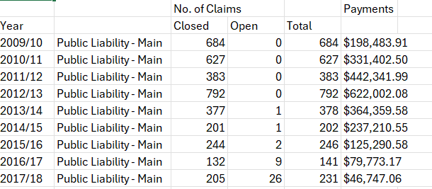
Figure 1: Pothole Claims (Leeds City Council, 2018)
(Leeds City Council, 2018).
With the mass number of potholes across England and Wales, being able to detect and locate potholes, is a massive success in addressing the overall issue of how potholes negatively impact road safety and road infrastructure as a whole.
Throughout this paper, discussions are made on the use of object detection AI, UAV implementation, previous research based on similar types of computer vision and their use cases, research objectives and any hypotheses made about this project, analysis about the data collected, detailed explanations on the creation of the project and how further research would be conducted and improved.

Lit Review

Object Detection for Drones on Raspberry Pi Potentials and Challenges (Quang Khoi, et al., 2021)
In a 2021 journal by Khoi, Quang and Hieu, called Object detection for drones on Raspberry Pi potentials and challenges, the authors explain how drones can be equipped with single board computers with object detection AI installed. The paper focuses on how using Python and TensorFlow libraries, an Artificial Neural Network (ANN) that focuses on estimating the distance and velocity of objects, can be implemented on a Raspberry Pi 3B+.
The project used TensorFlow's Object detection API and Microsoft's COCO dataset, and the SSDLite_MobileNet_V2 lightweight model. The COCO dataset was chosen due to its mass variety, offering 91 object categories over 200,000 images, whilst SSDlite_MobileNet_V2 was chosen due it's performance score of 0.81 when testing for bounding boxes for detected objects.
The results for this project explain how the highest precision for distance estimation was between 2-6 meters in distance away from the camera, with the model having a 10% error margin. Optimal accuracy was between 4-6 meters away with the model being able to detect objects at a rough maximum of 12 meters away.
In video tests with the model, a swinging pendulum was used to evaluate the model's "ability to determine the effect of distance and camera shutter speed to the accuracy of recognition". The model's accuracy decreased at lower shutter speeds due to motion blur, however, at higher shutter speeds of 1/30 seconds or faster, the program's accuracy was nearly identical, as seen in figure 2:
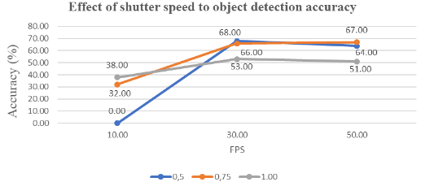
Figure 2: Effects of Shutter Speed to Object Detection Accuracy (Quang Khoi, et al., 2021)
As for real-time performance, the model struggled due to hardware limitations, with the model only reaching 0.71 fps. The model also could not keep up with higher frame rates, with the model's performance dropping linearly as FPS increased, which can be seen in figure 3:
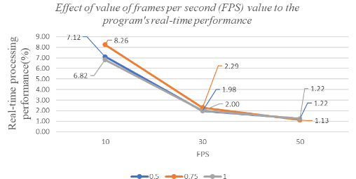
Figure 3: Effect of Value of Frames Per Second (FPS) Value to the Program's Real-Time Performance (Quang Khoi, et al., 2021)
The Authors concluded that the programme can run smoothly, with good accuracy and minimal problems on the Pi 3B+ for still images and videos. However, for real-time use, the model runs extremely poorly, and the hardware would need to be changed for an SBC with more resources, such as an Nvidia Jetson nano.

The Unmanned Aerial Vehicle Benchmark: Object Detection, Tracking and Baseline (Yu, et al., 2020)
In a 2020 journal article called "The Unmanned Aerial Vehicle Benchmark: Object Detection, Tracking and Baseline" by Li, Zhang, Huang, Du, Tian and Sebe, defines a comprehensive benchmark, which is designed to evaluate and analyse object detection and tracking methods for computer vision applications involving UAVs. The study presents a UAV dataset consisting of 100 real-world videos, featuring approximately 2,700 vehicles and over 840,000 manually annotated bounding boxes.
The benchmark proposed by the authors evaluates three fundamental computer vision tasks within the context of UAV video analysis. The three fundamentals are:
- Object Detection,
- Single-Object Tracking (SOT),
- Multi-Object Tracking (MOT).
Object detection focuses on the identification and localisation of relevant objects within each frame of the UAV video footage, with the relevant object mainly being vehicles. Single-Object Tracking evaluates the system’s ability to continuously follow a specific target object across multiple frames, even amongst background clutter, background noise and partially obscured views. Multi-Object Tracking works in the same way as SOT, however extending the functionality to multiple target objects instead of just one.
Through designing the dataset and benchmark for the aforementioned tasks, the authors address specific challenges of UAV scenarios, including small object sizes, fast camera motion, high object density and complex environments, with these challenges being specifically emphasized in the dataset’s diversity and annotation structure.
Alongside these fundamental CV tasks, the authors also introduce a baseline model called the 'Context-aware Multi-task Siamese Network' (CMSN), which incorporates both detection and tracking, through implementing contextual information surrounding each target object. The architecture reflects how performance of CV models in Aerial surveillance can be significantly improved through modelling the special and temporal contexts as well as the target object. The way the CMSN model works is through using a Siamese architecture based on ResNet for multi-task learning, which can be seen in figure 4 below. The CMSN model uses 2 sub-Siamese networks, one for appearance similarities using centre patches, and the other for context consistency using Exchange Object Context Sampling (EOCS) patches. Each sub-network shares weights across its Conv5 layers and produces 2048-dimensional feature maps (F-Conv5). For context consistency, EOCS feature maps are concatenated into F-FC and passed through a fully connected layer with softmax classification. A similar process applies to centre patches for appearance similarity. To estimate detection offsets, F-Conv5 maps from all four patches are combined into F-Conv, which passes through Conv6 and two fully connected layers to produce the final offset predictions.
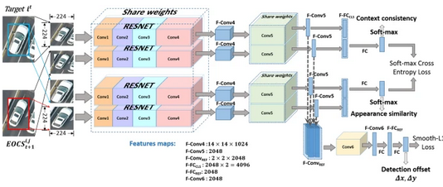
Figure 4: Architecture of the proposed context-aware multi-task Siamese network. Components in blue are the feature maps generated by various stages in the network. Components in other colours are the components of layers in the network. Gray arrows show the data flow in the network. The upper branch generates the context consistency, and the lower branch generates the appearance similarity (Yu, et al., 2020)
The benchmark evaluation demonstrates that conventional detection and tracking algorithms often struggle under the unique challenges posed by UAV footage, such as rapid scale variations, motion blur, and frequent occlusion. The proposed CMSN model, while not state-of-the-art across all metrics, establishes a solid performance baseline and showcases the advantages of leveraging context-aware features. Quantitative results presented in the paper show improved tracking accuracy and detection precision when context is included in the model architecture. Beyond individual performance gains, the benchmark’s real impact lies in its potential to unify and accelerate UAV-based vision research by providing a common ground for evaluating algorithms under a shared set of conditions. The study encourages the development of more resilient and context-sensitive models and sets a precedent for future aerial datasets in terms of scale, diversity, and annotation quality.
The UAV detection and tracking benchmark reveals that conventional detection and tracking algorithms struggle with UAV-specific challenges such as rapid scale changes, motion blur, small objects, and obscured views. The proposed CMSN model provides a strong context-aware baseline, improving accuracy and strength across object detection, SOT and MOT
The hardware evaluation setup is as follows:
- Detection: i9 7900X, GTX 1080 Ti, 64 GB RAM
- SOT: i7 4790k, Titan X, 16 GB RAM
- MOT: i7 6700, Titan X, 32 GB RAM
For Object detection, region-based methods (Faster-RCNN, R-FCN) outperform region-free ones (SSD, RON), though all degrade under UAV conditions. SSD offers high speed (41.55 fps) but lacks definitive accuracy for small objects. R-FCN AP drops from 70.06 (KITTI-D) to 34.35 (UAV detection and tracking).
For SOT, CMSN-based S-CMSN-M outperforms state-of-the-art trackers like MDNet and ECO by using context and domain knowledge, excelling across 8/10 common and 8/11 UAV-specific attributes. Fog surprisingly aids tracking due to simpler backgrounds.
For MOT, CMSN variant M-CMSN-M achieves the best scores (MOTA: 43.1, IDF1: 64.6), outperforming online (DSORT, MDP) and batch (GOG, IOUT) trackers. Faster-RCNN inputs provide better results. MOT accuracy drops with altitude and fog due to reduced visual distinctiveness.
Overall, the benchmark promotes a unified evaluation under real-world UAV conditions, further promoting development of context-aware models for aerial surveillance tasks.

An Intelligent Real-Time Object Detection System on Drones (Chen, et al., 2022)
In a 2020 journal article by Chen, Min, Peng, Yang and Wang called "An Intelligent Real-Time Object Detection System on Drones", the authors propose a real-time object detection system for drones, which is composed of a Field Programmable Gate Array (FPGA) and a drone. The FPGA is designed for real-time object classification and detection, with the drones sending image data to the FPGA through the host, which is assembled into the data stream for access by multiple fetch and jump pointers. The processing elements will run tasks in parallel to the filtration of the activation values for each thread, by using multiple weights and threads. This process speeds up the running of the deep-learning neural network.
The authors then explain how once the FPGA is designed, it is used to build an intelligent system so that the drones can adjust flyting routes to generate more pixels for objects, increasing the accuracy on detected objects based on the FPGA results. The projects experimental results explain how the proposed FPDA design uses a good amount of FPGA computing resources, with an 81.56% DSP and a 72.80% Look Up Table (LUT) rate. For fast object detection, the YOLOV3-tiny model was utilized, with the system being able to detect at 8FPS, also achieving a lower power consumption compared to state-of-the-art methods, such as ResNet-50 and YOLOV3. The intelligent object detection techniques provide more pixels for the target object and can also increase the detection confidence score from 0.74 to 0.90, and from 0.70 to 0.84 for people and cars.
To enable real-time object detection with various neural network models, a Kintex-7 410T FPGA (figure 5) was utilised to design a reconfigurable accelerator architecture. This FPGA features a 406,720 logic cells, 1540 DSP slices, and 28 Mb block RAM, supports high-speed, parallel processing ideal for neural-network applications. The neural-network engine architecture begins by transferring data to the FPGA, where it’s assembled into data streams. These are processed via a multi-threaded fetch-and-jump mechanism, allowing each thread to independently access activation data using programmable fetch pointers. Data is filtered through sliding windows, and threads are dynamically allocated using dedicated buffers. Activation data and weights are fed into multiple processing elements for parallel neural-network computation. The outputs are stored in an out-of-order buffer, reordered by an in-order module, and sent to the external data sink.
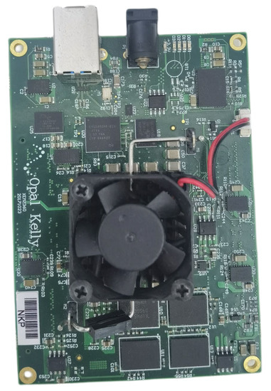
Figure 5: Kintex-7 410T FPGA (Chen, et al., 2022)
To build the intelligent drone system, a AMOVLAB Z410 drone was used. This drone is equipped with an Intel Realsense T265 tracking camera, a flight controller, and a Raspberry Pi 4 Model B host running Ubuntu 20.04. The host features a quad-core ARM Cortex-A72 CPU @ 1.5 GHz and is connected to an FPGA for neural-network acceleration. The host acts as the system's central controller, managing data flow and communication, receiving image data from the camera and sending it to the FPGA for AI processing, returning the results for further action. It also communicates with the flight controller to ensure stable and safe flight. The full system is made up of four main components:
- host,
- camera,
- flight controller,
- FPGA.
as well as supporting components such as a battery for GPS and positioning usage. The proposed intelligent system can be seen in figure 6 below.
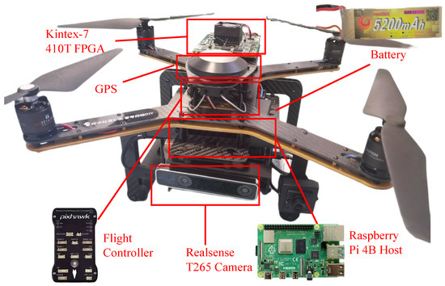
Figure 6: Proposed intelligent system (Chen, et al., 2022)
The intelligent detection system proposed has been designed to only report images above a certain confidence score, which reduces unnecessary data and transmission, also conserving bandwidth. During flight, the drone captures images using onboard sensors. The host sends these to the FPGA, which runs models like ResNet-50, Yolov3, and Yolov3-tiny for low-power object detection. The system checks for targets of interests such as people, cars or other objects that have been defined by the user. During flight, the drone captures images using onboard sensors. The host sends these to the FPGA, which runs models like ResNet-50, Yolov3, and Yolov3-tiny for low-power object detection. The system checks for targets of interest (TOIs)—e.g., people or cars—defined by the user.
If no target of interests is detected, the drone continues scanning. If a target of interest is found, the system evaluates the confidence score. If it meets or exceeds the threshold, the image is transmitted to the remote server. If not, the drone adjusts its position to capture better views, aiming to increase the score. The threshold balances accuracy and reporting frequency: low thresholds increase reporting but risk misclassification; high thresholds reduce uncertainty but may prevent reporting altogether. For example, an initial confidence of 0.60 may rise to 0.90 after repositioning, ensuring accurate detection before reporting.

Detection and Tracking Meet Drones Challenge (Zhu, et al., 2022)
In a 2022 journal article called "Detection and Tracking Meets Drones Challenges" by Zhu, Wen, Du, Bian, Fan and Hu, the article presents "VisDrone" which is a large-scale drone-captured benchmark dataset which is composed of roughly 260 video clips, and 10,000 static images which were captured across 14 cities in China. The Visdrone dataset has media captured in both rural and urban environments, different weather settings and camera platforms which provides extreme diversity in data.

The purpose of this article was to create a new benchmark for both video and image object detection, single object detection and multi object detection, providing an evaluation for all platforms. On top of this the article evaluates different object detection and tracking algorithms to analyse their advantages and disadvantages, as well as potential further research.
By collecting a large-scale dataset from 14 diverse urban and suburban locations across China, the authors ensure a wide variety of scenarios, including varying altitudes, lighting conditions, occlusions, and dynamic backgrounds, which are critical for testing algorithm effectiveness. Not only this but, the dataset is manually annotated with high-quality labels, ensuring precision and reliability for training and evaluation purposes. The benchmark also incorporates standardized evaluation metrics tailored to each track, facilitating fair and consistent comparison among different algorithms.
The paper as a whole, follows similar methods to Yu, et al's article from 2 year prior, "The Unmanned Aerial Vehicle Benchmark: Object Detection, Tracking and Baseline". This paper followed objectives, research purpose and evaluations as well as specific topics such as evaluating object detection, SOT and MOT.

Swarm Reconnaissance Drone System for Real-Time Object Detection Over a Large Area (Moon, et al., 2023)
In a 2023 journal article called "Swarm Reconnaissance Drone System for Real-Time Object Detection Over a Large Area" by Moon, jeon, Kim and Kim, the article proposes a data distributed service-based swarm reconnaissance drone system. This is a system which simultaneously controls and operated a drone swarm using integrated commands, an example of which can be seen in figure 7 below. The purpose behind this project is to create a multi-UAV reconnaissance system which can perform real-time object detection by using YOLOv5 and stitching together multiple images taken from different drones in the swarm.
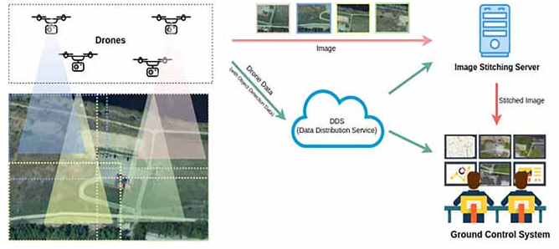
Figure 7: A data distributed service-based swarm reconnaissance drone system for real-time object detection over a large area is proposed in which the system simultaneously controls and operates multiple drones using safe and integrated command (Moon, et al., 2023).
For the multi-UAV system / drone swarm, each individual drone has a flight controller computer running PX4 autopilot for navigation and a mission computer based on ROS2 for real-time object detection. Communication relies on ROS2’s data distribution service for effectiveness and command redundancy, with the system featuring a UAV shift algorithm to swap drones with low battery, ensuring continuous operation. The image stitching server merges multiple UAV video streams into a unified view, enabling effective large-area surveillance.
The aerial stitching system merges separate images from multiple drones by extracting and matching feature points using a deep learning approach using SuperPoint and SuperGlue. The system estimates a homography matrix using direct linear transformation and refines it using the RANdom SAmple Consensus (RANSAC) algorithm to remove outliers. To handle any overlapping areas, the system uses weights to feature point errors based on their distance from the overlapping centre and then validates the homography matrix by checking distortion and project values. If abnormalities are detected, it switches from projective to affine transformation, which is sufficient due to camera stabilization. When overlap is minimal or errors occur, UAV positional data is used for image registration, ensuring robust and efficient stitching for real-time wide-area surveillance.
The VisDrone-2019 dataset (6,471 training and 1,610 test images) was used to train and evaluate the object detection network with a fixed batch size of 32 and image size of 1376×1376. Inference was tested on an Nvidia Jetson Xavier NX using PyTorch and TensorRT with INT8 quantization for faster performance. The proposed filter pruning method was compared to Liu’s and HFP pruning methods at 30%, 40%, and 50% pruning levels. The proposed method effectively pruned both parameters and FLOPs, achieving up to 51.2% parameter reduction and 46% FLOPs reduction with only a 0.9% drop in mAP (0.5:0.95). Inference speed improved by up to 58.7%, outperforming other methods which either over-pruned or failed to meet pruning targets. The pruning reduced memory usage and power consumption while maintaining accuracy, making it well-suited for embedded UAV hardware.

Research Objectives and Hypotheses
The primary objective for this research is to develop an object detection model, which is capable of adequately detecting potholes through real-time video and still images, using the YOLO AI model. During the testing, multiple YOLO models will be used and their effectiveness compared based on how well they perform, not only during the testing of real-time footage, but also when testing still images. The goal is to enable smarter, more efficient road maintenance by automating the identification of potholes. This involves collecting and annotating a large dataset, training the model, and evaluating its performance to assess accuracy and efficiency.
The secondary objective is to implement the trained YOLO model onto a SBC, which can be used to test the model using real-time video footage in real-time conditions, as well as testing the model using still images. Testing with still images allows for precise, frame-by-frame analysis of the model’s accuracy, while real-time video testing assesses the model's ability to detect potholes under varying conditions such as motion blur, lighting changes, and varying speeds.
The final objective is to implement VNC into the SBC so another machine can access the real-time video footage remotely, so that a separate machine can access the drone footage, whilst the drone is in operation.
This research hypothesizes how using various YOLO object detection models, there exists at least one model out of the models chosen, that can accurately and efficiently detect potholes in both real-time video and still images and can be successfully deployed on a single-board computer (SBC) for real-time inference as well as enabling remote monitoring via VNC.

Methodology
The main research philosophy used for this project will be positivism, due to the project relying on objective and measurable data. The Positivism research method relies on the adoption of a scientific end empirical approach to research, with the assertion that knowledge is best gained through observable facts and relationships as well as logical reasoning. Furthermore, the positivism philosophy is a scientific approach with the goal of validating social science studies, as well as the human organisations within social science studies (Helmi alharahsheh & Pius, 2020).
This project aims to create an object detection AI model, which is capable of detecting potholes as objects through object detection image analysis. The model will then be implemented into a UAV system, using an SBC and an external camera attached to the SBC for the object detection. Another machine on the ground will then have the video image from the drone streamed to it, providing aerial visuals to the ground machine and operator.
The development process will be broken down into a multi-stage process using the agile method:
- Obtain the dataset,
- Create and train the model,
- Implement the model into a SBC,
- Test the model on the SBC.
- Create a framework to implement the model into a UAV.
For the dataset, an online dataset was used which consisted of over 600 images, with the dataset having a "CC0: Public Domain" creative commerce license. As this dataset has a CC0 licence, this means that the author of the dataset has waived all rights, so that the dataset can be used by scientists, artists, educators and any other individual who may want to use the dataset. This also means that the dataset can be used, altered and expanded without any restrictions whatsoever (Creative Commons, 2025).
Once the dataset has been obtained, it can now be used to train the model, with the model being trained using different YOLO models to test which model is the most effective for the project. YOLO was chosen specifically for this project, as it can provide high real-time accuracy and performance for a single-stage detector, as well as being less resource intense in comparison to a two-stage detector (Cai, et al., 2022). Using a less resource intense model is optimal for this project, as the model will be running on a SBC which only has a limited amount of hardware resources the model can use.
Once the model has gone through the training and test process using YOLO, the next stage is to implement the model onto the SBC, which can then be tested in real-time environments, during the next stage.
The final stage of this project is to create a framework, on how the how the created model can be implemented into a UAV. As the main purpose for this drone is for it to be used within construction and surveying, there are legal requirements that need to be followed, so the drone can be used in public areas:
- First, the organisation needs to register their organisation with the Civil Aviation Authority (CAA), especially since these drones have cameras on them.
- Second, the drone operator will need an operational authorisation form from the CAA, for the operator to legally pilot the drone in public.
- Thirdly, the organisation will need to have insurance for both the drone itself as well as third party insurance in case the drone breaks any external property.
(Civil Aviation Authority (CAA), 2020)
The organisation will also need to follow GDPR and the Data privacy act 2018, especially if people are captured in the drone footage whilst flying (Civil Aviation Authority (CAA), 2025). Not only this but if individuals are captured whilst the drone is in operation, then for ethical reasons as well as legal reasons, only authorised individuals can access the footage, with any un-necessary footage being permanently deleted, and any individuals in the area where the drone is being used being notified that a video drone is in operation (Khalid, et al., 2021)
There are also situations where the drone can't be used in public. According to The Metropolitan Police, these include:
- flying over crowds of people,
- any higher than4t off the ground (120 meters),
- restricted airspaces, such as near airports / aerodromes, without explicit permission,
- near any emergency service vehicles / operators without explicit permission.
(Metroplitan Police, 2025)
The ethical issues for this project revolve around using UAV's in a construction environment, specifically regarding workers privacy, mental well-being and overall safety. If the UAV is constantly surveying individuals, this can create stress and distrust, especially if the drones are collecting personal data without clear regulation. Without any formal ethical guidelines, people also see the use of a construction-based drone in urban areas as an invasion of privacy, which is why informing anyone in the area of operation is crucial (Khalid, et al., 2021).
For this project, a minimal amount of equipment will be required. The necessary hardware components will consist of an SBC which will host the object detection model, and an external camera to record footage in real-time, as well as an external machine for the video footage to be streamed to.

Design
The project will focus on implementing an object detection AI onto a UAV mounted SBC, to identify potholes from still images as well as real-time footage from an aerial POV. To train the object detection model, a total of 3 different YOLO versions will be trained and compared, to see which model works best on the hardware used, with all 3 models being trained on the exact same dataset to ensure a fair comparison. The dataset used is a public dataset which is falls under the CC0: public domain creative commerce license (Creative Commons, 2025), which consists of around 600 images of potholes, which will be split into training and validation data.
With the dataset being a pre-existing public dataset, that has enough images for the creation of the model, then the first step in creating the model is to label the images with a data annotator. The chosen data annotation tool used for this project is Label Studio, as it is built specifically to export the annotated images into the YOLO format with the organised directory structure required for training YOLO models.

Acquiring the Dataset
The dataset was acquired from Kaggle, an online collaborative platform for the data science and machine learning communities, which provides published datasets, different AI models and other AI data for users to use and modify in the Jupyter Notebook format, for ease of use (Adegoke, 2023).
The dataset used for this project was a published dataset on Kaggle, under the title “Pothole Image Data-Set” by user “Sachin Patel” and can be found using the link provided:
https://www.kaggle.com/datasets/sachinpatel21/pothole-image-dataset/data

Annotating the Dataset
Label Studio is an open-source data labelling tool which is used for AI projects, to annotate different data formats, with the tool having integrated machine learning models to predict labels, as well as perform active learning tasks. For this project, the free version of this application is used. However, other, more advanced, versions of this tool are available which can be used for both commercial and collaborative use (Label Studio, 2025).
The tool works by allowing a user to overlay bounding boxes designated by classes onto an image, as example of which can be seen in figure 8 below. The bounding box will surround the desired object and is comprised five parameters: X, Y, W, H and 0. The X and Y parameters are the coordinates of the centre of the created bounding box, whereas W and H are the width and height of the box as shown in figure 9. The fifth parameter is 0, with this being the degree of rotation of the bounding box. These five parameters being used to represent how object detectors learn to localise the desired object.
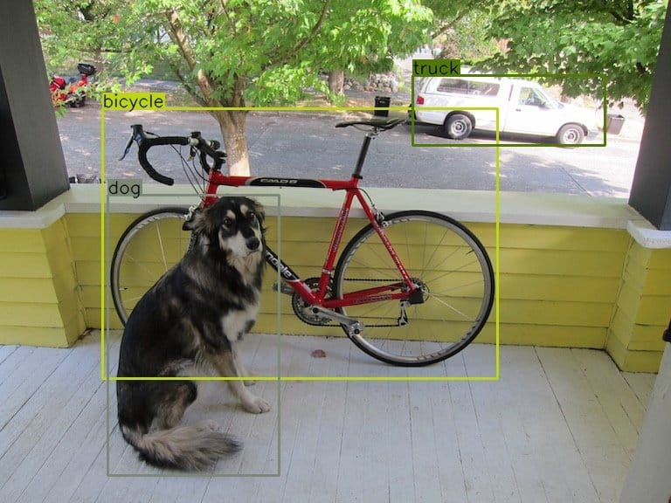
Figure 8: An example of bounding boxes used in Object Detection (Boesch, 2024)
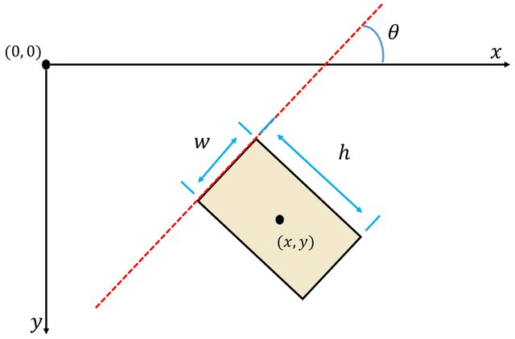
Figure 9: The five parameters for bounding boxes (Li, et al., 2020)
This project only has one class for detected objects, meaning that only objects from the "pothole" class will be highlighted, this also means that during the testing later on, only potholes will appear as detected objects and highlighted by a bounding box.
For the annotation of the dataset, a specific environment was created within Anaconda for Label Studio to be installed and run in. Anaconda Environments are self-contained spaces where specific software versions can be installed and run. This includes installing specific python versions, dependencies and libraries which if not used in an environment may conflict with each other (Anaconda, 2025). This was why an environment has been used for Label Studio for this project, so that no other python-based applications will conflict and cause further issues.
To create the custom environment for this project, conda prompt was opened and the following commands input:
The below terminal input is creating the environment, giving the environment the name “yolo_env” as well as what specific version of python to use.
The next step is to activate the environment, which will then change the environment from “base” to the “yolo_env” environment created, which can be seen below:
Now that the environment has been created, next is to install Label Studio using PIP.
Once label studio has been installed successfully, activate the tool by typing “label-studio” into the command line. Once that has been entered, label studio will start in the browser, as seen in figure 10.

Figure 10: Label Studio
Now that Label Studio has been successfully installed and run, the next step is to import the dataset and start the data annotation. To start the data annotation, first create the project import the dataset in the “data import” tab in figure 11.

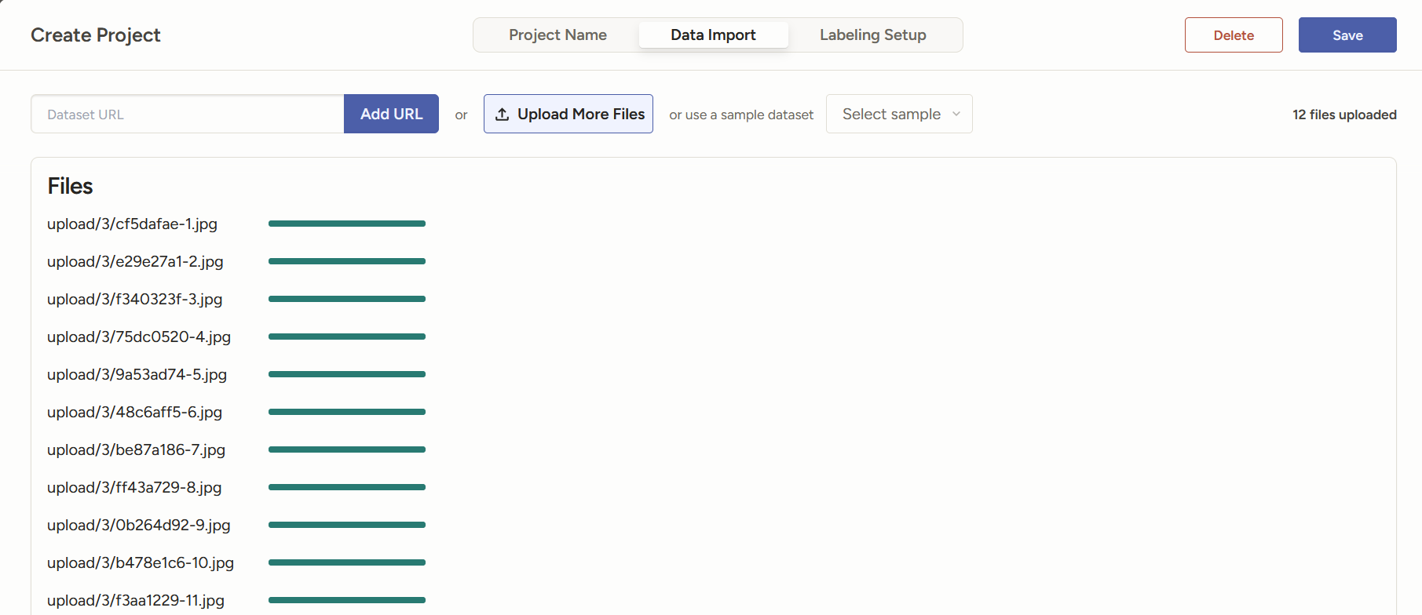
Figure 11: Label Studio data import
Once the data has been fully imported, next click the “labelling setup” tab, which is where Label Studio will give the option for different types of CV. For this project the “Object Detection with Bounding Boxes” is the option selected, with the default “airplane” and “cars” classes being removed and “potholes” being added instead. This now defines the classes being used for this project, so that the object detection will only be able to recognise and detect potholes as objects.
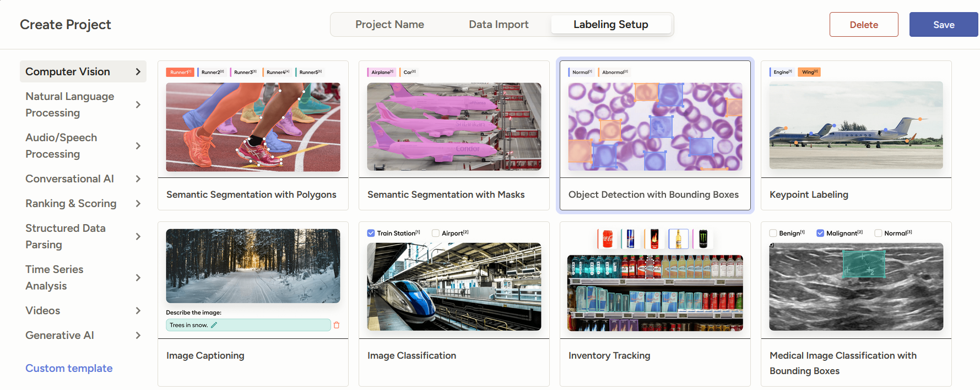
Figure 12: Label Studio Object Detection
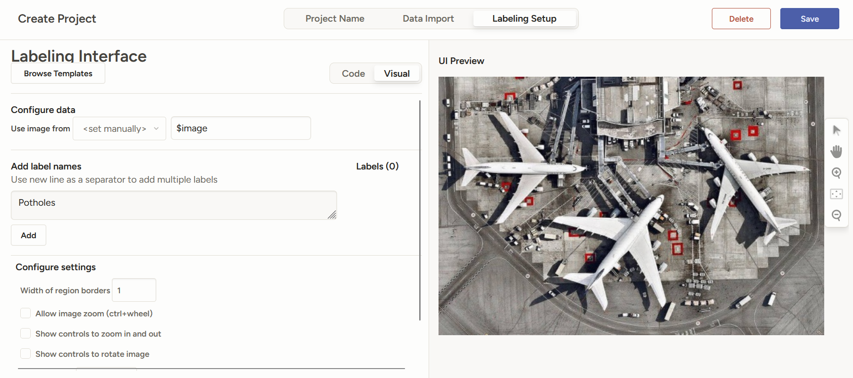
Figure 13: Creating the Label Studio project
Now that the project has been setup and created, the next step is to go through all the images in the dataset and label them individually using the bounding boxes. 14 below is an example of how the images should look, where all of the pothole objects within the image are selected and displayed. The bounding boxes can also be rotated to fit the object better if necessary.
This process is required for all the images used within the dataset, where each individual image needs bounding and then submitting.
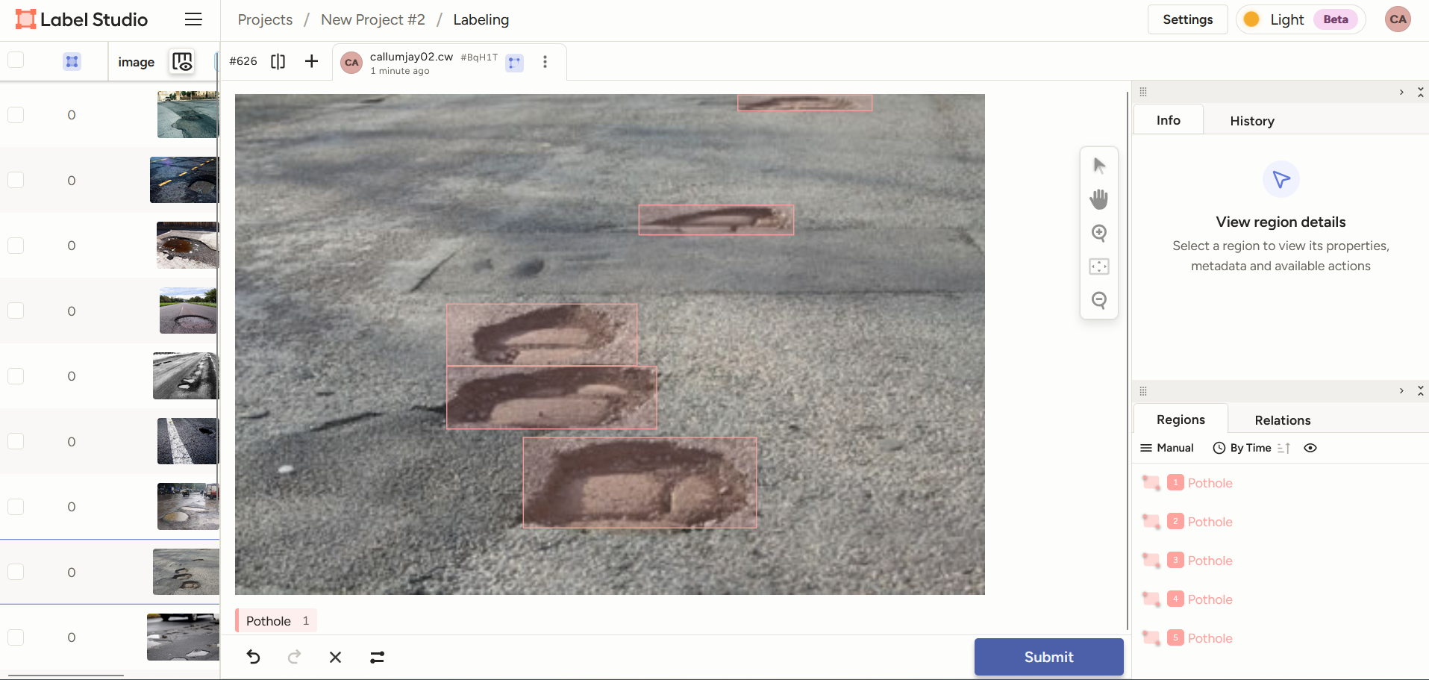
Figure 14: Example of data annotation
Once the dataset has been annotated using the steps above, now the annotated dataset needs exporting in the YOLO format, for it to be trained in Google Colab. Label Studio provides multiple different options for YOLO, however this project used “YOLO with Images” as this option can be used for multiple different models. This option also outputs the required directory structure that’s necessary for YOLO to work, which can be seen in figure 16. Choosing the “YOLOv8 OBB” or the YOLOv8 with Images” limits this project to just run on YOLOv8.
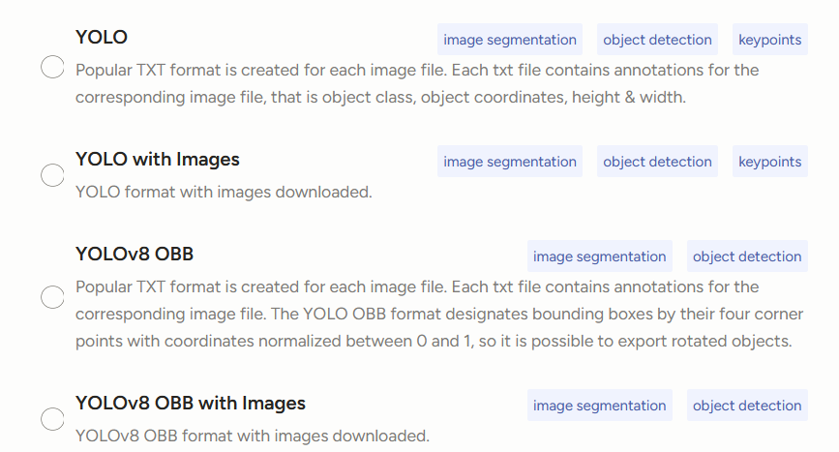
Figure 15: Label Studio export option
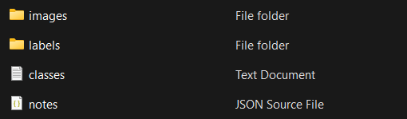
Figure 16: YOLO directory structure
Figure 17 below is a distributed chart on where all of the labels have been placed, across all annotated images in the dataset. The chart in the top right corner is an overlay of every single bounding box that was placed, the bottom left corner shows where the centre point for all of the bounding box is located and finally, the bottom right corner graphs the collective sizes of the bounding boxes.
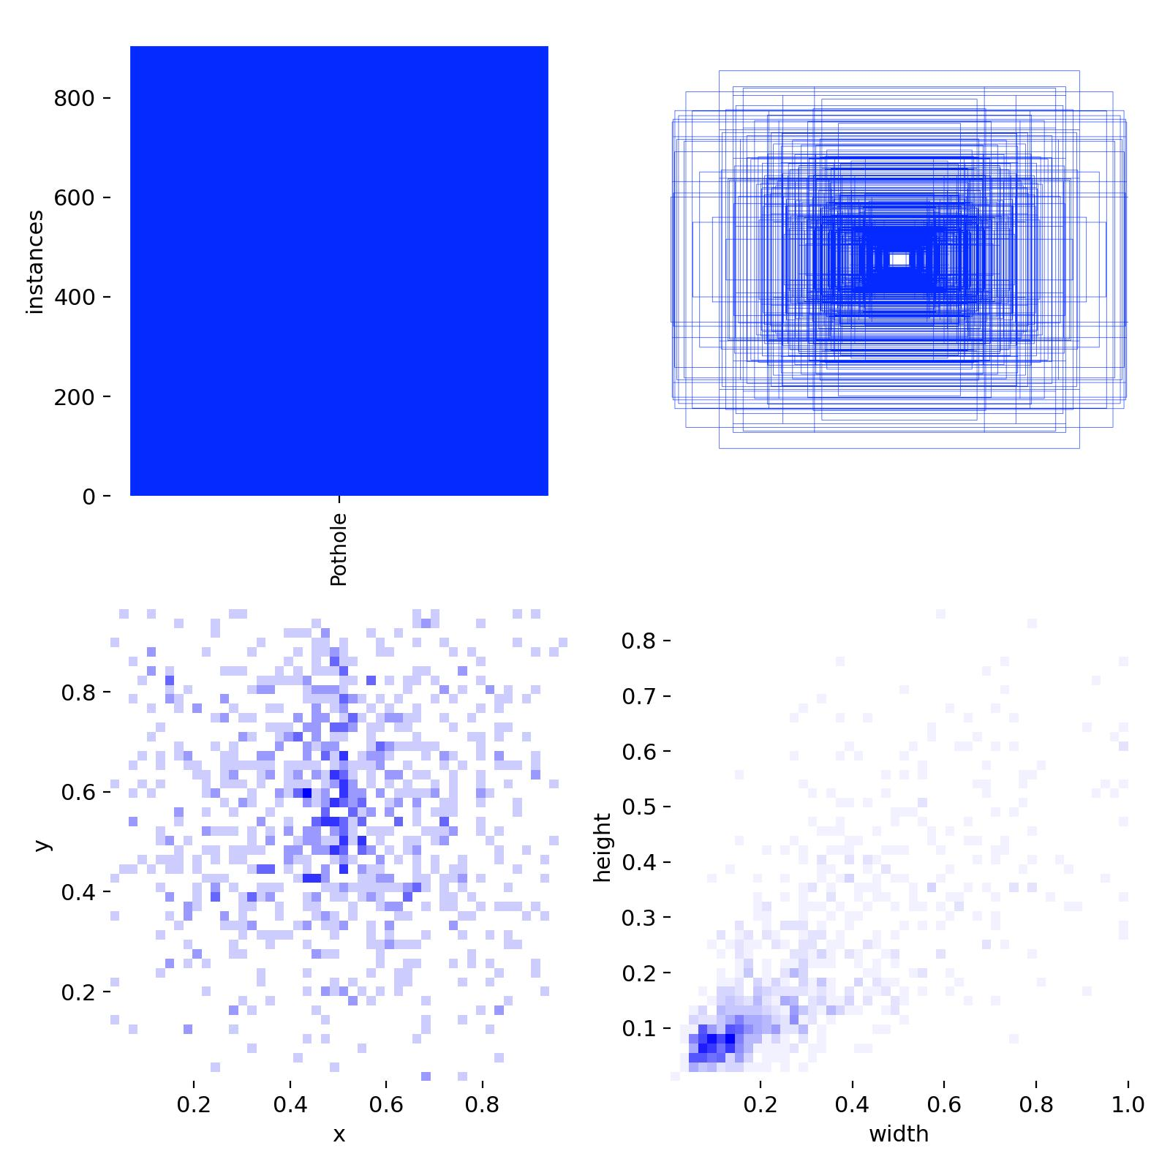
Figure 17: Label distribution

Training the YOLO Model
To train the model, a Google Colab notebook was used, as it provides GPU resources that can be used to more adequately train the model, as well as train it at fast speeds.
As a pre-requisite to training the YOLO model, first the annotated dataset needs to be uploaded to Colab as a .zip file under the name “data.zip” The runtime for this project will also be changed from the default option Colab sets, to the “T4 GPU”, as the Tesla T4 GPU is an Nvidia GPU which is built especially for Deep Learning usage (Yang, 2024), making it an ideal option for training YOLO models.
Once the runtime has been changed, verify the Nvidia GPU by running the following command:
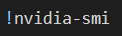
If the runtime results in an error, then the T4 GPU has not been selected. Once the GPU is setup and is verified, next unzip the “Data.zip” file which was imported earlier.
Before the install of Ultralytics, the contents of the data folder need to be organised in a way that Ultralytics can understand. To do this, the contents of the folder is split into 2 subfolders:
- train: This folder holds the images used to train the model. During each training epoch, every image in this folder is processed by the neural network, allowing the model to update its weights based on the image data.
- val (validation): This folder contains images used to evaluate the model's performance after each epoch. It helps monitor accuracy and detect overfitting.
With each of these folders (train and val) including two subfolders:
- images/: containing the image files.
- labels/: containing the corresponding annotation files in YOLO format.
To train the model, the Ultralytics library will be used. Ultralytics are an AI development company who have developed multiple iterations of the YOLO model, offering free open-source object detection models which save time and computational power as there is no need for training the models from scratch, with the models also being highly accurate as they have been trained on large-scale datasets. Due to Ultralytics having a large support and development community, it makes using YOLO a more beneficial option compared to other methods due to its ease of use, meticulous documentation and online tutorials, also making the creation of custom object detection models an easy task (Abbas Maaroof & Bouhlel, 2025). To install Ultralytics simply run the command:
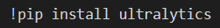
Once the installation has been complete, the next step is to create the Ultralytics YAML file. The YAML file specifies the model’s classes as well as where the training and validation data are stored. The file is required for Ultralytics to run as the YAML file defines the location for the training and validation data, as well as defines the model's classes which will be used for labelling. Without this file, the YOLO model will not function as it cannot find the locations of the data it needs and what classes it’s going to be using (Ultralytics, 2025). The code to create the YAML file in figure 18 below, explains the process on how to create the YAML file. First it reads the class.txt to gather the names of the classes that are going to be used, next it creates multiple different pathways which will be required for training, the pathways are written to the YAML file and finally, the path to the classes.txt is defined and the function run.
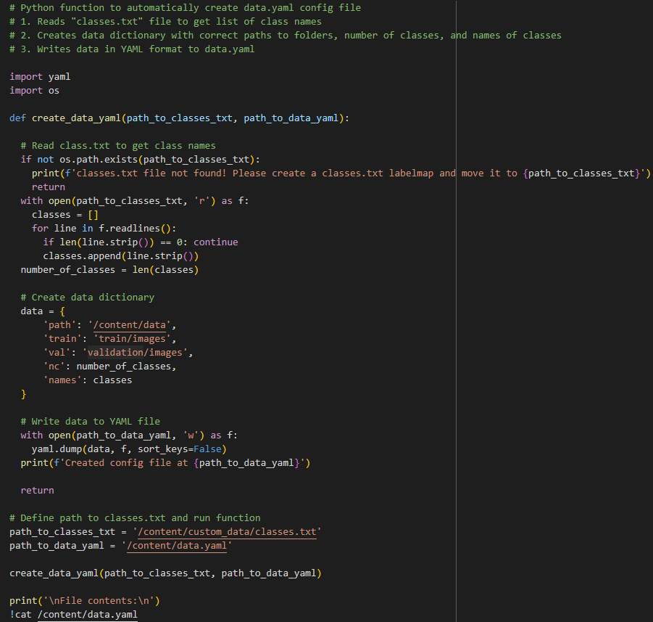
Figure 18: YAML file creation code
Now that the data has been correctly organised and the YAML file has been created, training the model is the next step.
For this, 3 key components need to be declared:
- The YOLO model that is going to be used,
- How many epochs are going to be used,
- The resolution for each image.
For this model, it will run on YOLO model 11s, at 60 epochs and with a resolution of 640x640 pixels. This is evident in figure 19:
Figure 19: YOLO training code
This shows that the model declared is YOLO model 8n, that we are training the model at 60 epochs and the pixel resolution is 640x640 pixels. Although this says YOLO8n as the model, for a comparison as to which model works best, the object detection will also be trained using YOLO5n and YOLO11n. All the models will be run on the nano version of the models as it is the most lightweight version of each model available.
Now that the model has been trained, the next step is to test the trained model. The model will run on the images, found in the validation folder.
To verify if the object detection has succeeded, 10 random images from the validation batches will be displayed, with their predicted label. An example of which can be found in figure 20, with the figure being both the code used to generate the images as well as the first image generated.
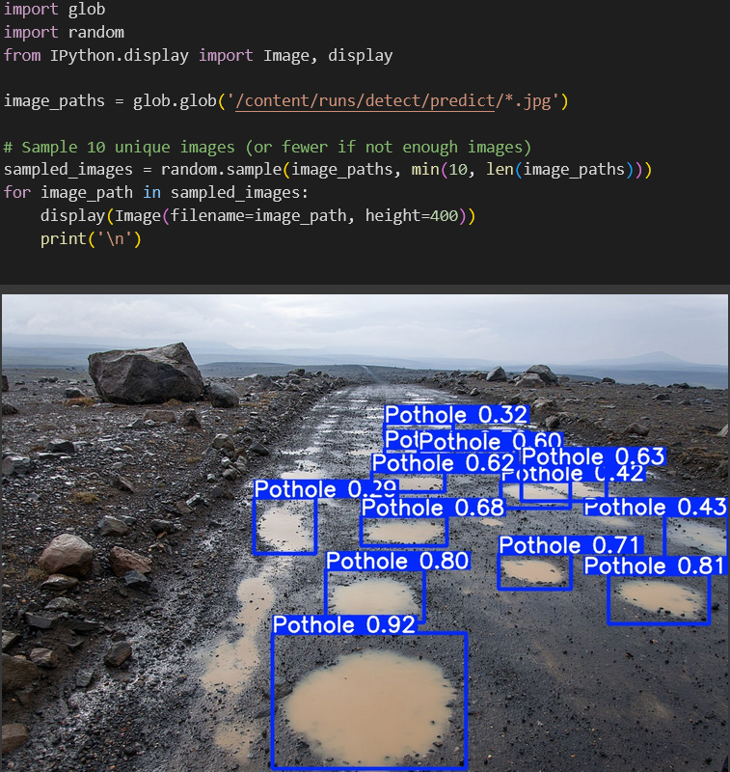
Figure 20: Object detection validation
This image has validated that the creation of the object detection model has succeeded, as it has output the predicted labels on images with the bounding boxes and their precision.

Implementing the Model into an SBC
The Pi used to run the object detection model is a Raspberry Pi 4 Model B running the Raspberry Pi OS (64 bit) which is Debian bookworm based.
Before anything is installed, ensure that the Pi is up to date using:
“sudo apt update && sudo apt upgrade -y”

This will update the pi to ensure that it is running the latest versions of software. Next is to create the directories that are going to be used, as well as the virtual environment that is going to be used. The virtual environment on the Raspberry Pi works in the same way as the anaconda virtual environments mentioned previously, in that they stop any python libraries conflicting with each other. Also ensure that the .zip file that was exported out of colab is in the “yolo” directory as this will contain the pytorch (.pt) file that the model runs on.
Creating the directory can be done by using the “mkdir yolo” command in the terminal, whereas the virtual environment can be created by doing:
“python -m venv –system-site-packages venv”

This can be activated by running:
“source venv/bin/activate”
Now that the virtual environment has been setup and activated, the next step is to install Ultralytics on the Pi, as this is what was used to create the YOLO model in the Colab file previously. This can be done by entering the terminal command:
“Sudo apt install Ultralytics ncnn”
Once that has been successfully installed, next is to convert the pytorch file to ncnn format. This is due to the NCNN format running better on ARM CPU’s like the one on the raspberry PI.
To do this run:
“yolo export model=yolo11n.pt format=ncnn”
If the .pt file has another name such as “object_detection.pt” for example, then the terminal input would be:
“yolo export model=object detection.pt format=ncnn”
Once this has been done, download the yolo_detect.py file using:
“wget https://ejtech.io/code/yolo_detect.py”
This is a pre-built yolo detection file which has been built to parse and display the inputs on screen. This file also needs to be saved in the “yolo” directory, along side everything else.
Finally, to run inference on the model, enter the terminal command:
“python yolo_detect.py --model=yolo11n_ncnn_model –-source=picamera0
--resolution=1280x1280”
This is using the yolo_detect.py file to display on screen what the model can see, as well as defining the yolo model, the camera source and what resolution the display box wants to open in.

VNC
Once the Object detection was implemented, the next step is to enable VNC so the object detection can be viewed from another device.
To do this, VNC was enabled in the Pi’s settings and then on a separate windows machine, VNCViewer was downloaded which is the application that’s going to allow for the VNC connection.
Once VNCViewer has been installed and logged in, on the same network as the Raspberry Pi, input the Pi’s IP address, username and password. Once this is done then the VNC is setup, and the object detection model can be accessed.
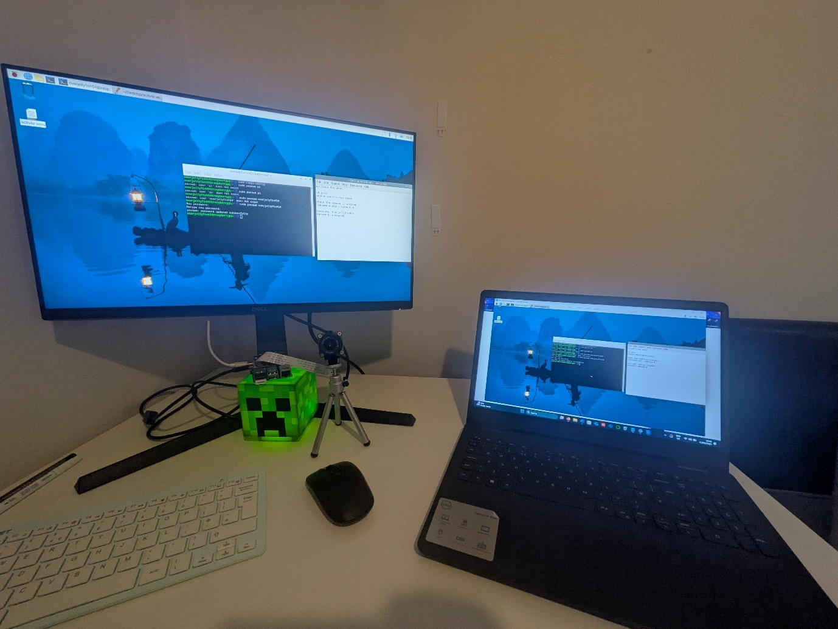
Figure 21: Windows machine accessing the Pi via VNC
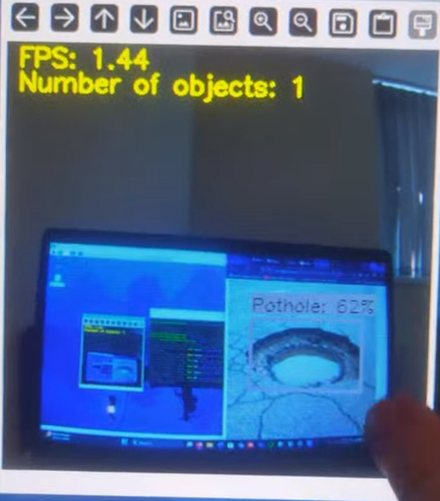
Figure 22: Object detection accessed through VNC

Design Overview
When choosing what hardware to use for this project, it came down to 3 different options:
- Raspberry Pi
- Jetson Nano
- Arduino
The Raspberry Pi was the chosen device to run the object detection model due to its ease of use, moderate processing power, accessibility and low power consumption. Compared to the Jetson Nano, which although offers a higher GPU performance for AI tasks, it’s more expensive to acquire, more complex to run and also has a much higher power consumption, meaning that the drone would either need a bigger battery to run the Nano on, or not be able to fly for as long, compared to a Pi.
The Arduino was also taken into consideration, as it can run object detection models with the right sensors as well as being cost effective, however lacks the processing power overall to keep up with the Raspberry Pi. A decision tree reflecting this decision can be seen in figure 23 below.
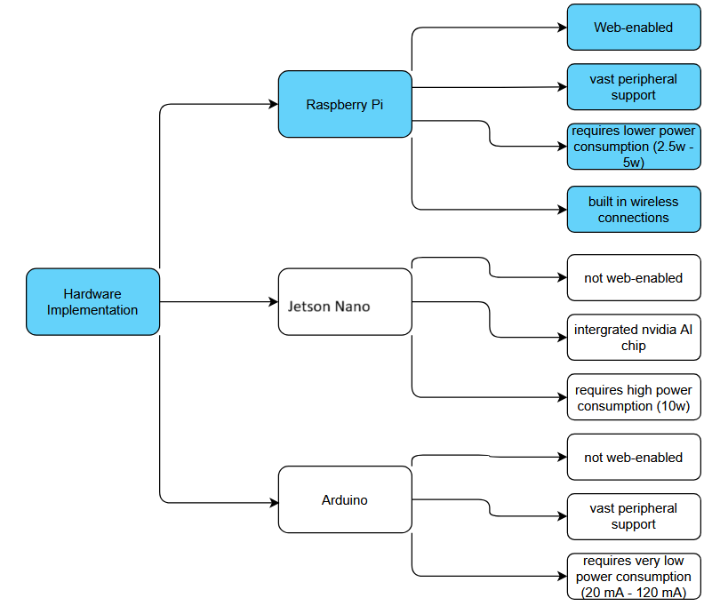
Figure 23: Decision tree
The projects timeline started on the 1st of June, until the 14th of August. The 12 weeks the project consists of was broken down into project research, project development then finally the documentation process. The Gantt chart in figure 24 breaks down the overall project, with the research being roughly 2 weeks long, the development lasting roughly 5 weeks, and the remaining time being broken down between the documentation process, which also took about 5 weeks.
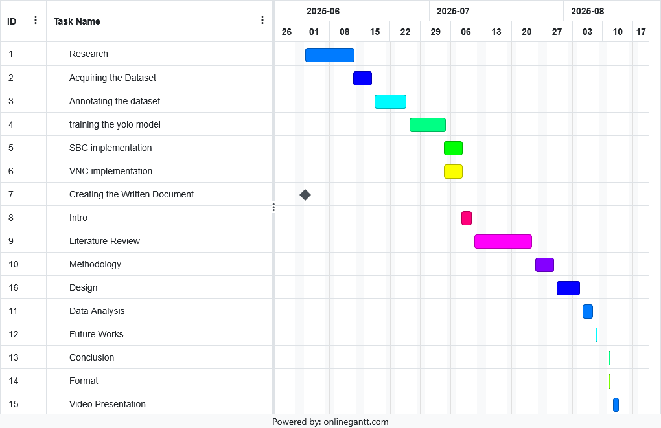
Figure 24: Project Gantt Chart
The hardware can be seen in figure 25 below and simply consists of the Raspberry Pi plugged into a monitor using a micro HMDI – HDMI cable, powered by a USB-C charger, with the Pi camera being attached via ribbon cable.
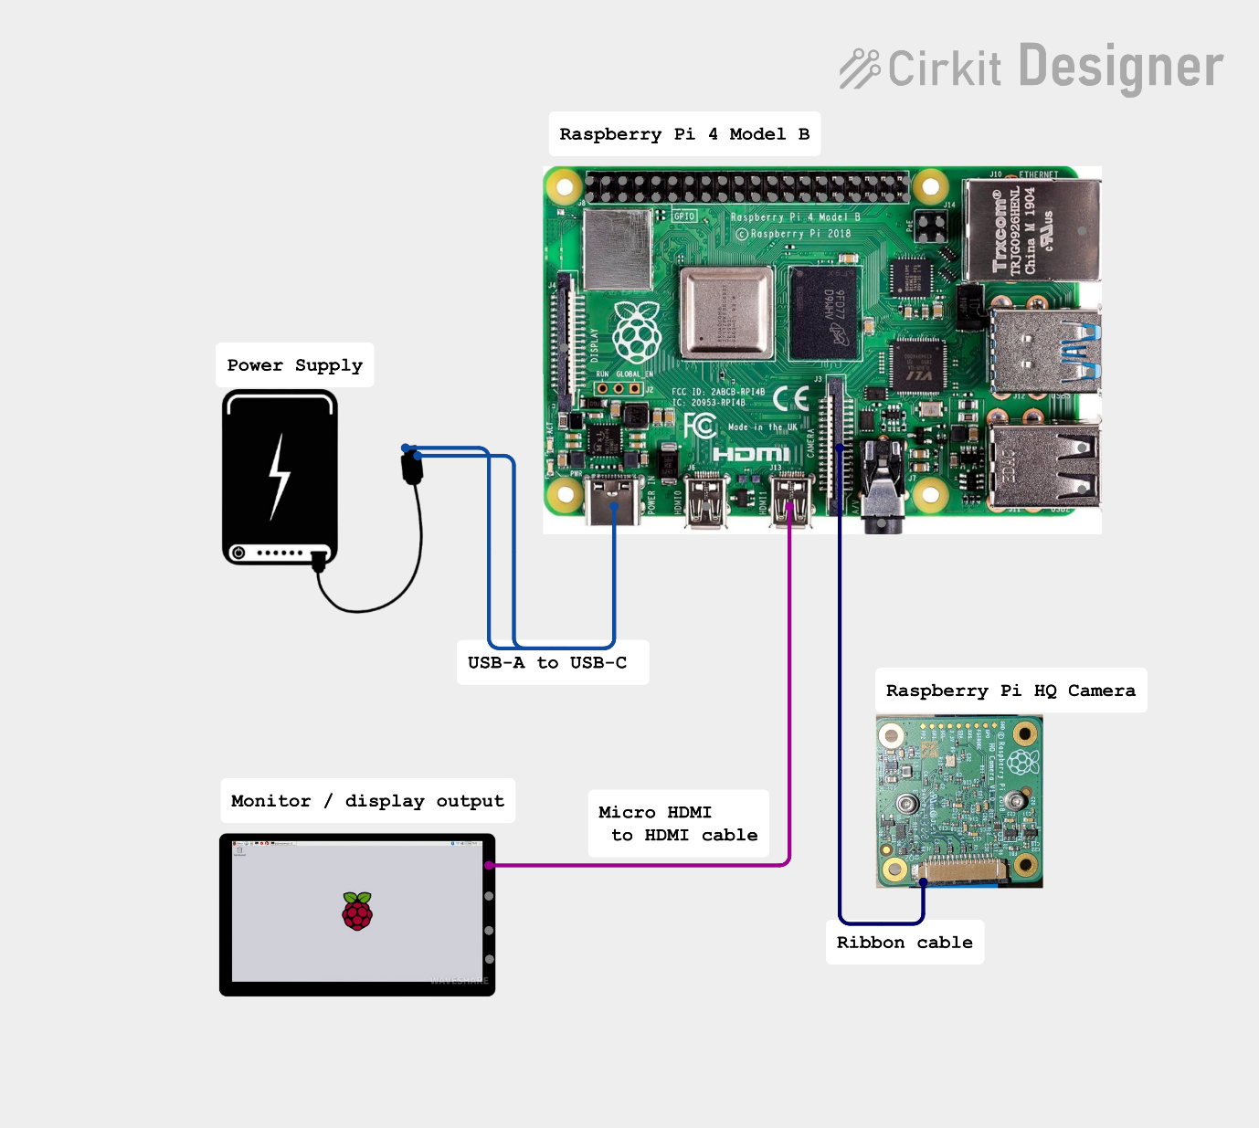
Figure 25: Circuit diagram
The IoT diagram explain how the project works, with the user interacting with the host machine, the host machine connects to the Pi through the internet using VNC, and the camera feeds the video footage back to the host machine to be displayed in real-time. This can be seen in figure 26.
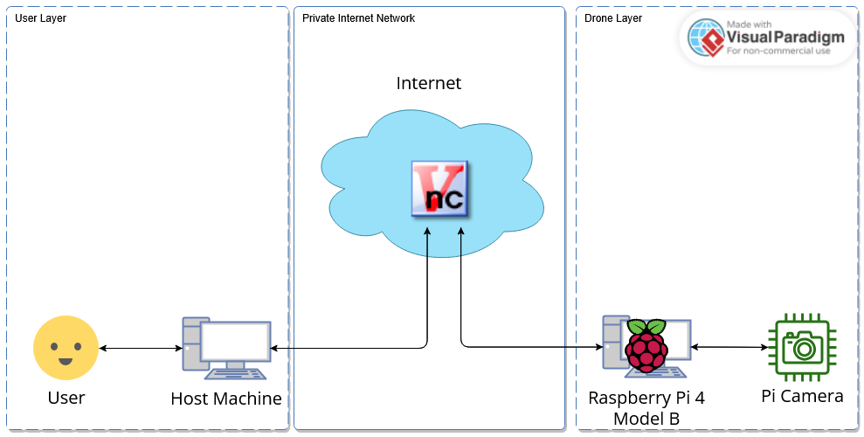
Figure 26: IoT diagram

Data Analysis
As the object detection has been trained across YOLOv5n YOLOv8n and YOLOv11n, the data analysis will be a breakdown of the effectiveness of each model, as well as a comparison of the model’s scores.

Precision Confidence
The precision-confidence curve visualises the relationship between the precision and confidence thresholds of an object detection model (Yu & Liu, 2023).

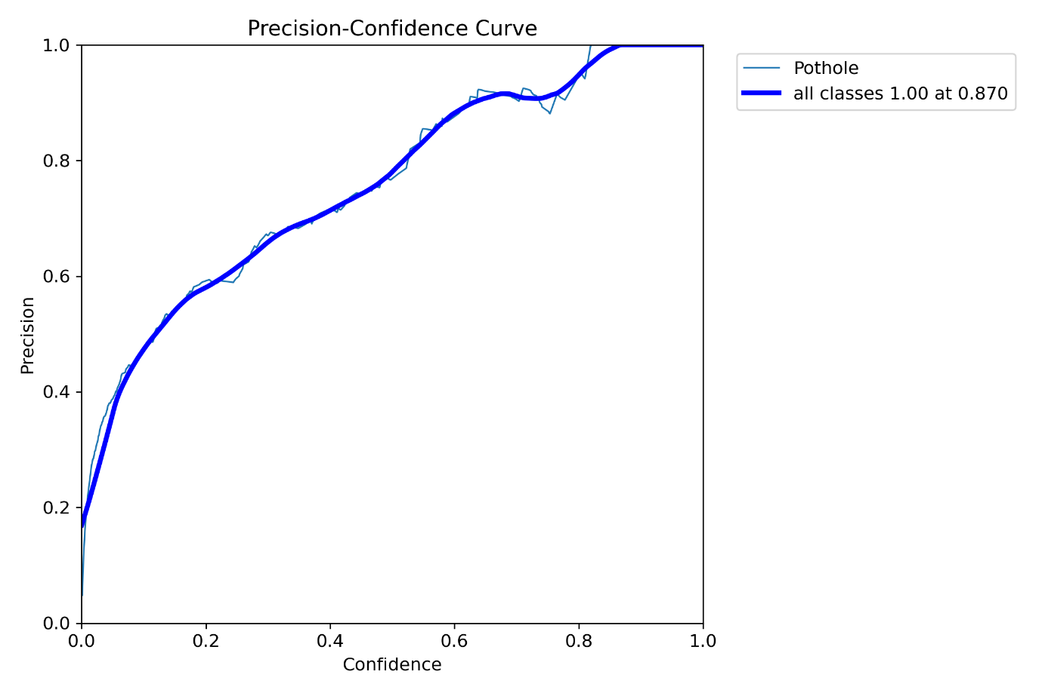
Figure 27: YOLOv5n Precision Confidence Curve
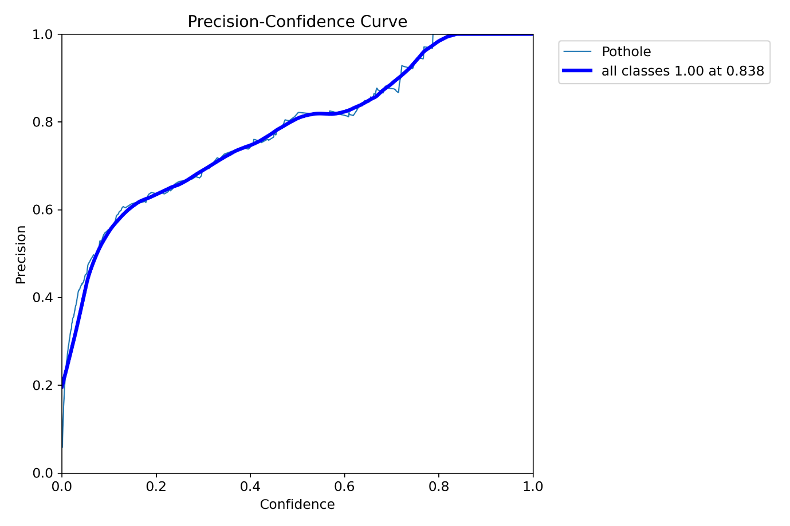
Figure 28: YOLOv8n Precision Confidence Curve
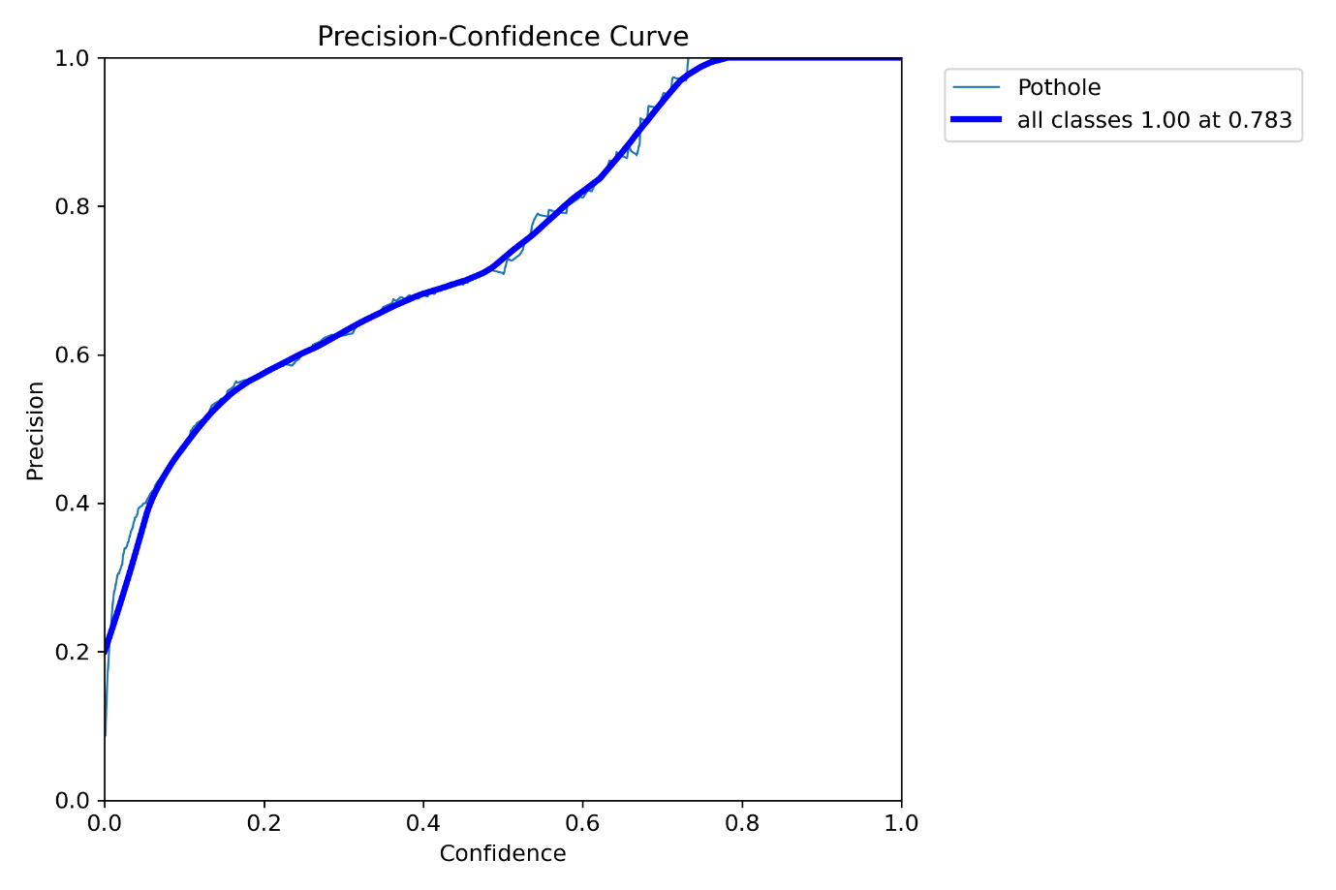
Figure 29: YOLOv11n Precision Confidence Curve
As seen from figures 27, 28 and 29 the precision-confidence curve rises steadily throughout all 3 models, with YOLOv5n having the highest confidence curve at 0.870.

Recall Confidence
The recall-confidence curve plots how metrics change as the threshold varies. With the decrease of the confidence threshold, more predictions are considered valid, with this including both true and false positives (Yu & Liu, 2023).
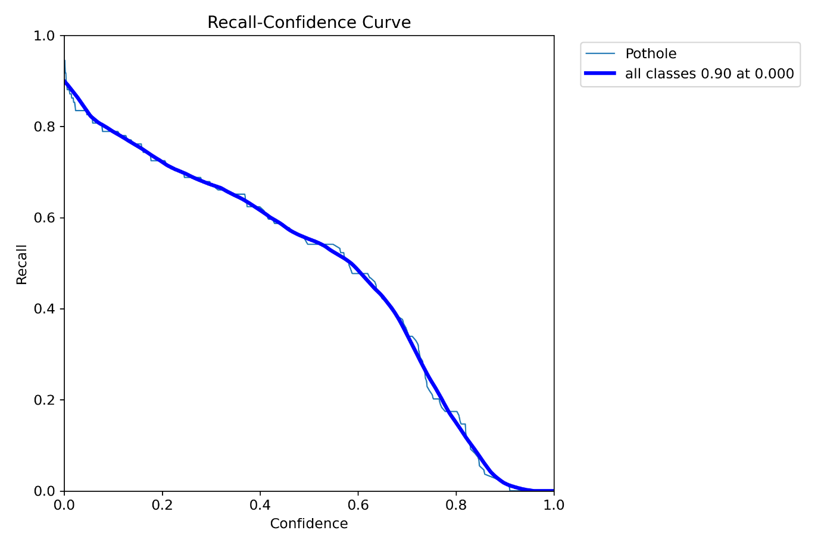
Figure 30: YOLOv5n Recall-confidence curve
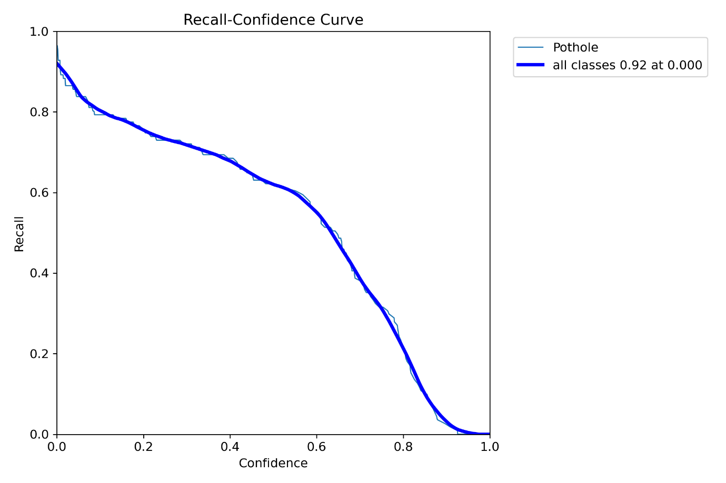
Figure 31: YOLOv8n Recall-confidence curve
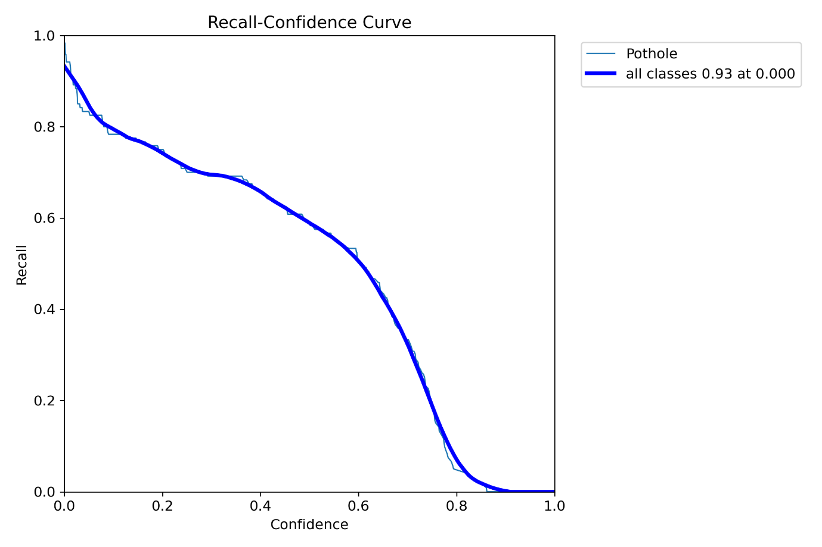
Figure 32: YOLOv11n Recall-confidence curve
The recall-confidence curve for the YOLO models all follows the standard pattern where the recall decreases as the confidence threshold increases. The YOLOv11n model achieved the highest recall at 0.93, only just beating the YOLOv8n model which achieved 0.92. This means that all 3 models achieve high true positive scores with a lenient detection criterion.

Precision Recall
The precision-recall curve is a comparison between the precision and the recall, with the x-axis representing the recall (true positive rate) and the y-axis representing the precision (addition of both true and false positives) (Yu & Liu, 2023).

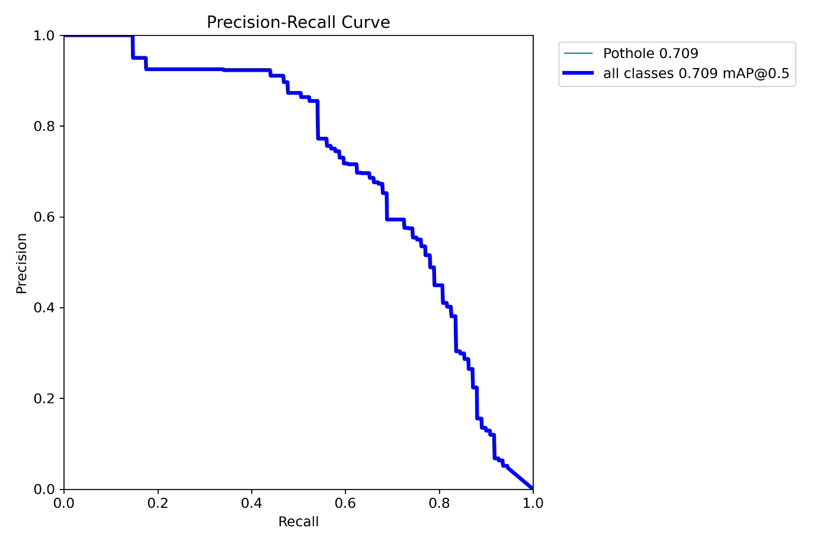
Figure 33: YOLOv5n Precision-recall curve
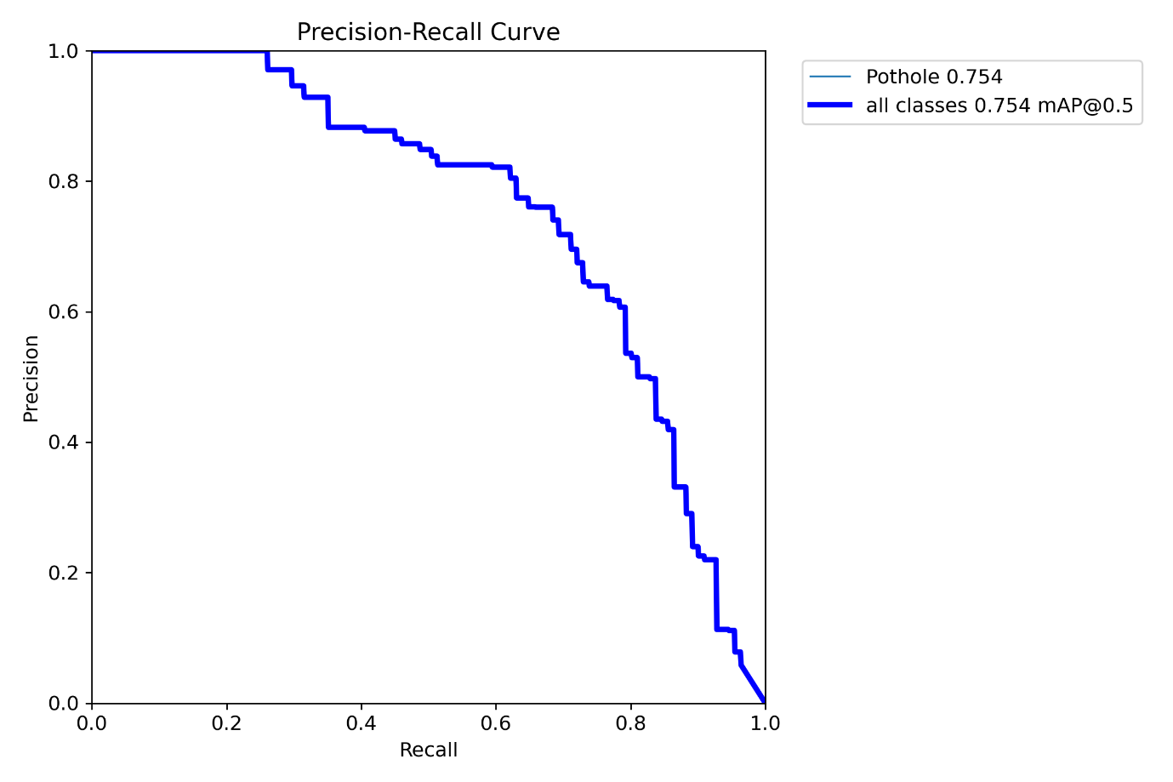
Figure 34: YOLOv8n Precision-recall curve
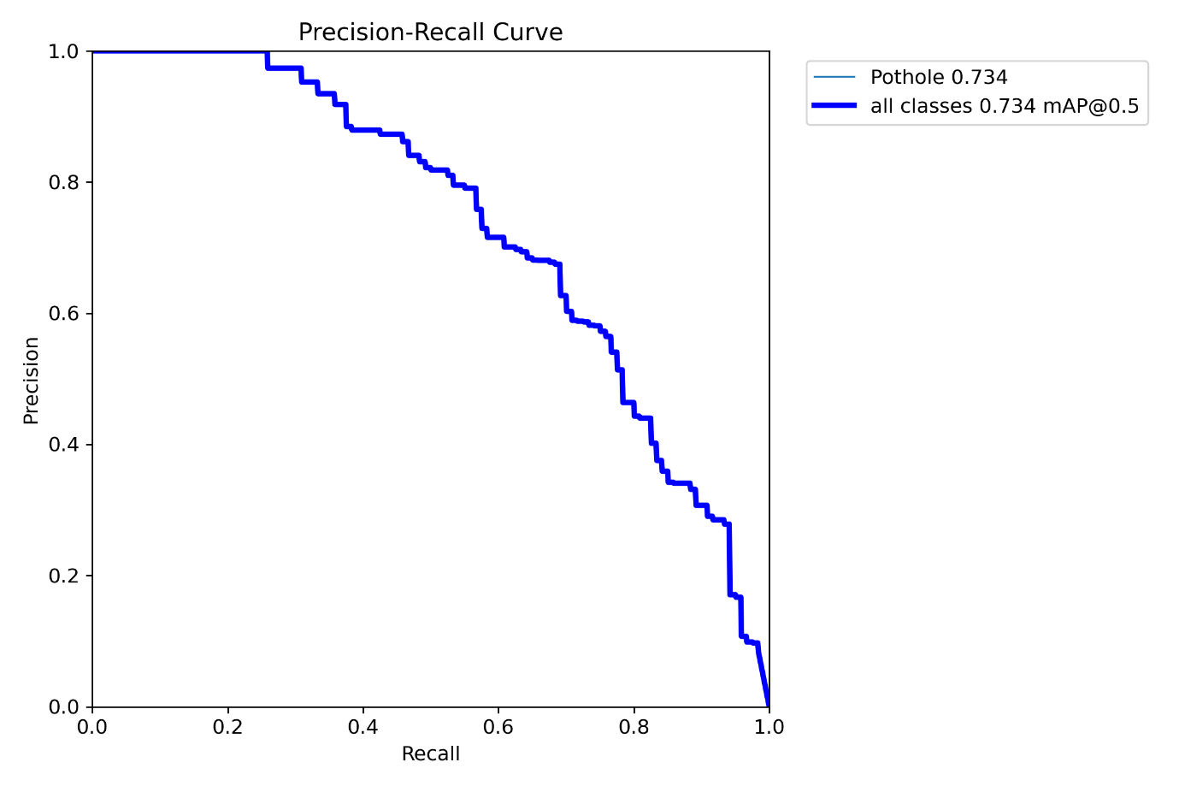
Figure 35: YOLOv11n Precision-recall curve
YOLOv8n achieves the highest area under the curve (0.754), indicating that it maintains a better balance between capturing true positives and minimizing false positives across various thresholds.
YOLOv11n achieves at 0.734, while YOLOv5n only achieves at 0.709. The shape of the curves also shows that YOLOv8n holds high precision longer before it starts to drop as recall increases, indicating better performance in scenarios where both accuracy and coverage are important.

F1 Score
The F1 score is the mean calculation between the precision and the recall (Santos, et al., 2022).
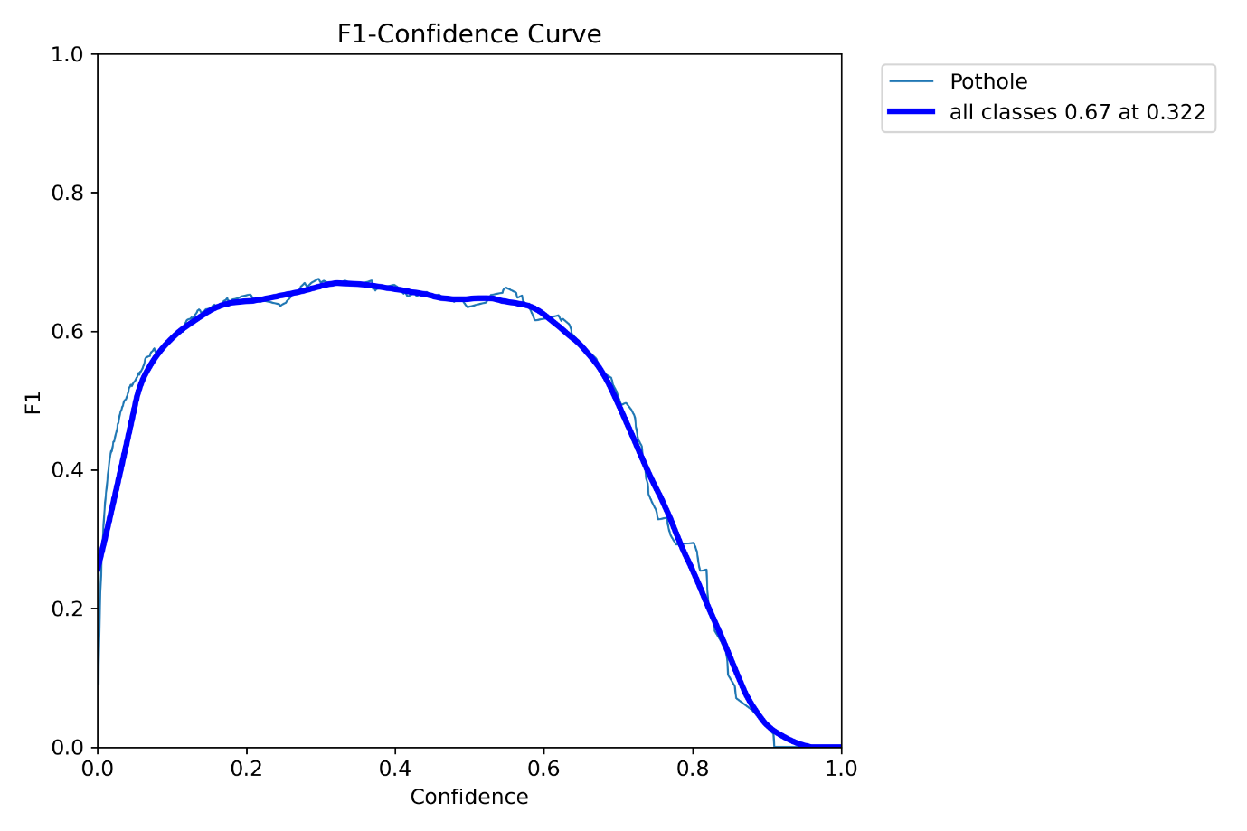
Figure 36: YOLOv5n F1-Confidence Curve
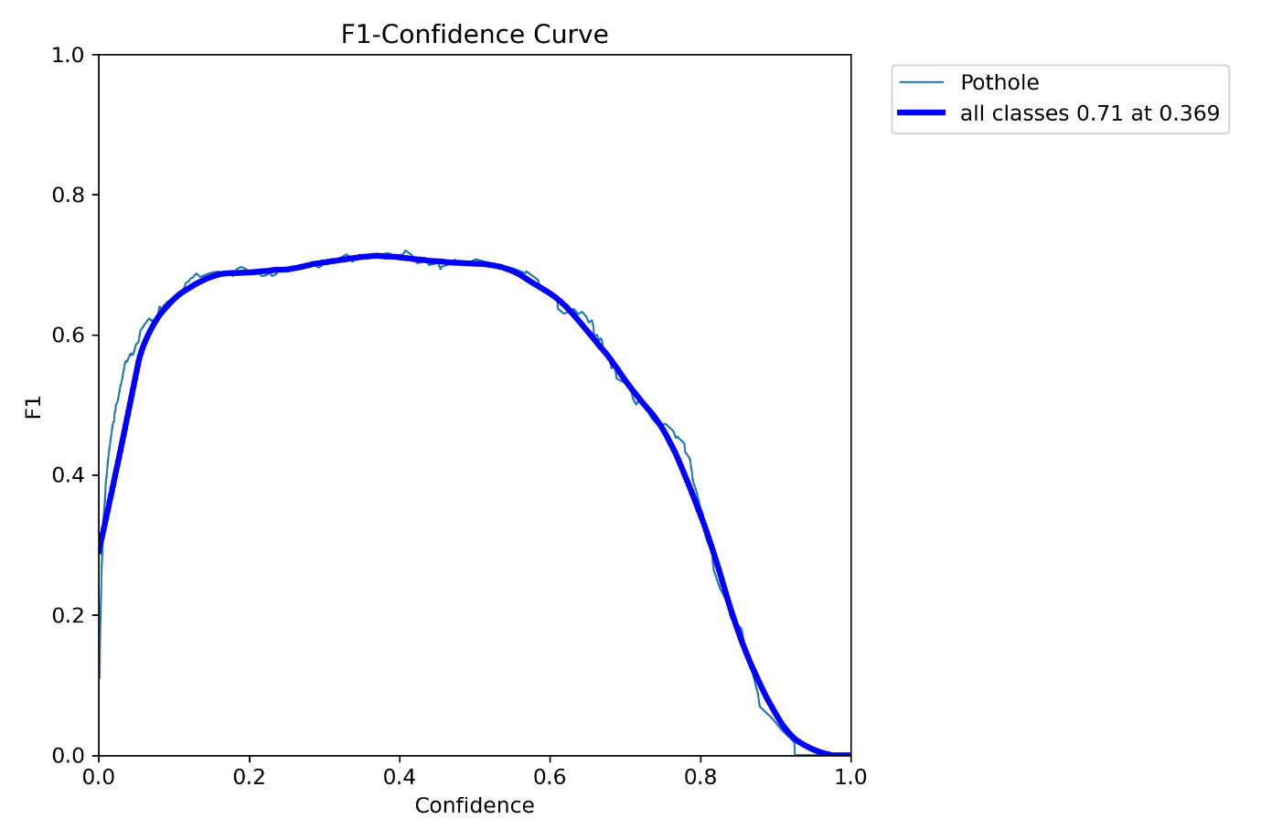
Figure 37:YOLOv8n F1-Confidence Curve
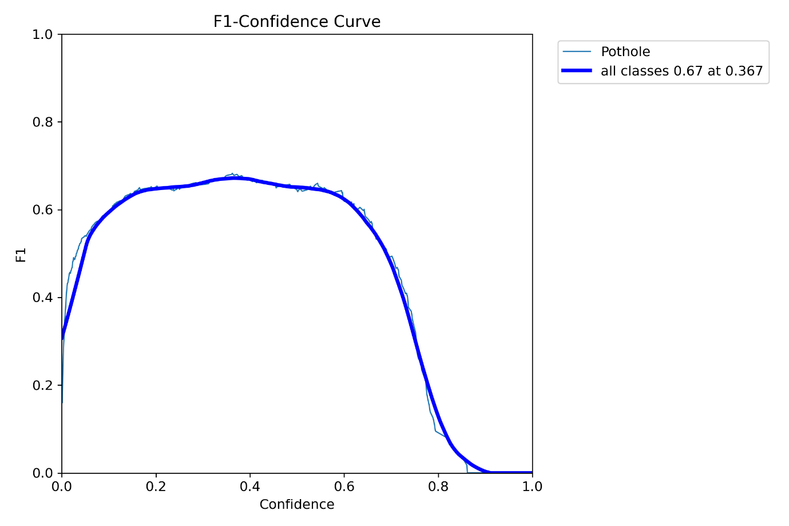
Figure 38: YOLOv11n F1-Confidence-Curve
The key results highlighted in the plots are:
- Figure 36 (YOLOv5n F1-Confidence Curve): The maximum F1 score for all classes is 0.67, achieved at a confidence threshold of 0.322.
- Figure 37 (YOLOv8n F1-Confidence Curve): The maximum F1 score for all classes is 0.71, achieved at a confidence threshold of 0.369.
- Figure 38 (YOLOv11n F1-Confidence Curve): The maximum F1 score for all classes is 0.67, achieved at a confidence threshold of 0.367.

Confusion Matrix
A confusion matrix is a table that helps you understand how well a classification model performed by showing where it made errors and where it was correct. It summarizes the results by breaking down predictions into four key categories. True Positives (TP) are the cases where the model correctly identified the positive class. True Negatives (TN) are the cases where it correctly identified the negative class. The errors are categorized as False Positives (FP), where the model incorrectly predicted a positive class, and False Negatives (FN), where it incorrectly predicted a negative class (Yu & Liu, 2023).

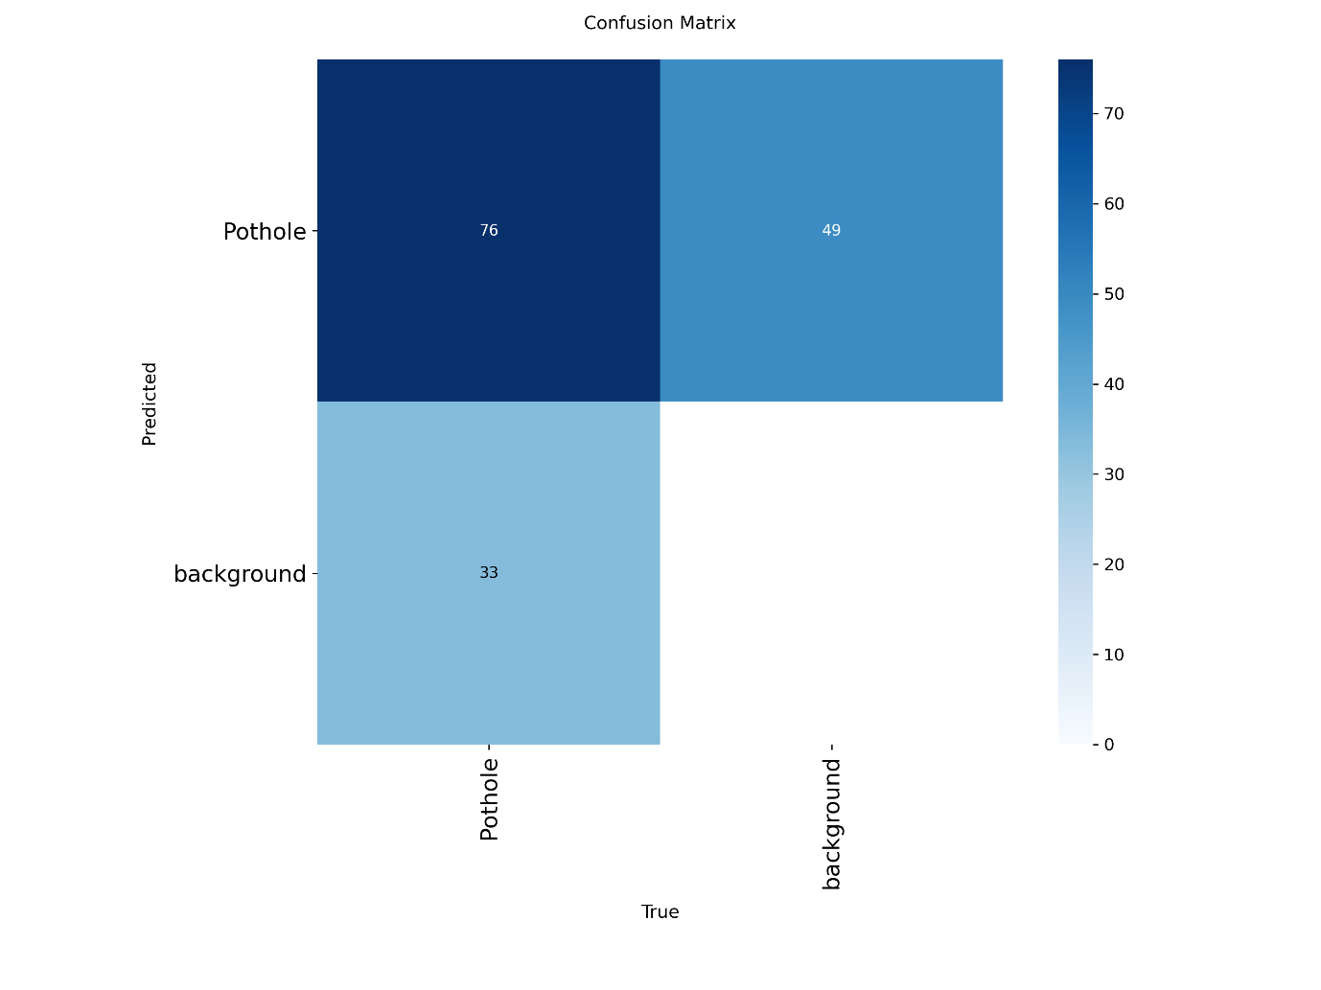
Figure 39: YOLOv5n Confusion Matrix
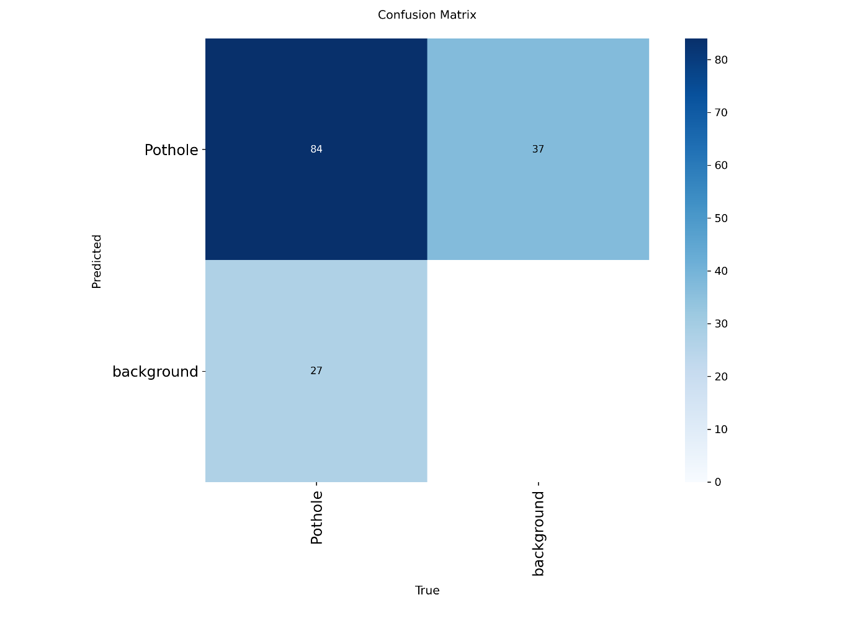
Figure 40: YOLOv8n Confusion Matrix
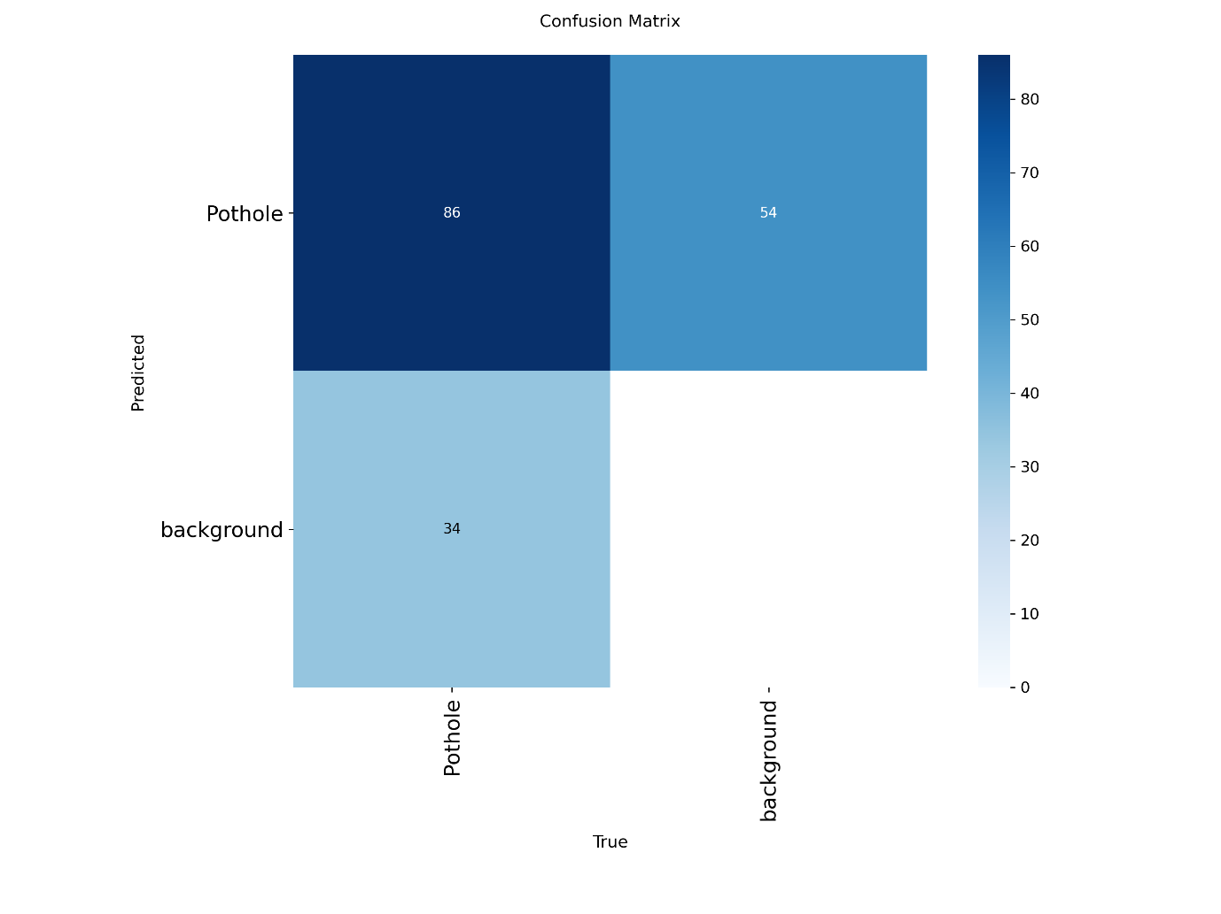
Figure 41: YOLOv11n Confusion Matrix

Future Works
For the next phase of this project, upgrading from the Raspberry Pi 4 Model B to a newer version would be ideal, allowing for direct comparison of performance and efficiency. It would also be valuable to evaluate how the Raspberry Pi 5 performs against the Jetson Nano, determining which platform is better suited for object detection. Additional testing could include Pi-based AI peripherals such as the Raspberry Pi AI Camera and the Raspberry Pi 5 AI Hat. All hardware would be benchmarked using the latest YOLO model to assess how the upgraded components compare to the current setup in terms of speed, accuracy, and overall capability.

Conclusion
The project successfully demonstrated the implementation of a YOLO-based object detection model on the Raspberry Pi 4 Model B for pothole detection. The research achieved its primary objective through the development of a model that was able to detect potholes in static images and live videos, with the intention of making road maintenance smart and efficient. The second objective of deploying this model on an SBC was also met, allowing for real-time testing under various conditions like motion blur and varying lighting. Further, the final objective was met through proper utilization of VNC, which allowed for the ability to remotely view the real-time video feed of the drone from another machine.
The success of the project verifies the hypothesis that one of the chosen YOLO models would be capable of detecting potholes effectively and efficiently and could easily be deployed on an SBC. While the existing configuration is a functional prototype, its efficiency is limited by existing hardware.

Bibliography
Abbas Maaroof, M. K. & Bouhlel, M. S., 2025. Real-Time Object Detection Using YOLO-8 Model: A Drone-Based Approach. Journal of wireless mobile networks, ubiquitous computing and dependable applications., Volume 16, pp. 190-204.
Adegoke, J., 2023. A Beginner’s Guide to Kaggle for Data Science. [Online]
Available at: https://www.makeuseof.com/beginners-guide-to-kaggle/
[Accessed 11 August 2025].
Anaconda, 2025. Environments. [Online]
Available at: https://www.anaconda.com/docs/tools/working-with-conda/environments
[Accessed 10 August 2025].
Boesch, G., 2024. Object Detection: The Definitive Guide. [Online]
Available at: https://viso.ai/deep-learning/object-detection/
[Accessed 8 August 2025].
Bouguettaya, A., Zarzour, H., Mohammed Taberkit, A. & Kechida, A., 2022. A review on early wildfire detection from unmanned aerial vehicles using deep learning-based computer vision algorithms. Signal Processing, Volume 190, p. 108309.
Cai, H., Xie, Y., Xu, J. & Ziong, Z., 2022. A Lightweight and Accurate UAV Detection Method Based on YOLOv4. Sensors (Basel), 22(18).
Chen, C. et al., 2022. An Intelligent Real-Time Object Detection System on Drones. Applied Sciences, 12(20), p. 10227.
Civil Aviation Authority (CAA), 2020. Flying drones for work. [Online]
Available at: https://www.caa.co.uk/drones/moving-on-to-more-advanced-flying/flying-drones-for-work/
[Accessed 27 July 2025].
Civil Aviation Authority (CAA), 2025. Privacy rules when flying drones. [Online]
Available at: https://www.caa.co.uk/drones/moving-on-to-more-advanced-flying/privacy-rules-when-flying-drones/
[Accessed 27 July 2025].
Creative Commons, 2025. CC0. [Online]
Available at: https://creativecommons.org/public-domain/cc0/
[Accessed 27 July 2025].
Diwan, T., Anirudh, G. & V. Tembhurne, J., 2022. Object detection using YOLO: challenges, architectural successors, datasets and applications. Multimedia Tools and Applications, Volume 82, pp. 9243-9275.
H.D.I, U. & Kuganandamurthy, L., 2021. Real-Time Object Detection using YOLO: A Review.
Helmi alharahsheh, H. & Pius, A., 2020. A Review of Key Paradigms: Positivism VS Interpretivisim. Global Academic Journal of Humanities and Social Science, 2(3), pp. 39-43.
Khalid, M., Namian, M. & Behm, M., 2021. Safety Implications of Using UAV's in Construction: An Ethical Perspective. Greenville, North Carolina, East Carolina University.
Khalid, M., Namian, M. & Massarra, C., 2021. The Dark Side of the Drones: A Review of Emerging. Greenville, North Carolina, East Carolina University.
Label Studio, 2025. Label Studio overview. [Online]
Available at: https://labelstud.io/guide/get_started
[Accessed 8 August 2025].
Leeds City Council, 2018. Pothole Claims, Leeds: Leeds City Council.
Li, C. et al., 2020. Object Detection Based on Global-Local Saliency Constraint in Aerial Images. Remote Sensing, 12(1435).
Metroplitan Police, 2025. Drones. [Online]
Available at: https://www.met.police.uk/advice/advice-and-information/drones/drones/
[Accessed 27 July 2025].
Moon, S., Jeon, J., Kim, D. & Kim, Y., 2023. Swarm Reconnaissance Drone System for Real-Time Object Detection Over a Large Area. IEEE Access, Volume 11.
Quang Khoi, T., Ahn Quang, N. & Khanh Hieu, N., 2021. Object Detection For Drones on Raspberry Pi Potentials and Challenges. Manila, IOP Publishing Ltd.
RAC, 2025. About us: The RAC. [Online]
Available at: https://www.rac.co.uk/business/about-us
[Accessed 25 July 2025].
RAC, 2025. RAC Pothole Index – statistics and data for UK roads. [Online]
Available at: https://www.rac.co.uk/drive/advice/driving-advice/rac-pothole-index-statistics-data-and-projections/
[Accessed 18 May 2025].
Santos, C., Aguiar, M., Welfer, D. & Belloni, B., 2022. A New Approach for Detecting Fundus Lesions Using Image Processing and Deep Neural Network Architecture Based on YOLO Model. Sensors, 22(17).
Turner, J., 2001. Positivism: Sociological. International Encyclopedia of the Social & Behavioral Sciences, pp. 11827-11831.
Ultralytics, 2025. YAML. [Online]
Available at: https://www.ultralytics.com/glossary/yaml
[Accessed 11 August 2025].
Yang, Y., 2024. Quantization and Acceleration of YOLOv5 Vehicle Detection Based on GPU Chips. New York, NY, Association for Computing Machinery.
Yu, H. et al., 2020. The Unmanned Aerial Vehicle Benchmark: Object Detection, Tracking and Baseline. International Journal of Computer Vision, Volume 128, pp. 1141-1159.
Yu, L. & Liu, S., 2023. A Single-Stage Deep Learning-based Approach for Real-Time License Plate Recognition in Smart Parking System. International Journal of Advanced Computer Science and Applications, 14(9).
Zhu, P. et al., 2022. Detection and Tracking Meet Drones Challenge. IEEE Transactions on Pattern Analysis and Machine Intelligence, 44(11).
Zou, Z. et al., 2023. Object Detection in 20 Years: A Survey. Proceedings of the IEEE, 111(3).

