Lab1 – Firewall basics
Joni Korpihalkola
Document your commands or take screenshots. Answer questions in english or finnish.
The labs use the following topology (Workstation will be Centos7 Desktop):

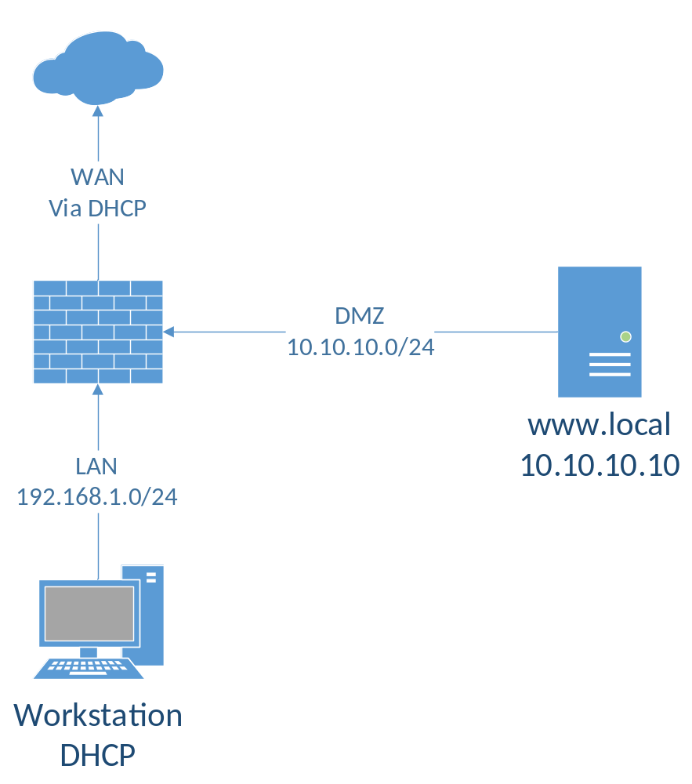

Install PfSense (1p)
Retrieve the pre-installed VM images for PfSense, Centos7 Workstation and the Webserver from \\ghost.labranet.jamk.fi\ (PATH TBA). Import them to virtualbox and be sure to set “Reinitialize the MAC address…” tickbox in the import wizard. Set VM interfaces as following:
Pfsense: NIC1 Bridged, NIC2 Internal network (Name: intnet), NIC3 Internal network (intnet2)
Workstation: NIC1 Internal network (intnet)
Linux webserver: NIC1 Internal network (intnet2)
Next, boot up PfSense and assign interfaces if asked. If the system asks about setting up VLANs, answer no. Set the interfaces in the order displayed (usually vtnet0 vtnet1 vtnet2). vtnet0 will be the WAN, vtnet1 will be LAN and vtnet2 will be OPT1. We will rename this interface later.
Interfacet säädetty PFSensessä.
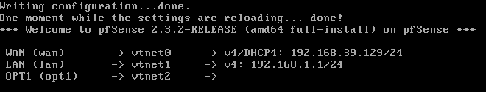
Boot up the Workstation VM and check that it gets IP address from the PfSense VM. If not, check your network settings and the ordering of interfaces in the PfSense VM.
When you get IP address, try accessing 192.168.1.1 with a browser in the Workstation VM. The default username/password are admin/pfsense
First configure the system to use LabraNet DNS servers (192.168.40.21 and .22). Go to Services -> DNS Resolver and turn it off. Then go to DNS Forwarder and turn it on.
DNS Serverit asetettu
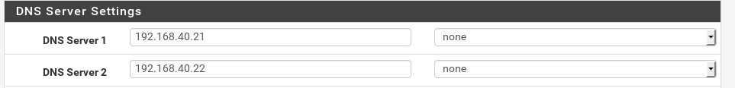

DNS Resolver laitettu pois päältä
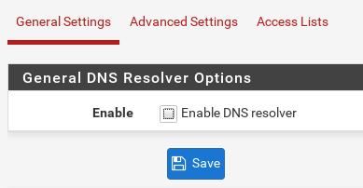
DNS Forwarder päällä
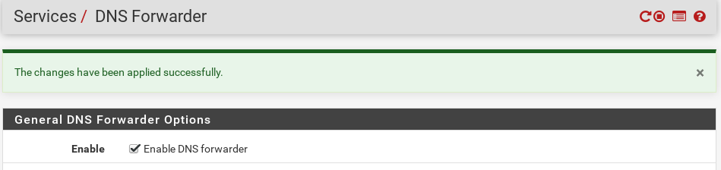

Firewall rules (1p)
By default, the LAN subnet has Allow any rule attached to it. The default installation also has automatic outgoing NAT. Confirm and screenshot these rules in the Firewall-tab.
Default säännöt löytyvät
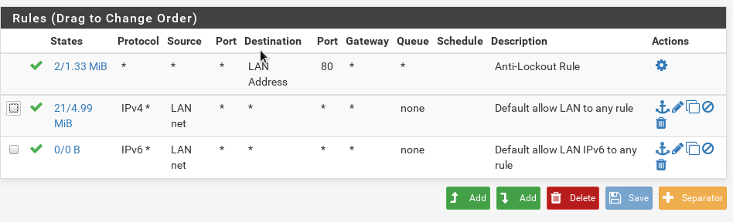
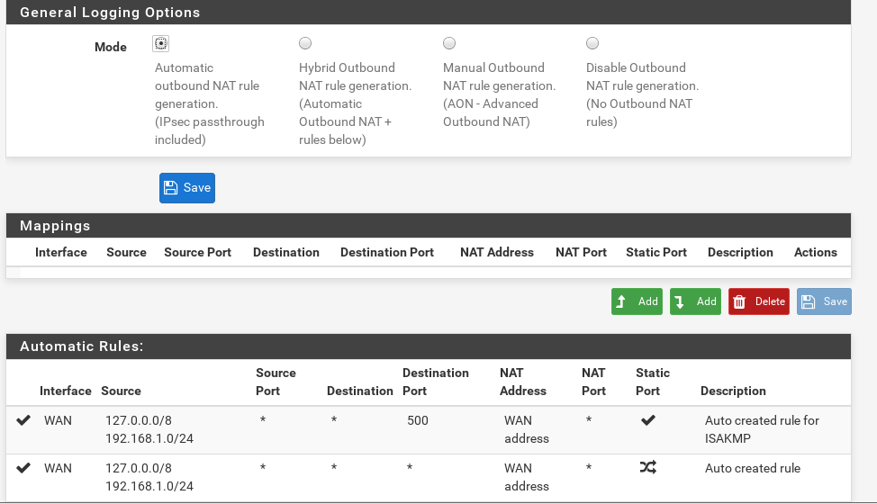
Delete the default Allow any rule. Add two rules to LAN that allow UDP/53 and TCP/80 to any. Also create a rule that allows ICMP (ping). Check the tickbox for traffic logging. Apply settings and test that Internet browsing still works from the Windows 7 VM. Find out where the traffic is logged and screenshot.
53 ja 80 portit avattu palomuurin säännöillä.
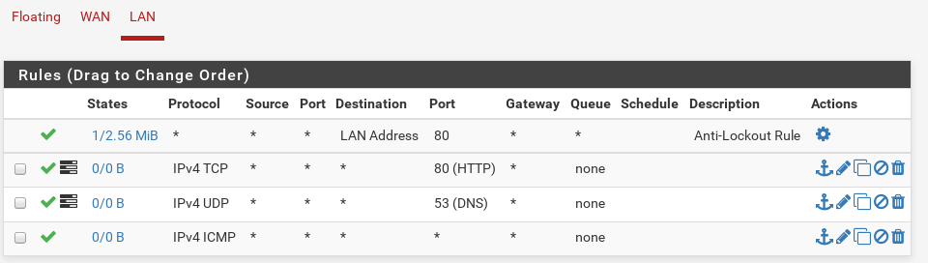
Netin selaaminen toimii:
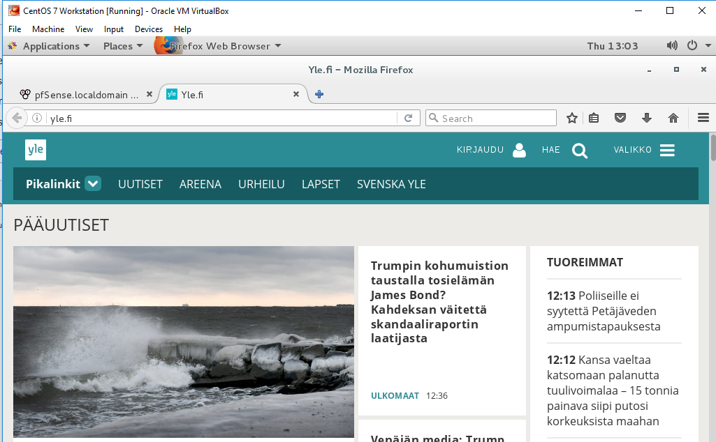
Liikennelogit löytyvät Status -> System Logs -> Firewall
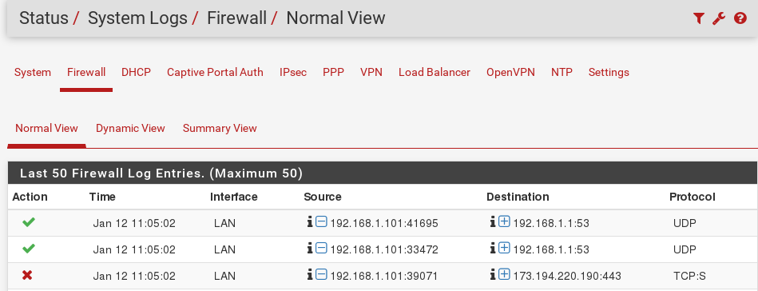

DMZ (1p)
Modify the OPT1 interface. Set the name as DMZ and IP address as 10.10.10.1/24. Remember to apply changes. Configure the same firewall rules for the DMZ as you did for the LAN.

Interfacen nimeäminen ja staattinen IPv4 osoite
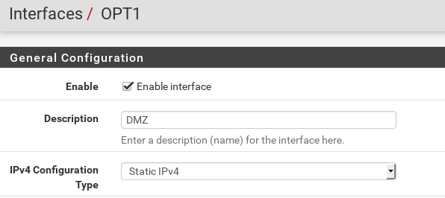
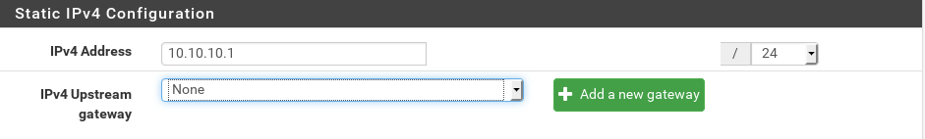
Palomuuri säännöt DMZ:lle
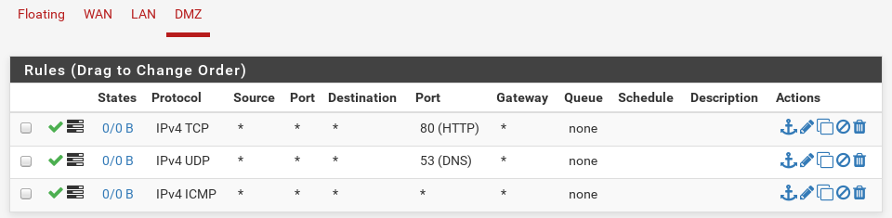
Boot the Linux Webserver VM and login (root/root66). Check if it can ping its new gateway or if you can access it from the Workstation VM.

Linux servulle pääsee CentOS Workstationilta
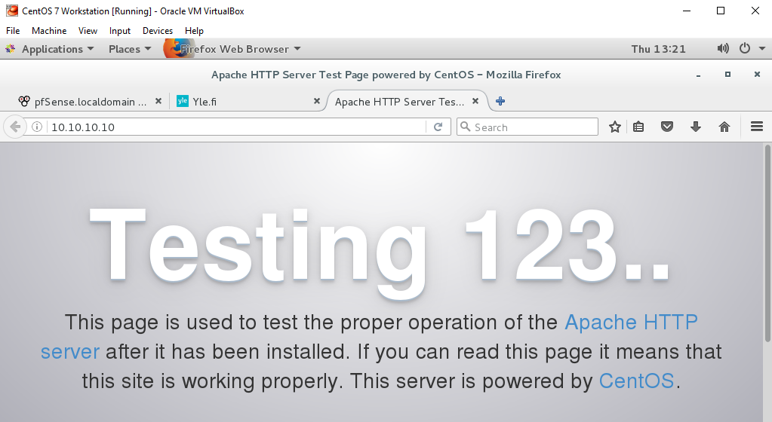

WWW NAT (1p)
In this lab we configure a port forward -based NAT. Incoming connection to port 80 from the WAN will be forwarded to the webserver.
Create a Port Forward NAT rule at Firewall - NAT. Select Destination port as 80. Destination NAT address is the webserver address. To port is also 80. By default a firewall rule to allow this traffic will be created for you also. Apply changes.
Find out your firewalls public (WAN) address. It will be on the same subnet as the classroom PCs. With your Classroom PC, try to access the WAN address with your browser. This should forward the traffic to your webserver. You can also ask your neighboring students to test your address.
Port Forward sääntö
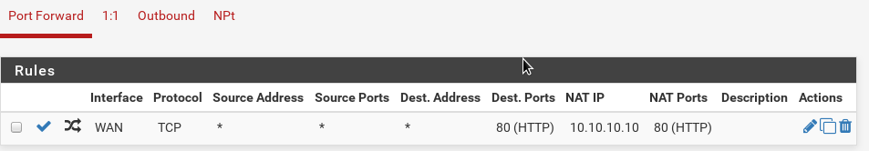
Interfaces -> WAN asetuksista piti ottaa esto pois privaatti osoitteista 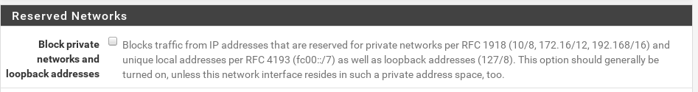
Yhteys koulun koneelta webserverille toimii
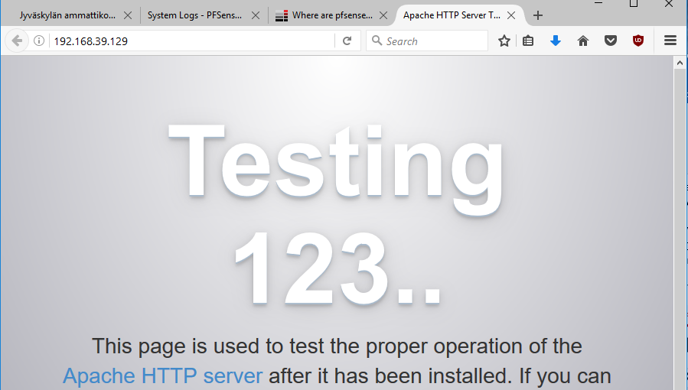

SSH NAT (1p)
Create another port forward rule for SSH traffic. Set destination port as 2222 and To port as 22. This will move the SSH port from the default to something that is harder to guess. Test again with your classroom PC using PuTTY.
Uusi NAT sääntö tehty
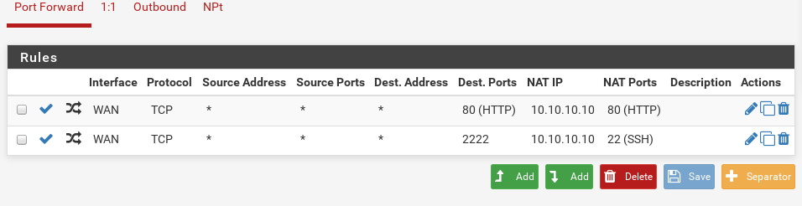
Testaus koulun koneen PuTTYllä
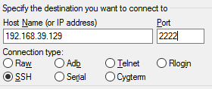
Loin webserverillä testi-kansion /var/www, jotta tunnistaisin, että NAT ohjaa oikealle serverille. Testi-kansio löytyy PuTTYllä.
