Lab2 – Certificates
Joni Korpihalkola
Document your commands or take screenshots. Answer questions in english or finnish. Replace your-student-id with your own student-id in the labs.
The labs use the following topology, some VMs are already installed in the previous labs:

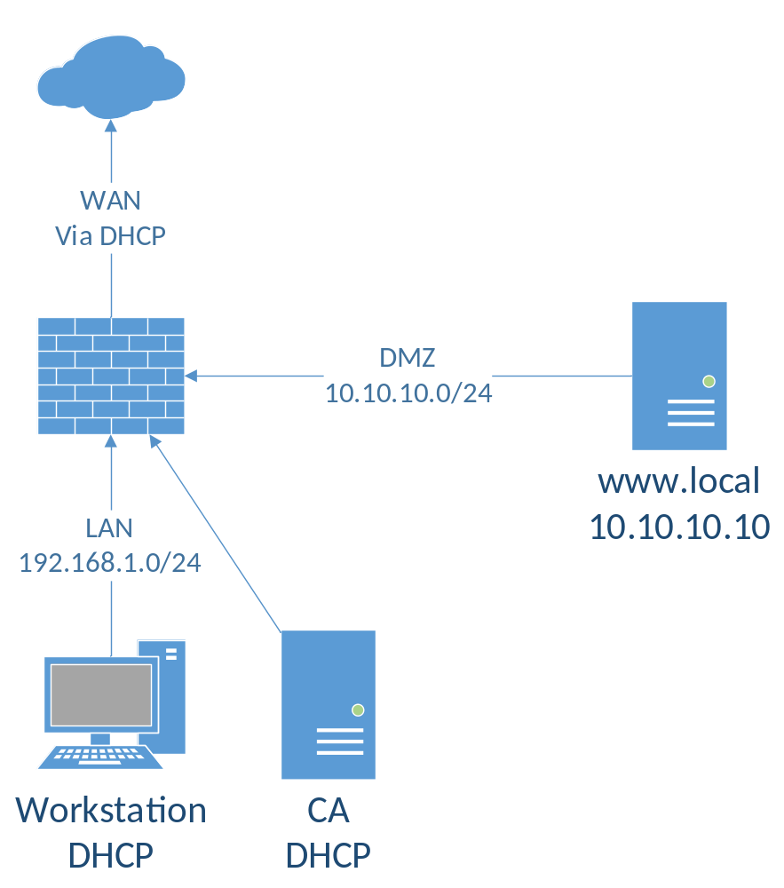

Install CA (1p)
Using the Centos7 tempalte from \\ghost.labranet.jamk.fi\virtuaalikoneet\TTKS\, clone another VM with the name CA. Remember to set “Reinitialize the MAC address…” tickbox in the import wizard. Set VM interface as Internal network (intnet)
Boot up the VMs shown in the topology and login to the new CA VM (root/root66). Check that it has got an IP. Download the ca.cnf and usr.cnf files from http://student.labranet.jamk.fi/~jojuh/ttks/. You can use wget for this. (wget <URL of the file>)
Ca.cnf ja usr.cnf tiedostojen lataus
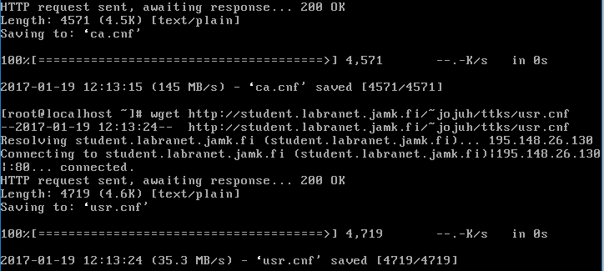
First, lets create the CA:
openssl req -new -newkey rsa:4096 -keyout ca.key -config ca.cnf -extensions v3_ca -x509 -out ca.pem
echo 01 > serial
touch index.txt

CA:n luonti

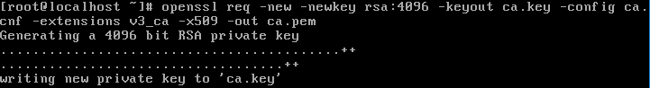

When asked for a passphrase for the key, use root66. Fill in the information, set CN (Common Name) as your-student-id-CA. Now check the contents of the CA certificate:
openssl x509 -text -noout -in ca.pem

Sertifikaatin sisältö
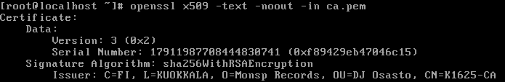

You should see the info you typed, public key is 4096bits and the most important part: CA:TRUE in Basic constraints. Without this, your CA cert will not be trusted by the clients.
CA:TRUE löytyy tulosteesta
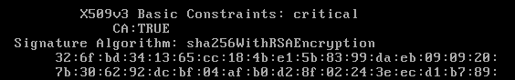

Creating a CSR (1p)
Boot up the Webserver VM. Create a new RSA key and CSR for the webserver. We will use the default openssl config. Set CN as www.your-student-id.com, other fields as you wish:
openssl req -new -newkey rsa:2048 -keyout www.key -nodes -out www.csr

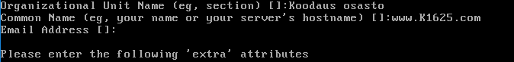
On the CA VM, copy the csr from the webserver to the CA machine (you may have to create a firewall rule for TCP/22 in the PfSense VM):
scp root@10.10.10.10:www.csr ./

www.csr tiedoston lataus
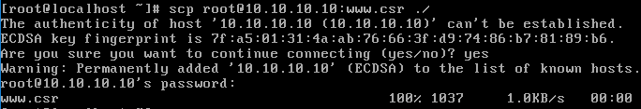
Check the contents of the CSR:
openssl req -noout -text -in www.csr

Tulosteesta löytyy CN oikealla nimellä
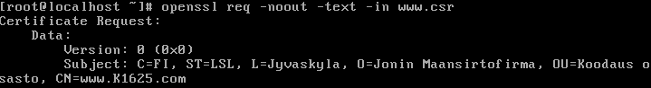
If everything seems to be right, sign the CSR with the CA key:
openssl ca -config usr.cnf -extensions usr_cert -days 365 -keyfile ca.key -cert ca.pem -in www.csr -out www.pem
Before answering yes, take time to check that the certificate info is correct. Especially check that Basic Constraints has CA:FALSE as we do not want our webserver to be a CA. Also X509v3 Key Usage should have Digital Signature, Non Repudiation and Key Encipherment.
Tiedot ovat oikein
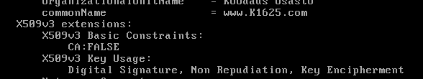
Examine the contents of the new CRT file:
openssl x509 -noout -text -in www.pem
And finally, copy it back to the Webserver VM:
scp www.pem root@10.10.10.10:www.pem

CRT kopioitu webserverille ja sen tuloste
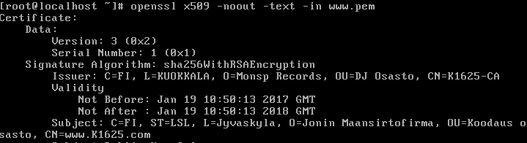

Configure SSL (1p)
In the Webserver, you have to do two things. First, install mod_ssl to Apache:
yum install mod_ssl
Then copy the key and certificate to the correct paths:
cp www.key /etc/pki/tls/private/
cp www.pem /etc/pki/tls/certs/
In those folders should exist also a default self-signed certificate (localhost.key and localhost.crt). Check their permissions and set the same permissions to the www.key and www.pem.
Oikeuksien vaihto www.key:lle
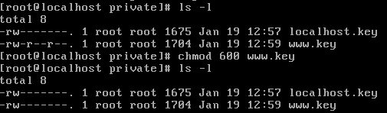
Oikeuksien vaihto www.pem:lle
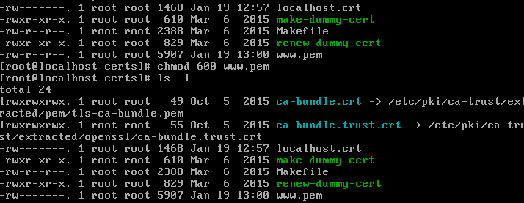
Last thing you need to do is edit /etc/httpd/conf.d/ssl.conf and change Apache to use your certificates. Find the following lines:
SSLCertificateFile=…
SSLCertificateKeyFile=…
And set them to point to your files. Reload apache (systemctl restart httpd).

Ssl.conf tiedoston muokkaus
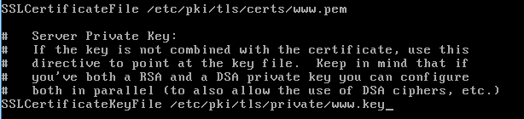
Firewall-cmd säännön lisäys https liikenteelle
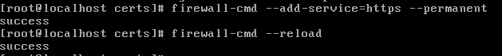

Trusted root (1p)
Your Workstation VM needs to trust to your CA certificate or it will alert you about the server. Fetch the ca.pem from the CA VM to your Workstation VM using SSH (scp root@a.b.c.d:ca.pem ca.pem). There are several places where the ca.pem needs to be put
Ca.pem tiedoston lataus workstationille
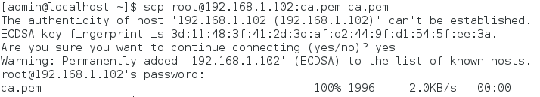
In a Windows-based PC, you can add the certificate to trusted roots in MMC console. We don’t currently use Windows in this lab.
In Centos7, put the certificate file in /etc/pki/ca-trust/source/anchors/ and run sudo update-ca trust. This will add the certificate as a trusted root.
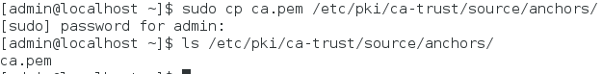
Alas, Firefox does not use the system certificates and you need to add the CA there also. Open Firefox, select Options -> Advanced -> Certificates -> View Certificates. Select the Authorities tab, Click Import and select ca.pem-file.

Certifikaatti Firefoxissa
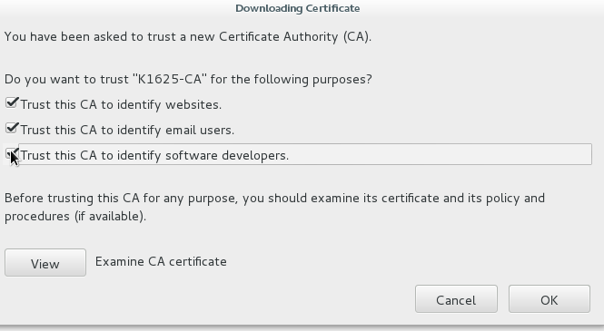

DNS name and testing (1p)
Final step is to add a DNS name for the webserver. The certificate is written only for the webserver name, not the IP address, so even if you try to access the webserver now, you will get an error.
Go to Pfsense management, and find DNS Forwarder settings. Add a Host override. Set host name as www, domain name as your-student-id.com and point the IP address to your webserver. Now you should be able to resolve host www.your-student-id.com from your Workstation. You can test this with nslookup.

Host override asetus
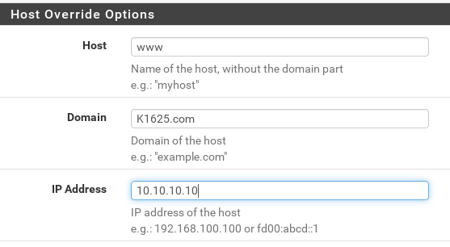
Tarkistus nslookupilla
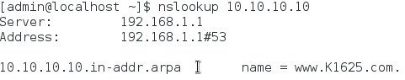
Try to browse to your webserver with the name from the Workstation. If you get no warning, everything works. If you get warning, check configuration, Firefox certificates, etc.
When you are finished, take a screenshot of the Certificate Hierarchy path (shown in View Certificate - Details)
BONUS: If you have time, try to find out how to add another hostname or IP address to subjectAltNames of the certificate.
Muokkasin PFSensestä port forwardin HTTPS liikenteelle ja sallin HTTPS liikenteen LAN rajapinnassa
Firefoxin sertifikaatti ja sertifikaatti hierarkia:
