Lab6 – Paloalto basics
Joni Korpihalkola

Document your commands or take screenshots. Answer questions in english or finnish.
Both Ubuntu credentials: Student/root-66 (notice there might be us keyboard, so “-“ can be used from numpad.
Paloalto: admin/admin
The labs use the following topology (Workstation will be Ubuntu Desktop):

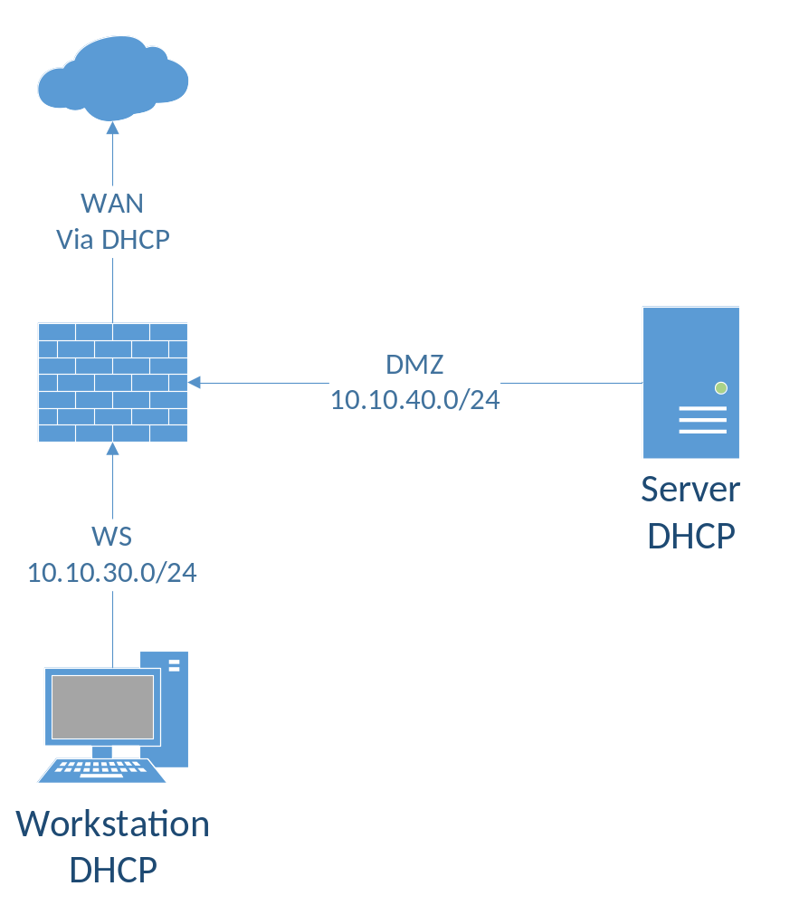

Install Paloalto (1p)
Retrieve the pre-installed VM images for Paloalto, Ubuntu Workstation and the Ubuntu server from \\ghost.labranet.jamk.fi\virtuaalikoneet\TTKS\VMware . Import them to VMware. Set interfaces as following:
Paloalto:
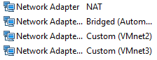
Ubuntu Desktop: Custom (VMnet2)
Ubuntu Server: Custom(VMnet3)
Generate MAC-address for every interface!
Next, we need to change which virtualDevices VMware uses for interfaces.
If you don’t remember/know where you imported virtual machines, select virtual machines, go to options tab, and there you should be able to find Working directory.
Close VMware workstation and use explorer to navigate where you imported virtual machines. There should be file like this:
Open it with notepad, find lines where it says ethernetX.virtualDev = ”e1000” (Where X is any number, depends on how many virtual network adapters you have on VM), and change e1000 to vmxnet3. Maybe the easiest way is to Find and Replace e1000 to vmxnet3.
So for every interfaces you should change this:
to this:
Save files and then open VMware again.
Next, boot up Paloalto, for login use admin/admin. It might take while before you actually can log in…
Then we need to figure out what ip address paloalto uses, type:
show interface all
and check Ip address for Ethernet1/1 .
Now we should be able to connect that ip address with host machine. Use firefox & Use HTTPS!!!!
If it doesn’t work, try check ip-address on ethernet1/2 and use it (With https)!
Ok, you get warning that connection isn’t secure, add exception.
Login to paloalto from browser, then choose Network tab and Virtual Routers from there. Select default, static routes, edit default gateway. Change next hop address to same that default gateway on your desktop.
Boot up the Ubuntu desktop (credentials are student/root-66) and check that it gets IP address from the Paloalto. If not, sudo ifdown ens33 then sudo ifup ens33.
When you get IP address, try accessing going to www.iltalehti.fi with a browser in the Ubuntu.
Do same with Ubuntu server, there isn’t browser, but try wget iltasanomat.fi

License + URL FILTERING (1p)
There I wrong DNS Resolver on paloalto change it from: device -> setup -> services to be 192.168.40.21 and 192.168.40.22
DNS Resolverin muokkaus
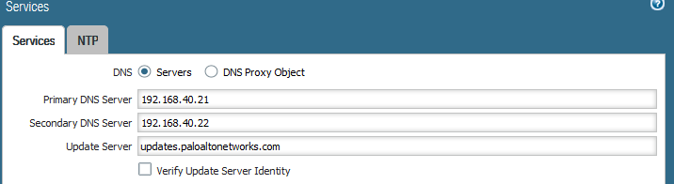
Go to Devices, Licenses, Activate feature using authorization code. Use license code: I9418680
Lisenssin aktivointi
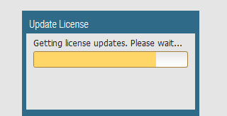
Activation will reboot paloalto, So you may need to check which ip-address it did get this time…
Next try to figure out how to do url filtering, we want to block yle.fi. Try to block advertisements too on site you wish. It is good to know that you can’t block https sites or advertisements without configuring decryption, so try to find site where advertisements are http. Remember to take screenshot form blocked site & Url filtering monitor…
Ensiksi tein säännön Objects -> Security Profiles -> URL Filtering
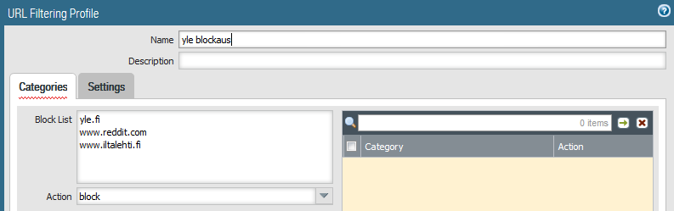
Sitten otin profilen käyttöön Policies -> Security
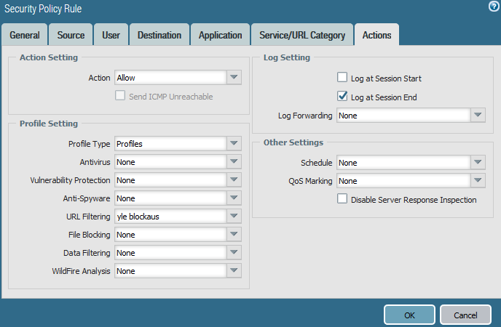

Mainosten blockaus:
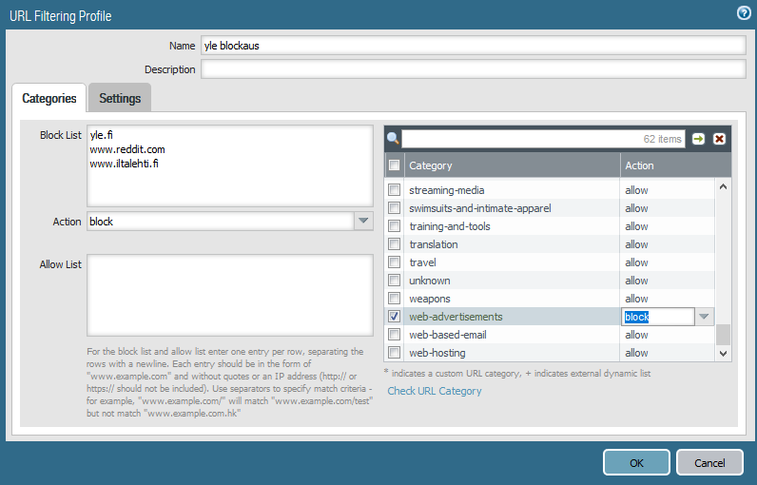
Ylen blockaus toimii:
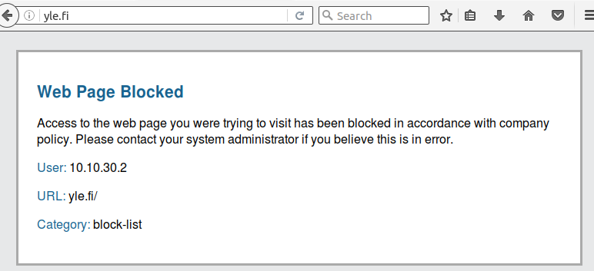
Mainosten blockaus toimii, esim. Kun menee osoitteeseen riemurasia.net, se alkaa valittamaan, että on mainostenesto päällä. Ilman mainostenestoa se ei asiasta huomauttanut.
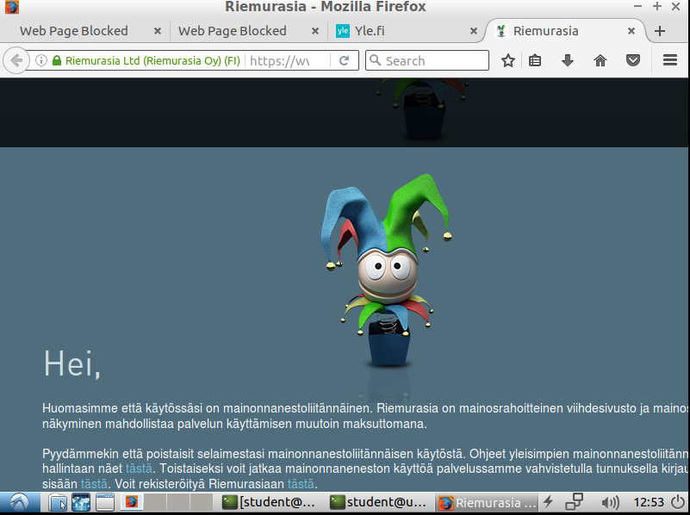

Firewall Rules (1p)
Ubuntu server has Apache running on it, make rule which allows you to browse from Ubuntu Desktop to it. So you need to make new security policy, from WS to DMZ, where you allow web-browsing
WS-to-DMZ sääntö, jossa applicationissa web-browsing
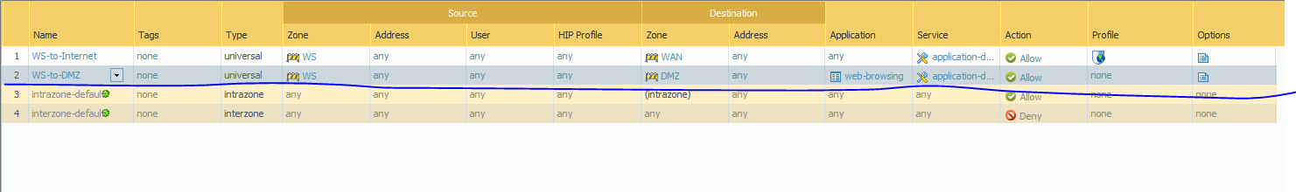
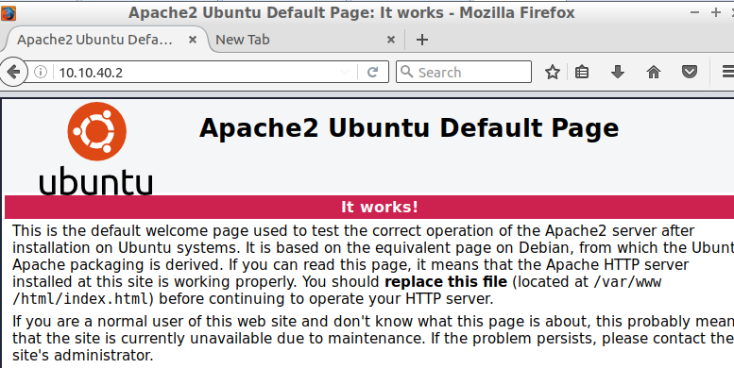

Ubuntu server has also ssh-server running on it, make rule so you can take ssh connection from Desktop to it..
Muokataan äskeistä sääntöä, jossa lisätään applicationeihin ssh
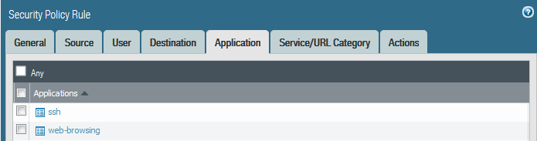

SSH Servulle
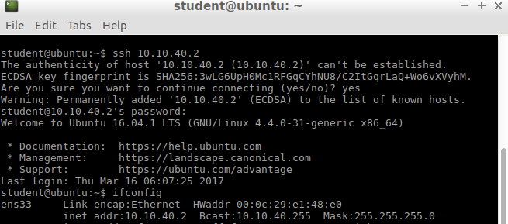

WWW NAT (1p)
In this lab we configure a port forward -based NAT. Incoming connection to port 80 from the WAN will be forwarded to the webserver.
First you need to create webserver-private and webserver-public objects, so go to Objects -> addresses

Add those two objects, for private set address to your server address.
For public set address to be same which one you have on ethernet1/1 (Click dynamic to see it)
Osoitteet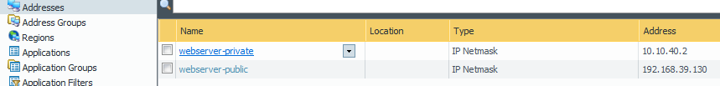
To get NAT working you need to do 2 things:
NAT rule and security rule
For NAT Source Zone WAN to Dest zone wan, any source, destination address is webserver-public service service-http destination translation address: webserver-private port 80
Sääntö
Security rule: from zone WAN to destination zone dmz and destination address webservers-public application web-browsing service any.

Toimii. Pöytäkoneelta kun kirjoittaa webserver-private osoitteen niin heittää servulle.
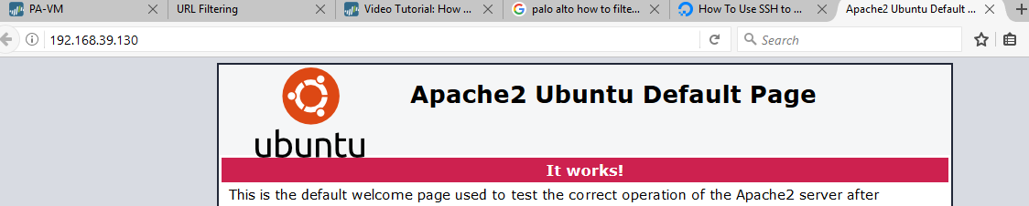

SSH NAT (1p)
Almost same as how you configured www NAT, now we just want do it for SSH, prove that you did get it working by taking ssh connection from windows host with putty ☺
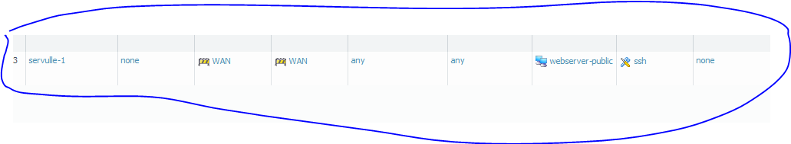
Puttyllä kun ottaa yhteyden webserver-private osoitteeseen, pääsee servulle.
